# Chapter 4:

# Exponential and Logarithmic Functions

Section 4.1 Exponential Functions 249

Section 4.2 Graphs of Exponential Functions 267

Section 4.3 Logarithmic Functions 277

Section 4.4 Logarithmic Properties 289

Section 4.5 Graphs of Logarithmic Functions 300

Section 4.6 Exponential and Logarithmic Models 308

Section 4.7 Fitting Exponentials to Data 328

## Section 4.1 Exponential Functions

India is the second most populous country in the world, with a population in 2008 of about 1.14 billion people. The population is growing by about 1.34% each year[1]. We might ask if we can find a formula to model the population, *P*, as a function of time, *t*, in years after 2008, if the population continues to grow at this rate.

In linear growth, we had a constant rate of change – a constant *number* that the output increased for each increase in input. For example, in the equation , the slope tells us the output increases by three each time the input increases by one. This population scenario is different – we have a *percent* rate of change rather than a constant number of people as our rate of change.

To see the significance of this difference consider these two companies:

Company *A* has 100 stores, and expands by opening 50 new stores a year

Company *B* has 100 stores, and expands by increasing the number of stores by 50% of their total each year.

Looking at a few years of growth for these companies:

|  |  |  |  |
| --- | --- | --- | --- |
| Year | Stores, company *A* |  | Stores, company *B* |
| 0 | 100 | Starting with 100 each | 100 |
| 1 | 100 + 50 = 150 | They both grow by 50 stores in the first year. | 100 + 50% of 100  100 + 0.50(100) = 150 |
| 2 | 150 + 50 = 200 | Store A grows by 50, Store B grows by 75 | 150 + 50% of 150  150 + 0.50(150) = 225 |
| 3 | 200 + 50 = 250 | Store A grows by 50, Store B grows by 112.5 | 225 + 50% of 225  225 + 0.50(225) = 337.5 |

Notice that with the percent growth, each year the company grows by 50% of the current year’s total, so as the company grows larger, the number of stores added in a year grows as well.

To try to simplify the calculations, notice that after 1 year the number of stores for company *B* was:

 or equivalently by factoring



We can think of this as “the new number of stores is the original 100% plus another 50%”.

After 2 years, the number of stores was:

 or equivalently by factoring

 now recall the 150 came from 100(1+0.50). Substituting that,



After 3 years, the number of stores was:

 or equivalently by factoring

 now recall the 225 came from . Substituting that,



From this, we can generalize, noticing that to show a 50% increase, each year we multiply by a factor of (1+0.50), so after *n* years, our equation would be



In this equation, the 100 represented the initial quantity, and the 0.50 was the percent growth rate. Generalizing further, we arrive at the general form of exponential functions.

Exponential Function

An **exponential growth or decay function** is a function that grows or shrinks at a constant percent growth rate. The equation can be written in the form

 or  where *b* = 1+*r*

Where

*a* is the initial or starting value of the function

*r* is the percent growth or decay rate, written as a decimal

*b* is the growth factor or growth multiplier. Since powers of negative numbers behave strangely, we limit *b* to positive values.

To see more clearly the difference between exponential and linear growth, compare the two tables and graphs below, which illustrate the growth of company *A* and *B* described above over a longer time frame if the growth patterns were to continue.

Chart
Two graphs on the same axes. The first, labeled A, is a straight line.  The second, labeled B,  curves upwards becoming increasingly steep as x increases.

|  |  |  |
| --- | --- | --- |
| years | Company *A* | Company *B* |
| 2 | 200 | 225 |
| 4 | 300 | 506 |
| 6 | 400 | 1139 |
| 8 | 500 | 2563 |
| 10 | 600 | 5767 |

Example 1

Write an exponential function for India’s population, and use it to predict the population in 2020.

At the beginning of the chapter we were given India’s population of 1.14 billion in the year 2008 and a percent growth rate of 1.34%. Using 2008 as our starting time (*t* = 0), our initial population will be 1.14 billion. Since the percent growth rate was 1.34%, our value for *r* is 0.0134.

Using the basic formula for exponential growth we can write the formula, 

To estimate the population in 2020, we evaluate the function at *t* = 12, since 2020 is 12 years after 2008.

billion people in 2020

For comparison, the actual population of India in 2020 was about 1.380 billion.

Try it Now

1. Given the three statements below, identify which represent exponential functions.

A. The cost of living allowance for state employees increases salaries by 3.1% each year.

B. State employees can expect a $300 raise each year they work for the state.

C. Tuition costs have increased by 2.8% each year for the last 3 years.

Example 2

A certificate of deposit (CD) is a type of savings account offered by banks, typically offering a higher interest rate in return for a fixed length of time you will leave your money invested. If a bank offers a 24 month CD with an annual interest rate of 1.2% compounded monthly, how much will a $1000 investment grow to over those 24 months?

First, we must notice that the interest rate is an annual rate, but is compounded monthly, meaning interest is calculated and added to the account monthly. To find the monthly interest rate, we divide the annual rate of 1.2% by 12 since there are 12 months in a year: 1.2%/12 = 0.1%. Each month we will earn 0.1% interest. From this, we can set up an exponential function, with our initial amount of $1000 and a growth rate of *r* = 0.001, and our input *m* measured in months.





After 24 months, the account will have grown to 

Try it Now

2. Looking at these two equations that represent the balance in two different savings accounts, which account is growing faster, and which account will have a higher balance after 3 years?  
 

In all the preceding examples, we saw exponential growth. Exponential functions can also be used to model quantities that are decreasing at a constant percent rate. An example of this is radioactive decay, a process in which radioactive isotopes of certain atoms transform to an atom of a different type, causing a percentage decrease of the original material over time.

Example 3

Bismuth-210 is an isotope that radioactively decays by about 13% each day, meaning 13% of the remaining Bismuth-210 transforms into another atom (polonium-210 in this case) each day. If you begin with 100 mg of Bismuth-210, how much remains after one week?

With radioactive decay, instead of the quantity increasing at a percent rate, the quantity is decreasing at a percent rate. Our initial quantity is *a* = 100 mg, and our growth rate will be negative 13%, since we are decreasing: *r* = -0.13. This gives the equation:



This can also be explained by recognizing that if 13% decays, then 87 % remains.

After one week, 7 days, the quantity remaining would be

mg of Bismuth-210 remains.

Try it Now

3. A population of 1000 is decreasing 3% each year. Find the population in 30 years.

Example 4

*T(q)* represents the total number of Android smart phone contracts, in thousands, held by a certain Verizon store region measured quarterly since January 1, 2016,

Interpret all the parts of the equation .

Interpreting this from the basic exponential form, we know that 86 is our initial value. This means that on Jan. 1, 2016 this region had 86,000 Android smart phone contracts. Since *b* = 1 + *r* = 1.64, we know that every quarter the number of smart phone contracts grows by 64%. *T*(2) = 231.3056 means that in the 2nd quarter (or at the end of the second quarter) there were approximately 231,306 Android smart phone contracts.

**Finding Equations of Exponential Functions**

In the previous examples, we were able to write equations for exponential functions since we knew the initial quantity and the growth rate. If we do not know the growth rate, but instead know only some input and output pairs of values, we can still construct an exponential function.

Example 5

In 2009, 80 deer were reintroduced into a wildlife refuge area from which the population had previously been hunted to elimination. By 2015, the population had grown to 180 deer. If this population grows exponentially, find a formula for the function.

By defining our input variable to be *t*, years after 2009, the information listed can be written as two input-output pairs: (0,80) and (6,180). Notice that by choosing our input variable to be measured as years after the first year value provided, we have effectively “given” ourselves the initial value for the function: *a* = 80. This gives us an equation of the form

.

Substituting in our second input-output pair allows us to solve for *b*:

 Divide by 80

 Take the 6th root of both sides.



This gives us our equation for the population:



Recall that since *b* = 1+*r*, we can interpret this to mean that the population growth rate is *r* = 0.1447, and so the population is growing by about 14.47% each year.

In this example, you could also have used (9/4)^(1/6) to evaluate the 6th root if your calculator doesn’t have an *n*th root button.

In the previous example, we chose to use the  form of the exponential function rather than the  form. This choice was entirely arbitrary – either form would be fine to use.

When finding equations, the value for *b* or *r* will usually have to be rounded to be written easily. To preserve accuracy, it is important to not over-round these values. Typically, you want to be sure to preserve at least 3 significant digits in the growth rate. For example, if your value for *b* was 1.00317643, you would want to round this no further than to 1.00318.

In the previous example, we were able to “give” ourselves the initial value by clever definition of our input variable. Next, we consider a situation where we can’t do this.

Example 6

Find a formula for an exponential function passing through the points (-2,6) and (2,1).

Since we don’t have the initial value, we will take a general approach that will work for any function form with unknown parameters: we will substitute in both given input-output pairs in the function form  and solve for the unknown values, *a* and *b*.

Substituting in (-2, 6) gives 

Substituting in (2, 1) gives 

We now solve these as a system of equations. To do so, we could try a substitution approach, solving one equation for a variable, then substituting that expression into the second equation.

Solving  for *a*:



In the second equation, , we substitute the expression above for *a*:



Going back to the equation  lets us find *a*:



Putting this together gives the equation 

Try it Now

4. Given the two points (1, 3) and (2, 4.5) find the equation of an exponential function that passes through these two points.

Example 7

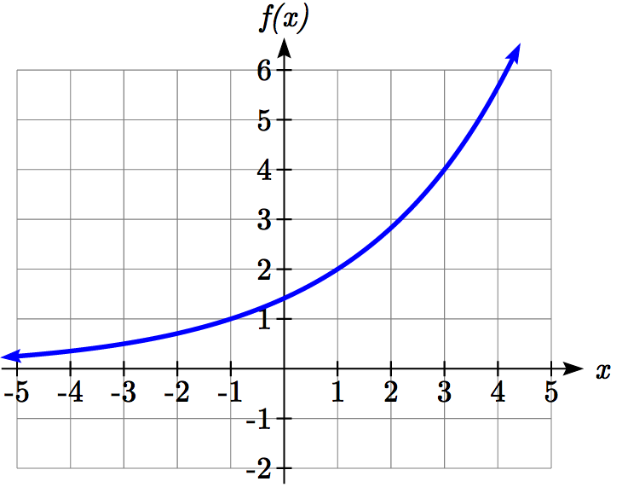Find an equation for the exponential function graphed.

The initial value for the function is not clear in this graph, so we will instead work using two clearer points. There are three clear points: (-1, 1), (1, 2), and (3, 4). As we saw in the last example, two points are sufficient to find the equation for a standard exponential, so we will use the latter two points.

Substituting in (1,2) gives 

Substituting in (3,4) gives 

Solving the first equation for *a* gives .

Substituting this expression for *a* into the second equation:



 Simplify the right-hand side



Since we restrict ourselves to positive values of *b*, we will use . We can then go back and find *a*:



This gives us a final equation of .

**Compound Interest**

In the bank certificate of deposit (CD) example earlier in the section, we encountered compound interest. Typically bank accounts and other savings instruments in which earnings are reinvested, such as mutual funds and retirement accounts, utilize compound interest. The term *compounding* comes from the behavior that interest is earned not on the original value, but on the accumulated value of the account.

In the example from earlier, the interest was compounded monthly, so we took the annual interest rate, usually called the **nominal rate** or **annual percentage rate (APR)** and divided by 12, the number of compounds in a year, to find the monthly interest. The exponent was then measured in months.

Generalizing this, we can form a general formula for compound interest. If the APR is written in decimal form as *r*, and there are *k* compounding periods per year, then the interest per compounding period will be *r/k*. Likewise, if we are interested in the value after *t* years, then there will be *kt* compounding periods in that time.

Compound Interest Formula

**Compound Interest** can be calculated using the formula



Where

*A(t)* is the account value

*t* is measured in years

*a* is the starting amount of the account, often called the principal

*r* is the annual percentage rate (APR), also called the nominal rate

*k* is the number of compounding periods in one year

Example 8

If you invest $3,000 in an investment account paying 3% interest compounded quarterly, how much will the account be worth in 10 years?

Since we are starting with $3000, *a* = 3000

Our interest rate is 3%, so *r* = 0.03

Since we are compounding quarterly, we are compounding 4 times per year, so *k* = 4

We want to know the value of the account in 10 years, so we are looking for *A*(10), the value when *t* = 10.



The account will be worth $4045.05 in 10 years.

Example 9

A 529 plan is a college savings plan in which a relative can invest money to pay for a child’s later college tuition, and the account grows tax free. If Lily wants to set up a 529 account for her new granddaughter, wants the account to grow to $40,000 over 18 years, and she believes the account will earn 6% compounded semi-annually (twice a year), how much will Lily need to invest in the account now?

Since the account is earning 6%, *r* = 0.06

Since interest is compounded twice a year, *k* = 2

In this problem, we don’t know how much we are starting with, so we will be solving for *a*, the initial amount needed. We do know we want the end amount to be $40,000, so we will be looking for the value of *a* so that *A*(18) = 40,000.



Lily will need to invest $13,801 to have $40,000 in 18 years.

Try it now

5. Recalculate example 2 from above with quarterly compounding.

Because of compounding throughout the year, with compound interest the actual increase in a year is *more* than the annual percentage rate. If $1,000 were invested at 10%, the table below shows the value after 1 year at different compounding frequencies:

|  |  |
| --- | --- |
| Frequency | Value after 1 year |
| Annually | $1100 |
| Semiannually | $1102.50 |
| Quarterly | $1103.81 |
| Monthly | $1104.71 |
| Daily | $1105.16 |

If we were to compute the actual percentage increase for the daily compounding, there was an increase of $105.16 from an original amount of $1,000, for a percentage increase of = 10.516% increase. This quantity is called the **annual percentage yield (APY)**.

Notice that given any starting amount, the amount after 1 year would be

. To find the total change, we would subtract the original amount, then to find the percentage change we would divide that by the original amount:



Annual Percentage Yield

The **annual percentage yield** is the actual percent a quantity increases in one year. It can be calculated as



This is equivalent to finding the value of $1 after 1 year, and subtracting the original dollar.

Example 10

Bank A offers an account paying 1.2% compounded quarterly. Bank B offers an account paying 1.1% compounded monthly. Which is offering a better rate?

We can compare these rates using the annual percentage yield – the actual percent increase in a year.

Bank A:  = 1.2054%

Bank B:  = 1.1056%

Bank B’s monthly compounding is not enough to catch up with Bank A’s better APR. Bank A offers a better rate.

**A Limit to Compounding**

As we saw earlier, the amount we earn increases as we increase the compounding frequency. The table, though, shows that the increase from annual to semi-annual compounding is larger than the increase from monthly to daily compounding. This might lead us to believe that although increasing the frequency of compounding will increase our result, there is an upper limit to this process.

To see this, let us examine the value of $1 invested at 100% interest for 1 year.

|  |  |
| --- | --- |
| **Frequency** | **Value** |
| Annual | $2 |
| Quarterly | $2.441406 |
| Monthly | $2.613035 |
| Daily | $2.714567 |
| Hourly | $2.718127 |
| Once per minute | $2.718279 |
| Once per second | $2.718282 |

These values do indeed appear to be approaching an upper limit. This value ends up being so important that it gets represented by its own letter, much like how represents a number.

Euler’s Number: *e*

***e***is the letter used to represent the value that  approaches as *k* gets big.



Because *e* is often used as the base of an exponential, most scientific and graphing calculators have a button that can calculate powers of *e*, usually labeled *ex*. Some computer software instead defines a function *exp(x)*, where *exp(x)* = *ex*.

Because *e* arises when the time between compounds becomes very small, *e* allows us to define **continuous growth** and allows us to define a new toolkit function, .

Continuous Growth Formula

**Continuous Growth** can be calculated using the formula



where

*a* is the starting amount

*r* is the continuous growth rate

This type of equation is commonly used when describing quantities that change more or less continuously, like chemical reactions, growth of large populations, and radioactive decay.

Example 11

Radon-222 decays at a continuous rate of 17.3% per day. How much will 100mg of Radon-222 decay to in 3 days?

Since we are given a continuous decay rate, we use the continuous growth formula. Since the substance is decaying, we know the growth rate will be negative: *r* = -0.173

mg of Radon-222 will remain.

Try it Now

6. Interpret the following: if *S(t)* represents the growth of a substance in grams, and time is measured in days.

Continuous growth is also often applied to compound interest, allowing us to talk about continuous compounding.

Example 12

If $1000 is invested in an account earning 10% compounded continuously, find the value after 1 year.

Here, the continuous growth rate is 10%, so *r* = 0.10. We start with $1000, so *a* = 1000.

To find the value after 1 year,



Notice this is a $105.17 increase for the year. As a percent increase, this is  increase over the original $1000.

Notice that this value is slightly larger than the amount generated by daily compounding in the table computed earlier.

The continuous growth rate is like the nominal growth rate (or APR) – it reflects the growth rate before compounding takes effect. This is different than the annual growth rate used in the formula, which is like the annual percentage yield – it reflects the *actual* amount the output grows in a year.

While the continuous growth rate in the example above was 10%, the actual annual yield was 10.517%. This means we could write two different looking but equivalent formulas for this account’s growth:

 using the 10% continuous growth rate

 using the 10.517% actual annual yield rate.

Important Topics of this Section

Percent growth

Exponential functions

Finding formulas

Interpreting equations

Graphs

Exponential Growth & Decay

Compound interest

Annual Percent Yield

Continuous Growth

Try it Now Answers

1. A & C are exponential functions, they grow by a % not a constant number.

2. B(t) is growing faster (*r* = 0.075 > 0.05), but after 3 years A(t) still has a higher account balance

3.   


4. , so ,   
, so .   
*b* = 1.5.   


5. 24 months = 2 years. = $1024.25

6. An initial substance weighing 20g is growing at a continuous rate of 12% per day.

## Section 4.1 Exercises

For each table below, could the table represent a function that is linear, exponential, or neither?

|  |  |  |  |  |  |  |  |  |  |  |  |  |  |  |  |  |  |  |  |  |  |  |  |
| --- | --- | --- | --- | --- | --- | --- | --- | --- | --- | --- | --- | --- | --- | --- | --- | --- | --- | --- | --- | --- | --- | --- | --- |
| 1. | |  |  |  |  |  | | --- | --- | --- | --- | --- | | ***x*** | 1 | 2 | 3 | 4 | | ***f(x)*** | 70 | 40 | 10 | -20 | | 2. | |  |  |  |  |  | | --- | --- | --- | --- | --- | | ***x*** | 1 | 2 | 3 | 4 | | ***g(x)*** | 40 | 32 | 26 | 22 | |
| 3. | |  |  |  |  |  | | --- | --- | --- | --- | --- | | ***x*** | 1 | 2 | 3 | 4 | | ***h(x)*** | 70 | 49 | 34.3 | 24.01 | | 4. | |  |  |  |  |  | | --- | --- | --- | --- | --- | | ***x*** | 1 | 2 | 3 | 4 | | ***k(x)*** | 90 | 80 | 70 | 60 | |
| 5. | |  |  |  |  |  | | --- | --- | --- | --- | --- | | ***x*** | 1 | 2 | 3 | 4 | | ***m(x)*** | 80 | 61 | 42.9 | 25.61 | | 6. | |  |  |  |  |  | | --- | --- | --- | --- | --- | | ***x*** | 1 | 2 | 3 | 4 | | ***n(x)*** | 90 | 81 | 72.9 | 65.61 | |

1. A population numbers 11,000 organisms initially and grows by 8.5% each year. Write an exponential model for the population.
2. A population is currently 6,000 and has been increasing by 1.2% each day. Write an exponential model for the population.
3. The fox population in a certain region has an annual growth rate of 9 percent per year. It is estimated that the population in the year 2010 was 23,900. Estimate the fox population in the year 2018.
4. The amount of area covered by blackberry bushes in a park has been growing by 12% each year. It is estimated that the area covered in 2009 was 4,500 square feet. Estimate the area that will be covered in 2020.
5. A vehicle purchased for $32,500 depreciates at a constant rate of 5% each year. Determine the approximate value of the vehicle 12 years after purchase.
6. A business purchases $125,000 of office furniture which depreciates at a constant rate of 12% each year. Find the residual value of the furniture 6 years after purchase.

Find a formula for an exponential function passing through the two points.

13.  14. 

15.  16. 

17.  18. 

19.  20. 

21.   22. 

1. A radioactive substance decays exponentially. A scientist begins with 100 milligrams of a radioactive substance. After 35 hours, 50 mg of the substance remains. How many milligrams will remain after 54 hours?
2. A radioactive substance decays exponentially. A scientist begins with 110 milligrams of a radioactive substance. After 31 hours, 55 mg of the substance remains. How many milligrams will remain after 42 hours?
3. A house was valued at $110,000 in the year 1985. The value appreciated to $145,000 by the year 2005. What was the annual growth rate between 1985 and 2005? Assume that the house value continues to grow by the same percentage. What did the value equal in the year 2010?
4. An investment was valued at $11,000 in the year 1995. The value appreciated to $14,000 by the year 2008. What was the annual growth rate between 1995 and 2008? Assume that the value continues to grow by the same percentage. What did the value equal in the year 2012?
5. A car was valued at $38,000 in the year 2003. The value depreciated to $11,000 by the year 2009. Assume that the car value continues to drop by the same percentage. What was the value in the year 2013?
6. A car was valued at $24,000 in the year 2006. The value depreciated to $20,000 by the year 2009. Assume that the car value continues to drop by the same percentage. What was the value in the year 2014?
7. If $4,000 is invested in a bank account at an interest rate of 7 per cent per year, find the amount in the bank after 9 years if interest is compounded annually, quarterly, monthly, and continuously.
8. If $6,000 is invested in a bank account at an interest rate of 9 per cent per year, find the amount in the bank after 5 years if interest is compounded annually, quarterly, monthly, and continuously.
9. Find the annual percentage yield (APY) for a savings account with annual percentage rate of 3% compounded quarterly.
10. Find the annual percentage yield (APY) for a savings account with annual percentage rate of 5% compounded monthly.
11. A population of bacteria is growing according to the equation , with *t* measured in years. Estimate when the population will exceed 7569.
12. A population of bacteria is growing according to the equation , with *t* measured in years. Estimate when the population will exceed 3443.
13. In 1968, the U.S. minimum wage was $1.60 per hour. In 1976, the minimum wage was $2.30 per hour. Assume the minimum wage grows according to an exponential model , where *t* represents the time in years after 1960. [UW]
    1. Find a formula for .
    2. What does the model predict for the minimum wage in 1960?
    3. If the minimum wage was $5.15 in 1996, is this above, below or equal to what the model predicts?
14. In 1989, research scientists published a model for predicting the cumulative number of AIDS cases (in thousands) reported in the United States: , where *t* is the year. This paper was considered a “relief”, since there was a fear the correct model would be of exponential type. Pick two data points predicted by the research model  to construct a new exponential model  for the number of cumulative AIDS cases. Discuss how the two models differ and explain the use of the word “relief.” [UW]
15. 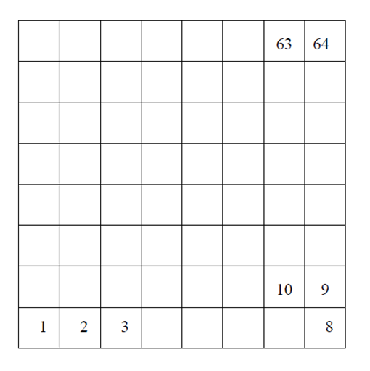You have a chess board as pictured, with squares numbered 1 through 64. You also have a huge change jar with an unlimited number of dimes. On the first square you place one dime. On the second square you stack 2 dimes. Then you continue, always doubling the number from the previous square. [UW]
    1. How many dimes will you have stacked on the 10th square?
    2. How many dimes will you have stacked on the nth square?
    3. How many dimes will you have stacked on the 64th square?
    4. Assuming a dime is 1 mm thick, how high will this last pile be?
    5. The distance from the earth to the sun is approximately 150 million km. Relate the height of the last pile of dimes to this distance.

## Section 4.2 Graphs of Exponential Functions

Like with linear functions, the graph of an exponential function is determined by the values for the parameters in the function’s formula.

To get a sense for the behavior of exponentials, let us begin by looking more closely at the function. Listing a table of values for this function:

|  |  |  |  |  |  |  |  |
| --- | --- | --- | --- | --- | --- | --- | --- |
| *x* | -3 | -2 | -1 | 0 | 1 | 2 | 3 |
| *f(x)* |  |  |  | 1 | 2 | 4 | 8 |

Notice that:

1. This function is positive for all values of *x*.
2. As *x* increases, the function grows faster and faster (the rate of change increases).
3. As *x* decreases, the function values grow smaller, approaching zero.
4. This is an example of exponential growth.

Looking at the function 

|  |  |  |  |  |  |  |  |
| --- | --- | --- | --- | --- | --- | --- | --- |
| *x* | -3 | -2 | -1 | 0 | 1 | 2 | 3 |
| *g(x)* | 8 | 4 | 2 | 1 |  |  |  |

Note this function is also positive for all values of *x*, but in this case grows as *x* decreases, and decreases towards zero as *x* increases. This is an example of exponential decay. You may notice from the table that this function appears to be the horizontal reflection of the  table. This is in fact the case:

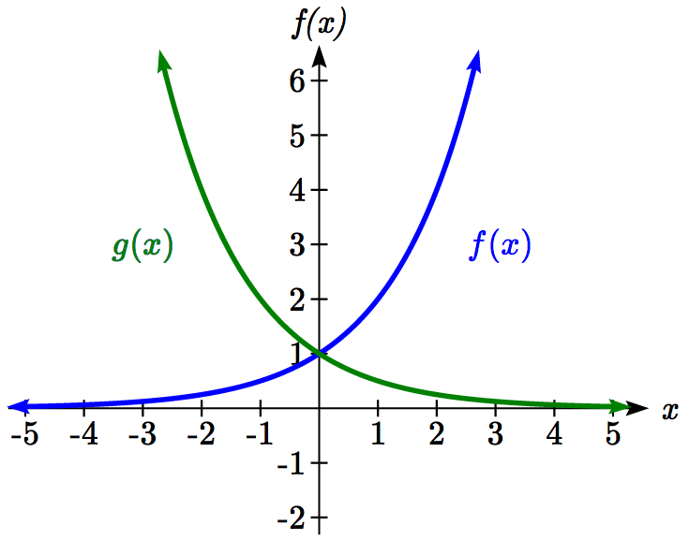

Looking at the graphs also confirms this relationship.

Consider a function of the form . Since *a*, which we called the initial value in the last section, is the function value at an input of zero, *a* will give us the vertical intercept of the graph.

From the graphs above, we can see that an exponential graph will have a horizontal asymptote on one side of the graph, and can either increase or decrease, depending upon the growth factor. This horizontal asymptote will also help us determine the long run behavior and is easy to determine from the graph.

The graph will grow when the growth rate is positive, which will make the growth factor *b* larger than one. When it’s negative, the growth factor will be less than one.

Graphical Features of Exponential Functions

Graphically, in the function 

*a* is the vertical intercept of the graph

*b* determines the rate at which the graph grows. When *a* is positive,

the function will increase if *b >* 1

the function will decrease if 0 < *b* < 1

The graph will have a horizontal asymptote at *y* = 0

The graph will be concave up if *a* > 0; concave down if *a* < 0.

The domain of the function is all real numbers

The range of the function is 

When sketching the graph of an exponential function, it can be helpful to remember that the graph will pass through the points (0, *a*) and (1, *ab*).

The value *b* will determine the function’s long run behavior:

If *b >* 1, as  ,  and as , .

If 0 < *b* < 1, as , and as , .

Example 1

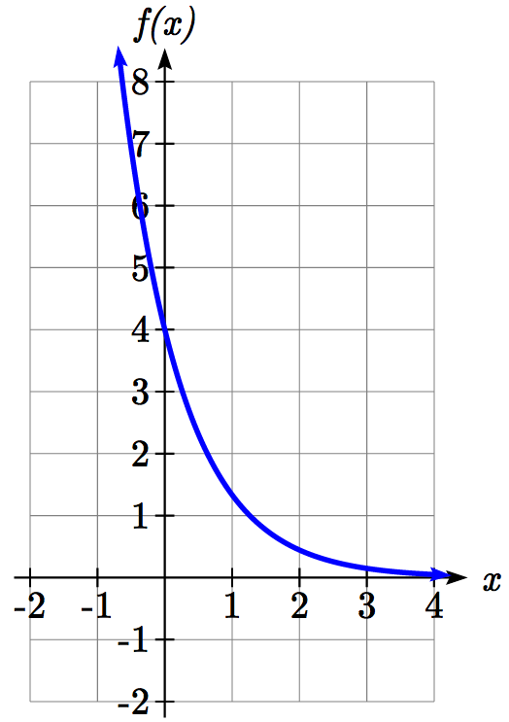Sketch a graph of 

This graph will have a vertical intercept at (0,4), and pass through the point . Since *b* < 1, the graph will be decreasing towards zero. Since *a* > 0, the graph will be concave up.

We can also see from the graph the long run behavior: as ,  and as , .

To get a better feeling for the effect of *a* and *b* on the graph, examine the sets of graphs below. The first set shows various graphs, where *a* remains the same and we only change the value for *b*.

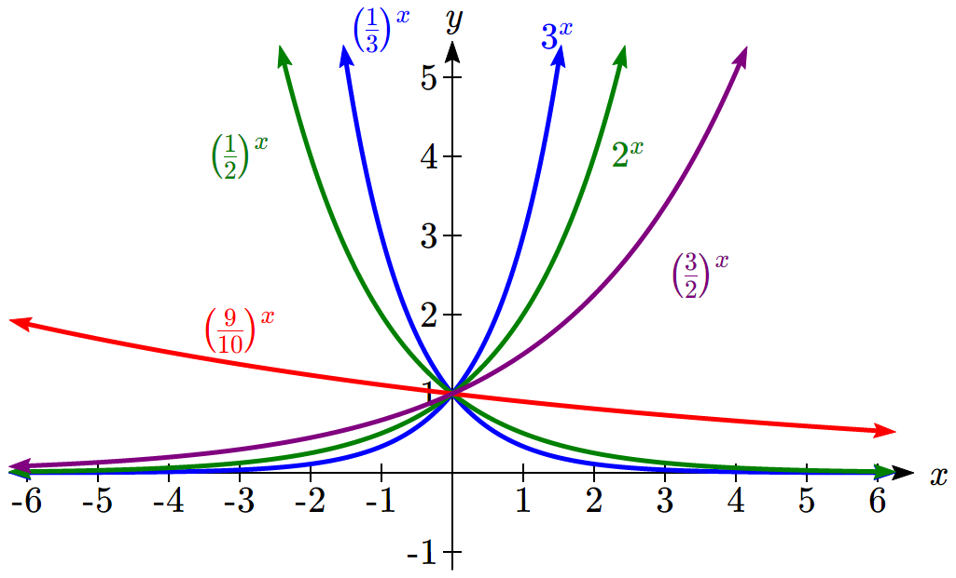

Notice that the closer the value of *b* is to 1, the less steep the graph will be.

In the next set of graphs, *a* is altered and our value for *b* remains the same.

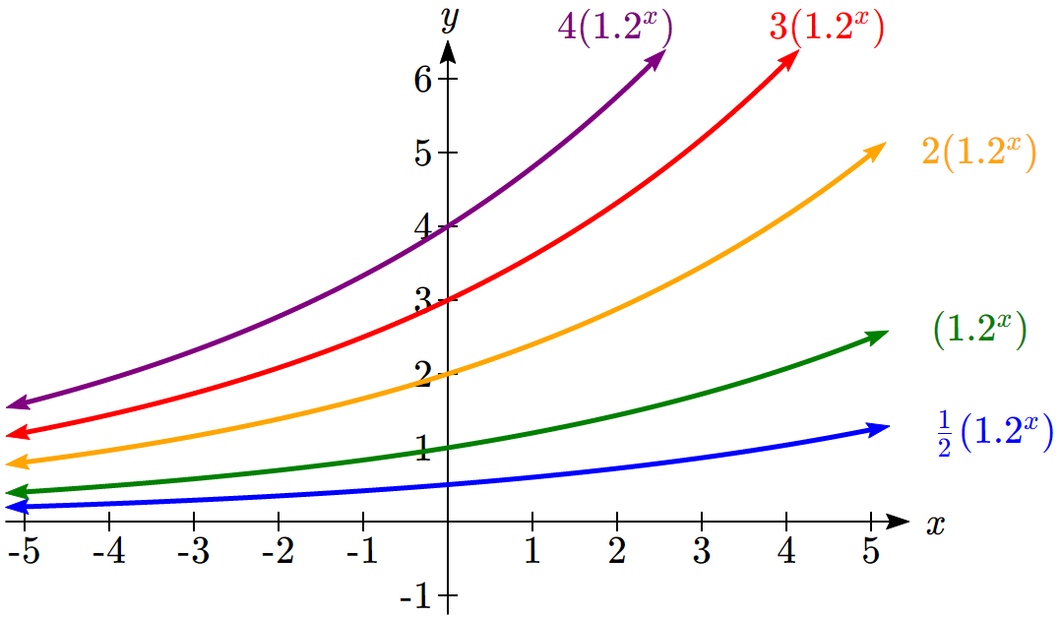

Notice that changing the value for *a* changes the vertical intercept. Since *a* is multiplying the *bx* term, *a* acts as a vertical stretch factor, not as a shift. Notice also that the long run behavior for all of these functions is the same because the growth factor did not change and none of these *a* values introduced a vertical flip.

Example 2

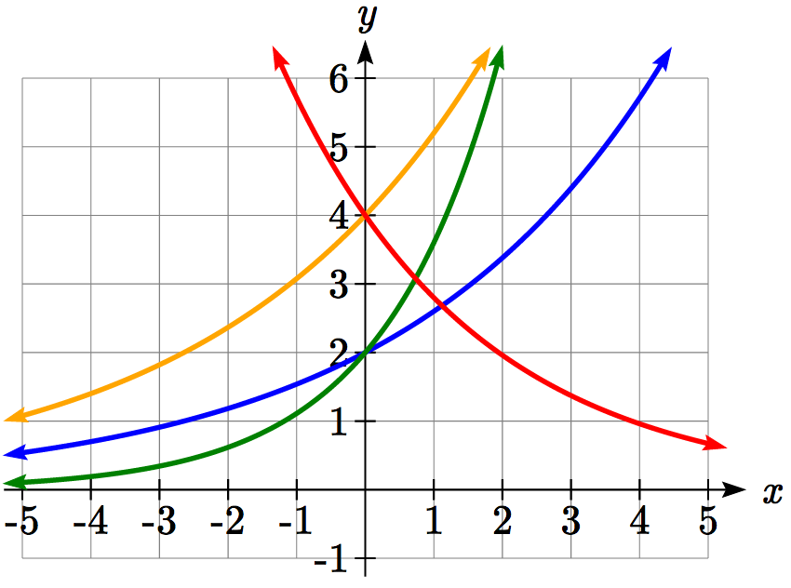Match each equation with its graph.



The graph of *k(x)* is the easiest to identify, since it is the only equation with a growth factor less than one, which will produce a decreasing graph. The graph of *h(x)* can be identified as the only growing exponential function with a vertical intercept at (0,4). The graphs of *f(x)* and *g(x)* both have a vertical intercept at (0,2), but since *g(x)* has a larger growth factor, we can identify it as the graph increasing faster.

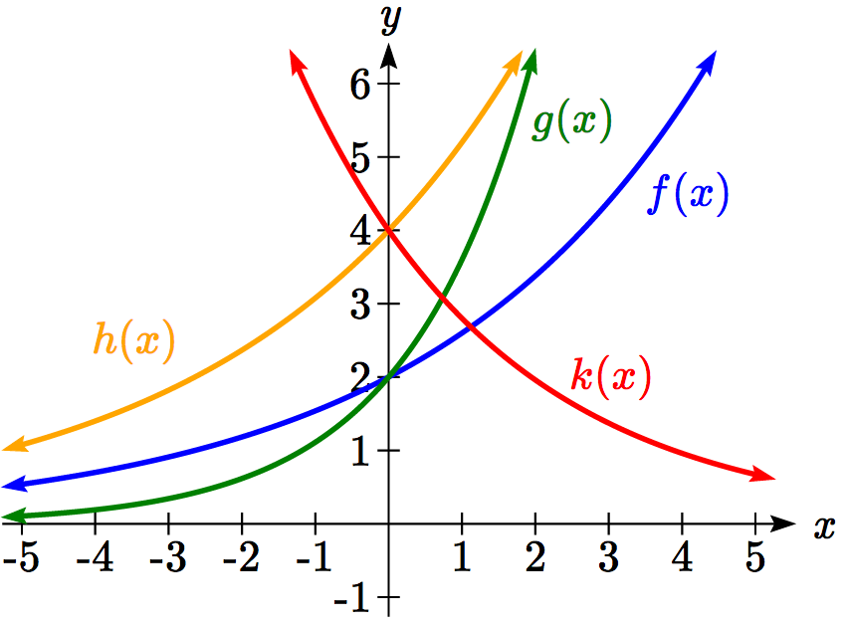

Try it Now

1. Graph the following functions on the same axis:   
 ; ; .

**Transformations of Exponential Graphs**

While exponential functions can be transformed following the same rules as any function, there are a few interesting features of transformations that can be identified. The first was seen at the beginning of the section – that a horizontal reflection is equivalent to a change in the growth factor. Likewise, since *a* is itself a stretch factor, a vertical stretch of an exponential corresponds with a change in the initial value of the function.

Next consider the effect of a horizontal shift on an exponential function. Shifting the function  four units to the left would give. Employing exponent rules, we could rewrite this:



Interestingly, it turns out that a horizontal shift of an exponential function corresponds with a change in initial value of the function.

Lastly, consider the effect of a vertical shift on an exponential function. Shifting  down 4 units would give the equation .

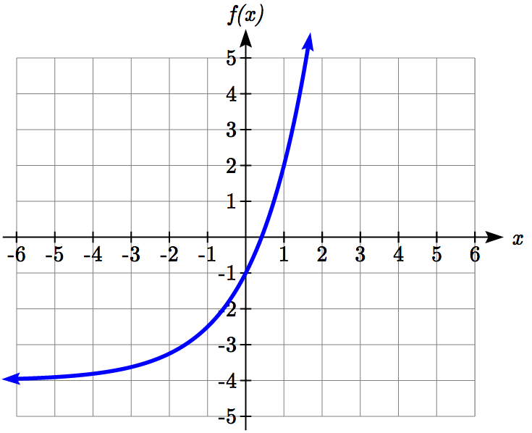

Graphing that, notice it is substantially different than the basic exponential graph. Unlike a basic exponential, this graph does not have a horizontal asymptote at *y* = 0; due to the vertical shift, the horizontal asymptote has also shifted to *y* = -4. We can see that as ,  and as , .

We have determined that a vertical shift is the only transformation of an exponential function that changes the graph in a way that cannot be achieved by altering the parameters *a* and *b* in the basic exponential function .

Transformations of Exponentials

Any transformed exponential can be written in the form



where *y = c* is the horizontal asymptote.

Note that, due to the shift, the vertical intercept is shifted to (0, *a+c*).

Try it Now

2. Write the equation and graph the exponential function described as follows:  
is vertically stretched by a factor of 2, flipped across the *y* axis and shifted up 4 units.

Example 3

Sketch a graph of .

Notice that in this exponential function, the negative in the stretch factor -3 will cause a vertical reflection, and the vertical shift up 4 will move the horizontal asymptote to *y* = 4. Sketching this as a transformation of ,

The basic  Vertically reflected and stretched by 3

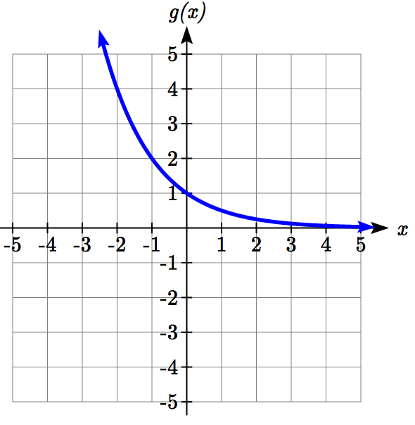 A graph that starts out negative and increasing rapidly, flattening out as x increases, passing through 0 comma negative 3, leveling off towards the y-axis as x gets large


Vertically shifted up four units

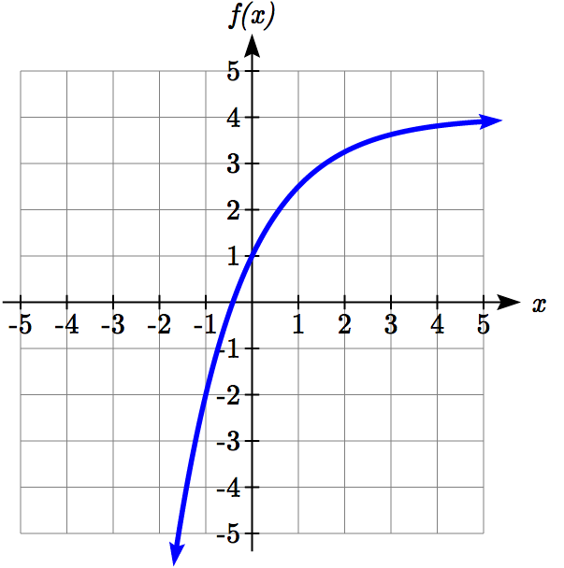

Notice that while the domain of this function is unchanged, due to the reflection and shift, the range of this function is .

As ,  and as , .

Functions leading to graphs like the one above are common as models for learning and models of growth approaching a limit.

Example 4

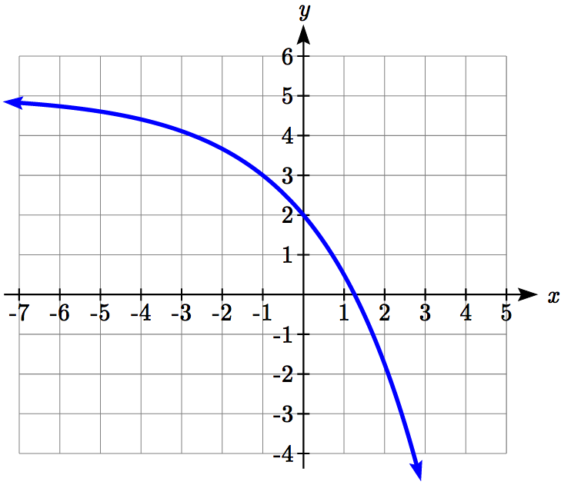Find an equation for the function graphed.

Looking at this graph, it appears to have a horizontal asymptote at *y* = 5, suggesting an equation of the form . To find values for *a* and *b*, we can identify two other points on the graph. It appears the graph passes through (0,2) and (-1,3), so we can use those points. Substituting in (0,2) allows us to solve for *a*.



Substituting in (-1,3) allows us to solve for *b*



The final formula for our function is .

Try it Now

3. Given the graph of the transformed exponential function, find a formula and describe the long run behavior.

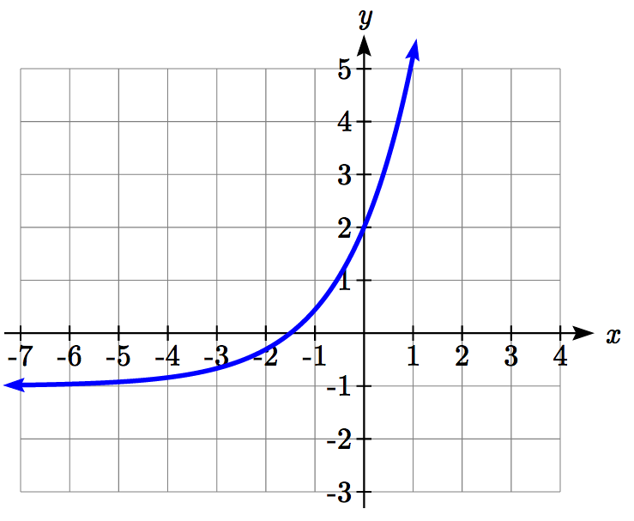

Important Topics of this Section

Graphs of exponential functions

Intercept

Growth factor

Exponential Growth

Exponential Decay

Horizontal intercepts

Long run behavior

Transformations

Try it Now Answers

1. 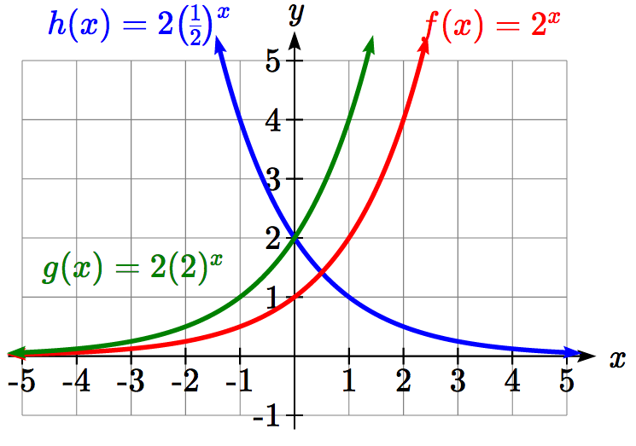

2. 

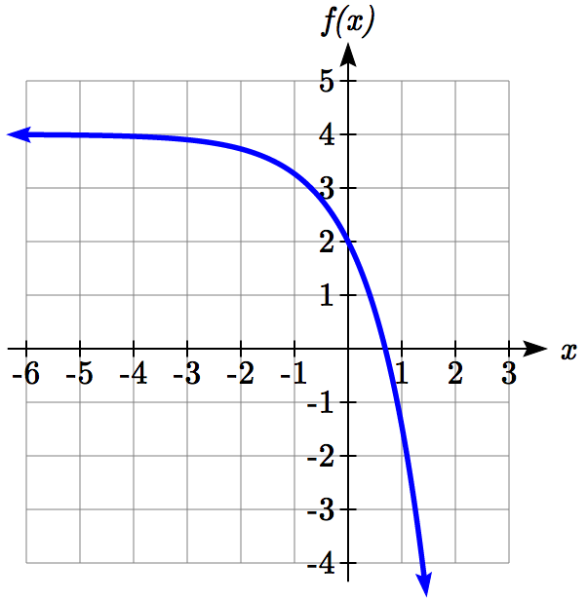

3. Horizontal asymptote at *y* = -1, so . Substitute (0, 2) to find *a* = 3.  
Substitute (1,5) to find , *b* = 2.  
 or   
As ,  and as , 

## Section 4.2 Exercises

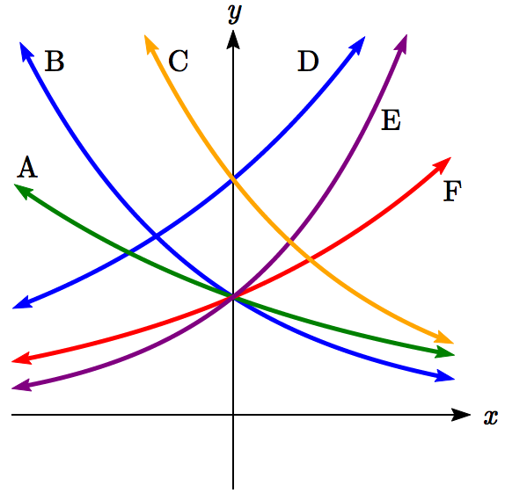Match each function with one of the graphs below.

1. 
2. 
3. 
4. 
5. 
6. 

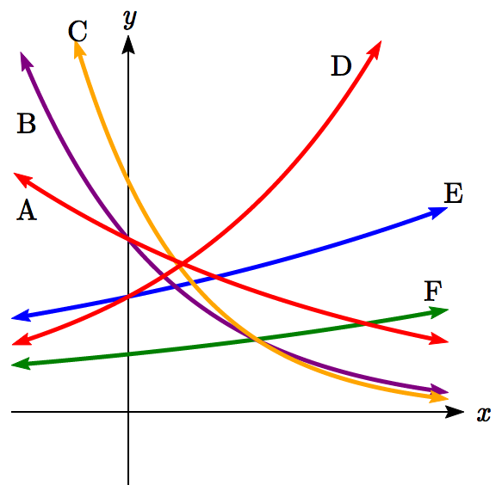If all the graphs to the right have equations with form ,

1. Which graph has the largest value for *b*?
2. Which graph has the smallest value for *b*?
3. Which graph has the largest value for *a*?
4. Which graph has the smallest value for *a*?

Sketch a graph of each of the following transformations of 

11.  12. 

13.  14. 

15.  16. 

Starting with the graph of , find a formula for the function that results from

1. Shifting  4 units upwards
2. Shifting  3 units downwards
3. Shifting  2 units left
4. Shifting  5 units right
5. Reflecting  about the *x*-axis
6. Reflecting  about the *y*-axis

Describe the long run behavior, as  and  of each function

23.  24. 

25.  26. 

27.  28. 

Find a formula for each function graphed as a transformation of .

29. 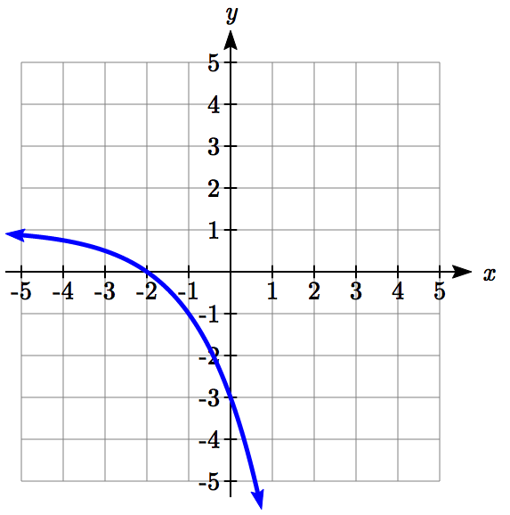 30. 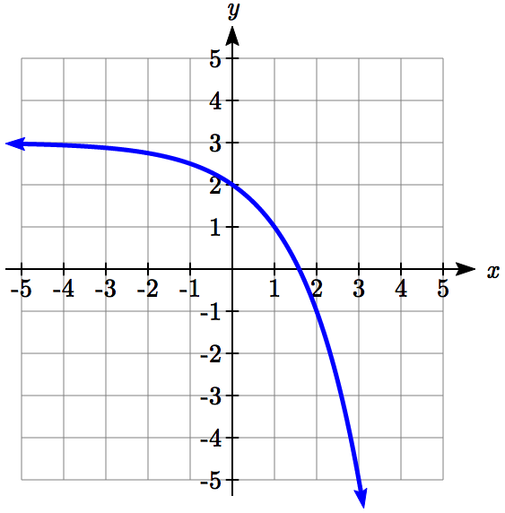

31. 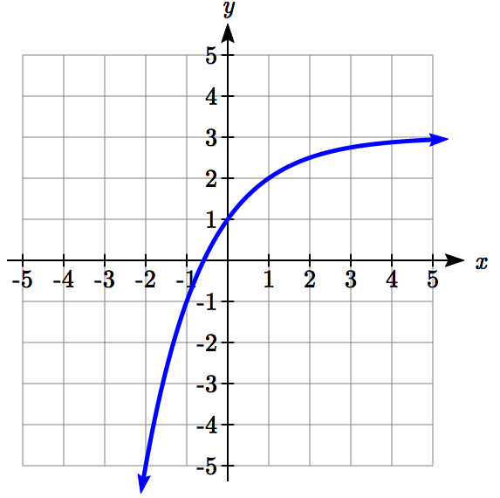 32. 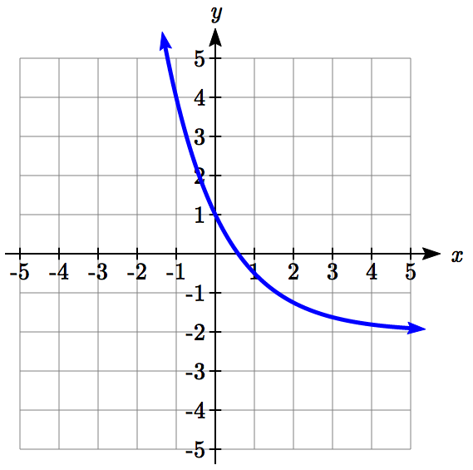

Find an equation for the exponential function graphed.

33. 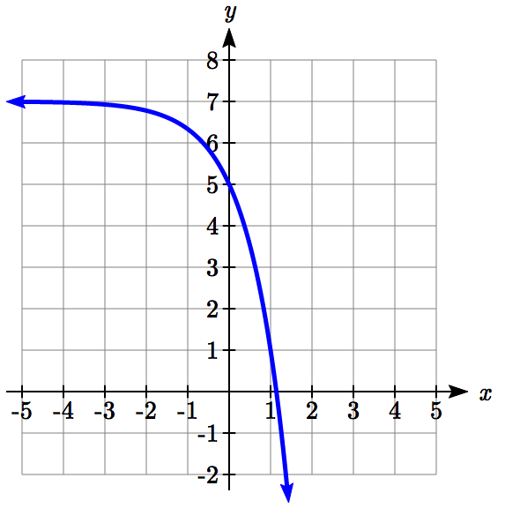 34. 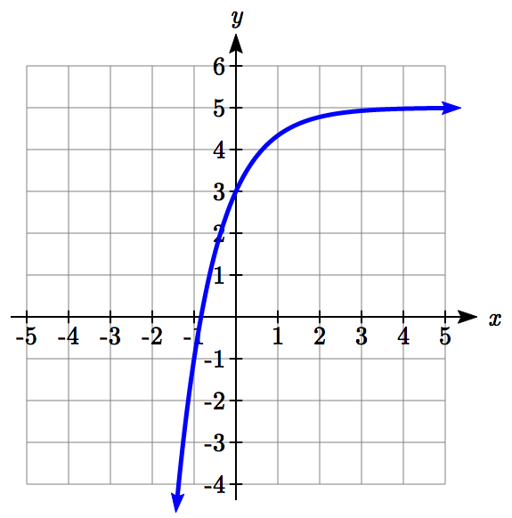

35. 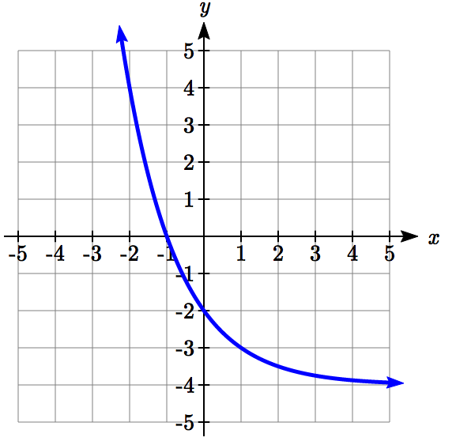 36. 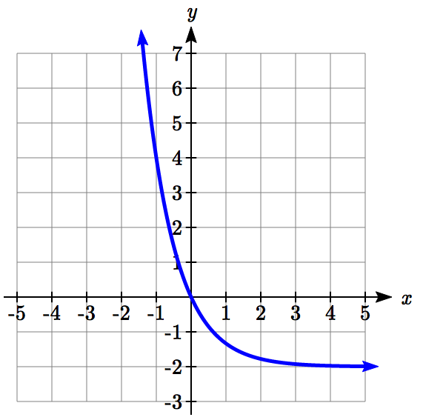

## Section 4.3 Logarithmic Functions

A population of 50 flies is expected to double every week, leading to a function of the form , where *x* represents the number of weeks that have passed. When will this population reach 500? Trying to solve this problem leads to:

 Dividing both sides by 50 to isolate the exponential



While we have set up exponential models and used them to make predictions, you may have noticed that solving exponential equations has not yet been mentioned. The reason is simple: none of the algebraic tools discussed so far are sufficient to solve exponential equations. Consider the equation  above. We know that  and , so it is clear that *x* must be some value between 3 and 4 since  is increasing. We could use technology to create a table of values or graph to better estimate the solution.

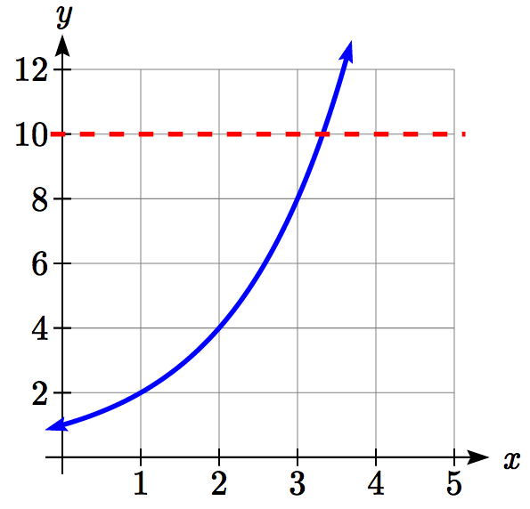

From the graph, we could better estimate the solution to be around 3.3. This result is still fairly unsatisfactory, and since the exponential function is one-to-one, it would be great to have an inverse function. None of the functions we have already discussed would serve as an inverse function and so we must introduce a new function, named **log** as the inverse of an exponential function. Since exponential functions have different bases, we will define corresponding logarithms of different bases as well.

Logarithm

**The logarithm** (base *b*) function, written , is the inverse of the exponential function (base *b*), .

Since the logarithm and exponential are inverses, it follows that:

Properties of Logs: Inverse Properties





Recall from the definition of an inverse function that if , then . Applying this to the exponential and logarithmic functions, we can convert between a logarithmic equation and its equivalent exponential.

Logarithm Equivalent to an Exponential

The statement  is equivalent to the statement .

Alternatively, we could show this by starting with the exponential function, then taking the log base *b* of both sides, giving . Using the inverse property of logs, we see that .

Since log is a function, it is most correctly written as , using parentheses to denote function evaluation, just as we would with *f(c)*. However, when the input is a single variable or number, it is common to see the parentheses dropped and the expression written as .

Example 1

Write these exponential equations as logarithmic equations:

a)  b)  c) 

a)  is equivalent to 

b)  is equivalent to 

c)  is equivalent to 

Example 2

Write these logarithmic equations as exponential equations:

a)  b) 

a)  is equivalent to 

b)  is equivalent to 

Try it Now

1. Write the exponential equation  as a logarithmic equation.

By establishing the relationship between exponential and logarithmic functions, we can now solve basic logarithmic and exponential equations by rewriting.

Example 3

Solve  for *x*.

By rewriting this expression as an exponential, , so *x* = 16.

Example 4

Solve  for *x*.

By rewriting this expression as a logarithm, we get .

While this does define a solution, and an exact solution at that, you may find it somewhat unsatisfying since it is difficult to compare this expression to the decimal estimate we made earlier. Also, giving an exact expression for a solution is not always useful – often we really need a decimal approximation to the solution. Luckily, this is a task calculators and computers are quite adept at. Unluckily for us, most calculators and computers will only evaluate logarithms of two bases. Happily, this ends up not being a problem, as we’ll see briefly.

Common and Natural Logarithms

The **common log** is the logarithm with base 10, and is typically written .

The **natural log** is the logarithm with base *e*, and is typically written .

Example 5

Evaluate  using the definition of the common log.

**Values of the common log**

|  |  |  |
| --- | --- | --- |
| number | number as  exponential | log(number) |
| 1000 | 103 | 3 |
| 100 | 102 | 2 |
| 10 | 101 | 1 |
| 1 | 100 | 0 |
| 0.1 | 10-1 | -1 |
| 0.01 | 10-2 | -2 |
| 0.001 | 10-3 | -3 |

To evaluate , we can let , then rewrite into exponential form using the common log base of 10:

.

From this, we might recognize that 1000 is the cube of 10, so *x* = 3.

We also can use the inverse property of logs to write .

Try it Now

2. Evaluate .

Example 6

Evaluate .

We can rewrite  as . Since ln is a log base *e*, we can use the inverse property for logs: .

Example 7

Evaluate log(500) using your calculator or computer.

Using a computer, we can evaluate 

To utilize the common or natural logarithm functions to evaluate expressions like , we need to establish some additional properties.

Properties of Logs: Exponent Property



To show why this is true, we offer a proof:

Since the logarithmic and exponential functions are inverses, .

Raising both sides to the *r* power, we get .

Utilizing the exponential rule that states, 

Taking the log of both sides, 

Utilizing the inverse property on the right side yields the result: 

Example 8

Rewrite  using the exponent property for logs.

Since 25 = 52,



Example 9

Rewrite using the exponent property for logs.

Using the property in reverse, .

Try it Now

3. Rewrite using the exponent property for logs: .

The exponent property allows us to find a method for changing the base of a logarithmic expression.

Properties of Logs: Change of Base



Proof:

Let .

Rewriting as an exponential gives .

Taking the log base *c* of both sides of this equation gives ,

Now utilizing the exponent property for logs on the left side, 

Dividing, we obtain  . Replacing our original expression for *x*,



With this change of base formula, we can finally find a good decimal approximation to our question from the beginning of the section.

Example 10

Evaluate  using the change of base formula.

According to the change of base formula, we can rewrite the log base 2 as a logarithm of any other base. Since our calculators can evaluate the natural log, we might choose to use the natural logarithm, which is the log base *e*:



Using our calculators to evaluate this,



This finally allows us to answer our original question – the population of flies we discussed at the beginning of the section will take 3.32 weeks to grow to 500.

Example 11

Evaluate  using the change of base formula.

We can rewrite this expression using any other base. If our calculators are able to evaluate the common logarithm, we could rewrite using the common log, base 10.



While we can solve the basic exponential equation  by rewriting in logarithmic form and then using the change of base formula to evaluate the logarithm, the proof of the change of base formula illuminates an alternative approach to solving exponential equations.

Solving exponential equations:

1. Isolate the exponential expressions when possible
2. Take the logarithm of both sides
3. Utilize the exponent property for logarithms to pull the variable out of the exponent
4. Use algebra to solve for the variable.

Example 12

Solve  for *x*.

Using this alternative approach, rather than rewrite this exponential into logarithmic form, we will take the logarithm of both sides of the equation. Since we often wish to evaluate the result to a decimal answer, we will usually utilize either the common log or natural log. For this example, we’ll use the natural log:

 Utilizing the exponent property for logs,

 Now dividing by ln(2),



Notice that this result matches the result we found using the change of base formula.

Example 13

In the first section, we predicted the population (in billions) of India *t* years after 2008 by using the function . If the population continues following this trend, when will the population reach 2 billion?

We need to solve for time *t* so that *f(t)* = 2.

 Divide by 1.14 to isolate the exponential expression

 Take the logarithm of both sides of the equation

 Apply the exponent property on the right side

 Divide both sides by ln(1.0134)

 years

If this growth rate continues, the model predicts the population of India will reach 2 billion about 42 years after 2008, or approximately in the year 2050.

Try it Now

4. Solve .

Example 14

Solve 

To start, we want to isolate the exponential part of the expression, the , so it is alone on one side of the equation. Then we can use the log to solve the equation. We can use any base log; this time we’ll use the common log.

 Divide both sides by 5 to isolate the exponential

 Take the log of both sides.

 Use the exponent property for logs

 Divide by  on both sides

 Simplify and evaluate



Note that when entering that expression on your calculator, be sure to put parentheses around the whole denominator to ensure the proper order of operations:

log(2/5)/(3*log(1.07))

In addition to solving exponential equations, logarithmic expressions are common in many physical situations.

Example 15

In chemistry, pH is a measure of the acidity or basicity of a liquid. The pH is related to the concentration of hydrogen ions, [*H*+], measured in moles per liter, by the equation .

If a liquid has concentration of 0.0001 moles per liber, determine the pH.

Determine the hydrogen ion concentration of a liquid with pH of 7.

To answer the first question, we evaluate the expression . While we could use our calculators for this, we do not really need them here, since we can use the inverse property of logs:



To answer the second question, we need to solve the equation . Begin by isolating the logarithm on one side of the equation by multiplying both sides by -1:

. Rewriting into exponential form yields the answer:

 moles per liter.

Logarithms also provide us a mechanism for finding continuous growth models for exponential growth given two data points.

Example 15

A population grows from 100 to 130 in 2 weeks. Find the continuous growth rate.

Measuring *t* in weeks, we are looking for an equation  so that *P*(0) = 100 and *P*(2) = 130. Using the first pair of values,

, so *a* = 100.

Using the second pair of values,

 Divide by 100

 Take the natural log of both sides

 Use the inverse property of logs



This population is growing at a continuous rate of 13.12% per week.

In general, we can relate the standard form of an exponential with the continuous growth form by noting (using *k* to represent the continuous growth rate to avoid the confusion of using *r* in two different ways in the same formula):







Converting Between Periodic to Continuous Growth Rate

In the equation , *r* is the **periodic growth rate**, the percent growth each time period (weekly growth, annual growth, etc.).

In the equation , *k* is the **continuous growth rate**.

You can convert between these using: .

Remember that the continuous growth rate *k* represents the nominal growth rate before accounting for the effects of continuous compounding, while *r* represents the actual percent increase in one time unit (one week, one year, etc.).

Example 16

A company’s sales can be modeled by the function , with *t* measured in years. Find the annual growth rate.

Noting that , then , so the annual growth rate is 12.75%. The sales function could also be written in the form .

Important Topics of this Section

The Logarithmic function as the inverse of the exponential function

Writing logarithmic & exponential expressions

Properties of logs

Inverse properties

Exponential properties

Change of base

Common log

Natural log

Solving exponential equations

Converting between periodic and continuous growth rate.

Try it Now Answers

1. 

2. 

3. 

4.   
  
  
  


## Section 4.3 Exercises

Rewrite each equation in exponential form

1.  2.  3.  4. 

 6.  7.  8. 

Rewrite each equation in logarithmic form.

9.  10.  11.  12. 

13.  14.  15.  16. 

Solve for *x*.

17.  18.  19.  20. 

21.  22.  23.  24. 

Simplify each expression using logarithm properties.

25.  26.  27.  28. 

29.  30.  31.  32. 

33.  34.  35.  36. 

Evaluate using your calculator.

37.  38.  39.  40. 

Solve each equation for the variable.

41.  42.  43.  44. 

45.  46.  47.  48. 

49.  50. 

51.  52. 

53.  54. 

55.  56. 

Convert the equation into continuous growth form, .

57.  58. 

59.  60. 

Convert the equation into annual growth form, .

61.  62. 

63.  64. 

1. The population of Kenya was 39.8 million in 2009 and has been growing by about 2.6% each year. If this trend continues, when will the population exceed 45 million?
2. The population of Algeria was 34.9 million in 2009 and has been growing by about 1.5% each year. If this trend continues, when will the population exceed 45 million?
3. The population of Seattle grew from 563,374 in 2000 to 608,660 in 2010. If the population continues to grow exponentially at the same rate, when will the population exceed 1 million people?
4. The median household income (adjusted for inflation) in Seattle grew from $42,948 in 1990 to $45,736 in 2000. If it continues to grow exponentially at the same rate, when will median income exceed $50,000?
5. A scientist begins with 100 mg of a radioactive substance. After 4 hours, it has decayed to 80 mg. How long after the process began will it take to decay to 15 mg?
6. A scientist begins with 100 mg of a radioactive substance. After 6 days, it has decayed to 60 mg. How long after the process began will it take to decay to 10 mg?
7. If $1000 is invested in an account earning 3% compounded monthly, how long will it take the account to grow in value to $1500?
8. If $1000 is invested in an account earning 2% compounded quarterly, how long will it take the account to grow in value to $1300?

## Section 4.4 Logarithmic Properties

In the previous section, we derived two important properties of logarithms, which allowed us to solve some basic exponential and logarithmic equations.

Properties of Logs

**Inverse Properties:**





**Exponential Property:**



**Change of Base:**



While these properties allow us to solve a large number of problems, they are not sufficient to solve all problems involving exponential and logarithmic equations.

Properties of Logs

**Sum of Logs Property:**



**Difference of Logs Property:**



It’s just as important to know what properties logarithms do *not* satisfy as to memorize the valid properties listed above. In particular, the logarithm is not a linear function, which means that it does not distribute: log(*A* + *B*) ≠ log(*A*) + log(*B*).

To help in this process we offer a proof to help solidify our new rules and show how they follow from properties you’ve already seen.

Let  and .

By definition of the logarithm,  and .

Using these expressions, 

Using exponent rules on the right, 

Taking the log of both sides, and utilizing the inverse property of logs,



Replacing *a* and *c* with their definition establishes the result



The proof for the difference property is very similar.

With these properties, we can rewrite expressions involving multiple logs as a single log, or break an expression involving a single log into expressions involving multiple logs.

Example 1

Write  as a single logarithm.

Using the sum of logs property on the first two terms,



This reduces our original expression to 

Then using the difference of logs property,



Example 2

Evaluate  without a calculator by first rewriting as a single logarithm.

On the first term, we can use the exponent property of logs to write



With the expression reduced to a sum of two logs, , we can utilize the sum of logs property



Since 100 = 102, we can evaluate this log without a calculator:



Try it Now

1. Without a calculator evaluate by first rewriting as a single logarithm:  


Example 3

Rewrite  as a sum or difference of logs

First, noticing we have a quotient of two expressions, we can utilize the difference property of logs to write



Then seeing the product in the first term, we use the sum property



Finally, we could use the exponent property on the first term



Interestingly, solving exponential equations was not the reason logarithms were originally developed. Historically, up until the advent of calculators and computers, the power of logarithms was that these log properties reduced multiplication, division, roots, or powers to be evaluated using addition, subtraction, division and multiplication, respectively, which are much easier to compute without a calculator. Large books were published listing the logarithms of numbers, such as in the table to the right. To find the product of two numbers, the sum of log property was used. Suppose for example we didn’t know the value of 2 times 3. Using the sum property of logs:

|  |  |
| --- | --- |
| **value** | **log(value)** |
| 1 | 0.0000000 |
| 2 | 0.3010300 |
| 3 | 0.4771213 |
| 4 | 0.6020600 |
| 5 | 0.6989700 |
| 6 | 0.7781513 |
| 7 | 0.8450980 |
| 8 | 0.9030900 |
| 9 | 0.9542425 |
| 10 | 1.0000000 |



Using the log table,



We can then use the table again in reverse, looking for 0.7781513 as an output of the logarithm. From that we can determine:

.

By using addition and the table of logs, we were able to determine.

Likewise, to compute a cube root like 



So .

Although these calculations are simple and insignificant, they illustrate the same idea that was used for hundreds of years as an efficient way to calculate the product, quotient, roots, and powers of large and complicated numbers, either using tables of logarithms or mechanical tools called slide rules.

These properties still have other practical applications for interpreting changes in exponential and logarithmic relationships.

Example 4

Recall that in chemistry,. If the concentration of hydrogen ions in a liquid is doubled, what is the affect on pH?

Suppose *C* is the original concentration of hydrogen ions, and *P* is the original pH of the liquid, so . If the concentration is doubled, the new concentration is 2*C*. Then the pH of the new liquid is



Using the sum property of logs,



Since , the new pH is



When the concentration of hydrogen ions is doubled, the pH decreases by 0.301.

**Log properties in solving equations**

The logarithm properties often arise when solving problems involving logarithms. First, we’ll look at a simpler log equation.

Example 5

Solve .

To solve for *x*, we need to get it out from inside the log function. There are two ways we can approach this.

Method 1: Rewrite as an exponential.

Recall that since the common log is base 10,  can be rewritten as the exponential . Likewise,  can be rewritten in exponential form as



Method 2: Exponentiate both sides.

If , then . Using this idea, since , then . Use the inverse property of logs to rewrite the left side and get .

Using either method, we now need to solve . Evaluate  to get

 Add 6 to both sides

 Divide both sides by 2



Occasionally the solving process will result in extraneous solutions – answers that are outside the domain of the original equation. In this case, our answer looks fine.

Example 6

Solve .

In order to rewrite in exponential form, we need a single logarithmic expression on the left side of the equation. Using the difference property of logs, we can rewrite the left side:



Rewriting in exponential form reduces this to an algebraic equation:

 Multiply both sides by *x*

 Combine like terms

 Divide by 50



Checking this answer in the original equation, we can verify there are no domain issues, and this answer is correct.

Try it Now

2. Solve .

Example 7

Solve .

 Use the sum of logs property on the right

 Expand



We have a log on both side of the equation this time. Rewriting in exponential form would be tricky, so instead we can exponentiate both sides.

 Use the inverse property of logs

 Move terms to one side

 Factor



*x* = 4 or *x* = −3.

Checking our answers, notice that evaluating the original equation at *x* = −3 would result in us evaluating , which is undefined. That answer is outside the domain of the original equation, so it is an extraneous solution and we discard it. There is one solution: *x* = 4.

More complex exponential equations can often be solved in more than one way. In the following example, we will solve the same problem in two ways – one using logarithm properties, and the other using exponential properties.

Example 8a

In 2008, the population of Kenya was approximately 38.8 million, and was growing by 2.64% each year, while the population of Sudan was approximately 41.3 million and growing by 2.24% each year[2]. If these trends continue, when will the population of Kenya match that of Sudan?

We start by writing an equation for each population in terms of *t*, the number of years after 2008.



To find when the populations will be equal, we can set the equations equal



For our first approach, we take the log of both sides of the equation.



Utilizing the sum property of logs, we can rewrite each side,



Then utilizing the exponent property, we can pull the variables out of the exponent



Moving all the terms involving *t* to one side of the equation and the rest of the terms to the other side,



Factoring out the *t* on the left,



Dividing to solve for *t*

years until the populations will be equal.

Example 8b

Solve the problem above by rewriting before taking the log.

Starting at the equation



Divide to move the exponential terms to one side of the equation and the constants to the other side



Using exponent rules to group on the left,



Taking the log of both sides



Utilizing the exponent property on the left,



Dividing gives

 years

While the answer does not immediately appear identical to that produced using the previous method, note that by using the difference property of logs, the answer could be rewritten:



While both methods work equally well, it often requires fewer steps to utilize algebra before taking logs, rather than relying solely on log properties.

Try it Now

3. Tank A contains 10 liters of water, and 35% of the water evaporates each week. Tank B contains 30 liters of water, and 50% of the water evaporates each week. In how many weeks will the tanks contain the same amount of water?

Important Topics of this Section

Inverse

Exponential

Change of base

Sum of logs property

Difference of logs property

Solving equations using log rules

Try it Now Answers

1. 

2.  Move both logs to one side  
 Use the difference property of logs  
 Factor  
 Simplify  
 Rewrite as an exponential  
 Add 2 to both sides  


3. Tank A: . Tank B:   
Solving *A(t) = B(t)*,  
 Using the method from Example 8b  
 Regroup  
 Simplify  
 Take the log of both sides  
 Use the exponent property of logs  
 Divide and evaluate  
 weeks

## Section 4.4 Exercises

Simplify to a single logarithm, using logarithm properties.

1.  2. 

3.  4. 

5.  6. 

7.  8. 

9.  10. 

11.  12. 

13.  14. 

15.  16. 

Use logarithm properties to expand each expression.

17.  18. 

19.  20. 

21.  22. 

23.  24. 

25.  26. 

Solve each equation for the variable.

27.  28. 

29.  30. 

31.  32. 

33.  34. 

35.  36. 

37.  38. 

39.  40. 

41.  42. 

43.  44. 

45.  46. 

47.  48. 

## Section 4.5 Graphs of Logarithmic Functions

Recall that the exponential function  produces this table of values

|  |  |  |  |  |  |  |  |
| --- | --- | --- | --- | --- | --- | --- | --- |
| *x* | -3 | -2 | -1 | 0 | 1 | 2 | 3 |
| *f(x)* |  |  |  | 1 | 2 | 4 | 8 |

Since the logarithmic function is an inverse of the exponential,  produces the table of values

|  |  |  |  |  |  |  |  |
| --- | --- | --- | --- | --- | --- | --- | --- |
| *x* |  |  |  | 1 | 2 | 4 | 8 |
| *g(x)* | -3 | -2 | -1 | 0 | 1 | 2 | 3 |

In this second table, notice that

1. As the input increases, the output increases.
2. As input increases, the output increases more slowly.
3. Since the exponential function only outputs positive values, the logarithm can only accept positive values as inputs, so the domain of the log function is .
4. Since the exponential function can accept all real numbers as inputs, the logarithm can output any real number, so the range is all real numbers or .

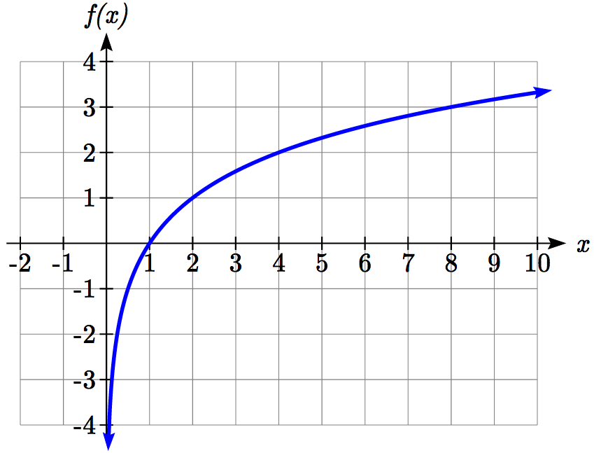

Sketching the graph, notice that as the input approaches zero from the right, the output of the function grows very large in the negative direction, indicating a vertical asymptote at

*x* = 0.

In symbolic notation we write

as , and as

Graphical Features of the Logarithm

Graphically, in the function 

The graph has a horizontal intercept at (1, 0)

The graph has a vertical asymptote at *x* = 0

The graph is increasing and concave down

The domain of the function is *x* > 0, or 

The range of the function is all real numbers, or 

When sketching a general logarithm with base *b*, it can be helpful to remember that the graph will pass through the points (1, 0) and (*b*, 1).

To get a feeling for how the base affects the shape of the graph, examine the graphs below.

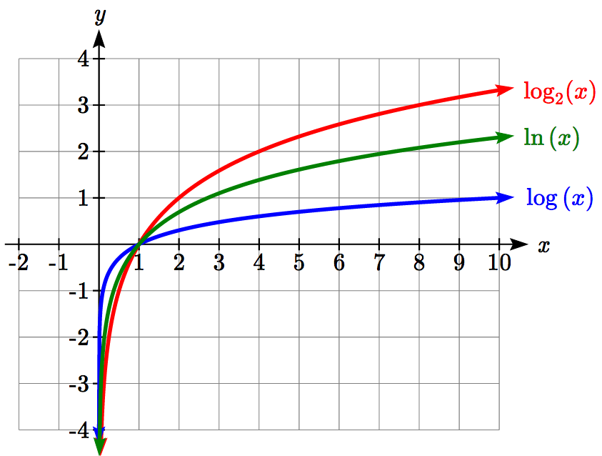

Notice that the larger the base, the slower the graph grows. For example, the common log graph, while it grows without bound, it does so very slowly. For example, to reach an output of 8, the input must be 100,000,000.

Another important observation made was the domain of the logarithm. Like the reciprocal and square root functions, the logarithm has a restricted domain which must be considered when finding the domain of a composition involving a log.

Example 1

Find the domain of the function 

The logarithm is only defined with the input is positive, so this function will only be defined when . Solving this inequality,



The domain of this function is , or in interval notation, 

Try it Now

1. Find the domain of the function ; before solving this as an inequality, consider how the function has been transformed.

**Transformations of the Logarithmic Function**

Transformations can be applied to a logarithmic function using the basic transformation techniques, but as with exponential functions, several transformations result in interesting relationships.

First recall the change of base property tells us that 

From this, we can see that  is a vertical stretch or compression of the graph of the  graph. This tells us that a vertical stretch or compression is equivalent to a change of base. For this reason, we typically represent all graphs of logarithmic functions in terms of the common or natural log functions.

Next, consider the effect of a horizontal compression on the graph of a logarithmic function. Considering , we can use the sum property to see



Since log(*c*) is a constant, the effect of a horizontal compression is the same as the effect of a vertical shift.

Example 2

Sketch  and .

Graphing these,

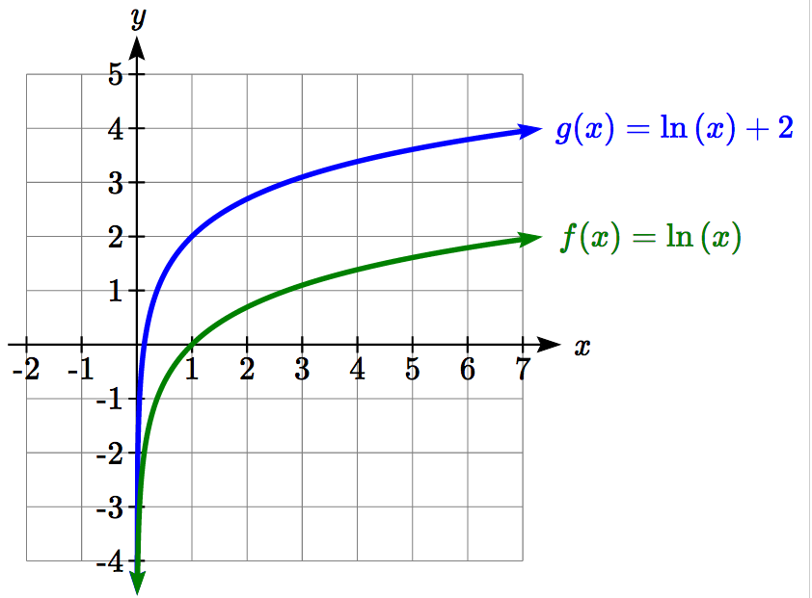

Note that this vertical shift could also be written as a horizontal compression, since

.

While a horizontal stretch or compression can be written as a vertical shift, a horizontal reflection is unique and separate from vertical shifting.

Finally, we will consider the effect of a horizontal shift on the graph of a logarithm.

Example 3

Sketch a graph of .

This is a horizontal shift to the left by 2 units. Notice that none of our logarithm rules allow us rewrite this in another form, so the effect of this transformation is unique. Shifting the graph,

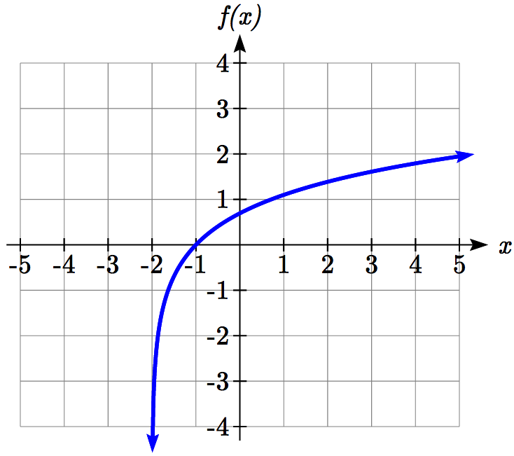

Notice that due to the horizontal shift, the vertical asymptote shifted to *x* = -2, and the domain shifted to .

Combining these transformations,

Example 4

Sketch a graph of .

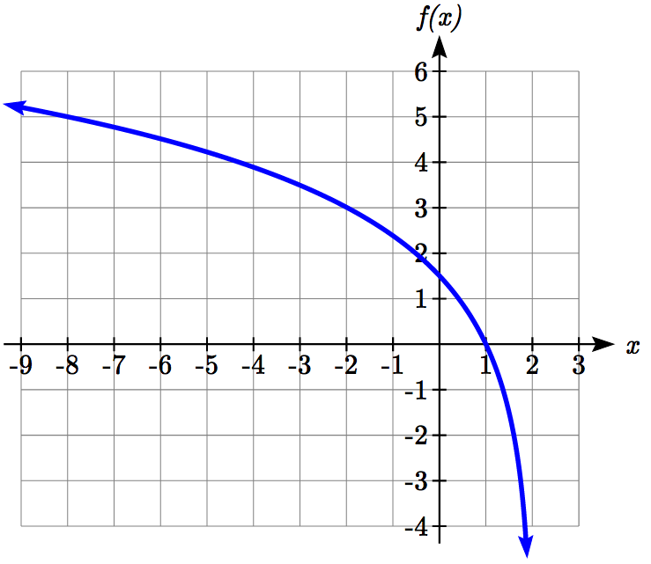Factoring the inside as  reveals that this graph is that of the common logarithm, horizontally reflected, vertically stretched by a factor of 5, and shifted to the right by 2 units.

The vertical asymptote will be shifted to *x* = 2, and the graph will have domain . A rough sketch can be created by using the vertical asymptote along with a couple points on the graph, such as



Try it Now

2. Sketch a graph of the function .

Transformations of Logs

Any transformed logarithmic function can be written in the form

, or  if horizontally reflected,

where *x = b* is the vertical asymptote.

Example 5

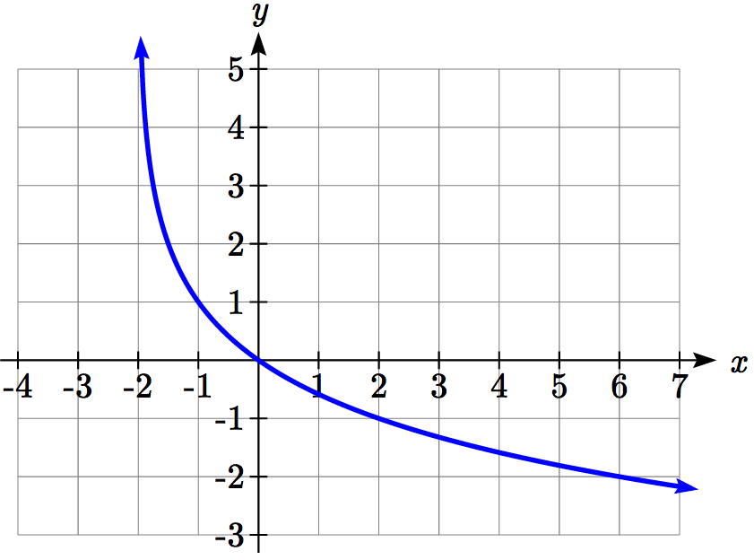Find an equation for the logarithmic function graphed.

This graph has a vertical asymptote at *x* = –2 and has been vertically reflected. We do not know yet the vertical shift (equivalent to horizontal stretch) or the vertical stretch (equivalent to a change of base). We know so far that the equation will have form



It appears the graph passes through the points (–1, 1) and (2, –1). Substituting in (–1, 1),



Next, substituting in (2, –1),



This gives us the equation .

This could also be written as .

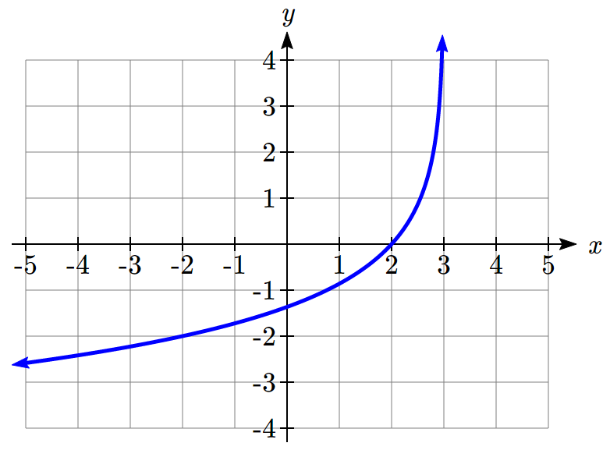Try it Now

3. Write an equation for the function graphed here.

Flashback

4. Write the domain and range of the function graphed in Example 5, and describe its long run behavior.

Important Topics of this Section

Graph of the logarithmic function (domain and range)

Transformation of logarithmic functions

Creating graphs from equations

Creating equations from graphs

Try it Now and Flashback Answers

1. Domain: {*x*| *x* > 5}

2. A graph that approaches infinity as x approaches 2 from the right and decreases curving upwards, passing through 3 comma 1, 4 comma 0, and 12 comma negative 2


3. The graph is horizontally reflected and has a vertical asymptote at *x* = 3, giving form . Substituting in the point (2,0) gives , simplifying to *k* = 0. Substituting in (-2,-2), , so .  
The equation is  or .

4. Domain: {*x*| *x*>-2}, Range: all real numbers; As and as .

## Section 4.5 Exercises

For each function, find the domain and the vertical asymptote.

1.  2. 

3.  4. 

5.  6. 

7.  8. 

Sketch a graph of each pair of functions.

9.  10. 

Sketch each transformation.

11.  12. 

13.  14. 

15.  16. 

Find a formula for the transformed logarithm graph shown.

17. 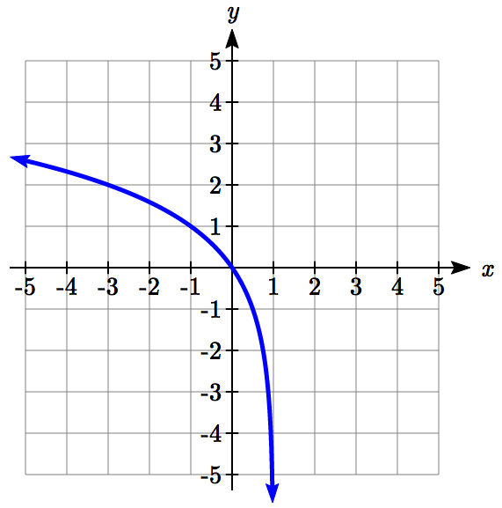 18. 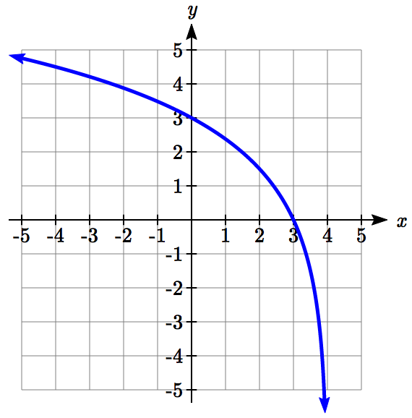

19. 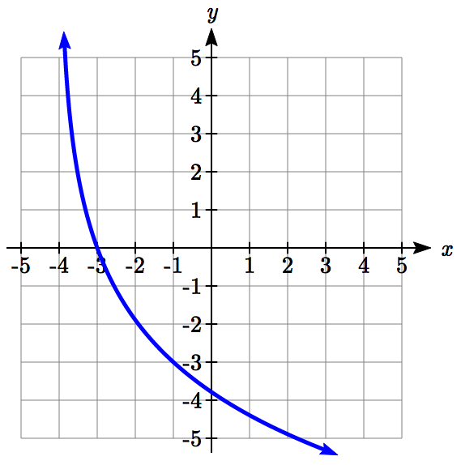 20. 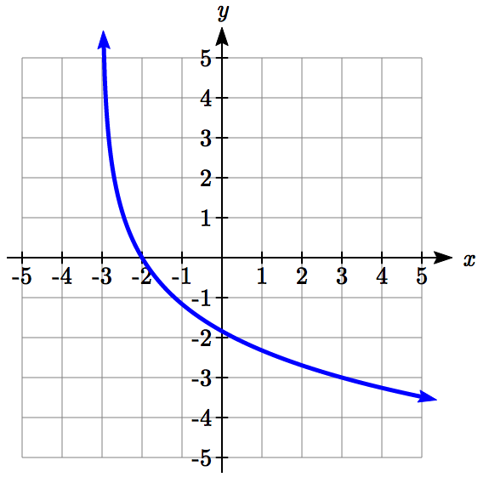

Find a formula for the transformed logarithm graph shown.

21. 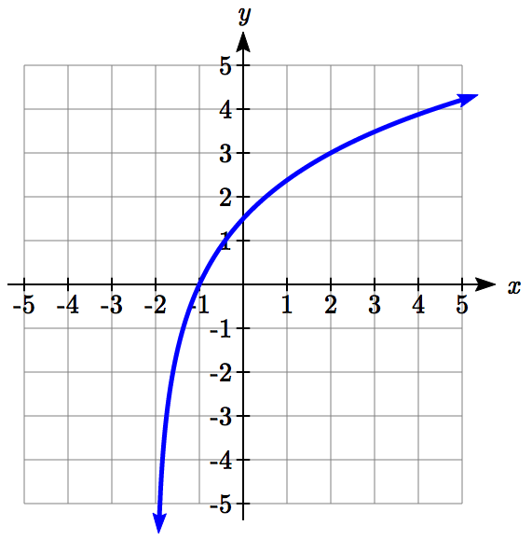 22.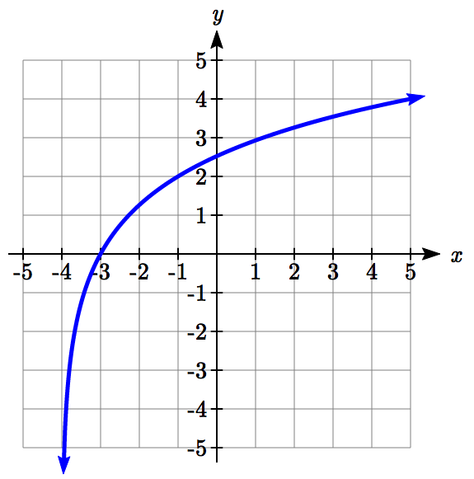

23. 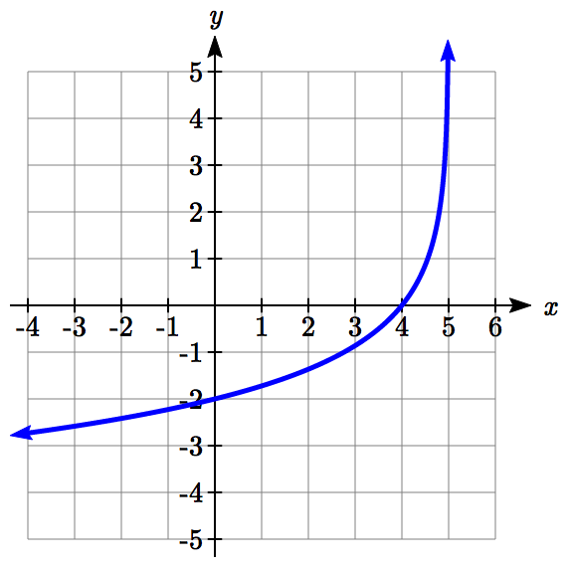 24. 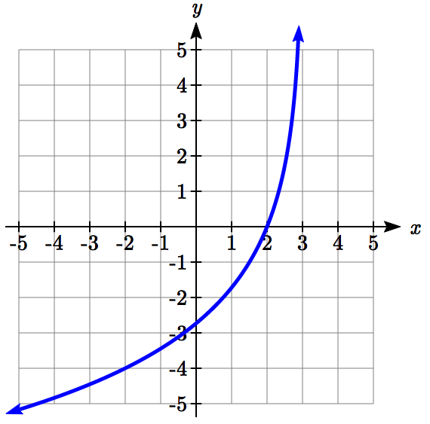

## Section 4.6 Exponential and Logarithmic Models

While we have explored some basic applications of exponential and logarithmic functions, in this section we explore some important applications in more depth.

**Radioactive Decay**

In an earlier section, we discussed radioactive decay – the idea that radioactive isotopes change over time. One of the common terms associated with radioactive decay is half-life.

Half Life

The **half-life** of a radioactive isotope is the time it takes for half the substance to decay.

Given the basic exponential growth/decay equation , half-life can be found by solving for when half the original amount remains; by solving , or more simply . Notice how the initial amount is irrelevant when solving for half-life.

Example 1

Bismuth-210 is an isotope that decays by about 13% each day. What is the half-life of Bismuth-210?

We were not given a starting quantity, so we could either make up a value or use an unknown constant to represent the starting amount. To show that starting quantity does not affect the result, let us denote the initial quantity by the constant *a*. Then the decay of Bismuth-210 can be described by the equation .

To find the half-life, we want to determine when the remaining quantity is half the original: . Solving,

 Divide by *a*,

 Take the log of both sides

 Use the exponent property of logs

 Divide to solve for *d*

 days

This tells us that the half-life of Bismuth-210 is approximately 5 days.

Example 2

Cesium-137 has a half-life of about 30 years. If you begin with 200mg of cesium-137, how much will remain after 30 years? 60 years? 90 years?

Since the half-life is 30 years, after 30 years, half the original amount, 100mg, will remain.

After 60 years, another 30 years have passed, so during that second 30 years, another half of the substance will decay, leaving 50mg.

After 90 years, another 30 years have passed, so another half of the substance will decay, leaving 25mg.

Example 3

Cesium-137 has a half-life of about 30 years. Find the annual decay rate.

Since we are looking for an annual decay rate, we will use an equation of the form . We know that after 30 years, half the original amount will remain. Using this information

 Dividing by *a*

 Taking the 30th root of both sides

 Subtracting one from both sides,



This tells us cesium-137 is decaying at an annual rate of 2.284% per year.

Try it Now

1. Chlorine-36 is eliminated from the body with a biological half-life of 10 days[3]. Find the daily decay rate.

Example 4

Carbon-14 is a radioactive isotope that is present in organic materials, and is commonly used for dating historical artifacts. Carbon-14 has a half-life of 5730 years. If a bone fragment is found that contains 20% of its original carbon-14, how old is the bone?

To find how old the bone is, we first will need to find an equation for the decay of the carbon-14. We could either use a continuous or annual decay formula, but opt to use the continuous decay formula since it is more common in scientific texts. The half life tells us that after 5730 years, half the original substance remains. Solving for the rate,

 Dividing by *a*

 Taking the natural log of both sides

 Use the inverse property of logs on the right side

 Divide by 5730



Now we know the decay will follow the equation . To find how old the bone fragment is that contains 20% of the original amount, we solve for *t* so that *Q(t)* = 0.20*a*.









 years

The bone fragment is about 13,300 years old.

Try it Now

2. In Example 2, we learned that Cesium-137 has a half-life of about 30 years. If you begin with 200mg of cesium-137, will it take more or less than 230 years until only 1 milligram remains?

**Doubling Time**

For decaying quantities, we asked how long it takes for half the substance to decay. For growing quantities we might ask how long it takes for the quantity to double.

Doubling Time

The **doubling time** of a growing quantity is the time it takes for the quantity to double.

Given the basic exponential growth equation , doubling time can be found by solving for when the original quantity has doubled; by solving , or more simply . Like with decay, the initial amount is irrelevant when solving for doubling time.

Example 5

Cancer cells sometimes increase exponentially. If a cancerous growth contained 300 cells last month and 360 cells this month, how long will it take for the number of cancer cells to double?

Defining *t* to be time in months, with *t* = 0 corresponding to this month, we are given two pieces of data: this month, (0, 360), and last month, (-1, 300).

From this data, we can find an equation for the growth. Using the form , we know immediately *a* = 360, giving . Substituting in (-1, 300),



This gives us the equation 

To find the doubling time, we look for the time when we will have twice the original amount, so when *C(t)* = 2*a*.









 months for the number of cancer cells to double.

Example 6

Use of a new social networking website has been growing exponentially, with the number of new members doubling every 5 months. If the site currently has 120,000 users and this trend continues, how many users will the site have in 1 year?

We can use the doubling time to find a function that models the number of site users, and then use that equation to answer the question. While we could use an arbitrary *a* as we have before for the initial amount, in this case, we know the initial amount was 120,000.

If we use a continuous growth equation, it would look like, measured in thousands of users after *t* months. Based on the doubling time, there would be 240 thousand users after 5 months. This allows us to solve for the continuous growth rate:









Now that we have an equation, , we can predict the number of users after 12 months:

 thousand users.

So after 1 year, we would expect the site to have around 633,140 users.

Try it Now

3. If tuition at a college is increasing by 6.6% each year, how many years will it take for tuition to double?

**Newton’s Law of Cooling**

When a hot object is left in surrounding air that is at a lower temperature, the object’s temperature will decrease exponentially, leveling off towards the surrounding air temperature. This "leveling off" will correspond to a horizontal asymptote in the graph of the temperature function. Unless the room temperature is zero, this will correspond to a vertical shift of the generic exponential decay function.

Newton’s Law of Cooling

The temperature of an object, *T*, in surrounding air with temperature *Ts* will behave according to the formula



Where

*t* is time

*a* is a constant determined by the initial temperature of the object

*k* is a constant, the continuous rate of cooling of the object

While an equation of the form  could be used, the continuous growth form is more common.

Example 7

A cheesecake is taken out of the oven with an ideal internal temperature of 165 degrees Fahrenheit, and is placed into a 35 degree refrigerator. After 10 minutes, the cheesecake has cooled to 150 degrees. If you must wait until the cheesecake has cooled to 70 degrees before you eat it, how long will you have to wait?

Since the surrounding air temperature in the refrigerator is 35 degrees, the cheesecake’s temperature will decay exponentially towards 35, following the equation



We know the initial temperature was 165, so . Substituting in these values,



We were given another pair of data, , which we can use to solve for *k*





Together this gives us the equation for cooling: .

Now we can solve for the time it will take for the temperature to cool to 70 degrees.











It will take about 107 minutes, or one hour and 47 minutes, for the cheesecake to cool. Of course, if you like your cheesecake served chilled, you’d have to wait a bit longer.

Try it Now

4. A pitcher of water at 40 degrees Fahrenheit is placed into a 70 degree room. One hour later the temperature has risen to 45 degrees. How long will it take for the temperature to rise to 60 degrees?

**Logarithmic Scales**

For quantities that vary greatly in magnitude, a standard scale of measurement is not always effective, and utilizing logarithms can make the values more manageable. For example, if the average distances from the sun to the major bodies in our solar system are listed, you see they vary greatly.

|  |  |
| --- | --- |
| **Planet** | **Distance (millions of km)** |
| Mercury | 58 |
| Venus | 108 |
| Earth | 150 |
| Mars | 228 |
| Jupiter | 779 |
| Saturn | 1430 |
| Uranus | 2880 |
| Neptune | 4500 |

Placed on a linear scale – one with equally spaced values – these values get bunched up.

0

500

1000

1500

2000

2500

3000

3500

4000

4500

Mercury

Venus

Earth

Mars

Jupiter

Saturn

Uranus

Neptune

distance

However, computing the logarithm of each value and plotting these new values on a number line results in a more manageable graph, and makes the relative distances more apparent.[4]

|  |  |  |
| --- | --- | --- |
| **Planet** | **Distance (millions of km)** | **log(distance)** |
| Mercury | 58 | 1.76 |
| Venus | 108 | 2.03 |
| Earth | 150 | 2.18 |
| Mars | 228 | 2.36 |
| Jupiter | 779 | 2.89 |
| Saturn | 1430 | 3.16 |
| Uranus | 2880 | 3.46 |
| Neptune | 4500 | 3.65 |

Mercury

Venus

Neptune

1.5

1.75

2

2.25

2.5

2.75

3

3.25

3.5

Earth

Mars

3.75

Jupiter

Saturn

Uranus

4

104=10000

103=1000

102=100

log(distance)

Sometimes, as shown above, the scale on a logarithmic number line will show the log values, but more commonly the original values are listed as powers of 10, as shown below.

102

103

104

105

106

101

100

10-1

10-2

107

*A*

*B*

*P*

*C*

*D*

Example 8

Estimate the value of point *P* on the log scale above

The point *P* appears to be half way between -2 and -1 in log value, so if *V* is the value of this point,

 Rewriting in exponential form,



Example 9

Place the number 6000 on a logarithmic scale.

Since , this point would belong on the log scale about here:

102

103

104

105

106

101

100

10-1

10-2

107

6000

Try it Now

5. Plot the data in the table below on a logarithmic scale[5].

|  |  |
| --- | --- |
| Source of Sound/Noise | Approximate Sound Pressure in µPa (micro Pascals) |
| Launching of the Space Shuttle | 2,000,000,000 |
| Full Symphony Orchestra | 2,000,000 |
| Diesel Freight Train at High Speed at 25 m | 200,000 |
| Normal Conversation | 20,000 |
| Soft Whispering at 2 m in Library | 2,000 |
| Unoccupied Broadcast Studio | 200 |
| Softest Sound a human can hear | 20 |

Notice that on the log scale above Example 8, the visual distance on the scale between points *A* and *B* and between *C* and *D* is the same. When looking at the values these points correspond to, notice *B* is ten times the value of *A*, and *D* is ten times the value of *C*. A visual *linear* difference between points corresponds to a *relative* (ratio) change between the corresponding values.

Logarithms are useful for showing these relative changes. For example, comparing $1,000,000 to $10,000, the first is 100 times larger than the second.



Likewise, comparing $1000 to $10, the first is 100 times larger than the second.



When one quantity is roughly ten times larger than another, we say it is one **order of magnitude** larger. In both cases described above, the first number was two orders of magnitude larger than the second.

Notice that the order of magnitude can be found as the common logarithm of the ratio of the quantities. On the log scale above, *B* is one order of magnitude larger than *A*, and *D* is one order of magnitude larger than *C*.

Orders of Magnitude

Given two values *A* and *B*, to determine how many **orders of magnitude** *A* is greater than *B*,

Difference in orders of magnitude = 

Example 10

On the log scale above Example 8, how many orders of magnitude larger is *C* than *B*?

The value *B* corresponds to 

The value *C* corresponds to 

The relative change is . The log of this value is 3.

*C* is three orders of magnitude greater than *B*, which can be seen on the log scale by the visual difference between the points on the scale.

Try it Now

6. Using the table from Try it Now #5, what is the difference of order of magnitude between the softest sound a human can hear and the launching of the space shuttle?

**Earthquakes**

An example of a logarithmic scale is the Moment Magnitude Scale (MMS) used for earthquakes. This scale is commonly and mistakenly called the Richter Scale, which was a very similar scale succeeded by the MMS.

Moment Magnitude Scale

For an earthquake with seismic moment *S*, a measurement of earth movement, the MMS value, or magnitude of the earthquake, is



Where  is a baseline measure for the seismic moment.

Example 11

If one earthquake has a MMS magnitude of 6.0, and another has a magnitude of 8.0, how much more powerful (in terms of earth movement) is the second earthquake?

Since the first earthquake has magnitude 6.0, we can find the amount of earth movement for that quake, which we’ll denote *S*1. The value of *S*0 is not particularly relevant, so we will not replace it with its value.











This tells us the first earthquake has about 109 times more earth movement than the baseline measure.

Doing the same with the second earthquake, *S*2, with a magnitude of 8.0,





Comparing the earth movement of the second earthquake to the first,



The second value’s earth movement is 1000 times as large as the first earthquake.

Example 12

One earthquake has magnitude of 3.0. If a second earthquake has twice as much earth movement as the first earthquake, find the magnitude of the second quake.

Since the first quake has magnitude 3.0,



Solving for *S*,



Since the second earthquake has twice as much earth movement, for the second quake,



Finding the magnitude,





The second earthquake with twice as much earth movement will have a magnitude of about 3.2.

In fact, using log properties, we could show that whenever the earth movement doubles, the magnitude will increase by about 0.201:









This illustrates the most important feature of a log scale: that *multiplying* the quantity being considered will *add* to the scale value, and vice versa.

Important Topics of this Section

Radioactive decay

Half life

Doubling time

Newton’s law of cooling

Logarithmic Scales

Orders of Magnitude

Moment Magnitude scale

Try it Now Answers

1.  or 6.7% is the daily rate of decay.

2. Less than 230 years, 229.3157 to be exact

3. Solving , it will take 10.845 years, or approximately 11 years, for tuition to double.

4. . Substituting (0, 40), we find *a* = -30. Substituting (1, 45), we solve  
 to get .  
Solving  gives  
 hours

5.

105

106

107

108

109

104

103

102

101

1010

Softest

Sound

Broadcast

room

Soft

Whisper

Conversation

Train

Symphony

Space Shuttle

6. . The sound pressure in µPa created by launching the space shuttle is 8 orders of magnitude greater than the sound pressure in µPa created by the softest sound a human ear can hear.

## Section 4.6 Exercises

1. You go to the doctor and he injects you with 13 milligrams of radioactive dye. After 12 minutes, 4.75 milligrams of dye remain in your system. To leave the doctor's office, you must pass through a radiation detector without sounding the alarm. If the detector will sound the alarm whenever more than 2 milligrams of the dye are in your system, how long will your visit to the doctor take, assuming you were given the dye as soon as you arrived and the amount of dye decays exponentially?
2. You take 200 milligrams of a headache medicine, and after 4 hours, 120 milligrams remain in your system. If the effects of the medicine wear off when less than 80 milligrams remain, when will you need to take a second dose, assuming the amount of medicine in your system decays exponentially?
3. The half-life of Radium-226 is 1590 years. If a sample initially contains 200 mg, how many milligrams will remain after 1000 years?
4. The half-life of Fermium-253 is 3 days. If a sample initially contains 100 mg, how many milligrams will remain after 1 week?
5. The half-life of Erbium-165 is 10.4 hours. After 24 hours a sample still contains 2 mg. What was the initial mass of the sample, and how much will remain after another 3 days?
6. The half-life of Nobelium-259 is 58 minutes. After 3 hours a sample still contains10 mg. What was the initial mass of the sample, and how much will remain after another 8 hours?
7. A scientist begins with 250 grams of a radioactive substance. After 225 minutes, the sample has decayed to 32 grams. Find the half-life of this substance.
8. A scientist begins with 20 grams of a radioactive substance. After 7 days, the sample has decayed to 17 grams. Find the half-life of this substance.
9. A wooden artifact from an archeological dig contains 60 percent of the carbon-14 that is present in living trees. How long ago was the artifact made? (The half-life of carbon-14 is 5730 years.)
10. A wooden artifact from an archeological dig contains 15 percent of the carbon-14 that is present in living trees. How long ago was the artifact made? (The half-life of carbon-14 is 5730 years.)
11. A bacteria culture initially contains 1500 bacteria and doubles in size every half hour. Find the size of the population after: a) 2 hours b) 100 minutes
12. A bacteria culture initially contains 2000 bacteria and doubles in size every half hour. Find the size of the population after: a) 3 hours b) 80 minutes
13. The count of bacteria in a culture was 800 after 10 minutes and 1800 after 40 minutes.
    1. What was the initial size of the culture?
    2. Find the doubling time.
    3. Find the population after 105 minutes.
    4. When will the population reach 11000?
14. The count of bacteria in a culture was 600 after 20 minutes and 2000 after 35 minutes.
    1. What was the initial size of the culture?
    2. Find the doubling time.
    3. Find the population after 170 minutes.
    4. When will the population reach 12000?
15. Find the time required for an investment to double in value if invested in an account paying 3% compounded quarterly.
16. Find the time required for an investment to double in value if invested in an account paying 4% compounded monthly
17. The number of crystals that have formed after *t* hours is given by . How long does it take the number of crystals to double?
18. The number of building permits in Pasco *t* years after 1992 roughly followed the equation . What is the doubling time?
19. A turkey is pulled from the oven when the internal temperature is 165° Fahrenheit, and is allowed to cool in a 75° room. If the temperature of the turkey is 145° after half an hour,
    1. What will the temperature be after 50 minutes?
    2. How long will it take the turkey to cool to 110°?
20. A cup of coffee is poured at 190° Fahrenheit, and is allowed to cool in a 70° room. If the temperature of the coffee is 170° after half an hour,
    1. What will the temperature be after 70 minutes?
    2. How long will it take the coffee to cool to 120°?
21. The population of fish in a farm-stocked lake after *t* years could be modeled by the equation .
    1. Sketch a graph of this equation.
    2. What is the initial population of fish?
    3. What will the population be after 2 years?
    4. How long will it take for the population to reach 900?
22. The number of people in a town who have heard a rumor after *t* days can be modeled by the equation .
    1. Sketch a graph of this equation.
    2. How many people started the rumor?
    3. How many people have heard the rumor after 3 days?
    4. How long will it take until 300 people have heard the rumor?

Find the value of the number shown on each logarithmic scale

23.  24.

25.  26.

Plot each set of approximate values on a logarithmic scale.

1. Intensity of sounds: Whisper: , Vacuum: , Jet: 
2. Mass: Amoeba: , Human: , Statue of Liberty: 
3. The 1906 San Francisco earthquake had a magnitude of 7.9 on the MMS scale. Later there was an earthquake with magnitude 4.7 that caused only minor damage. How many times more intense was the San Francisco earthquake than the second one?
4. The 1906 San Francisco earthquake had a magnitude of 7.9 on the MMS scale. Later there was an earthquake with magnitude 6.5 that caused less damage. How many times more intense was the San Francisco earthquake than the second one?
5. One earthquake has magnitude 3.9 on the MMS scale. If a second earthquake has 750 times as much energy as the first, find the magnitude of the second quake.
6. One earthquake has magnitude 4.8 on the MMS scale. If a second earthquake has 1200 times as much energy as the first, find the magnitude of the second quake.
7. A colony of yeast cells is estimated to contain 106 cells at time *t* = 0. After collecting experimental data in the lab, you decide that the total population of cells at time *t* hours is given by the function . [UW]
   1. How many cells are present after one hour?
   2. How long does it take of the population to double?.
   3. Cherie, another member of your lab, looks at your notebook and says: “That formula is wrong, my calculations predict the formula for the number of yeast cells is given by the function. .” Should you be worried by Cherie’s remark?
   4. Anja, a third member of your lab working with the same yeast cells, took these two measurements: cells after 4 hours;  cells after 6 hours. Should you be worried by Anja’s results? If Anja’s measurements are correct, does your model over estimate or under estimate the number of yeast cells at time *t*?
8. As light from the surface penetrates water, its intensity is diminished. In the clear waters of the Caribbean, the intensity is decreased by 15 percent for every 3 meters of depth. Thus, the intensity will have the form of a general exponential function. [UW]
   1. If the intensity of light at the water’s surface is, find a formula for , the intensity of light at a depth of *d* meters. Your formula should depend on and *d*.
   2. At what depth will the light intensity be decreased to 1% of its surface intensity?
9. Myoglobin and hemoglobin are oxygen-carrying molecules in the human body. Hemoglobin is found inside red blood cells, which flow from the lungs to the muscles through the bloodstream. Myoglobin is found in muscle cells. The function  calculates the fraction of myoglobin saturated with oxygen at a given pressure *p* Torrs. For example, at a pressure of 1 Torr, *M*(1) = 0.5, which means half of the myoglobin (i.e. 50%) is oxygen saturated. (Note: More precisely, you need to use something called the “partial pressure”, but the distinction is not important for this problem.) Likewise, the function  calculates the fraction of hemoglobin saturated with oxygen at a given pressure *p*. [UW]
   1. 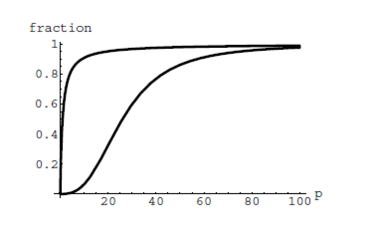The graphs of  and  are given here on the domain

0 ≤ *p* ≤ 100; which is which?

* 1. If the pressure in the lungs is 100 Torrs, what is the level of oxygen saturation of the hemoglobin in the lungs?
  2. The pressure in an active muscle is 20 Torrs. What is the level of oxygen saturation of myoglobin in an active muscle? What is the level of hemoglobin in an active muscle?
  3. Define the efficiency of oxygen transport at a given pressure *p* to be . What is the oxygen transport efficiency at 20 Torrs? At 40 Torrs? At 60 Torrs? Sketch the graph of ; are there conditions under which transport efficiency is maximized (explain)?

1. The length of some fish are modeled by a von Bertalanffy growth function. For Pacific halibut, this function has the form  where  is the length (in centimeters) of a fish *t* years old. [UW]
   1. What is the length of a newborn halibut at birth?
   2. Use the formula to estimate the length of a 6–year–old halibut.
   3. At what age would you expect the halibut to be 120 cm long?
   4. What is the practical (physical) significance of the number 200 in the formula for ?
2. A cancer cell lacks normal biological growth regulation and can divide continuously. Suppose a single mouse skin cell is cancerous and its mitotic cell cycle (the time for the cell to divide once) is 20 hours. The number of cells at time *t* grows according to an exponential model. [UW]
   1. Find a formula  for the number of cancerous skin cells after *t* hours.
   2. Assume a typical mouse skin cell is spherical of radius 50×10−4 cm. Find the combined volume of all cancerous skin cells after *t* hours. When will the volume of cancerous cells be 1 cm3?
3. A ship embarked on a long voyage. At the start of the voyage, there were 500 ants in the cargo hold of the ship. One week into the voyage, there were 800 ants. Suppose the population of ants is an exponential function of time. [UW]
   1. How long did it take the population to double?
   2. How long did it take the population to triple?
   3. When were there be 10,000 ants on board?
   4. There also was an exponentially growing population of anteaters on board. At the start of the voyage there were 17 anteaters, and the population of anteaters doubled every 2.8 weeks. How long into the voyage were there 200 ants per anteater?
4. The populations of termites and spiders in a certain house are growing exponentially. The house contains 100 termites the day you move in. After 4 days, the house contains 200 termites. Three days after moving in, there are two times as many termites as spiders. Eight days after moving in, there were four times as many termites as spiders. How long (in days) does it take the population of spiders to triple? [UW]

## Section 4.7 Fitting Exponential Models to Data

In the previous section, we saw number lines using logarithmic scales. It is also common to see two dimensional graphs with one or both axes using a logarithmic scale.

One common use of a logarithmic scale on the vertical axis is to graph quantities that are changing exponentially, since it helps reveal relative differences. This is commonly used in stock charts, since values historically have grown exponentially over time. Both stock charts below show the Dow Jones Industrial Average, from 1928 to 2010.

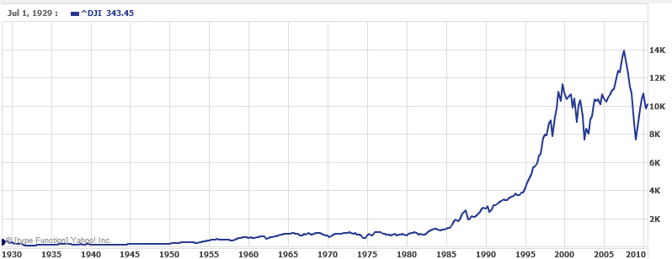

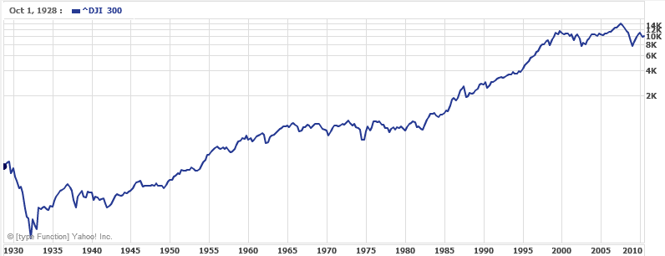

Both charts have a linear horizontal scale, but the first graph has a linear vertical scale, while the second has a logarithmic vertical scale. The first scale is the one we are more familiar with, and shows what appears to be a strong exponential trend, at least up until the year 2000.

Example 1

There were stock market drops in 1929 and 2008. Which was larger?

In the first graph, the stock market drop around 2008 looks very large, and in terms of dollar values, it was indeed a large drop. However, the second graph shows relative changes, and the drop in 2009 seems less major on this graph, and in fact the drop starting in 1929 was, percentage-wise, much more significant.

Specifically, in 2008, the Dow value dropped from about 14,000 to 8,000, a drop of 6,000. This is obviously a large value drop, and amounts to about a 43% drop. In 1929, the Dow value dropped from a high of around 380 to a low of 42 by July of 1932. While value-wise this drop of 338 is much smaller than the 2008 drop, it corresponds to a 89% drop, a much larger relative drop than in 2008. The logarithmic scale shows these relative changes.

The second graph above, in which one axis uses a linear scale and the other axis uses a logarithmic scale, is an example of a **semi-log** graph.

Semi-log and Log-log Graphs

A **semi-log** graph is a graph with one axis using a linear scale and one axis using a logarithmic scale.

A **log-log** graph is a graph with both axes using logarithmic scales.

Example 2

Plot 5 points on the graph of on a semi-log graph with a logarithmic scale on the vertical axis.

To do this, we need to find 5 points on the graph, then calculate the logarithm of the output value. Arbitrarily choosing 5 input values,

|  |  |  |
| --- | --- | --- |
| ***x*** | ***f(x)*** | **log*(f(x))*** |
| -3 |  | -0.426 |
| -1 |  | 0.176 |
| 0 |  | 0.477 |
| 2 |  | 1.079 |
| 5 |  | 1.982 |

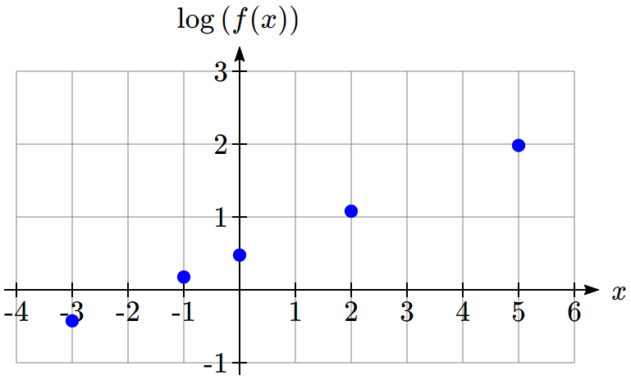Plotting these values on a semi-log graph,

Notice that on this semi-log scale, values from the exponential function appear linear. We can show this behavior is expected by utilizing logarithmic properties. For the function , finding log(*f(x)*) gives

 Utilizing the sum property of logs,

 Now utilizing the exponent property,



This relationship is linear, with log(*a*) as the vertical intercept, and log(*b*) as the slope. This relationship can also be utilized in reverse.

Example 3

An exponential graph is plotted on semi-log axes. Find a formula for the exponential function *g(x)* that generated this graph.

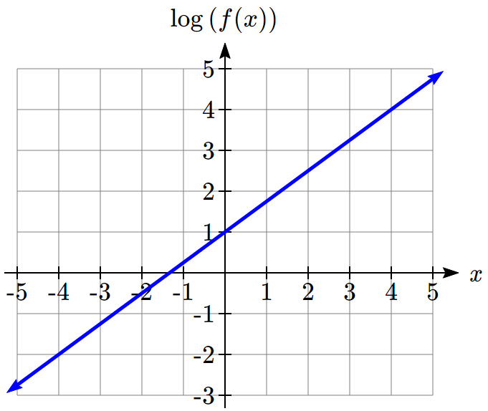

The graph is linear, with vertical intercept at (0, 1). Looking at the change between the points (0, 1) and (4, 4), we can determine the slope of the line is . Since the output is log(*g(x)*), this leads to the equation .

We can solve this formula for *g(x)* by rewriting in exponential form and simplifying:

 Rewriting as an exponential,

 Breaking this apart using exponent rules,

 Using exponent rules to group the second factor,

 Evaluating the powers of 10,



Try it Now

1. An exponential graph is plotted on a semi-log graph below. Find a formula for the exponential function *g(x)* that generated this graph.  
     
   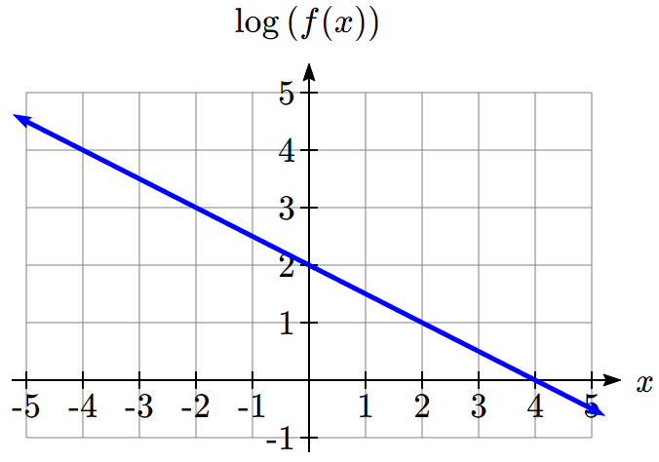

**Fitting Exponential Functions to Data**

Some technology options provide dedicated functions for finding exponential functions that fit data, but many only provide functions for fitting linear functions to data. The semi-log scale provides us with a method to fit an exponential function to data by building upon the techniques we have for fitting linear functions to data.

To fit an exponential function to a set of data using linearization

1. Find the log of the data output values
2. Find the linear equation that fits the (input, log(output)) pairs. This equation will be of the form log(*f(x)*) = *b* + *mx*.
3. Solve this equation for the exponential function *f(x)*

Example 4

The table below shows the cost in dollars per megabyte of storage space on computer hard drives from 1980 to 2004, and the data is shown on a standard graph to the right, with the input changed to years after 1980.

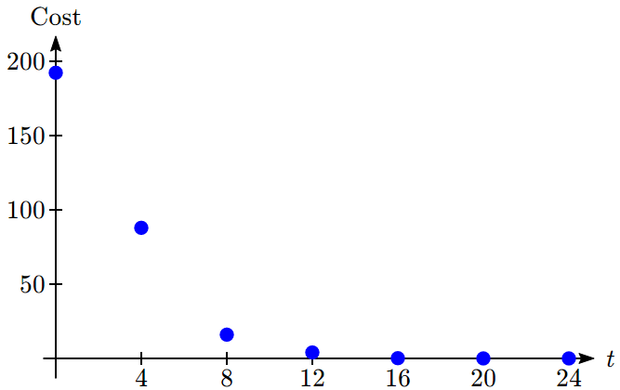

|  |  |
| --- | --- |
| Year | Cost per MB |
| 1980 | 192.31 |
| 1984 | 87.86 |
| 1988 | 15.98 |
| 1992 | 4 |
| 1996 | 0.173 |
| 2000 | 0.006849 |
| 2004 | 0.001149 |

This data appears to be decreasing exponentially. To find a function that models this decay, we would start by finding the log of the costs.

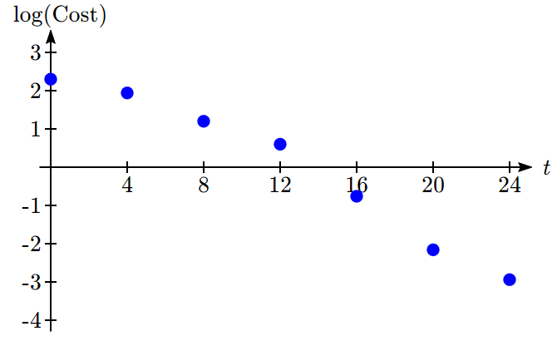

|  |  |  |  |
| --- | --- | --- | --- |
| Year | *t* | Cost per MB | log(Cost) |
| 1980 | 0 | 192.31 | 2.284002 |
| 1984 | 4 | 87.86 | 1.943791 |
| 1988 | 8 | 15.98 | 1.203577 |
| 1992 | 12 | 4 | 0.60206 |
| 1996 | 16 | 0.173 | -0.76195 |
| 2000 | 20 | 0.006849 | -2.16437 |
| 2004 | 24 | 0.001149 | -2.93952 |

As hoped, the graph of the log of costs appears fairly linear, suggesting an exponential function will fit the original data will fit reasonably well. Using technology, we can find a linear equation to fit the log(Cost) values. Using *t* as years after 1980, linear regression gives the equation:



Solving for *C(t)*,









This equation suggests that the cost per megabyte for storage on computer hard drives is decreasing by about 41% each year.

Using this function, we could predict the cost of storage in the future. Predicting the cost in the year 2020 (*t* = 40):

dollars per megabyte, a really small number. That is equivalent to $0.36 per terabyte of hard drive storage.

Comparing the values predicted by this model to the actual data, we see the model matches the original data in order of magnitude, but the specific values appear quite different. This is, unfortunately, the best exponential model that can fit the data. It is possible that a non-exponential model would fit the data better, or there could just be wide enough variability in the data that no relatively simple model would fit the data any better.

|  |  |  |
| --- | --- | --- |
| Year | Actual Cost per MB | Cost predicted by model |
| 1980 | 192.31 | 622.3 |
| 1984 | 87.86 | 74.3 |
| 1988 | 15.98 | 8.9 |
| 1992 | 4 | 1.1 |
| 1996 | 0.173 | 0.13 |
| 2000 | 0.006849 | 0.015 |
| 2004 | 0.001149 | 0.0018 |
| 2020 | 0.0000168 | 0.000000364 |

Try it Now

2. The table below shows the value *V,* in billions of dollars, of US imports from China *t* years after 2000.

|  |  |  |  |  |  |  |
| --- | --- | --- | --- | --- | --- | --- |
| year | 2000 | 2001 | 2002 | 2003 | 2004 | 2005 |
| *t* | 0 | 1 | 2 | 3 | 4 | 5 |
| *V* | 100 | 102.3 | 125.2 | 152.4 | 196.7 | 243.5 |

This data appears to be growing exponentially. Linearize this data and build a model to predict how many billions of dollars of imports were expected in 2011.

Important Topics of this Section

Semi-log graph

Log-log graph

Linearizing exponential functions

Fitting an exponential equation to data

Try it Now Answers

1. . 

2. . Predicting in 2011, billion dollars

## Section 4.7 Exercises

Graph each function on a semi-log scale, then find a formula for the linearized function in the form .

1.  2. 

3.  4. 

The graph below is on a semi-log scale, as indicated. Find a formula for the exponential function .

5. 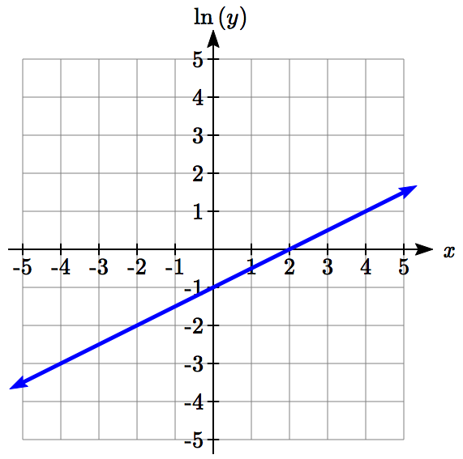 6.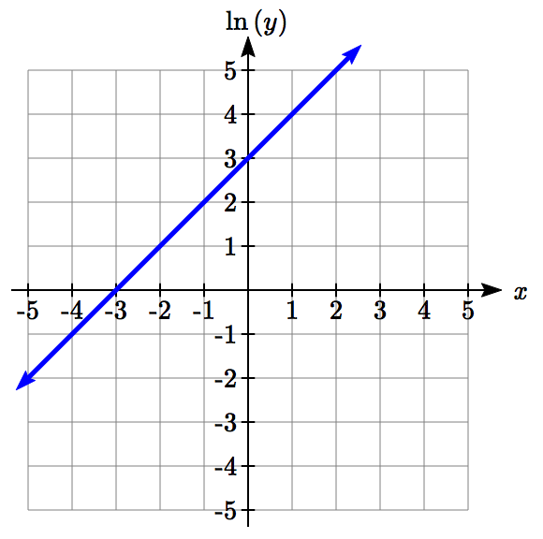

7. 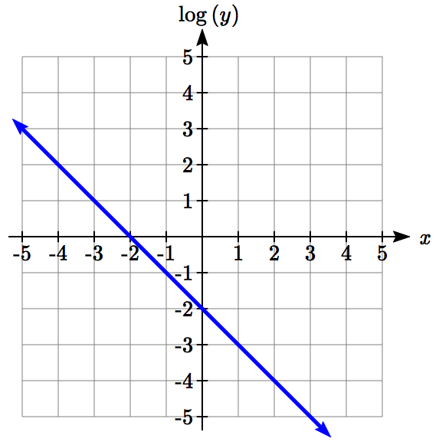 8. 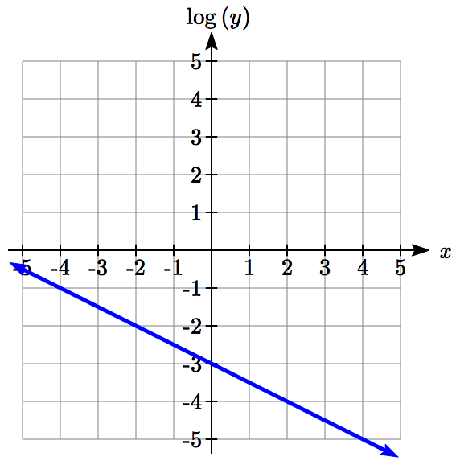

Use regression to find an exponential function that best fits the data given.

|  |  |  |  |  |  |  |  |  |  |  |  |  |  |  |  |
| --- | --- | --- | --- | --- | --- | --- | --- | --- | --- | --- | --- | --- | --- | --- | --- |
| 9. | |  |  |  |  |  |  |  | | --- | --- | --- | --- | --- | --- | --- | | **x** | 1 | 2 | 3 | 4 | 5 | 6 | | **y** | 1125 | 1495 | 2310 | 3294 | 4650 | 6361 | |
| 10. | |  |  |  |  |  |  |  | | --- | --- | --- | --- | --- | --- | --- | | **x** | 1 | 2 | 3 | 4 | 5 | 6 | | **y** | 643 | 829 | 920 | 1073 | 1330 | 1631 | |
| 11. | |  |  |  |  |  |  |  | | --- | --- | --- | --- | --- | --- | --- | | **x** | 1 | 2 | 3 | 4 | 5 | 6 | | **y** | 555 | 383 | 307 | 210 | 158 | 122 | |
| 12. | |  |  |  |  |  |  |  | | --- | --- | --- | --- | --- | --- | --- | | **x** | 1 | 2 | 3 | 4 | 5 | 6 | | **y** | 699 | 701 | 695 | 668 | 683 | 712 | |

1. Total expenditures (in billions of dollars) in the US for nursing home care are shown below. Use regression to find an exponential function that models the data. What does the model predict expenditures will be in 2015?

|  |  |  |  |  |  |  |
| --- | --- | --- | --- | --- | --- | --- |
| Year | 1990 | 1995 | 2000 | 2003 | 2005 | 2008 |
| Expenditure | 53 | 74 | 95 | 110 | 121 | 138 |

1. Light intensity as it passes through water decreases exponentially with depth. The data below shows the light intensity (in lumens) at various depths. Use regression to find an function that models the data. What does the model predict the intensity will be at 25 feet?

|  |  |  |  |  |  |  |
| --- | --- | --- | --- | --- | --- | --- |
| Depth (ft) | 3 | 6 | 9 | 12 | 15 | 18 |
| Lumen | 11.5 | 8.6 | 6.7 | 5.2 | 3.8 | 2.9 |

1. The average price of electricity (in cents per kilowatt hour) from 1990 through 2008 is given below. Determine if a linear or exponential model better fits the data, and use the better model to predict the price of electricity in 2014.

|  |  |  |  |  |  |  |  |  |  |  |
| --- | --- | --- | --- | --- | --- | --- | --- | --- | --- | --- |
| Year | 1990 | 1992 | 1994 | 1996 | 1998 | 2000 | 2002 | 2004 | 2006 | 2008 |
| Cost | 7.83 | 8.21 | 8.38 | 8.36 | 8.26 | 8.24 | 8.44 | 8.95 | 10.40 | 11.26 |

1. The average cost of a loaf of white bread from 1986 through 2008 is given below. Determine if a linear or exponential model better fits the data, and use the better model to predict the price of a loaf of bread in 2016.

|  |  |  |  |  |  |  |  |  |  |  |
| --- | --- | --- | --- | --- | --- | --- | --- | --- | --- | --- |
| Year | 1986 | 1988 | 1990 | 1995 | 1997 | 2000 | 2002 | 2004 | 2006 | 2008 |
| Cost | 0.57 | 0.66 | 0.70 | 0.84 | 0.88 | 0.99 | 1.03 | 0.97 | 1.14 | 1.42 |

1. World Bank, World Development Indicators, as reported on <http://www.google.com/publicdata>, retrieved August 20, 2010
2. World Bank, World Development Indicators, as reported on <http://www.google.com/publicdata>, retrieved August 24, 2010
3. <http://www.ead.anl.gov/pub/doc/chlorine.pdf>
4. It is interesting to note the large gap between Mars and Jupiter on the log number line. The asteroid belt is located there, which scientists believe is a planet that never formed because of the effects of the gravity of Jupiter.
5. From <http://www.epd.gov.hk/epd/noise_education/web/ENG_EPD_HTML/m1/intro_5.html>, retrieved Oct 2, 2010