# Chapter 5: Trigonometric Functions of Angles

In the previous chapters, we have explored a variety of functions which could be combined to form a variety of shapes. In this discussion, one common shape has been missing: the circle. We already know certain things about the circle, like how to find area and circumference, and the relationship between radius and diameter, but now, in this chapter, we explore the circle and its unique features that lead us into the rich world of trigonometry.

Section 5.1 Circles 337

Section 5.2 Angles 347

Section 5.3 Points on Circles using Sine and Cosine 362

Section 5.4 The Other Trigonometric Functions 375

Section 5.5 Right Triangle Trigonometry 385

## Section 5.1 Circles

To begin, we need to find distances. Starting with the Pythagorean Theorem, which relates the sides of a right triangle, we can find the distance between two points.

Pythagorean Theorem

**The Pythagorean Theorem** states that the sum of the squares of the legs of a right triangle will equal the square of the hypotenuse of the triangle.

*a*

*b*

*c*

In graphical form, given the triangle shown,.

We can use the Pythagorean Theorem to find the distance between two points on a graph.

Example 1

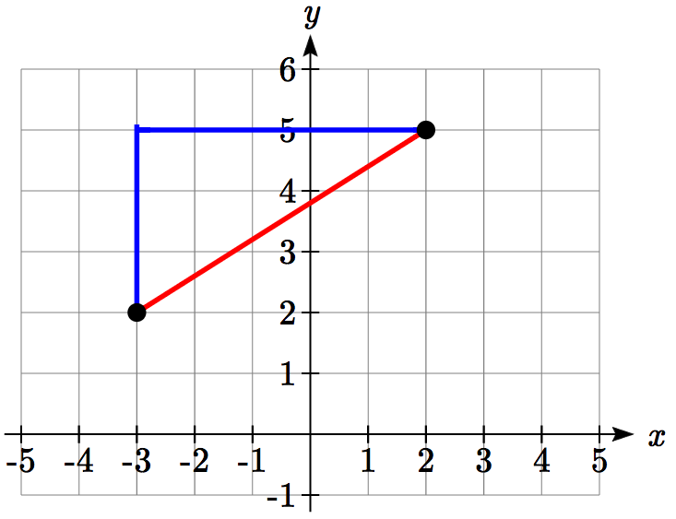Find the distance between the points (-3, 2) and (2, 5).

By plotting these points on the plane, we can then draw a right triangle with these points at each end of the hypotenuse. We can calculate horizontal width of the triangle to be 5 and the vertical height to be 3.

From these we can find the distance between the points using the Pythagorean Theorem:



Notice that the width of the triangle was calculated using the difference between the *x* (input) values of the two points, and the height of the triangle was found using the difference between the *y* (output) values of the two points. Generalizing this process gives us the distance formula.

Distance Formula

The distance between two points  and  can be calculated as



Try it Now

1. Find the distance between the points (1, 6) and (3, -5).

**Circles**

*r*

(*h, k*)

(*x, y*)

If we wanted to find an equation to represent a circle with a radius of *r* centered at a point (*h*, *k*), we notice that the distance between any point (*x*, *y*) on the circle and the center point is always the same: *r*. Noting this, we can use our distance formula to write an equation for the radius:



Squaring both sides of the equation gives us the standard equation for a circle.

Equation of a Circle

The **equation of a circle** centered at the point (*h, k*) with radius *r* can be written as



Notice that a circle does not pass the vertical line test. It is not possible to write *y* as a function of *x* or vice versa.

Example 2

Write an equation for a circle centered at the point (-3, 2) with radius 4.

Using the equation from above, *h* = -3, *k* = 2, and the radius *r* = 4. Using these in our formula,

 simplified, this gives



Example 3

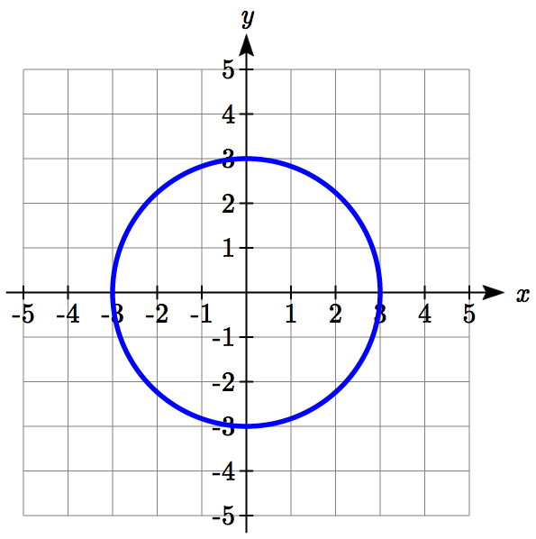Write an equation for the circle graphed here.

This circle is centered at the origin, the point (0, 0). By measuring horizontally or vertically from the center out to the circle, we can see the radius is 3. Using this information in our formula gives:

 simplified, this gives



Try it Now

2. Write an equation for a circle centered at (4, -2) with radius 6.

Notice that, relative to a circle centered at the origin, horizontal and vertical shifts of the circle are revealed in the values of *h* and *k*, which are the coordinates for the center of the circle.

**Points on a Circle**

As noted earlier, an equation for a circle cannot be written so that *y* is a function of *x* or vice versa. To find coordinates on the circle given only the *x* or *y* value, we must solve algebraically for the unknown values.

Example 4

Find the points on a circle of radius 5 centered at the origin with an *x* value of 3.

We begin by writing an equation for the circle centered at the origin with a radius of 5.



Substituting in the desired *x* value of 3 gives an equation we can solve for *y*.



There are two points on the circle with an *x* value of 3: (3, 4) and (3, -4).

Example 5

Find the *x* intercepts of a circle with radius 6 centered at the point (2, 4).

We can start by writing an equation for the circle.



To find the *x* intercepts, we need to find the points where *y* = 0. Substituting in zero for *y*, we can solve for *x*.











The *x* intercepts of the circle are  and 

Example 6

In a town, Main Street runs east to west, and Meridian Road runs north to south. A pizza store is located on Meridian 2 miles south of the intersection of Main and Meridian. If the store advertises that it delivers within a 3-mile radius, how much of Main Street do they deliver to?

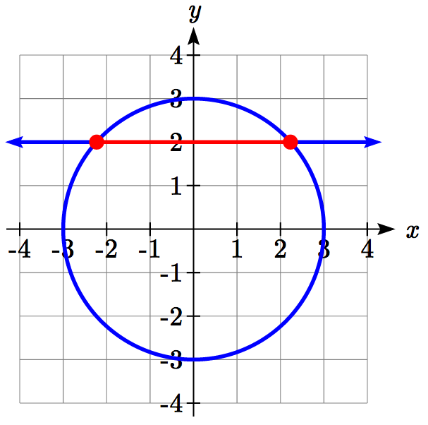This type of question is one in which introducing a coordinate system and drawing a picture can help us solve the problem. We could either place the origin at the intersection of the two streets, or place the origin at the pizza store itself. It is often easier to work with circles centered at the origin, so we’ll place the origin at the pizza store, though either approach would work fine.

Placing the origin at the pizza store, the delivery area with radius 3 miles can be described as the region inside the circle described by .

Main Street, located 2 miles north of the pizza store and running east to west, can be described by the equation *y* = 2.

To find the portion of Main Street the store will deliver to, we first find the boundary of their delivery region by looking for where the delivery circle intersects Main Street. To find the intersection, we look for the points on the circle where *y* = 2. Substituting *y* = 2 into the circle equation lets us solve for the corresponding *x* values.



This means the pizza store will deliver 2.236 miles down Main Street east of Meridian and 2.236 miles down Main Street west of Meridian. We can conclude that the pizza store delivers to a 4.472 mile long segment of Main St.

In addition to finding where a vertical or horizontal line intersects the circle, we can also find where an arbitrary line intersects a circle.

Example 7

Find where the line  intersects the circle .

Normally, to find an intersection of two functions *f(x)* and *g(x)* we would solve for the *x* value that would make the functions equal by solving the equation *f(x)* = *g(x)*. In the case of a circle, it isn’t possible to represent the equation as a function, but we can utilize the same idea.

The output value of the line determines the *y* value: . We want the *y* value of the circle to equal the *y* value of the line, which is the output value of the function. To do this, we can substitute the expression for *y* from the line into the circle equation.

 replace *y* with the line formula: 

 expand

 simplify

 since this equation is quadratic, we arrange one side to be 0



Since this quadratic doesn’t appear to be easily factorable, we can use the quadratic formula to solve for *x*:

, or approximately *x* ≈ 0.966 or -0.731

From these *x* values we can use either equation to find the corresponding *y* values.

Since the line equation is easier to evaluate, we might choose to use it:



The line intersects the circle at the points (0.966, 3.864) and (-0.731, -2.923).

Try it Now

3. A small radio transmitter broadcasts in a 50 mile radius. If you drive along a straight line from a city 60 miles north of the transmitter to a second city 70 miles east of the transmitter, during how much of the drive will you pick up a signal from the transmitter?

Important Topics of This Section

Distance formula

Equation of a Circle

Finding the *x* coordinate of a point on the circle given the *y* coordinate or vice versa

Finding the intersection of a circle and a line

Try it Now Answers

1. 

2. 

3. The circle can be represented by .   
Finding a line from (0,60) to (70,0) gives .   
Substituting the line equation into the circle gives .   
Solving this equation, we find *x* = 14 or *x* = 45.29, corresponding to points (14, 48) and (45.29, 21.18).   
The distance between these points is 41.21 miles.

## Section 5.1 Exercises

1. Find the distance between the points (5,3) and (-1,-5).
2. Find the distance between the points (3,3) and (-3,-2).
3. Write an equation of the circle centered at (8 , -10) with radius 8.
4. Write an equation of the circle centered at (-9, 9) with radius 16.
5. Write an equation of the circle centered at (7, -2) that passes through (-10, 0).
6. Write an equation of the circle centered at (3, -7) that passes through (15, 13).
7. Write an equation for a circle where (2, 6) and (8, 10) lie at the ends of a diameter.
8. Write an equation for a circle where (-3, 3) and (5, 7) lie at the ends of a diameter.
9. Sketch a graph of .
10. Sketch a graph of .
11. Find the *y* intercept(s) of the circle with center (2, 3) with radius 3.
12. Find the *x* intercept(s) of the circle with center (2, 3) with radius 4.
13. At what point in the first quadrant does the line with equation  intersect a circle with radius 3 and center (0, 5)?
14. At what point in the first quadrant does the line with equation  intersect the circle with radius 6 and center (0, 2)?
15. At what point in the second quadrant does the line with equation  intersect a circle with radius 3 and center (-2, 0)?
16. At what point in the first quadrant does the line with equation  intersect the circle with radius 6 and center (-1,0)?
17. A small radio transmitter broadcasts in a 53 mile radius. If you drive along a straight line from a city 70 miles north of the transmitter to a second city 74 miles east of the transmitter, during how much of the drive will you pick up a signal from the transmitter?
18. A small radio transmitter broadcasts in a 44 mile radius. If you drive along a straight line from a city 56 miles south of the transmitter to a second city 53 miles west of the transmitter, during how much of the drive will you pick up a signal from the transmitter?

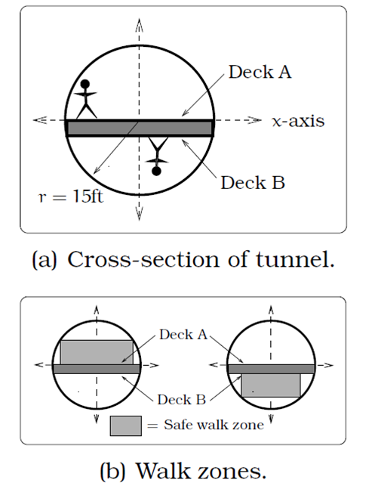

1. A tunnel connecting two portions of a space station has a circular cross-section of radius 15 feet. Two walkway decks are constructed in the tunnel. Deck A is along a horizontal diameter and another parallel Deck B is 2 feet below Deck A. Because the space station is in a weightless environment, you can walk vertically upright along Deck A, or vertically upside down along Deck B. You have been assigned to paint “safety stripes” on each deck level, so that a 6 foot person can safely walk upright along either deck. Determine the width of the “safe walk zone” on each deck. [UW]
2. 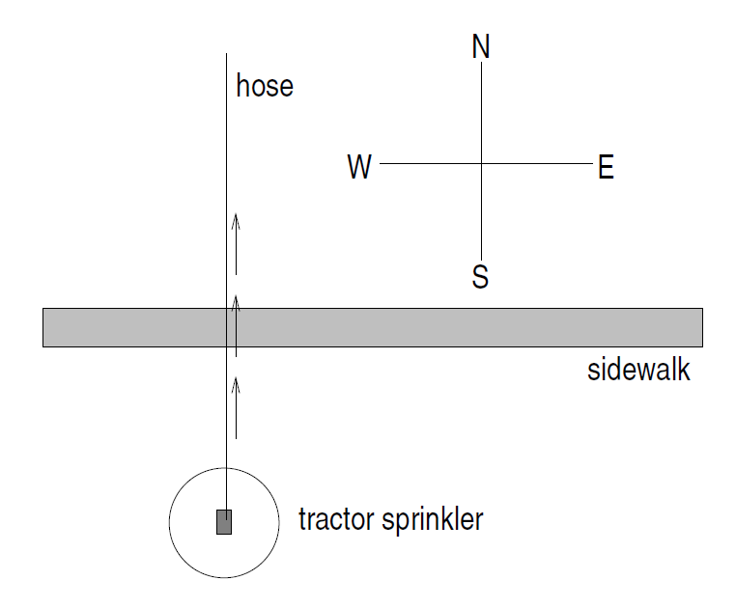A crawling tractor sprinkler is located as pictured here, 100 feet south of a sidewalk. Once the water is turned on, the sprinkler waters a circular disc of radius 20 feet and moves north along the hose at the rate of ½ inch/second. The hose is perpendicular to the 10 ft. wide sidewalk. Assume there is grass on both sides of the sidewalk. [UW]
3. Impose a coordinate system. Describe the initial coordinates of the sprinkler and find equations of the lines forming and find equations of the lines forming the north and south boundaries of the sidewalk.
4. When will the water first strike the sidewalk?
5. When will the water from the sprinkler fall completely north of the sidewalk?
6. Find the total amount of time water from the sprinkler falls on the sidewalk.
7. Sketch a picture of the situation after 33 minutes. Draw an accurate picture of the watered portion of the sidewalk.
8. Find the area of grass watered after one hour.
9. Erik’s disabled sailboat is floating anchored 3 miles East and 2 miles north of Kingsford. A ferry leaves Kingsford heading toward Eaglerock at 12 mph. Eaglerock is 6 miles due east of Kingsford. After 20 minutes the ferry turns, heading due south. Bander is 8 miles south and 1 mile west of Eaglerock. Impose coordinates with Bander as the origin. [UW]



North

Kingsford

Eaglerock

Bander

1. Find equations for the lines along which the ferry is moving and draw in these lines.
2. The sailboat has a radar scope that will detect any object within 3 miles of the sailboat. Looking down from above, as in the picture, the radar region looks like a circular disk. The boundary is the “edge” or circle around this disk, the interior is everything inside of the circle, and the exterior is everything outside of the circle. Give the mathematical description (an equation or inequality) of the boundary, interior and exterior of the radar zone. Sketch an accurate picture of the radar zone by determining where the line connecting Kingsford and Eaglerock would cross the radar zone.
3. When does the ferry enter the radar zone?
4. Where and when does the ferry exit the radar zone?
5. How long does the ferry spend inside the radar zone?
6. Nora spends part of her summer driving a combine during the wheat harvest. Assume she starts at the indicated position heading east at 10 ft/sec toward a circular wheat field of radius 200 ft. The combine cuts a swath 20 feet wide and begins when the corner of the machine labeled “a” is 60 feet north and 60 feet west of the western-most edge of the field. [UW]

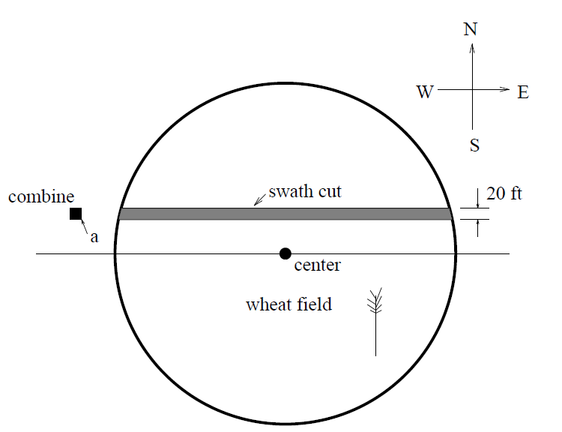

1. When does Nora’s combine first start cutting the wheat?
2. When does Nora’s combine first start cutting a swath 20 feet wide?
3. Find the total amount of time wheat is being cut during this pass across the field.
4. Estimate the area of the swath cut during this pass across the field.
5. 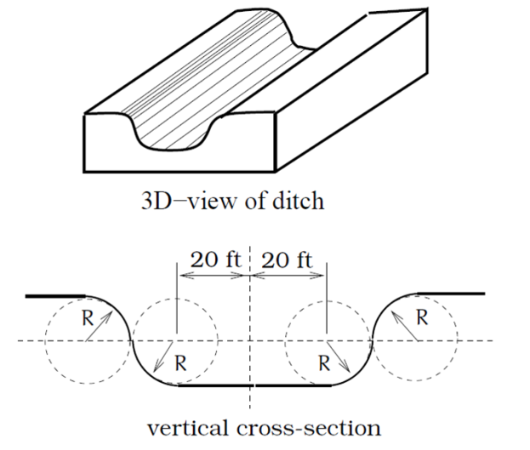The vertical cross-section of a drainage ditch is pictured to the right. Here, *R* indicates in each case the radius of a circle with *R* = 10 feet, where all of the indicated circle centers lie along a horizontal line 10 feet above and parallel to the ditch bottom. Assume that water is flowing into the ditch so that the level above the bottom is rising at a rate of 2 inches per minute. [UW]
6. When will the ditch be completely full?
7. Find a piecewise defined function that models the vertical cross-section of the ditch.
8. What is the width of the filled portion of the ditch after 1 hour and 18 minutes?
9. When will the filled portion of the ditch be 42 feet wide? 50 feet wide? 73 feet wide?

## Section 5.2 Angles

Because many applications involving circles also involve a rotation of the circle, it is natural to introduce a measure for the rotation, or angle, between two rays (line segments) emanating from the center of a circle. The angle measurement you are most likely familiar with is degrees, so we’ll begin there.

Measure of an Angle

The **measure of an** **angle** is a measurement between two   
intersecting lines, line segments or rays, starting at the **initial side**   
and ending at the **terminal side**. It is a rotational measure, not a  
linear measure.

initial side

terminal side

angle

**Measuring Angles**

Degrees

A **degree** is a measurement of angle. One full rotation around the circle is equal to 360 degrees, so one degree is 1/360 of a circle.

An angle measured in degrees should always include the unit “degrees” after the number, or include the degree symbol °. For example, 90 degrees = .

Standard Position

When measuring angles on a circle, unless otherwise directed, we measure angles in **standard position**: starting at the positive horizontal axis and with counter-clockwise rotation.

Example 1

Give the degree measure of the angle shown on the circle.

The vertical and horizontal lines divide the circle into quarters. Since one full rotation is 360 degrees=, each quarter rotation is 360/4 =  or 90 degrees.

Example 2

Show an angle of on the circle.

An angle of is 1/3 of , so by dividing a quarter rotation into thirds, we can sketch a line at .

**Going Greek**

When representing angles using variables, it is traditional to use Greek letters. Here is a list of commonly encountered Greek letters.

|  |  |  |  |  |
| --- | --- | --- | --- | --- |
|  | or |  |  |  |
| theta | phi | alpha | beta | gamma |

**Working with Angles in Degrees**

Notice that since there are 360 degrees in one rotation, an angle greater than 360 degrees would indicate more than 1 full rotation. Shown on a circle, the resulting direction in which this angle’s terminal side points would be the same as for another angle between 0 and 360 degrees. These angles would be called **coterminal**.

Coterminal Angles

After completing their full rotation based on the given angle, two angles are **coterminal** if they terminate in the same position, so their terminal sides coincide (point in the same direction).

Example 3

Find an angle *θ* that is coterminal with , where 

Since adding or subtracting a full rotation, 360 degrees, would result in an angle with terminal side pointing in the same direction, we can find coterminal angles by adding or subtracting 360 degrees. An angle of 800 degrees is coterminal with an angle of 800-360 = 440 degrees. It would also be coterminal with an angle of 440-360 = 80 degrees.

The angle is coterminal with .

By finding the coterminal angle between 0 and 360 degrees, it can be easier to see which direction the terminal side of an angle points in.

Try it Now

1. Find an angle  that is coterminal with , where .

On a number line a positive number is measured to the right and a negative number is measured in the opposite direction (to the left). Similarly a positive angle is measured counterclockwise and a negative angle is measured in the opposite direction (clockwise).

Example 4

Show the angle on the circle and find a positive angle that is coterminal and .

-45°

315°

Since 45 degrees is half of 90 degrees, we can start at the positive horizontal axis and measure clockwise half of a 90 degree angle.

Since we can find coterminal angles by adding or subtracting a full rotation of 360 degrees, we can find a positive coterminal angle here by adding 360 degrees:



Try it Now

2. Find an angle coterminal with  where .

It can be helpful to have a familiarity with the frequently encountered angles in one rotation of a circle. It is common to encounter multiples of 30, 45, 60, and 90 degrees. These values are shown to the right. Memorizing these angles and understanding their properties will be very useful as we study the properties associated with angles

0°

30°

60°

90°

120°

150°

180°

210°

240°

270°

300°

330°

45°

135°

225°

315°

**Angles in Radians**

While measuring angles in degrees may be familiar, doing so often complicates matters since the units of measure can get in the way of calculations. For this reason, another measure of angles is commonly used. This measure is based on the distance around a circle.

Arclength

**Arclength** is the length of an arc, *s*, along a circle of radius *r*subtended (drawn out) by an angle.

*θ*

*r*

*s*

It is the portion of the circumference between the initial and   
terminal sides of the angle.

The length of the arc around an entire circle is called the circumference of a circle. The circumference of a circle is . The ratio of the circumference to the radius, produces the constant. Regardless of the radius, this ratio is always the same, just as how the degree measure of an angle is independent of the radius.

To elaborate on this idea, consider two circles, one with radius 2 and one with radius 3. Recall the circumference (perimeter) of a circle is , where *r* is the radius of the circle. The smaller circle then has circumference  and the larger has circumference.

45°

2

3

Drawing a 45 degree angle on the two circles, we might be interested in the length of the arc of the circle that the angle indicates. In both cases, the 45 degree angle draws out an arc that is 1/8th of the full circumference, so for the smaller circle, the arclength = , and for the larger circle, the length of the arc or arclength = .

Notice what happens if we find the *ratio* of the arclength divided by the radius of the circle:

Smaller circle: 

Larger circle: 

The ratio is the same regardless of the radius of the circle – it only depends on the angle. This property allows us to define a measure of the angle based on arclength.

Radians

The **radian measure** of an angle is the ratio of the length of the circular arc subtended by the angle to the radius of the circle.

In other words, if *s* is the length of an arc of a circle, and *r* is the radius of the circle, then

radian measure

If the circle has radius 1, then the radian measure corresponds to the length of the arc.

Because radian measure is the ratio of two lengths, it is a **unitless measure**. It is not necessary to write the label “radians” after a radian measure, and if you see an angle that is not labeled with “degrees” or the degree symbol, you should assume that it is a radian measure.

Considering the most basic case, the unit circle (a circle with radius 1), we know that 1 rotation equals 360 degrees, . We can also track one rotation around a circle by finding the circumference, , and for the unit circle . These two different ways to rotate around a circle give us a way to convert from degrees to radians.

1 rotation = =radians

½ rotation =  = radians

¼ rotation = = radians

Example 5

Find the radian measure of one third of a full rotation.

For any circle, the arclength along such a rotation would be one third of the circumference, . The radian measure would be the arclength divided by the radius:

Radian measure = .

Converting Between Radians and Degrees

1 degree =  radians

or: to convert from degrees to radians, multiply by 

1 radian =  degrees

or: to convert from radians to degrees, multiply by 

Example 6

Convert  radians to degrees.

Since we are given a problem in radians and we want degrees, we multiply by .

Remember radians are a unitless measure, so we don’t need to write “radians.”

 radians =  degrees.

Example 7

Convert 15 degrees to radians.

In this example, we start with degrees and want radians so we use the other conversionso that the degree units cancel and we are left with the unitless measure of radians.

15 degrees = 

Try it Now

3. Convert  radians to degrees.

0, 































Just as we listed all the common angles in degrees on a circle, we should also list the corresponding radian values for the common measures of a circle corresponding to degree multiples of 30, 45, 60, and 90 degrees. As with the degree measurements, it would be advisable to commit these to memory.

We can work with the radian measures of an angle the same way we work with degrees.

Example 8

Find an angle  that is coterminal with , where .

When working in degrees, we found coterminal angles by adding or subtracting 360 degrees, a full rotation. Likewise, in radians, we can find coterminal angles by adding or subtracting full rotations of  radians.



The angle is coterminal, but not less than , so we subtract another rotation.



The angle  is coterminal with .

Try it Now

4. Find an angle that is coterminal with  where .

**Arclength and Area of a Sector**

Recall that the radian measure of an angle was defined as the ratio of the arclength of a circular arc to the radius of the circle, . From this relationship, we can find arclength along a circle given an angle.

Arclength on a Circle

The length of an arc, *s*, along a circle of radius *r* subtended by angle in radians is



Example 9

Mercury orbits the sun at a distance of approximately 36 million miles. In one Earth day, it completes 0.0114 rotation around the sun. If the orbit was perfectly circular, what distance through space would Mercury travel in one Earth day?

To begin, we will need to convert the decimal rotation value to a radian measure.

Since one rotation =  radians,

0.0114 rotation =  radians.

Combining this with the given radius of 36 million miles, we can find the arclength:

 million miles travelled through space.

Try it Now

5. Find the arclength along a circle of radius 10 subtended by an angle of 215 degrees.

In addition to arclength, we can also use angles to find the area of a sector of a circle. A sector is a portion of a circle contained between two lines from the center, like a slice of pizza or pie.

Recall that the area of a circle with radius *r* can be found using the formula . If a sector is cut out by an angle of , measured in radians, then the fraction of full circle that angle has cut out is , since  is one full rotation. Thus, the area of the sector would be this fraction of the whole area:

Area of sector 

Area of a Sector

The **area of a sector** of a circle with radius *r* subtended by an   
angle , measured in radians, is

*r*

*θ*

Area of sector

Example 10

An automatic lawn sprinkler sprays a distance of 20 feet while rotating 30 degrees. What is the area of the sector of grass the sprinkler waters?

First, we need to convert the angle measure into radians. Since 30 degrees is one of our common angles, you ideally should already know the equivalent radian measure, but if not we can convert:

20 ft

30°

30 degrees =  radians.

The area of the sector is then Area  ft2

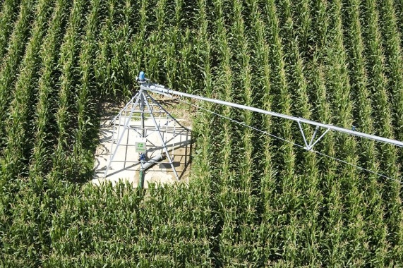Try it Now

6. In central pivot irrigation, a large irrigation pipe on wheels rotates around a center point, as pictured here[1]. A farmer has a central pivot system with a radius of 400 meters. If water restrictions only allow her to water 150 thousand square meters a day, what angle should she set the system to cover?

**Linear and Angular Velocity**

When your car drives down a road, it makes sense to describe its speed in terms of miles per hour or meters per second. These are measures of speed along a line, also called linear velocity. When a point on a circle rotates, we would describe its angular velocity, or rotational speed, in radians per second, rotations per minute, or degrees per hour.

Angular and Linear Velocity

As a point moves along a circle of radius *r*, its **angular velocity,** , can be found as the angular rotation  per unit time, *t*.



The **linear velocity**,*v*, of the point can be found as the distance travelled, arclength *s*, per unit time, *t*.



Example 11

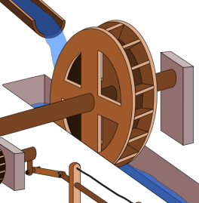A water wheel completes 1 rotation every 5 seconds. Find the angular velocity in radians per second.[2]

The wheel completes 1 rotation =  radians in 5 seconds, so the angular velocity would be radians per second.

Combining the definitions above with the arclength equation, , we can find a relationship between angular and linear velocities. The angular velocity equation can be solved for , giving . Substituting this into the arclength equation gives .

Substituting this into the linear velocity equation gives



Relationship Between Linear and Angular Velocity

When the angular velocity is measured in radians per unit time, linear velocity and angular velocity are related by the equation



Example 12

A bicycle has wheels 28 inches in diameter. A tachometer determines the wheels are rotating at 180 RPM (revolutions per minute). Find the speed the bicycle is travelling down the road.

Here we have an angular velocity and need to find the corresponding linear velocity, since the linear speed of the outside of the tires is the speed at which the bicycle travels down the road.

We begin by converting from rotations per minute to radians per minute. It can be helpful to utilize the units to make this conversion



Using the formula from above along with the radius of the wheels, we can find the linear velocity



You may be wondering where the “radians” went in this last equation. Remember that radians are a unitless measure, so it is not necessary to include them.

Finally, we may wish to convert this linear velocity into a more familiar measurement, like miles per hour.

 miles per hour (mph).

Try it Now

7. A satellite is rotating around the earth at 27,934 kilometers per minute at an altitude of 242 km above the earth. If the radius of the earth is 6378 kilometers, find the angular velocity of the satellite.

Important Topics of This Section

Degree measure of angle

Radian measure of angle

Conversion between degrees and radians

Common angles in degrees and radians

Coterminal angles

Arclength

Area of a sector

Linear and angular velocity

Try it Now Answers

1. 

2. 

3. 

4. 

5. 215° =  radians. 

6. . , or 

7. *v* = 27934. *r* = 6378+242=6620.  radians per hour.

## Section 5.2 Exercises

1. Indicate each angle on a circle: 30°, 300°, -135°, 70°, , 
2. Indicate each angle on a circle: 30°, 315°, -135°, 80°, , 
3. Convert the angle 180° to radians.
4. Convert the angle 30° to radians.
5. Convert the angle  from radians to degrees.
6. Convert the angle  from radians to degrees.
7. Find the angle between 0° and 360° that is coterminal with a 685° angle.
8. Find the angle between 0° and 360° that is coterminal with a 451° angle.
9. Find the angle between 0° and 360° that is coterminal with a -1746° angle.
10. Find the angle between 0° and 360° that is coterminal with a -1400° angle.
11. Find the angle between 0 and 2π in radians that is coterminal with the angle .
12. Find the angle between 0 and 2π in radians that is coterminal with the angle .
13. Find the angle between 0 and 2π in radians that is coterminal with the angle .
14. Find the angle between 0 and 2π in radians that is coterminal with the angle .
15. On a circle of radius 7 miles, find the length of the arc that subtends a central angle of 5 radians.
16. On a circle of radius 6 feet, find the length of the arc that subtends a central angle of 1 radian.
17. On a circle of radius 12 cm, find the length of the arc that subtends a central angle of 120 degrees.
18. On a circle of radius 9 miles, find the length of the arc that subtends a central angle of 800 degrees.
19. Find the distance along an arc on the surface of the Earth that subtends a central angle of 5 minutes (1 minute = 1/60 degree). The radius of the Earth is 3960 miles.
20. Find the distance along an arc on the surface of the Earth that subtends a central angle of 7 minutes (1 minute = 1/60 degree). The radius of the Earth is 3960 miles.
21. On a circle of radius 6 feet, what angle in degrees would subtend an arc of length 3 feet?
22. On a circle of radius 5 feet, what angle in degrees would subtend an arc of length 2 feet?
23. A sector of a circle has a central angle of 45°. Find the area of the sector if the radius of the circle is 6 cm.
24. A sector of a circle has a central angle of 30°. Find the area of the sector if the radius of the circle is 20 cm.
25. A truck with 32-in.-diameter wheels is traveling at 60 mi/h. Find the angular speed of the wheels in rad/min. How many revolutions per minute do the wheels make?
26. A bicycle with 24-in.-diameter wheels is traveling at 15 mi/h. Find the angular speed of the wheels in rad/min. How many revolutions per minute do the wheels make?
27. A wheel of radius 8 in. is rotating 15°/sec. What is the linear speed *v*, the angular speed in RPM, and the angular speed in rad/sec?
28. A wheel of radius 14 in. is rotating 0.5 rad/sec. What is the linear speed *v*, the angular speed in RPM, and the angular speed in deg/sec?
29. A CD has diameter of 120 millimeters. When playing audio, the angular speed varies to keep the linear speed constant where the disc is being read. When reading along the outer edge of the disc, the angular speed is about 200 RPM (revolutions per minute). Find the linear speed.
30. When being burned in a writable CD-R drive, the angular speed of a CD is often much faster than when playing audio, but the angular speed still varies to keep the linear speed constant where the disc is being written. When writing along the outer edge of the disc, the angular speed of one drive is about 4800 RPM (revolutions per minute). Find the linear speed.
31. You are standing on the equator of the Earth (radius 3960 miles). What is your linear and angular speed?
32. The restaurant in the Space Needle in Seattle rotates at the rate of one revolution every 47 minutes. [UW]
33. Through how many radians does it turn in 100 minutes?
34. How long does it take the restaurant to rotate through 4 radians?
35. How far does a person sitting by the window move in 100 minutes if the radius of the restaurant is 21 meters?

## Section 5.3 Points on Circles Using Sine and Cosine

While it is convenient to describe the location of a point on a circle using an angle or a distance along the circle, relating this information to the *x* and *y* coordinates and the circle equation we explored in Section 5.1 is an important application of trigonometry.

A distress signal is sent from a sailboat during a storm, but the transmission is unclear and the rescue boat sitting at the marina cannot determine the sailboat’s location. Using high powered radar, they determine the distress signal is coming from a distance of 20 miles at an angle of 225 degrees from the marina. How many miles east/west and north/south of the rescue boat is the stranded sailboat?

(*x*, *y*)

*r*

*θ*

In a general sense, to investigate this, we begin by drawing a circle centered at the origin with radius *r*, and marking the point on the circle indicated by some angle *θ*. This point has coordinates (*x*, *y*).

If we drop a line segment vertically down from this point to the *x* axis, we would form a right triangle inside of the circle.

No matter which quadrant our angle *θ* puts us in we can draw a triangle by dropping a perpendicular line segment to the *x* axis, keeping in mind that the values of *x* and *y* may be positive or negative, depending on the quadrant.

Additionally, if the angle *θ* puts us on an axis, we simply measure the radius as the *x* or *y* with the other value being 0, again ensuring we have appropriate signs on the coordinates based on the quadrant.

Triangles obtained from different radii will all be similar triangles, meaning corresponding sides scale proportionally. While the lengths of the sides may change, as we saw in the last section, the *ratios* of the side lengths will always remain constant for any given angle.



*r1*

*θ*

*y1*

*x1*

*r2*

*θ*

*y2*

*x2*



To be able to refer to these ratios more easily, we will give them names. Since the ratios depend on the angle, we will write them as functions of the angle .

Sine and Cosine

For the point (*x*, *y*) on a circle of radius *r* at an angle of , we can   
define two important functions as the ratios of the sides of the  
corresponding triangle:

(*x*, *y*)

*r*

*θ*

*y*

*x*

The **sine** function: 

The **cosine** function: 

In this chapter, we will explore these functions using both circles and right triangles. In the next chapter, we will take a closer look at the behavior and characteristics of the sine and cosine functions.

Example 1

The point (3, 4) is on the circle of radius 5 at some angle *θ*. Find and .

Knowing the radius of the circle and coordinates of the point, we can evaluate the cosine and sine functions as the ratio of the sides.

 

There are a few cosine and sine values which we can determine fairly easily because the corresponding point on the circle falls on the *x* or *y* axis.

Example 2

(0, *r*)

Find  and 

*r*

90°

On any circle, the terminal side of a 90 degree angle points straight up, so the coordinates of the corresponding point on the circle would be (0, *r*). Using our definitions of cosine and sine,





Try it Now

1. Find cosine and sine of the angle .

Notice that the definitions above can also be stated as:

Coordinates of the Point on a Circle at a Given Angle

On a circle of radius *r* at an angle of , we can find the **coordinates of the point   
(*x*, *y*)** at that angle using





On a unit circle, a circle with radius 1,  and .

Utilizing the basic equation for a circle centered at the origin, , combined with the relationships above, we can establish a new identity.

 substituting the relations above,

 simplifying,

 dividing by 

 or using shorthand notation



Here  is a commonly used shorthand notation for . Be aware that many calculators and computers do not understand the shorthand notation.

In Section 5.1 we related the Pythagorean Theorem  to the basic equation of a circle , which we have now used to arrive at the Pythagorean Identity.

Pythagorean Identity

The **Pythagorean Identity**. For any angle *θ*, .

One use of this identity is that it helps us to find a cosine value of an angle if we know the sine value of that angle or vice versa. However, since the equation will yield two possible values, we will need to utilize additional knowledge of the angle to help us find the desired value.

Example 3

If  and  is in the second quadrant, find .

Substituting the known value for sine into the Pythagorean identity,









Since the angle is in the second quadrant, we know the *x* value of the point would be negative, so the cosine value should also be negative. Using this additional information, we can conclude that .

**Values for Sine and Cosine**

At this point, you may have noticed that we haven’t found any cosine or sine values from angles not on an axis. To do this, we will need to utilize our knowledge of triangles.

1

45°

*y*

*x*

(*x*, *y*) = (*x*, *x*)

First, consider a point on a circle at an angle of 45 degrees, or . At this angle, the *x* and *y* coordinates of the corresponding point on the circle will be equal because 45 degrees divides the first quadrant in half. Since the *x* and *y* values will be the same, the sine and cosine values will also be equal. Utilizing the Pythagorean Identity,

 since the sine and cosine are equal, we can

substitute sine with cosine

 add like terms

 divide

 since the *x* value is positive, we’ll keep the positive root

 often this value is written with a rationalized denominator

Remember, to rationalize the denominator we multiply by a term equivalent to 1 to get rid of the radical in the denominator.



Since the sine and cosine are equal,  as well. The (*x*, *y*) coordinates for a point on a circle of radius 1 at an angle of 45 degrees are .

Example 4

Find the coordinates of the point on a circle of radius 6 at an angle of .

Using our new knowledge that  and , along with our relationships that stated  and , we can find the coordinates of the point desired:





Try it Now

1. Find the coordinates of the point on a circle of radius 3 at an angle of .

*r*

30°

(*x*, *y*)

Next, we will find the cosine and sine at an angle of 30 degrees, or . To do this, we will first draw a triangle inside a circle with one side at an angle of 30 degrees, and another at an angle of -30 degrees. If the resulting two right triangles are combined into one large triangle, notice that all three angles of this larger triangle will be 60 degrees.

Since all the angles are equal, the sides will all be equal as well. The vertical line has length 2*y*, and since the sides are all equal we can conclude that 2*y* = *r*, or . Using this, we can find the sine value:

60°

60°

60°

*r*

*r*

*y*

*y*



Using the Pythagorean Identity, we can find the cosine value:





 since the *x* value is positive, we’ll keep the positive root



The (*x*, *y*) coordinates for the point on a circle of radius 1 at an angle of 30 degrees are .

By drawing a the triangle inside the unit circle with a 30 degree angle and reflecting it over the line *y* = *x*, we can find the cosine and sine for 60 degrees, or , without any additional work.

30°





1

*y = x*

30°



1

60°

*y = x*





By this symmetry, we can see the coordinates of the point on the unit circle at an angle of 60 degrees will be , giving

 and 

We have now found the cosine and sine values for all the commonly encountered angles in the first quadrant of the unit circle.

|  |  |  |  |  |  |
| --- | --- | --- | --- | --- | --- |
| Angle |  | , or 30° | , or 45° | , or 60° | , or 90° |
| Cosine | 1 |  |  |  | 0 |
| Sine | 0 |  |  |  | 1 |

For any given angle in the first quadrant, there will be an angle in another quadrant with the same sine value, and yet another angle in yet another quadrant with the same cosine value. Since the sine value is the *y* coordinate on the unit circle, the other angle with the same sine will share the same *y* value, but have the opposite *x* value. Likewise, the angle with the same cosine will share the same *x* value, but have the opposite *y* value.

As shown here, angle α has the same sine value as angle *θ*; the cosine values would be opposites. The angle *β* has the same cosine value as the angle *θ*; the sine values would be opposites.

 and   and 

(*x*, *y*)

*r*

*θ*

*α*

(*x*, *y*)

*r*

*θ*

*β*

It is important to notice the relationship between the angles. If, from the angle, you measured the smallest angle to the horizontal axis, all would have the same measure in absolute value. We say that all these angles have a **reference angle** of *θ*.

Reference Angle

An angle’s **reference angle** is the size of the  
smallest angle to the horizontal axis.

(*x*, *y*)

*θ*

*θ*

*θ*

*θ*

A reference angle is always an angle between 0   
and 90 degrees, or 0 and  radians.

Angles share the same cosine and sine values as   
their reference angles, except for signs (positive or   
negative) which can be determined from the   
quadrant of the angle.

Example 5

Find the reference angle of 150 degrees. Use it to find and .

150 degrees is located in the second quadrant. It is 30 degrees short of the horizontal axis at 180 degrees, so the reference angle is 30 degrees.

This tells us that 150 degrees has the same sine and cosine values as 30 degrees, except for sign. We know that  and . Since 150 degrees is in the second quadrant, the *x* coordinate of the point on the circle would be negative, so the cosine value will be negative. The *y* coordinate is positive, so the sine value will be positive.

 and 

The (*x*, *y*) coordinates for the point on a unit circle at an angle of  are .

Using symmetry and reference angles, we can fill in cosine and sine values at the rest of the special angles on the unit circle. Take time to learn the (*x*, *y*) coordinates of all the major angles in the first quadrant!

































Example 6

Find the coordinates of the point on a circle of radius 12 at an angle of .

Note that this angle is in the third quadrant, where both *x* and *y* are negative. Keeping this in mind can help you check your signs of the sine and cosine function.





The coordinates of the point are .

Try it Now

1. Find the coordinates of the point on a circle of radius 5 at an angle of .

Example 7

We now have the tools to return to the sailboat question posed at the beginning of this section.

20 mi

225°



E

W

N

S

A distress signal is sent from a sailboat during a storm, but the transmission is unclear and the rescue boat sitting at the marina cannot determine the sailboat’s location. Using high powered radar, they determine the distress signal is coming from a point 20 miles away at an angle of 225 degrees from the marina. How many miles east/west and north/south of the rescue boat is the stranded sailboat?

We can now answer the question by finding the coordinates of the point on a circle with a radius of 20 miles at an angle of 225 degrees.

miles

miles

The sailboat is located 14.142 miles west and 14.142 miles south of the marina.

The special values of sine and cosine in the first quadrant are very useful to know, since knowing them allows you to quickly evaluate the sine and cosine of very common angles without needing to look at a reference or use your calculator. However, scenarios do come up where we need to know the sine and cosine of other angles.

To find the cosine and sine of any other angle, we turn to a computer or calculator. **Be aware**: most calculators can be set into “degree” or “radian” mode, which tells the calculator the units for the input value. When you evaluate “cos(30)” on your calculator, it will evaluate it as the cosine of 30 degrees if the calculator is in degree mode, or the cosine of 30 radians if the calculator is in radian mode. Most computer software with cosine and sine functions only operates in radian mode.

Example 8

Evaluate the cosine of 20 degrees using a calculator or computer.

On a calculator that can be put in degree mode, you can evaluate this directly to be approximately 0.939693.

On a computer or calculator without degree mode, you would first need to convert the angle to radians, or equivalently evaluate the expression .

Important Topics of This Section

The sine function

The cosine function

Pythagorean Identity

Unit Circle values

Reference angles

Using technology to find points on a circle

Try it Now Answers

1.  

2. 

1. 

## Section 5.3 Exercises

1. Find the quadrant in which the terminal point determined by *t* lies if

a.  and  b.  and 

1. Find the quadrant in which the terminal point determined by *t* lies if

a.  and  b.  and 

1. The point *P* is on the unit circle. If the *y*-coordinate of *P* is , and *P* is in quadrant II, find the *x* coordinate.
2. The point *P* is on the unit circle. If the *x*-coordinate of *P* is , and *P* is in quadrant IV, find the *y* coordinate.
3. If  and *θ* is in the 4th quadrant, find .
4. If  and *θ* is in the 1st quadrant, find .
5. If  and *θ* is in the 2nd quadrant, find .
6. If  and *θ* is in the 3rd quadrant, find .
7. For each of the following angles, find the reference angle and which quadrant the angle lies in. Then compute sine and cosine of the angle.

a. 225° b. 300° c. 135° d. 210°

1. For each of the following angles, find the reference angle and which quadrant the angle lies in. Then compute sine and cosine of the angle.

a. 120° b. 315° c. 250° d. 150°

1. For each of the following angles, find the reference angle and which quadrant the angle lies in. Then compute sine and cosine of the angle.

a.  b.  c.  d. 

1. For each of the following angles, find the reference angle and which quadrant the angle lies in. Then compute sine and cosine of the angle.

a.  b.  c.  d. 

1. Give exact values for  and  for each of these angles.

a.  b.  c.  d. 

1. Give exact values for  and  for each of these angles.

a.  b.  c.  d. 

1. Find an angle *θ* with  or  that has the same sine value as:

a.  b. 80° c. 140° d.  e. 305°

1. Find an angle *θ* with  or  that has the same sine value as:

a.  b. 15° c. 160° d.  e. 340°

1. Find an angle *θ* with  or  that has the same cosine value as:

a.  b. 80° c. 140° d.  e. 305°

1. Find an angle *θ* with  or  that has the same cosine value as:

a.  b. 15° c. 160° d.  e. 340°

1. Find the coordinates of the point on a circle with radius 15 corresponding to an angle of 220°.
2. Find the coordinates of the point on a circle with radius 20 corresponding to an angle of 280°.

21. Marla is running clockwise around a circular track. She runs at a constant speed of 3 meters per second. She takes 46 seconds to complete one lap of the track. From her starting point, it takes her 12 seconds to reach the northernmost point of the track. Impose a coordinate system with the center of the track at the origin, and the northernmost point on the positive *y*-axis. [UW]

1. Give Marla’s coordinates at her starting point.
2. Give Marla’s coordinates when she has been running for 10 seconds.
3. Give Marla’s coordinates when she has been running for 901.3 seconds.

## Section 5.4 The Other Trigonometric Functions

In the previous section, we defined the sine and cosine functions as ratios of the sides of a right triangle in a circle. Since the triangle has 3 sides there are 6 possible combinations of ratios. While the sine and cosine are the two prominent ratios that can be formed, there are four others, and together they define the 6 trigonometric functions.

Tangent, Secant, Cosecant, and Cotangent Functions

For the point (*x*, *y*) on a circle of radius *r* at an angle of , we can  
define four additional important functions as the ratios of the  
sides of the corresponding triangle:

(*x*, *y*)

*r*

*θ*

*y*

*x*

The **tangent** function: 

The **secant** function: 

The **cosecant** function: 

The **cotangent** function: 

Geometrically, notice that the definition of tangent corresponds with the slope of the line segment between the origin (0, 0) and the point (*x*, *y*). This relationship can be very helpful in thinking about tangent values.

You may also notice that the ratios defining the secant, cosecant, and cotangent are the reciprocals of the ratios defining the cosine, sine, and tangent functions, respectively. Additionally, notice that using our results from the last section,



Applying this concept to the other trig functions we can state the reciprocal identities.

Identities

The other four trigonometric functions can be related back to the sine and cosine functions using these basic relationships:

   

These relationships are called **identities**. Identities are statements that are true for all values of the input on which they are defined. Identities are usually something that can be derived from definitions and relationships we already know, similar to how the identities above were derived from the circle relationships of the six trig functions. The Pythagorean Identity we learned earlier was derived from the Pythagorean Theorem and the definitions of sine and cosine. We will discuss the role of identities more after an example.

Example 1

Evaluate  and .

Since we know the sine and cosine values for these angles, it makes sense to relate the tangent and secant values back to the sine and cosine values.



Notice this result is consistent with our interpretation of the tangent value as the slope of the line passing through the origin at the given angle: a line at 45 degrees would indeed have a slope of 1.

, which could also be written as .

Try it Now

1. Evaluate .

Just as we often need to simplify algebraic expressions, it is often also necessary or helpful to simplify trigonometric expressions. To do so, we utilize the definitions and identities we have established.

Example 2

Simplify .

We can simplify this by rewriting both functions in terms of sine and cosine

 To divide the fractions we could invert and multiply

 cancelling the cosines,

 simplifying and using the identity

By showing that  can be simplified to , we have, in fact, established a new identity: that .

Occasionally a question may ask you to “prove the identity” or “establish the identity.” This is the same idea as when an algebra book asks a question like “show that .” In this type of question, we must show the algebraic manipulations that demonstrate that the left and right side of the equation are in fact equal. You can think of a “prove the identity” problem as a simplification problem where you *know the answer*: you know what the end goal of the simplification should be, and just need to show the steps to get there.

To prove an identity, in most cases you will start with the expression on one side of the identity and manipulate it using algebra and trigonometric identities until you have simplified it to the expression on the other side of the equation. **Do not** treat the identity like an equation to solve – it isn’t! The proof is establishing *if* the two expressions are equal, so we must take care to work with one side at a time rather than applying an operation simultaneously to both sides of the equation.

Example 3

Prove the identity .

Since the left side seems a bit more complicated, we will start there and simplify the expression until we obtain the right side. We can use the right side as a guide for what might be good steps to make. In this case, the left side involves a fraction while the right side doesn’t, which suggests we should look to see if the fraction can be reduced.

Additionally, since the right side involves sine and cosine and the left does not, it suggests that rewriting the cotangent and cosecant using sine and cosine might be a good idea.

 Rewriting the cotangent and cosecant

 To divide the fractions, we invert and multiply

 Distributing,

 Simplifying the fractions,

 Establishing the identity.

Notice that in the second step, we could have combined the 1 and  before inverting and multiplying. It is very common when proving or simplifying identities for there to be more than one way to obtain the same result.

We can also utilize identities we have previously learned, like the Pythagorean Identity, while simplifying or proving identities.

Example 4

Establish the identity .

Since the left side of the identity is more complicated, it makes sense to start there. To simplify this, we will have to reduce the fraction, which would require the numerator to have a factor in common with the denominator. Additionally, we notice that the right side only involves sine. Both of these suggest that we need to convert the cosine into something involving sine.

Recall the Pythagorean Identity told us . By moving one of the trig functions to the other side, we can establish:

 and 

Utilizing this, we now can establish the identity. We start on one side and manipulate:

 Utilizing the Pythagorean Identity

= Factoring the numerator

 Cancelling the like factors

 Establishing the identity

We can also build new identities from previously established identities. For example, if we divide both sides of the Pythagorean Identity by cosine squared (which is allowed since we’ve already shown the identity is true),

 Splitting the fraction on the left,

 Simplifying and using the definitions of tan and sec

.

Try it Now

2. Use a similar approach to establish that .

Identities

**Alternate forms of the Pythagorean Identity**





Example 5

If  and  is in the 3rd quadrant, find .

There are two approaches to this problem, both of which work equally well.

Approach 1

Since  and the angle is in the third quadrant, we can imagine a triangle in a circle of some radius so that the point on the circle is (-7, -2), so .

Using the Pythagorean Theorem, we can find the radius of the circle: , so .

Now we can find the cosine value:



Approach 2

Using the  form of the Pythagorean Identity with the known tangent value,









Since the angle is in the third quadrant, the cosine value will be negative so the secant value will also be negative. Keeping the negative result, and using definition of secant,



 Inverting both sides



Try it Now

3. If  and , find  and .

Important Topics of This Section

6 Trigonometric Functions:

Sine

Cosine

Tangent

Cosecant

Secant

Cotangent

Trig identities

Try it Now Answers

1. 

2.



3. . By definition, , so .  
Using Pythagorean Identity with the sec, . Solving gives . We use the negative square root since an angle in the second quadrant would have a negative tangent.  
Using Pythagorean Identity with the cos, . Solving, .

## Section 5.4 Exercises

1. If  , find exact values for .
2. If  , find exact values for .
3. If  , find exact values for .
4. If  , find exact values for .
5. If  , find exact values for .
6. If  , find exact values for .
7. Evaluate: a.  b.  c.  d. 
8. Evaluate: a.  b.  c.  d. 
9. If , and  is in quadrant II, find .
10. If , and  is in quadrant II, find .
11. If , and  is in quadrant III, find .
12. If , and  is in quadrant I, find .
13. If , and , find .
14. If , and , find .
15. Use a calculator to find sine, cosine, and tangent of the following values:

a. 0.15 b. 4 c. 70° d. 283°

1. Use a calculator to find sine, cosine, and tangent of the following values:

a. 0.5 b. 5.2 c. 10° d. 195°

Simplify each of the following to an expression involving a single trig function with no fractions.

1. 
2. 
3. 
4. 
5. 
6. 
7. 
8. 
9. 
10. 

Prove the identities.

1. 
2. 
3. 
4. 
5. 
6. 
7. 
8. 
9. 
10. 
11. 
12. 

## Section 5.5 Right Triangle Trigonometry

In section 5.3 we were introduced to the sine and cosine function as ratios of the sides of a triangle drawn inside a circle, and spent the rest of that section discussing the role of those functions in finding points on the circle. In this section, we return to the triangle, and explore the applications of the trigonometric functions to right triangles where circles may not be involved.

(*x*, *y*)

*r*

*θ*

*y*

*x*

Recall that we defined sine and cosine as





Separating the triangle from the circle, we can make equivalent but more general definitions of the sine, cosine, and tangent on a right triangle. On the right triangle, we will label the hypotenuse as well as the side opposite the angle and the side adjacent (next to) the angle.

Right Triangle Relationships

Given a right triangle with an angle of 

*θ*

adjacent

opposite

hypotenuse







A common mnemonic for remembering these relationships is SohCahToa, formed from the first letters of “Sine is opposite over hypotenuse, Cosine is adjacent over hypotenuse, Tangent is opposite over adjacent.”

Example 1

Given the triangle shown, find the value for .



15

8

17

The side adjacent to the angle is 15, and the hypotenuse of the triangle is 17, so



When working with general right triangles, the same rules apply regardless of the orientation of the triangle. In fact, we can evaluate the sine and cosine of either of the two acute angles in the triangle.





Adjacent to α

Opposite β

Hypotenuse

Adjacent to β

Opposite α

Example 2

Using the triangle shown, evaluate , , , and .





3

5

4









Try it Now

1. A right triangle is drawn with angle  opposite a side with length 33, angle opposite a side with length 56, and hypotenuse 65. Find the sine and cosine of  and.

You may have noticed that in the above example that  and . This makes sense since the side opposite *α* is also adjacent to *β*. Since the three angles in a triangle need to add to π, or 180 degrees, then the other two angles must add to , or 90 degrees, so , and . Since , then .

Cofunction Identities

The **cofunction identities** for sine and cosine are:

 

In the previous examples, we evaluated the sine and cosine on triangles where we knew all three sides of the triangle. Right triangle trigonometry becomes powerful when we start looking at triangles in which we know an angle but don’t know all the sides.

Example 3

Find the unknown sides of the triangle pictured here.

30°

*a*

7

*b*

Since , .

From this, we can solve for the side *b*.





To obtain a value, we can evaluate the sine and simplify



To find the value for side *a*, we could use the cosine, or simply apply the Pythagorean Theorem:







Notice that if we know at least one of the non-right angles of a right triangle and one side, we can find the rest of the sides and angles.

Try it Now

1. A right triangle has one angle of  and a hypotenuse of 20. Find the unknown sides and angles of the triangle.

Example 4

To find the height of a tree, a person walks to a point 30 feet from the base of the tree, and measures the angle from the ground to the top of the tree to be 57 degrees. Find the height of the tree.

57°

30 feet



We can introduce a variable, *h*, to represent the height of the tree. The two sides of the triangle that are most important to us are the side opposite the angle, the height of the tree we are looking for, and the adjacent side, the side we are told is 30 feet long.

The trigonometric function which relates the side opposite of the angle and the side adjacent to the angle is the tangent.

 Solving for *h*,

 Using technology, we can approximate a value

 feet

The tree is approximately 46 feet tall.

Example 5

A person standing on the roof of a 100 foot tall building is looking towards a skyscraper a few blocks away, wondering how tall it is. She measures the angle of declination from the roof of the building to the base of the skyscraper to be 20 degrees and the angle of inclination to the top of the skyscraper to be 42 degrees.

To approach this problem, it would be good to start with a picture. Although we are interested in the height, *h*, of the skyscraper, it can be helpful to also label other unknown quantities in the picture – in this case the horizontal distance *x* between the buildings and *a*, the height of the skyscraper above the person.

100 ft

*h*

*a*

*x*

42°

20°

100 ft

To start solving this problem, notice we have two right triangles. In the top triangle, we know one angle is 42 degrees, but we don’t know any of the sides of the triangle, so we don’t yet know enough to work with this triangle.

In the lower right triangle, we know one angle is 20 degrees, and we know the vertical height measurement of 100 ft. Since we know these two pieces of information, we can solve for the unknown distance *x*.

 Solving for *x*





Now that we have found the distance *x*, we know enough information to solve the top right triangle.









Approximating a value,

 feet

Adding the height of the first building, we determine that the skyscraper is about 347 feet tall.

Important Topics of This Section

SOH CAH TOA

Cofunction identities

Applications with right triangles

Try it Now Answers

1.    

2.  so, 

 so, 

Missing angle = 180-90-60 = 30 degrees or .

## Section 5.5 Exercises

*Note: pictures may not be drawn to scale.*

In each of the triangles below, find .

*A*

10

4

*A*

8

10

1. 2.

In each of the following triangles, solve for the unknown sides and angles.

3. 4.

30°

7

c

*B*

b

60°

a

10

c

*A*

62°

a

10

c

*A*

5. 6.

35°

7

c

*B*

b

65°

b

a

10

*B*

7. 8.

10°

b

a

12

*B*

1. A 33-ft ladder leans against a building so that the angle between the ground and the ladder is 80°. How high does the ladder reach up the side of the building?

1. A 23-ft ladder leans against a building so that the angle between the ground and the ladder is 80°. How high does the ladder reach up the side of the building?

1. The angle of elevation to the top of a building in New York is found to be 9 degrees from the ground at a distance of 1 mile from the base of the building. Using this information, find the height of the building.
2. The angle of elevation to the top of a building in Seattle is found to be 2 degrees from the ground at a distance of 2 miles from the base of the building. Using this information, find the height of the building.
3. A radio tower is located 400 feet from a building. From a window in the building, a person determines that the angle of elevation to the top of the tower is 36° and that the angle of depression to the bottom of the tower is 23°. How tall is the tower?
4. A radio tower is located 325 feet from a building. From a window in the building, a person determines that the angle of elevation to the top of the tower is 43° and that the angle of depression to the bottom of the tower is 31°. How tall is the tower?
5. A 200 foot tall monument is located in the distance. From a window in a building, a person determines that the angle of elevation to the top of the monument is 15° and that the angle of depression to the bottom of the tower is 2°. How far is the person from the monument?
6. A 400 foot tall monument is located in the distance. From a window in a building, a person determines that the angle of elevation to the top of the monument is 18° and that the angle of depression to the bottom of the tower is 3°. How far is the person from the monument?
7. There is an antenna on the top of a building. From a location 300 feet from the base of the building, the angle of elevation to the top of the building is measured to be 40°. From the same location, the angle of elevation to the top of the antenna is measured to be 43°. Find the height of the antenna.

1. There is lightning rod on the top of a building. From a location 500 feet from the base of the building, the angle of elevation to the top of the building is measured to be 36°. From the same location, the angle of elevation to the top of the lightning rod is measured to be 38°. Find the height of the lightning rod.

19. Find the length *x*. 20. Find the length *x*.

*x*

82

63°

39°

*x*

85

36°

50°

21. Find the length *x*. 22. Find the length *x*.

*x*

115

56°

35°

*x*

119

70°

26°

1. 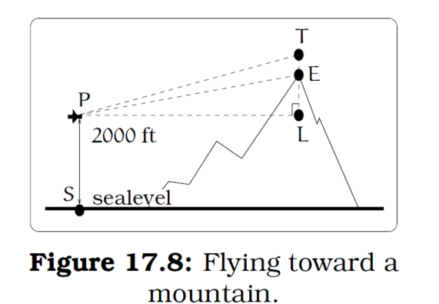A plane is flying 2000 feet above sea level toward a mountain. The pilot observes the top of the mountain to be 18o above the horizontal, then immediately flies the plane at an angle of 20o above horizontal. The airspeed of the plane is 100 mph. After 5 minutes, the plane is directly above the top of the mountain. How high is the plane above the top of the mountain (when it passes over)? What is the height of the mountain? [UW]
2. Three airplanes depart SeaTac Airport. A United flight is heading in a direction 50° counterclockwise from east, an Alaska flight is heading 115° counterclockwise from east and a Delta flight is heading 20° clockwise from east. [UW]
   1. Find the location of the United flight when it is 20 miles north of SeaTac.
   2. Find the location of the Alaska flight when it is 50 miles west of SeaTac.
   3. Find the location of the Delta flight when it is 30 miles east of SeaTac.

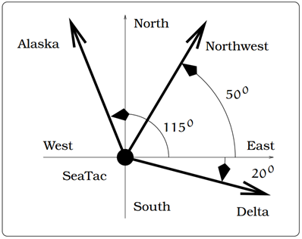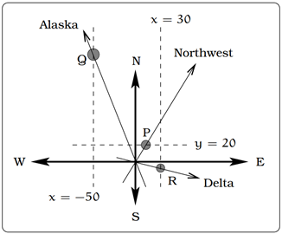

(a) The flight paths of three airplanes

(b) Modeling the paths of each flight

Alaska

United

Delta

Alaska

United

Delta

1. 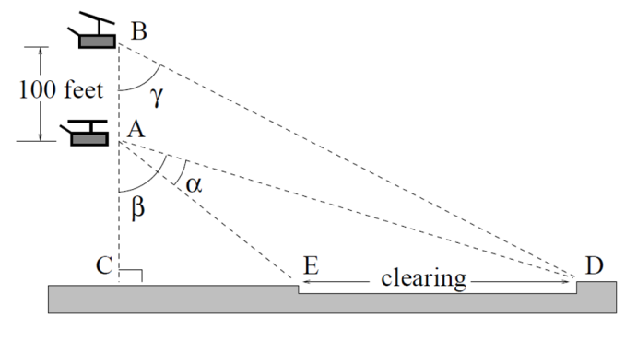The crew of a helicopter needs to land temporarily in a forest and spot a flat piece of ground (a clearing in the forest) as a potential landing site, but are uncertain whether it is wide enough. They make two measurements from A (see picture) finding α = 25° and β = 54°. They rise vertically 100 feet to B and measure γ = 47°. Determine the width of the clearing to the nearest foot. [UW]
2. 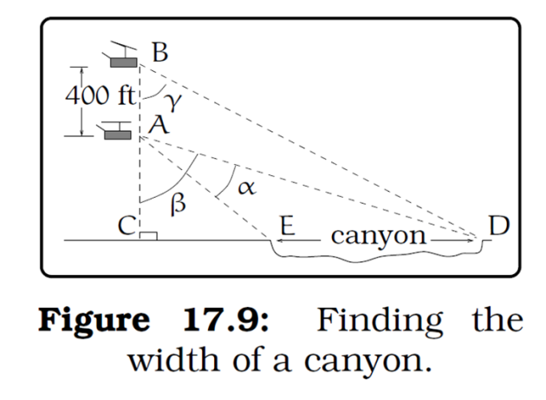A Forest Service helicopter needs to determine the width of a deep canyon. While hovering, they measure the angle γ = 48° at position B (see picture), then descend 400 feet to position A and make two measurements: *α* = 13° (the measure of EAD), *β* = 53° (the measure of CAD). Determine the width of the canyon to the nearest foot. [UW]

1. <http://commons.wikimedia.org/wiki/File:Pivot_otech_002.JPG> CC-BY-SA
2. <http://en.wikipedia.org/wiki/File:R%C3%B6mische_S%C3%A4gem%C3%BChle.svg> CC-BY