**2.1 Solutions to Exercises**  
1. 3.

5. Timmy will have the amount given by the linear equation .

7. From the equation, we see that the slope is , which is positive, so the function is increasing.

9. From the equation, we see that the slope is , which is negative, so the function is decreasing.

11. From the equation, we see that the slope is , which is negative, so the function is decreasing.

13. From the equation, we see that the slope is , which is positive, so the function is increasing.

15. From the equation, we see that the slope is , which is negative, so the function is decreasing.

17. . 19.

21. 23.

25.

27. . The negative rate means that the population is declining by approximately 400 people per year.

29. The rate is equal to the slope, which is 0.1. The initial value is the y-intercept, which is 24. This means that the phone company charges 0.1 dollars per minute, or 10 cents a minute, plus an additional fixed 24 dollars per month.

31. Terry starts skiing at 3000 feet, and skis downhill at a constant rate of 70 feet per second.

33. From this information we can extract two ordered pairs, . The slope between these two points is This gives us the formula To find the y-intercept we can substitute one of our ordered pairs into the equation for For example: . Solving for gives us So, the final equation is

35. The slope between these two points is This gives us the formula To find the y-intercept we can substitute one of our ordered pairs into the equation for For example: . Solving for gives us So, the final equation is

37. The slope between these two points is This gives us the formula To find the y-intercept we can substitute one of our ordered pairs into the equation for For example: . Solving for gives us So, the final equation is

39. The slope between these two points is We are given the y-intercept So, the final equation is

41. 43.

45. From this information we can extract two ordered pairs, . The slope between these two points is This gives us the formula To find the y-intercept we can substitute one of our ordered pairs into the equation for For example: . Solving for gives us So, the final equation is

47. (a) Linear, because is changing at a constant rate, and is also changing at a constant rate. The output is changing by -15, and the input is changing by 5. So, the rate of change is The y-intercept is given from the table as the ordered pair (0,5), so So, the final equation is

(b) Not linear, because is not increasing a constant rate.

(c) Linear, because is changing at a constant rate, and is also changing at a constant rate. The output is changing by 25, and the input is changing by 5. So, the rate of change is The y-intercept is given from the table as the ordered pair (0,-5), so So, the final equation is

(d) Not linear, because is not increasing a constant rate.

49. (a) From this information we can extract two points, (32,0) and (212,100) using F as the input and C as the output. The slope between these two points is This gives us the formula To find the y-intercept we can substitute one of our ordered pairs into the equation For example: . Solving for gives us So, the final equation is

(b) This can be done by solving the equation we found in part (a) for F instead of C. So, .

(c) To find C in Fahrenheit, we plug it into this equation for C and solve for F, giving us degrees F

**2.2 Solutions to Exercises**

1. E 3. D 5. B

7. 9.

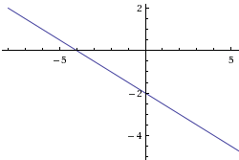 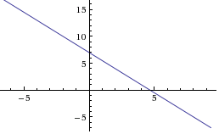

11. 13.

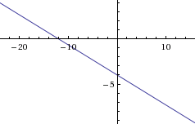 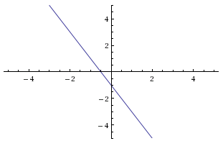

15. 17.

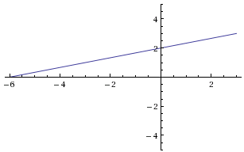 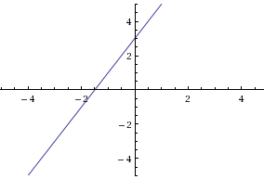

19. 21.

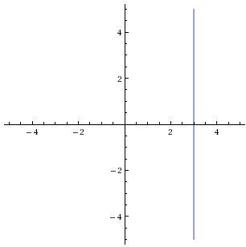 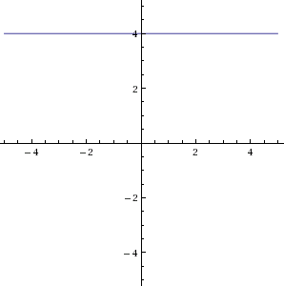

23. (a) Incorporating each transformation gives the function , which can be simplified as .

(b) From the point-slope form of the equation, we see that the slope is

(c) From the point-slope form of the equation, we see that the vertical intercept is

25. 27.

29. Horizontal intercept (when vertical intercept (when

31. Horizontal intercept (when vertical intercept (when

33. Horizontal intercept (when vertical intercept (when

35. Slope of line 1 , Slope of line 2 . They have the same slope, so they are parallel.

37. Slope of line 1 , Slope of line 2 . They are neither perpendicular or parallel.

39. Slope of line 1 , Slope of line 2 . The product of the two slopes is , so they are perpendicular.

41. A line parallel to the graph of will have the same slope as ; its slope is Then the equation has the form Plugging in the given point (2, 12), we get . Solving this equation, we get , so the desired equation is .

43. A line perpendicular to has a slope which is the opposite reciprocal of . So it’s equation has the form Plugging in the given point (-4,1) allows us to solve for which equals . So, the final equation is

45. At the point where the two lines intersect, they will have the same value, so we can set equal to each other. So, Solving for gives To find the So, the point that the two lines intersect is .

47. At the point where the two lines intersect, they will have the same value, so we can set equal to each other. So, Solving for gives To find the So, the point that the two lines intersect is .

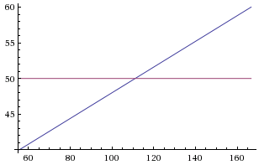49. Plan A can be modeled by the linear equation , and Plan B can be represented by the fixed equation As the graph shows, the cost of renting a car is cheaper with Plan A, until a certain point. This is the point of intersection, which can be found algebraically or graphically. This point is (111.11, 50) meaning that at around 111 miles,

it is cheaper to go with Plan B.

51.

53. (a)

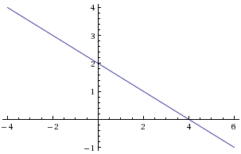

To find the point of intersection algebraically, we set the two lines equal to each other and solve for So, This gives us . Plugging this back into either equation gives the value . So the point of intersection is

(b) The -coordinate has the form , so we use to solve for So, . This gives us .

(c) For the point to lie on the -axis, . The -coordinate has the form , so we use to solve for . So, . This gives us .

**2.3 Solutions to Exercises**

1. (a) 696 (b) 4 years

(c) (d) 1001

(e) (f)

3. (a) From this information we can make two ordered pairs (410, 71.50) and (720,118). The slope between these two points is So, the equation of the line has the form To find , we can substitute either of the two points in for and and solve for For this equation, So, the final equation is   
 (b) The slope (0.15) is the price per minute of 15 cents, and the y-intercept is the flat monthly fee of ten dollars.  
 (c)

5. (a) From this information we can make two ordered pairs (1991, 4360) and (1999,5880). The slope between these two points is The slope represents population growth of moose per year. If we want the equation to represent population growth in years after 1990, we have to figure out the moose population in 1990, which will be the y-intercept. We can subtract 190 from the population in 1991 to get the population in 1990, So So, the final equation is   
 (b) 2003 is 13 years after 1990, so we will evaluate

7. (a) From this information we have an ordered pair (16,2010) and the slope of The slope is negative because the helium is being depleted. The slope represents the amount of helium being depleted each year. We want the equation to represent helium reserves in terms of the number of years since 2010, so the y-intercept will be helium amount in 2010, which is given to be 16. So, the final equation is   
 (b) 2015 is 5 years after 2010, so we will evaluate   
 (c) We want to know the value of when . So, we replace with and solve for

9. The two cell phone plans can be modeled by two linear equations: the first plan by , the second plan by When the two equations are equal to each other, the cost for that amount of minutes will be the same for both plans. To find that point, we can set the equations equal to each other and solve for So, This gives us So, if you use less than 133 minutes, the first plan is cheaper, if you use more than 133 minutes, the second plan is cheaper.

11. The two pay options can be modeled by two linear equations: the first by , the second by When the two equations are equal to each other, the income for that amount of sales will be the same for both options. To find that point, we can set the equations equal to each other and solve for So, This gives us So, if you sell less than $42,857 of jewelry, option A produces a larger income, if you sell more than $42,857 of jewelry, option B produces a larger income.

13. 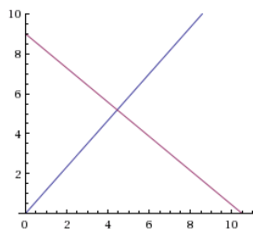It is useful to draw a picture for this problem (see below). The area of a triangle is found by We know that the base, but we don’t know the height( We do know, however, that the height of the triangle will be the value at the point where the two lines intersect. The equation for the line perpendicular to is because its slope will be the opposite reciprocal and it has a y-intercept at (0,0). To find the point where the two lines intersect, we can set them equal to each other and solve for This gives us , which is the height of the triangle. So, the Area =

15. The equation of the line parallel to  which passes through (2, 7) has equation  with , , and : .

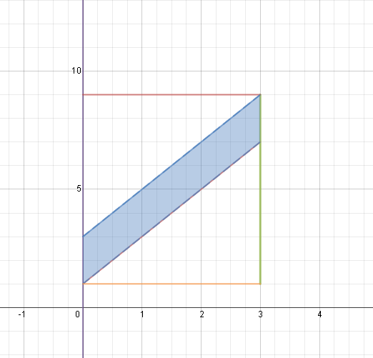

*y*



⦁



⦁





⦁

⦁



*x*

8

The area of the rectangle drawn around the

parallelogram is  square units.

3

3

The area of the upper triangle is

 square units.

6

The area of the lower triangle is

 square units.

6

3

Therefore, the area of the region shaded in blue in the original figure -- the area of the parallelogram bounded by the *y*-axis, the line , the line , and the line parallel to  passing through (2, 7) which has equation  -- is the area of the rectangle minus the area of the two triangles. So, the area of the parallelogram is  square units.

**Answer:** 6

Note: there are other ways to solve this problem, such as using the formula for the area of a rectangle: *A = bh*. Imagining turning the parallelogram so that the segment along the *y*-axis is the base. The solution would start the same way as the solution above to show that *b* = 2. Looking at the figure this way, the height to the top is 3, so we see that we get the same answer as above: *A = bh =* 2 ∙ 3 = 6.

17. The area of the triangle is . From the figure on the right we can see that the height is and the value of the -intercept of the line The -intercept is found by replacing with 0 and solving for This gives So, the area in terms of and is which can be simplified to .

19. (a) Mississippi home values increased at a rate of , and the Hawaii home values increased at a rate of So, Hawaii’s home values increased faster.

(b) 80,640

(c) We can model these two equations in the following way: and

where is the number of years after 2000. To find when house values are the same in both states, we can set the equations equal to each other and solve for This gives which would mean 66 years before 2000, so 1934.

21. We can think of these points on the coordinate plane as shown in the figure to the right. Pam will be closest to Paris when there is the shortest distance between her and Paris, which is when the dotted line is perpendicular to her path. We can find the equations of both lines, if we make her starting place R(0,0) and her ending place F(25,45). The equation for her path is , and the equation for the dotted line is perpendicular to her path, so it has a slope of and we know the point (30,0) lies on this line, so we can find the y-intercept to be The equation for the dotted line is Knowing these equations helps us to find the point where they intersect, by setting them equal to each other and solving for This point is (7.09, 12.76), which on the graph is rounded to (7,13). So, when she is at this point she is closest to Paris, and we can calculate this distance using the distance formula with points (7,13) and (30,0), which comes out to approximately 26.4 miles.

**2.4 Solutions to Exercises**

1.

3.

Regression line equation: .

Correlation coefficient: R=0.966954.

5.

Regression line equation: .

Correlation coefficient, R=-0.967988

7. With the equation of a line we are given and , let our regression line be, . Since our correlation coefficient is close to negative one we know that the regression line will be a relatively good fit for the data and thus will give us a good prediction. Since is thenumber of hours someone watches TV and is the amount of sit-ups someone can do we can plug in for in our equation to get the predicted amount of sit-ups that person can do. That is,

.

A person who watches hours of TV a day can do a predicted sit-ups.

9. Noticing that r is positive and close to one, we look for a scatter plot that is increasing and that has plotted points that are close to the line of regression. D.

11. Noticing that r is positive but that r is not close to one, we look for a scatter plot that is increasing and has points that are further away from the regression line. A.

13.

From graphing the data it is apparent that the trend appears linear. Finding the equation for the regression line with a computer we can calculate what year (if the trend continues) the percentage will exceed. That is, with equal to the year and equal to percentage of persons years or older who are college graduates. We can plug in , so ; adding to each side, . Then by dividing both sides by we arrive at . And so we can conclude that if the trend continues we will arrive at of college graduates being persons over years of age in the year .

**2.5 Solutions to Exercises**

1. 3.

5. 7.

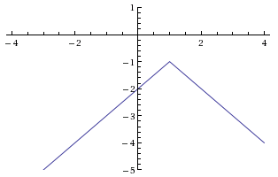 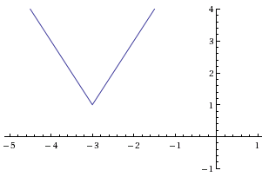

9.

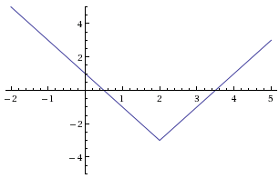

11. The only two numbers whose absolute value is 11 are -11 and 11, so:

or

or

or

13.

or

or

or

15.

or

or

17. Horizontal intercepts occur when giving the equation:

Then:

or   
 or so the horizontal intercepts are (4, 0) and (-6, 0).

Vertical intercepts occur when : . So the vertical intercept is (0, 8).

19. Horizontal intercepts occur when giving the equation:

Then: . The absolute value of a quantity cannot give a negative value, so this equation has no solutions; there are no horizontal intercepts.

Vertical intercepts occur when : . So the vertical intercept is (0, -7).

21. First, we solve the equation :

or

or

From here, either use test points in the regions , , and to determine which of these regions are solutions, or consider the graph of . Using the prior method, let’s test the points with *x*-coordinates -12, 0, and 2 (though you could use different numbers, as long as there’s one from each of the three regions above):

, which is greater than 6, and thus not a solution to the original inequality .

, which is less than 6, and thus a solution to .

, which is greater than 6, and thus not a solution to .

Since is the only one that gave a solution to the inequality, the region it represents, , is the solution set.

23. First, we solve the equation :

or

or

From here, either use test points in the regions , , and to determine which of these regions are solutions, or consider the graph of . Using the prior method, let’s test the points with *x*-coordinates -2, 0, and 6:

, which is greater than 3, and thus a solution to .

, which is less than 3, and thus not a solution to .

, which is greater than 3, and thus a solution to .

Since and gave solutions to the inequality, the regions it represents give us the full solution set: or .

25. First, we solve the equation :

or

or

From here, either use test points in the regions , , and to determine which of these regions are solutions, or consider the graph of . Using the prior method, let’s test the points with *x*-coordinates -5, -2, and 0:

, which is greater than 4, and thus not a solution to .

, which is less than 4, and thus a solution to .

, which is greater than 4, and thus not a solution to .

Since is the only one that gave a solution to the inequality, the region it represents, , is the solution set.