Section 9.1 Solutions
1. Center at (0,0). Equation has form $\frac{x^{2}}{b^{2}}+\frac{y^{2}}{a^{2}}=1$. Vertices at (0,±3) giving a=3 and minor axis endpoints at (±1,0) giving b=1. Substituting gives $\frac{x^{2}}{1^{2}}+\frac{y^{2}}{3^{2}}=1$. Answer is D.
3. Center at (0,0). Equation has form $\frac{x^{2}}{a^{2}}+\frac{y^{2}}{b^{2}}=1$. Vertices at (0, ±3) giving a=3 and minor axis endpoints at (±2,0) giving b = 2. Substituting gives $\frac{x^{2}}{3^{2}}+\frac{y^{2}}{2^{2}}=1$. Answer is B.
5. Center at (0,0). Major axis is vertical since y-denominator bigger. Equation has form $\frac{x^{2}}{b^{2}}+\frac{y^{2}}{a^{2}}=1$. Value of$a=\sqrt{25}=5$ and value of$b=\sqrt{4}=2$. Vertices at (0,0±a) or (0,±5) and minor axis endpoints (0±b,0) or ( ±2,0). Major axis length = 2a = 2(5)=10. Minor axis length = 2b = 2(2) =4. Graph is:
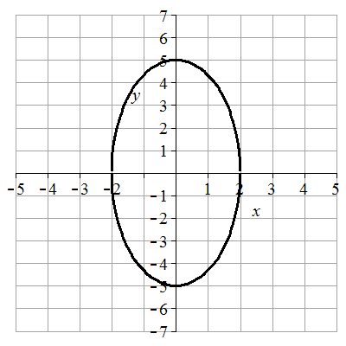
Check on graphing utility using $=5\sqrt{1-\frac{x^{2}}{4}}$ and $y=-5\sqrt{1-\frac{x^{2}}{4}}$.
7. Center at (0,0). Major axis is horizontal since x-denominator bigger. Equation has form $\frac{x^{2}}{a^{2}}+\frac{y^{2}}{b^{2}}=1$. Value of $a=\sqrt{4}=2$ and value of $b=\sqrt{1}=1$. Vertices at (0±a,0) or ( ±2,0) minor axis endpoints at (0,0±b) or (0,±1). Major axis length = 2a = 2(2)=4. Minor axis length = 2b = 2(1) =2. Graph is:
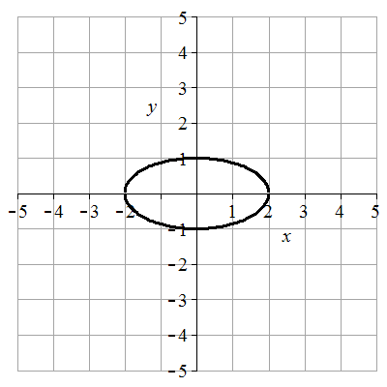
Check on graphing utility using $=\sqrt{1-\frac{x^{2}}{4}}$ and $y=-\sqrt{1-\frac{x^{2}}{4}}$.
9. Equation can be put in form $\frac{x^{2}}{25}+\frac{y^{2}}{1}=1$ by dividing by 25. Major axis is horizontal since x-denominator bigger. Equation has form $\frac{x^{2}}{b^{2}}+\frac{y^{2}}{a^{2}}=1$. Center at (0,0). Value of $a=\sqrt{25}=5$ and value of $b=\sqrt{1}=1$. Vertices at (0±a,0) or ( ±5,0) and minor axis endpoints at and (0,0±b) or (0,±1). Major axis length = 2a = 2(5)=10. Minor axis length = 2b = 2(1) =2. Graph is:

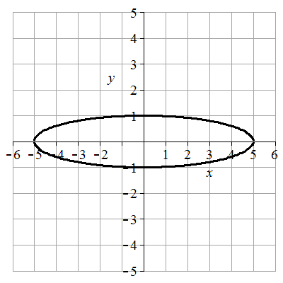
Check on graphing utility using $=\sqrt{1-\frac{x^{2}}{9}}$ and $y=-\sqrt{1-\frac{x^{2}}{9}}$.
11. Equation can be put in form $\frac{x^{2}}{9}+\frac{y^{2}}{16}=1$ by dividing by 144. Center at (0,0). Major axis is vertical since y-denominator bigger. Equation has form $\frac{x^{2}}{b^{2}}+\frac{y^{2}}{a^{2}}=1$. Value of $a=\sqrt{16}=4$ and value of $b=\sqrt{9}=3$. Vertices at (0,0±a) or (0,±4) and minor axis endpoints at (0±a,0) or (±3,0). Major axis length = 2a = 2(4)=8. Minor axis length = 2b = 2(3) =6. Graph is:
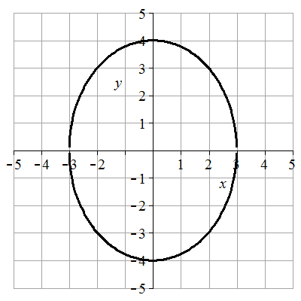
Check on graphing utility using $=4\sqrt{1-\frac{x^{2}}{9}}$ and $y=-4\sqrt{1-\frac{x^{2}}{9}}$.
13. Equation can be put in form $\frac{x^{2}}{2}+\frac{y^{2}}{18}=1$ by dividing by 18. Center at (0,0). Major axis is vertical since y-denominator bigger. Equation has form $\frac{x^{2}}{b^{2}}+\frac{y^{2}}{a^{2}}=1$. Value of $a=\sqrt{18}=3\sqrt{2}$. and value of $b=\sqrt{2}$. Vertices at (0,0±a) or $(0,±3\sqrt{2})$ and minor axis endpoints at (0±b,0) or $(±\sqrt{2},0)$. Major axis length =$2a=2\left(3\sqrt{2}\right)=6\sqrt{2}$. Minor axis length =$2b=2\left(\sqrt{2}\right)=2\sqrt{2}$. Graph is:
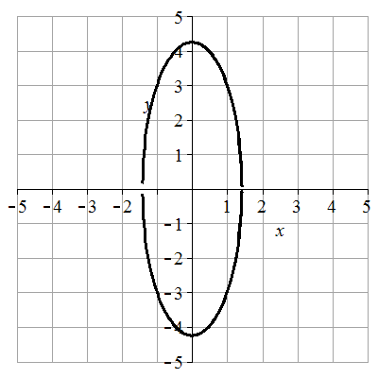
Check on graphing utility using $=3\sqrt{2}\sqrt{1-\frac{x^{2}}{2}}$ and $y=-3\sqrt{2}\sqrt{1-\frac{x^{2}}{2}}$.
15. Center at (0,0) where the major and minor axes intersect. Horizontal ellipse since it’s wider than it is tall. Equation has form $\frac{x^{2}}{a^{2}}+\frac{y^{2}}{b^{2}}=1$. Vertices (±4,0) giving a=4. Minor axis endpoints at (0,±2) giving b=2. Substituting gives $\frac{x^{2}}{4^{2}}+\frac{y^{2}}{2^{2}}=1$ or $\frac{x^{2}}{16}+\frac{y^{2}}{4}=1$.
17. Center at (0,0). Equation has form $\frac{x^{2}}{a^{2}}+\frac{y^{2}}{b^{2}}=1$. Horizontal major axis has length 2a = 64 giving a = 32. Minor axis has length 2b = 14 giving b = 7. Substituting gives $\frac{x^{2}}{{32}^{2}}+\frac{y^{2}}{7^{2}}=1$ or $\frac{x^{2}}{1024}+\frac{y^{2}}{49}=1$.
19. Center at (0,0). Vertical ellipse since vertex on y-axis. Equation has form $\frac{x^{2}}{b^{2}}+\frac{y^{2}}{a^{2}}=1$. Vertex at (0,3)=(0,a) shows a = 3. Substituting a and b = 2 gives $\frac{x^{2}}{2^{2}}+\frac{y^{2}}{3^{2}}=1$ or $\frac{x^{2}}{4}+\frac{y^{2}}{9}=1$.
21. Vertical ellipse since it’s taller than it is wide. Equation has form $\frac{{(x-h)}^{2}}{b^{2}}+\frac{{(y-k)}^{2}}{a^{2}}=1$. Center at (2,1) where the major and minor axes intersect so h=2 and k=1. Vertex at (5,1) shows a = 5-1=4. Minor axis endpoint at (4,1) shows b =4-2=2. Substituting gives $\frac{{(x-2)}^{2}}{2^{2}}+\frac{{(y-1)}^{2}}{4^{2}}=1$ or $\frac{{(x-2)}^{2}}{4}+\frac{{(y-1)}^{2}}{16}=1$. Answer is B.
23. Horizontal ellipse since it’s wider than it is tall. Equation has form $\frac{{(x-h)}^{2}}{a^{2}}+\frac{{(y-k)}^{2}}{b^{2}}=1$. Center at (2,1) where the major and minor axes intersect so h=2 and k=1. Vertex at (6,1) shows a =6-2=4. Minor axis endpoint at (2,3) shows b = 3-1=2. Substituting gives $\frac{{(x-2)}^{2}}{4^{2}}+\frac{{(y-1)}^{2}}{2^{2}}=1$ or $\frac{{(x-2)}^{2}}{16}+\frac{{(y-1)}^{2}}{4}=1$. Answer is C.
25. Vertical ellipse since it’s taller than it is wide. Equation has form $\frac{{(x-h)}^{2}}{b^{2}}+\frac{{(y-k)}^{2}}{a^{2}}=1$. Center at (-2,-1) where the major and minor axes intersect so h=-2 and k=-1. Vertex at (-2,-3) shows a = 3-(-1)=4. Minor axis endpoint at (0,-1) shows a =0-(-2)=2. Substituting gives $\frac{{(x+2)}^{2}}{2^{2}}+\frac{{(y+1)}^{2}}{4^{2}}=1$ or $\frac{{(x+2)}^{2}}{4}+\frac{{(y+1)}^{2}}{16}=1$. Answer is F.
27. Horizontal ellipse since it’s wider than it is tall. Equation has form $\frac{{(x-h)}^{2}}{a^{2}}+\frac{{(y-k)}^{2}}{b^{2}}=1$. Center at (-2,-1) where the major and minor axes intersect so h=-2 and k=-1. Vertex at (2,-1) shows a =2-(-2)=4. Minor axis endpoint at (-2,1) shows b = 1-(-1)=2. Substituting gives $\frac{{(x+2)}^{2}}{4^{2}}+\frac{{(y+1)}^{2}}{2^{2}}=1$ or $\frac{{(x+2)}^{2}}{16}+\frac{{(y+1)}^{2}}{4}=1$. Answer is G.
29. Equation can be put into the form $\frac{{(x-1)}^{2}}{25}+\frac{{(y-(-2))}^{2}}{4}=1$ showing center at (1,-2). Major axis is horizontal since x-denominator bigger. Value of $a=\sqrt{25}=5$ and value of $b=\sqrt{4}=2$. Vertices are (h±a) giving (6,-2) and (-4,-2). Minor axis endpoints are (h,k±b) giving (1,0) and (1,-4). Major axis length = 2a = 2(5)=10. Minor axis length = 2b = 2(2) = 4. The graph is:
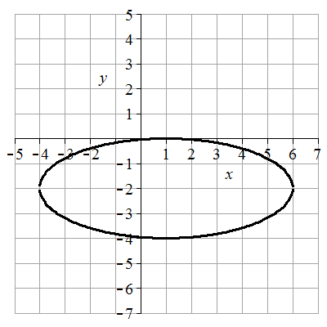
Check on graphing utility using $=2\sqrt{1-\frac{{(x-1)}^{2}}{25}}+(-2)$ and $y=-2\sqrt{1-\frac{{\left(x-1\right)}^{2}}{25}}+(-2)$.
31. Equation can be put into the form $\frac{{(x-(-2))}^{2}}{1}+\frac{{(y-3)}^{2}}{25}=1$ showing center at (-2,3). Major axis is vertical since y-denominator bigger. Value of $a=\sqrt{25}=5$ and value of $b=\sqrt{1}=1$. Vertices (h,k±a) giving (-2,8) and (-2,-2). Minor axis endpoint are (h±a) giving (-1,3) and (-3,3). Major axis length = 2b = 2(5)=10. Minor axis length = 2a = 2(1) = 2. The graph is:
Check on graphing utility using $=5\sqrt{1-{\left(x+2\right)}^{2}}+(-3)$ and $y=-5\sqrt{1-{\left(x+2\right)}^{2}}+(-3)$.
33. $4x^{2}+8x+4+y^{2}=16$ can be transformed into $4{(x}^{2}+2x+1)+y^{2}=16$ giving $4{\left(x+1\right)}^{2}+y^{2}=16$ or $\frac{{\left(x-(-1)\right)}^{2}}{4}+\frac{{(y-0)}^{2}}{16}=1$. Center at (-1,0). Major axis is vertical since y-denominator bigger. Value of $a=\sqrt{16}=4$ and value of $b=\sqrt{4}=2$. Vertices at (h,k±a) giving (-1,4), (-1,-4). Minor axis endpoints at (h±b,k) giving (-1,0) and (-3,0). Major axis length = 2b = 2(4)=8. Minor axis length = 2a = 2(2) = 4. The graph is:
Check on graphing utility using $=4\sqrt{1-\frac{{\left(x+1\right)}^{2}}{4}}$ and $y=-4\sqrt{1-\frac{{\left(x+1\right)}^{2}}{4}}$.
35. $x^{2}+2x+4y^{2}-16y=-1$ can be transformed into $x^{2}+2x+1+4\left(y^{2}-4y+4\right)=-1+1+16$ giving ${\left(x+1\right)}^{2}+{4\left(y-2\right)}^{2}=16$ which becomes $\frac{{\left(x-(-1)\right)}^{2}}{16}+\frac{{(y-2)}^{2}}{4}=1$. Center at (-1,2). Major axis is horizontal since x-denominator bigger. Value of $a=\sqrt{16}=4$ and value of $b=\sqrt{4}=2$. Vertices are (h±a) giving (3,-2) and (-5,-2). Minor axis endpoints at (h,k±b) giving (-1,0) and (-1,-4). Major axis length = 2a = 2(4)=8. Minor axis length = 2b = 2(2) = 4. The graph is:
Check on graphing utility using $=2\sqrt{1-\frac{{\left(x+1\right)}^{2}}{16}}+2$ and $y=-2\sqrt{1-\frac{{\left(x+1\right)}^{2}}{16}}+2$.
37. $9x^{2}-36x+4y^{2}+8y=104$ can be transformed into $9{(x}^{2}-4x+4-4)+{4(y}^{2}+2y+1-1)=104$ giving $9{\left(x-2\right)}^{2}-36+{4\left(y+1\right)}^{2}-4=104$ or $\frac{{\left(x-2\right)}^{2}}{16}+\frac{{(y-(-1))}^{2}}{36}=1$. Center at (2,-1). Major axis is vertical since y-denominator bigger. Value of$a=\sqrt{36}=6$ and value of $b=\sqrt{16}=4$. Vertices (h,k±a) giving (2,5) and (2,-7). Minor axis endpoints at (h±b, k) giving (6,-1) and (-2,-1). Major axis length = 2b = 2(6)=12. Minor axis length = 2a = 2(4) = 8. The graph is:
Check on graphing utility using $y=6\sqrt{1-\frac{{\left(x-2\right)}^{2}}{16}}+(-1)$ and $y=-6\sqrt{1-\frac{{\left(x-2\right)}^{2}}{16}}+(-1)$.
39. Vertical ellipse since it’s taller than it is wide. Equation has form $\frac{{(x-h)}^{2}}{b^{2}}+\frac{{(y-k)}^{2}}{a^{2}}=1$ . Center at (3,-1) where the major and minor axes intersect so h=3 and k=-1. Vertex at (3,3) shows a = 3-(-1)=4. Minor axis endpoint at (4,-1) shows b =4-3=1. Substituting gives $\frac{{(x-3)}^{2}}{1^{2}}+\frac{{(y+1)}^{2}}{4^{2}}=1$ or ${\left(x-3\right)}^{2}+\frac{{(y+1)}^{2}}{16}=1$.
41. Center at (-4,3) and at vertex (-4,8) means major axis is vertical since the y-values change. Equation has form $\frac{{(x-h)}^{2}}{b^{2}}+\frac{{(y-k)}^{2}}{a^{2}}=1$ . The value of a = 8-3=5. Substituting h=-4, k=3, and a gives $\frac{{(x+4)}^{2}}{b^{2}}+\frac{{(y-3)}^{2}}{5^{2}}=1$. Using the point (0,3) to substituting x=0 and y=3 gives $\frac{{(0+4)}^{2}}{b^{2}}+\frac{{(3-3)}^{2}}{25}=1$ which shows $b^{2}=16$. The equation is $\frac{{(x+4)}^{2}}{16}+\frac{{(y-3)}^{2}}{25}=1$
43. Put center at (0,0). Horizontal ellipse since width is horizontal and is bigger than the height. Equation has form $\frac{x^{2}}{a^{2}}+\frac{y^{2}}{b^{2}}=1$.
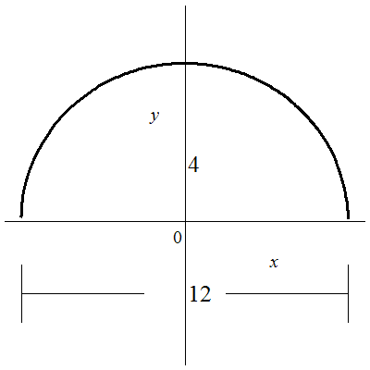
The value of a = ½ (12) = 6. The value of b = 4. Substituting a, b, and x = 5 gives $\frac{5^{2}}{6^{2}}+\frac{y^{2}}{4^{2}}=1$. Solving for $y=4\sqrt{1-\frac{25}{36}}=2.211083$.
45. Put center at (0,0). Horizontal ellipse since width is horizontal and is bigger than the height. Equation has form $\frac{x^{2}}{a^{2}}+\frac{y^{2}}{b^{2}}=1$.
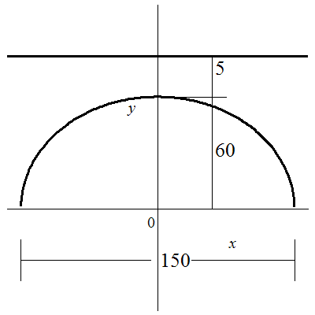
The value of a = ½ (150) = 75. The value of b = 60. Substituting a, b, and x = 45 gives $\frac{{45}^{2}}{{75}^{2}}+\frac{y^{2}}{{60}^{2}}=1$. Solving for $y=60\sqrt{1-\frac{2025}{5625}}=48$. The roadway is 60 + 5 = 65 feet above the river. The vertical distance between the roadway and the arch 45 feet from the center is 65 - 48 = 17 feet
47. Put center at (0,0). Make major axis horizontal. Equation has form $\frac{x^{2}}{a^{2}}+\frac{y^{2}}{b^{2}}=1$
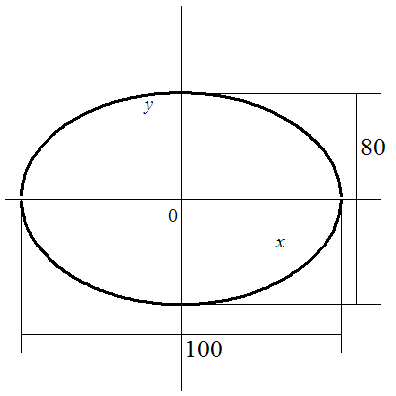
The value of a = ½ (100) = 50. The value of b = ½ (80) = 40. We want to find the width of the track 20 feet from a vertex on the major axis which lies at 50-20 = 30 feet from the center on the major axis. Substituting a, b, and x = 30 gives $\frac{{30}^{2}}{{50}^{2}}+\frac{y^{2}}{{40}^{2}}=1$. Solving for $y=40\sqrt{1-\frac{900}{1600}}=32$. The width of the track 20 feet from a vertex on the major axis is 2(32) = 64 feet.
49. Since 19 > 3 the major axis is horizontal. The value of $a^{2}=19$and $b^{2}=3$. The distance to the foci c is governed by $b^{2}=a^{2}-c^{2}$ which is equivalent to $c^{2}=a^{2}-b^{2}$ . Substituting $a^{2}$ and $b^{2}$ shows $c^{2}=19-3=16$ so c = 4. The foci are at (±c,0) or (±4,0).
51. Since 26 > 1 the major axis is vertical. The value of h=-6, k=1, $a^{2}=26$, and $b^{2}=1$. The distance to the foci c is governed by $b^{2}=a^{2}-c^{2}$ which is equivalent to $c^{2}=a^{2}-b^{2}$ . Substituting $a^{2}$ and $b^{2}$ shows $c^{2}=26-1=25$ so c = 5. The foci are at (h,k±c) or (-6,6) and (-6,-4).
53. Center at midpoint of vertices $\left(\frac{x_{1}+x_{2}}{2},\frac{y_{1}+y_{2}}{2}\right)=\left(\frac{3+(-3)}{2},\frac{0+0}{2}\right)=(0,0)$. Major axis is horizontal since vertices x-values change. Equation has form $\frac{x^{2}}{a^{2}}+\frac{y^{2}}{b^{2}}=1$. The value of a = 3-0 = 3. Substitution of a and c = 2 into $b^{2}=a^{2}-c^{2}$ which is equivalent to $c^{2}=a^{2}-b^{2}$ yields $c^{2}=3^{2}-2^{2}=5$. Equation is $\frac{x^{2}}{9}+\frac{y^{2}}{5}=1$.
55. Center at midpoint of foci $\left(\frac{x_{1}+x_{2}}{2},\frac{y_{1}+y_{2}}{2}\right)=\left(\frac{0+0}{2},\frac{5+(-5)}{2}\right)=(0,0)$. Major axis is vertical since vertices y-values change. Equation has form $\frac{x^{2}}{b^{2}}+\frac{y^{2}}{a^{2}}=1$. The value of a = ½(12) = 6. The value of c = 5-0 = 5. Substitution of a and c into $b^{2}=a^{2}-c^{2}$ yields $b^{2}=6^{2}-5^{2}=11$. Equation is $\frac{x^{2}}{11}+\frac{y^{2}}{36}=1$.
57. Center at midpoint of vertices $\left(\frac{x_{1}+x_{2}}{2},\frac{y_{1}+y_{2}}{2}\right)=\left(\frac{7+(-7)}{2},\frac{0+0}{2}\right)=(0,0)$. Major axis is horizontal since vertices x-values change. Equation has form $\frac{x^{2}}{a^{2}}+\frac{y^{2}}{b^{2}}=1$. The value of a = 7-0 = 7. The value of c = 5-0 = 5. Substitution of a and c into $b^{2}=a^{2}-c^{2}$ yields $b^{2}=7^{2}-5^{2}=24$. Equation is $\frac{x^{2}}{49}+\frac{y^{2}}{24}=1$.
59. Center at midpoint of foci $\left(\frac{x_{1}+x_{2}}{2},\frac{y_{1}+y_{2}}{2}\right)=\left(\frac{0+0}{2},\frac{4+(-4)}{2}\right)=(0,0)$. Major axis is vertical since vertices y-values change. Equation has form $\frac{x^{2}}{b^{2}}+\frac{y^{2}}{a^{2}}=1$. Center at origin makes x-intercepts minor axis endpoints. The value of b = 2-0 = 2. The value of c = 4-0 = 4. Substitution of b and c into $b^{2}=a^{2}-c^{2}$ which is equivalent to $a^{2}=b^{2}+c^{2}$ yields $a^{2}=2^{2}+4^{2}=20$. Equation is $\frac{x^{2}}{4}+\frac{y^{2}}{20}=1$.
61. Foci on x-axis means major axis is horizontal. Equation has form $\frac{x^{2}}{a^{2}}+\frac{y^{2}}{b^{2}}=1$. The value of a = ½ (8) = 4. Substitution of a and $(2,\sqrt{6})$ gives $\frac{2^{2}}{4^{2}}+\frac{{\left(\sqrt{3}\right)}^{2}}{b^{2}}=1$. Solving for $b^{2}=8$. The equation is $\frac{x^{2}}{16}+\frac{y^{2}}{8}=1$.
63. Center (-2,1), vertex (-2,5), and focus (-2,3) on vertical line x = -2. Major axis is vertical. Equation has form $\frac{{(x-h)}^{2}}{b^{2}}+\frac{{(y-k)}^{2}}{a^{2}}=1$. The value of a = 5 – 1 = 4. The value of c = 3-1 = 2. Substitution of a and c into $b^{2}=a^{2}-c^{2}$ yields $b^{2}=4^{2}-2^{2}=12$. The equation is $\frac{{(x+2)}^{2}}{12}+\frac{{\left(y-1\right)}^{2}}{16}=1$.
65. Foci (8,2) and (-2,2) on horizontal line y =2. Major axis is horizontal. Equation has form $\frac{{\left(x-h\right)}^{2}}{a^{2}}+\frac{{(y-k)}^{2}}{b^{2}}=1$. Center at midpoint of foci $\left(\frac{x_{1}+x_{2}}{2},\frac{y_{1}+y_{2}}{2}\right)=\left(\frac{8+(-2)}{2},\frac{2+2}{2}\right)=(3,2)$. The value of a = ½ (12) = 6. The value of c = 8 – 3 = 5. Substitution of a and c into $b^{2}=a^{2}-c^{2}$ yields $b^{2}=6^{2}-5^{2}=11$. The equation is $\frac{{(x-3)}^{2}}{36}+\frac{{\left(y-2\right)}^{2}}{11}=1$.
67. Major axis vertices (3,4) and (3,-6) on vertical line y = 3. Major axis is vertical. Equation has form $\frac{{\left(x-h\right)}^{2}}{b^{2}}+\frac{{(y-k)}^{2}}{a^{2}}=1$. Center at midpoint of vertices $\left(\frac{x_{1}+x_{2}}{2},\frac{y_{1}+y_{2}}{2}\right)=\left(\frac{3+3}{2},\frac{4+(-6)}{2}\right)=(3,-1)$. The value of a = 4-(-1) = 5. Substitution of a and c = 2 into $b^{2}=a^{2}-c^{2}$ yields $b^{2}=5^{2}-2^{2}=11$. The equation is $\frac{{(x-3)}^{2}}{21}+\frac{{\left(y+1\right)}^{2}}{25}=1$.
69. Center (1,3) and focus (0,3) on horizontal line y = 3. Major axis is horizontal. Equation has form $\frac{{\left(x-h\right)}^{2}}{a^{2}}+\frac{{(y-k)}^{2}}{b^{2}}=1$. The value of $c=\left|0-1\right|=1$. Point (1,5) lies on minor axis making it a minor axis endpoint. The value of b = 5-3 = 2. Substitution of b and c into $b^{2}=a^{2}-c^{2}$ which is equivalent to $a^{2}=b^{2}+c^{2}$ yields $a^{2}=2^{2}+1^{2}=5$. The equation is $\frac{{(x-1)}^{2}}{5}+\frac{{\left(y-3\right)}^{2}}{4}=1$.
71. Focus (-15,-1) and vertices (-19,-1) and (15,-1) lie on horizontal line y = -1. Major axis is horizontal. Equation has form $\frac{{\left(x-h\right)}^{2}}{a^{2}}+\frac{{(y-k)}^{2}}{b^{2}}=1$. Center at midpoint of vertices $\left(\frac{x_{1}+x_{2}}{2},\frac{y_{1}+y_{2}}{2}\right)=\left(\frac{-19+15}{2},\frac{-1+(-1)}{2}\right)=(-2,-1)$. The value of a = 15-(-2) = 17. The value of $c=\left|-15-(-2)\right|=13$. Substitution of a and c into $b^{2}=a^{2}-c^{2}$ yeilds $b^{2}={17}^{2}-{13}^{2}=120$. The equation is $\frac{{(x+2)}^{2}}{289}+\frac{{\left(y+1\right)}^{2}}{120}=1$.
73. The major axis length is $2a=80$ giving $a=40$. Substitution of a and b = 25 into $b^{2}=a^{2}-c^{2}$ which is equivalent to $c^{2}=a^{2}-b^{2}$ yields $c^{2}={40}^{2}-{25}^{2}$ and $c=\sqrt{975}=31.224…≈31.22$ feet.
75. Let the center be (0,0) and the major axis be horizontal. Equation has form $\frac{x^{2}}{a^{2}}+\frac{y^{2}}{b^{2}}=1$. The length of the major axis is the sum of the aphelion and perihelion $94.51+91.40=185.91=2a$ giving $a=92.955$. The distance between the foci is the major axis length less twice the perihelion $185.9-2\left(91.40\right)=3.11=2c$ giving $a=1.555$. Substitution of a and c into $b^{2}=a^{2}-c^{2}$ yields $b^{2}={92.955}^{2}-{1.555}^{2}=$ $8638.241$. The equation is $\frac{x^{2}}{8640.632025}+\frac{y^{2}}{8638.214}=1$.
77. Center at midpoint of foci $\left(\frac{x_{1}+x_{2}}{2},\frac{y_{1}+y_{2}}{2}\right)=\left(\frac{4+\left(-4\right)}{2},\frac{0+0}{2}\right)=(0,0)$. Major axis vertices (-4,0) and (4,0) on x-axis. Major axis is horizontal. Equation has form $\frac{x^{2}}{a^{2}}+\frac{y^{2}}{b^{2}}=1$. The eccentricity $e$ is the ratio $=\frac{c}{a}$ . Substituting $e=0.8$ and c= 4 gives $0.8=\frac{4}{a}$. The value of a = 5. Substitution of a and c into $b^{2}=a^{2}-c^{2}$ yields $b^{2}=5^{2}-4^{2}=9$. The equation is $\frac{x^{2}}{5^{2}}+\frac{y^{2}}{9}=1$ or $\frac{x^{2}}{25}+\frac{y^{2}}{9}=1$
79. The center is at (0,0). Since a > b, the ellipse is horizontal. Let (c,0) be the focus on the positive x-axis. Let (c, h) be the endpoint in Quadrant 1 of the latus rectum passing through (c,0).
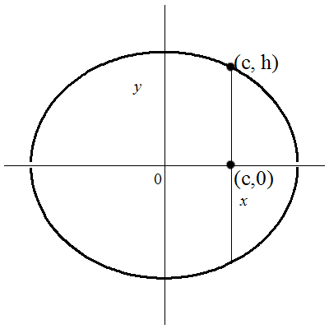
The distance between the focus and latus rectum endpoint can be found by substituting (c,0) and (c,h) into the distance formula $d=\sqrt{{\left(x_{1}-x_{2}\right)}^{2}+{\left(y_{1}-y_{2}\right)}^{2}}$ which yields $d=\sqrt{{\left(c-c\right)}^{2}+{\left(h-0\right)}^{2}}=h$. So h is half the latus rectum distance. Substituting (c,h) into the ellipse equation to find h gives $\frac{c^{2}}{a^{2}}+\frac{h^{2}}{b^{2}}=1$. Solving for h yields $h^{2}=b^{2}\left(1-\frac{c^{2}}{a^{2}}\right)= b^{2}\left(\frac{a^{2}}{a^{2}}-\frac{c^{2}}{a^{2}}\right)=b^{2}\left(\frac{a^{2}-c^{2}}{a^{2}}\right)=b^{2}\left(\frac{b^{2}}{a^{2}}\right)=\frac{b^{4}}{a^{2}}$ so $h=\sqrt{\frac{b^{4}}{a^{2}}}=\frac{b^{2}}{a}$. The distance of the latus rectum is $2h=\frac{{2b}^{2}}{a}$.
Section 9.2 Solutions
1. Horizontal hyperbola. Equation has form $\frac{x^{2}}{a^{2}}-\frac{y^{2}}{b^{2}}=1$ so A or B. Center at (0,0). Vertex at (0,3). Value of a =3-0=3 making $a^{2}=9$. Answer is B.
3. Vertical hyperbola. Equation has form $\frac{y^{2}}{a^{2}}-\frac{x^{2}}{b^{2}}=1$ so C or D. Center at (0,0). Vertex at (0,3). Value of a=3-0 =3 making $a^{2}=9$. Answer is D.
5. Equation has form $\frac{x^{2}}{a^{2}}-\frac{y^{2}}{b^{2}}=1$ so vertices at (±a,0). Value of $a=\sqrt{4}=2$. Vertices are (±2, 0) and transverse axis length is $2a=2\left(2\right)=4$. Asymptotes are $y=±\frac{b}{a}x$. Value of $b=\sqrt{25}=5$. Asymptotes are $y=±\frac{5}{2}x$. Graph is:
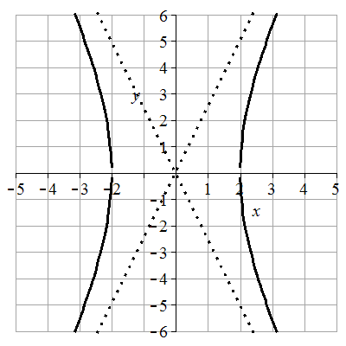
Check on graphing utility using $=5\sqrt{\frac{x^{2}}{4}-1}$ ,$y=-5\sqrt{\frac{x^{2}}{4}-1}$,$y=\frac{5}{2}x$, and $y=-\frac{5}{2}x$.
7. Equation has form $\frac{y^{2}}{a^{2}}-\frac{x^{2}}{b^{2}}=1$ so vertices at (0,±a). Value of $a=\sqrt{1}=1$. Vertices are (0,±1) and transverse axis length is $2a=2\left(1\right)=2$. Asymptotes are $y=±\frac{a}{b}x$. Value of $b=\sqrt{4}=2$. Asymptotes are $y=±\frac{1}{2}x$. Graph is:
Check on graphing utility using $=1\sqrt{\frac{x^{2}}{4}+1}$ ,$y=-1\sqrt{\frac{x^{2}}{4}+1}$,$y=\frac{1}{2}x$, and $y=-\frac{1}{2}x$.
9. Equation can be put in form $\frac{x^{2}}{9}-\frac{y^{2}}{1}=1$ by dividing by 9. Equation has form $\frac{x^{2}}{a^{2}}-\frac{y^{2}}{b^{2}}=1$ so vertices at (±a,0). Value of $a=\sqrt{9}=3$. Vertices are (±3,0) and transverse axis length is $2a=2\left(3\right)=6$. Asymptotes are $y=±\frac{b}{a}x$. Value of $b=\sqrt{1}=2$. Asymptotes are $y=±\frac{1}{3}$. Graph is:
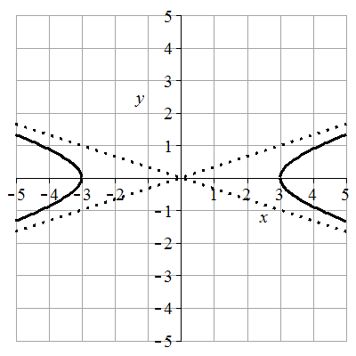
Check on graphing utility using $=1\sqrt{\frac{x^{2}}{9}-1}$ ,$y=-1\sqrt{\frac{x^{2}}{9}-1}$,$y=\frac{1}{3}x$, and $y=-\frac{1}{3}x$.
11. Equation can be put in form $\frac{y^{2}}{16}-\frac{x^{2}}{9}=1$ by dividing by 144. Equation has form $\frac{y^{2}}{a^{2}}-\frac{x^{2}}{b^{2}}=1$ so vertices at (0,±a). Value of $a=\sqrt{16}=4$. Vertices are (0,±4) and transverse axis length is $2a=2\left(4\right)=8$. Asymptotes are $y=±\frac{a}{b}x$. Value of $b=\sqrt{9}=3$. Asymptotes are $y=±\frac{4}{3}$. Graph is:
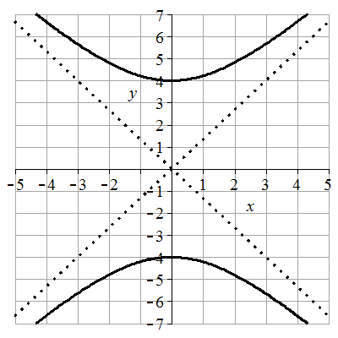
Check on graphing utility using $=4\sqrt{\frac{x^{2}}{9}+1}$ ,$y=-4\sqrt{\frac{x^{2}}{9}+1}$,$y=\frac{4}{3}x$, and $y=-\frac{4}{3}x$.
13. Equation can be put in form $\frac{x^{2}}{2}-\frac{y^{2}}{18}=1$ by dividing by 18. Equation has form $\frac{x^{2}}{a^{2}}-\frac{y^{2}}{b^{2}}=1$ so vertices at (±a,0). Value of $a=\sqrt{2}$. Vertices are $(±\sqrt{2},0)$ and transverse axis length is $2a=2\left(\sqrt{2}\right)=2\sqrt{2}$. Asymptotes are $y=±\frac{b}{a}x$. Value of $b=\sqrt{18}=3\sqrt{2}$. Asymptotes are $y=±\frac{3\sqrt{2}}{\sqrt{2}}x$ or $y=±3x$. Graph is:
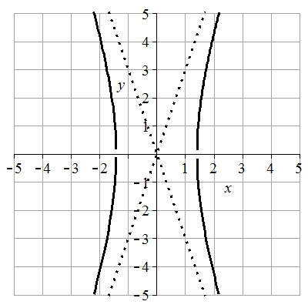
Check on graphing utility using $=\sqrt{18\left(\frac{x^{2}}{2}-1\right)}$ ,$y=-\sqrt{18\left(\frac{x^{2}}{2}-1\right)}$,$y=3x$, and $y=-3x$.
15. Hyperbola opens vertically. Equation has form $\frac{y^{2}}{a^{2}}-\frac{x^{2}}{b^{2}}=1$. Center at (0,0). Vertices at (0,±2). Value of a=2-0 =2. Points (0,0) and (3,2) on asymptote show $m=\frac{2-0}{3-0}=\frac{2}{3}$ . Asymptote equation has form $=±\frac{a}{b}x$ . Setting $\frac{a}{b}=\frac{2}{3}$ and substituting a gives $\frac{2}{b}=\frac{2}{3}$ showing b=3. Equation is $\frac{y^{2}}{2^{2}}-\frac{x^{2}}{3^{2}}=1$ or $\frac{y^{2}}{4}-\frac{x^{2}}{9}=1$.
17. Center at (0,0). Vertical hyperbola since vertices (0,±4) on y-axis . Equation has form $\frac{y^{2}}{a^{2}}-\frac{x^{2}}{b^{2}}=1$. Value of a= 4-0=4. Asymptote has slope ½. Asymptote equation has form $y=±\frac{a}{b}x$. Setting $\frac{a}{b}=\frac{1}{2}$ and substituting a gives $\frac{4}{b}=\frac{1}{2}$ showing b=8. Equation is $\frac{y^{2}}{4^{2}}-\frac{x^{2}}{8^{2}}=1$ or $\frac{y^{2}}{16}-\frac{x^{2}}{64}=1$.
19. Center at (0,0). Horizontal hyperbola since vertices at (±3,0) on x-axis. Equation has form $\frac{x^{2}}{a^{2}}-\frac{y^{2}}{b^{2}}=1$. Value of a= 3-0=3. Substituting a and point (5,8) yields $\frac{5^{2}}{3^{2}}-\frac{8^{2}}{b^{2}}=1$. Solving gives b = 6. Equation is $\frac{x^{2}}{3^{2}}-\frac{y^{2}}{6^{2}}=1$ or $\frac{x^{2}}{9}-\frac{y^{2}}{36}=1$.
21. The point on the hyperbola (5,3) lies below the asymptote point of (5,5) showing that the hyperbola opens horizontally. Equation has form $\frac{x^{2}}{a^{2}}-\frac{y^{2}}{b}=1$. Asymptote has slope 1. Asymptote equation has form $=±\frac{b}{a}x$ . Setting $\frac{b}{a}=1$ shows b=a. Substituting b=a and the point (5,3) into the hyperbola equation yields $\frac{5^{2}}{a^{2}}-\frac{3^{2}}{a^{2}}=1$. Solving gives a = 4. The equation is $\frac{x^{2}}{4^{2}}-\frac{y^{2}}{4^{2}}=1$ or $\frac{x^{2}}{16}-\frac{y^{2}}{16}=1$.
23. Horizontal hyperbola means the equation has form $\frac{{(x-h)}^{2}}{a^{2}}-\frac{{(y-k)}^{2}}{b^{2}}=1$ narrowing it to A, B, C, or D. Center at (-1, -2) makes equation $\frac{{(x+1)}^{2}}{a^{2}}-\frac{{(y+2)}^{2}}{b}=1$ and narrows it to B or C. Vertex at (2, -2) give value of a = 2-(-1)=3. Points (-1,-2) and (2,2) on asymptote show $m=\frac{2-(-2)}{2-(-1)}=\frac{4}{3}$. Asymptote equation has form $=±\frac{b}{a}x$ . Setting $\frac{b}{a}=\frac{4}{3}$ substituting a gives $\frac{b}{3}=\frac{4}{3}$ showing b=4. Equation is $\frac{{(x+1)}^{2}}{3^{2}}-\frac{{(y+2)}^{2}}{4^{2}}=1$ or $\frac{{(x+1)}^{2}}{9}-\frac{{(y+2)}^{2}}{16}=1$ . Answer is C.
25. Vertical hyperbola means the equation has form $\frac{{(y-k)}^{2}}{a^{2}}-\frac{{(x-h)}^{2}}{b^{2}}=1$ narrowing it to E, F, G, or H. Center at (1, 2) makes equation $\frac{{(y-2)}^{2}}{a^{2}}-\frac{{(x-1)}^{2}}{b^{2}}=1$ and narrows it to E or H. Vertex at (1, 4) give value of a = 4-2=2. Points (1,2) and (3,3) on asymptote show $m=\frac{3-2}{3-1}=\frac{1}{2}$. Asymptote equation has form $=±\frac{a}{b}x$ . Setting $\frac{a}{b}=\frac{1}{2}$ substituting a gives $\frac{2}{b}=\frac{1}{2}$ showing b=4. Equation is $\frac{{(y-2)}^{2}}{2^{2}}=\frac{{(x-1)}^{2}}{4^{2}}-1$ or $\frac{{(y-2)}^{2}}{4}=\frac{{(x-1)}^{2}}{1}-1$. Answer is H.
27. Horizontal hyperbola means the equation has form $\frac{{(x-h)}^{2}}{a^{2}}-\frac{{(y-k)}^{2}}{b^{2}}=1$ narrowing it A, B, C, or D. Center at (-1, -2) makes equation $\frac{{(x+1)}^{2}}{a^{2}}-\frac{{(y+2)}^{2}}{b}=1$ and narrows it to B or C. Vertex at (2, -2) give value of a = 2-(-1)=3. Points (-1,-2) and (2,0) on asymptote show $m=\frac{0-(-2)}{2-(-1)}=\frac{2}{3}$. Asymptote equation has form $=±\frac{b}{a}x$ . Setting $\frac{b}{a}=\frac{2}{3}$ substituting a gives $\frac{b}{3}=\frac{2}{3}$ showing b=2. Equation is $\frac{{(x+1)}^{2}}{3^{2}}-\frac{{(y+2)}^{2}}{2^{2}}=1$ or $\frac{{(x+1)}^{2}}{9}-\frac{{(y+2)}^{2}}{4}=1$. Answer is B.
29. Horizontal hyperbola means the equation has form $\frac{{(x-h)}^{2}}{a^{2}}-\frac{{(y-k)}^{2}}{b^{2}}=1$ narrowing it A, B, C, or D. Center at (1, 2) makes equation $\frac{{(x-1)}^{2}}{a^{2}}-\frac{{(y-2)}^{2}}{b^{2}}=1$ and narrows it to A or D. Vertex at (4, 2) give value of a = 4-1=3. Points (1,2) and (4,4) on asymptote show $m=\frac{4-2}{4-1}=\frac{2}{3}$. Asymptote equation has form $=±\frac{b}{a}x$ . Setting $\frac{b}{a}=\frac{2}{3}$ substituting a gives $\frac{b}{3}=\frac{2}{3}$ showing b=2. Equation is $\frac{{(x-1)}^{2}}{a^{2}}-\frac{{(y-2)}^{2}}{b^{2}}=1$ or $\frac{{(x-1)}^{2}}{3^{2}}-\frac{{(y-2)}^{2}}{2^{2}}=1$. Answer is A.
31. Equation has form $\frac{{(x-h)}^{2}}{a^{2}}-\frac{{(y-k)}^{2}}{b^{2}}=1$. Center at (1,-2) giving h=1 and k=-2. Value of $a=\sqrt{25}=5$. Vertices are (h±a,k) giving (6,-2) and (-4,-2). Transverse axis length 2a=2(5)=10. Value of $b=\sqrt{4}=2$. Asymptotes are $y=±\frac{b}{a}\left(x-h\right)+k$ giving $y=±\frac{2}{5}\left(x-1\right)-2$. Graph is:
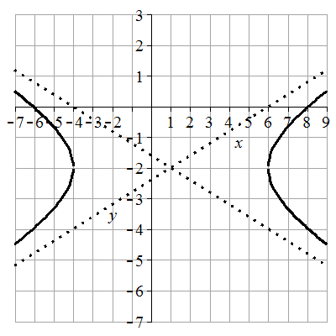
Check on graphing utility using $=2\sqrt{\frac{{(x-1)}^{2}}{25}-1}-2$ ,$y=-2\sqrt{\frac{{(x-1)}^{2}}{25}-1}-2$, $y=\frac{2}{5}\left(x-1\right)-2$ and $y=-\frac{2}{5}\left(x+5\right)-2$.
33. Equation has form $\frac{{(y-k)}^{2}}{a^{2}}-\frac{{(x-h)}^{2}}{b^{2}}=1$. h=-2 and k=1 giving center at (-2,1). Value of $a=\sqrt{9}=3$. Vertices are (h,k±a) giving (-2,4) and (-2,-2). Transverse axis length 2a=2(3)=6. Value of $b=\sqrt{1}=1$. Asymptotes are $y=±\frac{a}{b}\left(x-h\right)+k$ giving $y=±\frac{3}{1}\left(x+2\right)+1$. Graph is:
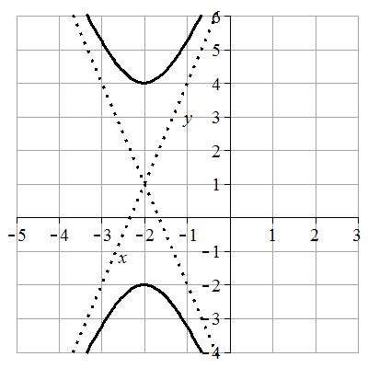
Check on graphing utility using $=3\sqrt{{(x+2)}^{2}+1}+1$ ,$y=-3\sqrt{{\left(x+2\right)}^{2}+1}+1$, $y=3\left(x+2\right)+1$ and $y=-3\left(x+2\right)+1$.
35. $4x^{2}-8x-y^{2}=12$ can be transformed into $4{(x}^{2}-2x+1)-y^{2}=12+4$ giving $4{\left(x-1\right)}^{2}-y^{2}=16$ or $\frac{{\left(x-1\right)}^{2}}{4}-\frac{{(y-0)}^{2}}{16}=1$. Equation has form $\frac{{(x-h)}^{2}}{a^{2}}-\frac{{(y-k)}^{2}}{b^{2}}=1$. h=1 and k=0 giving center at (1,0). Value of $a=\sqrt{4}=2$. Vertices are (h±a,k) giving (3,0) and (-1,0). Transverse axis length 2a=2(2) = 4. Value of $b=\sqrt{16}=4$. Asymptotes are $y=±\frac{b}{a}\left(x-h\right)+k$ giving $y=±\frac{4}{2}\left(x-1\right)+0$ or $y=±2\left(x-1\right)$. Graph is:
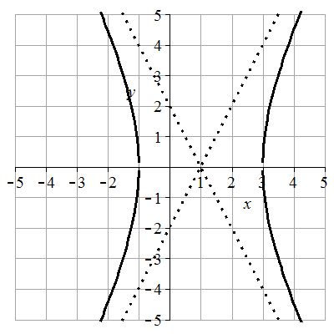
Check on graphing utility using $=4\sqrt{\frac{{(x-1)}^{2}}{4}-1}$ ,$y=-4\sqrt{\frac{{(x-1)}^{2}}{4}-1}$, $y=2\left(x-1\right)$ and $y=-2\left(x-1\right)$.
37. $4y^{2}-16y-x^{2}-2x=1$ can be transformed into $4\left(y^{2}-4y+4\right)-\left(x^{2}+2x+1\right)=1+16-1$ giving $4{\left(y-2\right)}^{2}-({x+1)}^{2}=16$ or $\frac{{\left(y-2\right)}^{2}}{4}-\frac{{(x+1)}^{2}}{16}=1$. Equation has form $\frac{{(y-k)}^{2}}{a^{2}}-\frac{{(x-h)}^{2}}{b^{2}}=1$. h=-1 and k=2 giving center at (-1,2). Value of $a=\sqrt{4}=2$. Vertices are (h,k±a) giving (-1,4) and (-1,0). Transverse axis length 2a=2(2) = 4. Value of $b=\sqrt{16}=4$. Asymptotes are $y=±\frac{a}{b}\left(x-h\right)+k$ giving $y=±\frac{2}{4}\left(x-1\right)+2$ or $y=±\frac{1}{2}\left(x-1\right)+2$. Graph is:
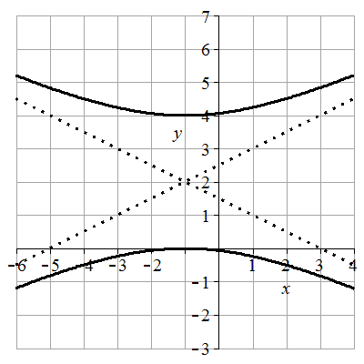
Check on graphing utility using $=2\sqrt{\frac{{(x+1)}^{2}}{16}+1}+2$ ,$y=-2\sqrt{\frac{{(x+1)}^{2}}{16}+1}+2$, $y=\frac{1}{2}\left(x+1\right)+2$ and $y=-\frac{1}{2}\left(x+1\right)+2$.
39. $9x^{2}+36x-4y^{2}+8y=4$ can be transformed into $9\left(x^{2}+4x+4\right)-4\left(y^{2}-2y+1\right)=4+36-4$ giving $9{\left(x+2\right)}^{2}-4({y-1)}^{2}=36$ or $\frac{{\left(x+2\right)}^{2}}{4}-\frac{{(y-1)}^{2}}{9}=1$. Equation has form $\frac{{(x-h)}^{2}}{a^{2}}-\frac{{(y-k)}^{2}}{b^{2}}=1$. h=-2and k=1 giving center at (-2,1). Value of $a=\sqrt{4}=2$. Vertices are (h±a,k) giving (0,1) and (-4,1). Transverse axis length 2a=2(2) = 4. Value of $b=\sqrt{9}=3$. Asymptotes are $y=±\frac{b}{a}\left(x-h\right)+k$ giving $y=±\frac{3}{2}\left(x+2\right)+1$. Graph is:
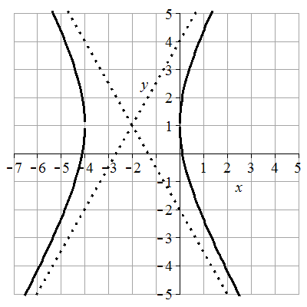
Check on graphing utility using $=3\sqrt{\frac{{(x+2)}^{2}}{4}-1}+1$ ,$y=-3\sqrt{\frac{{\left(x+2\right)}^{2}}{4}-1}+1$, $y=\frac{3}{4}\left(x+2\right)+1$ and $y=-\frac{3}{4}\left(x+2\right)+1$.
41. Vertical hyperbola means the equation has form $\frac{{(y-k)}^{2}}{a^{2}}-\frac{{(x-h)}^{2}}{b^{2}}=1$. Center at (4, -1). Vertex at (4, 2) give value of a = 2-(-1)=3. Points (6,2) and (4,-1) on asymptote show $m=\frac{2-(-1)}{6-4}=\frac{3}{2}$. Asymptote equation has form $+k=±\frac{a}{b}(x-h)$ . Setting $\frac{a}{b}=\frac{3}{2}$ substituting a gives $\frac{3}{b}=\frac{3}{2}$ showing b=2. Equation is $\frac{{\left(y+1\right)}^{2}}{3^{2}}-\frac{{(x-4)}^{2}}{2^{2}}=1$ or $\frac{{\left(y+1\right)}^{2}}{9}-\frac{{(x-4)}^{2}}{4}=1$.
43. Vertices (-1,-2) and (-1,6) on vertical line x =-1. Vertical hyperbola means the equation has form $\frac{{(y-k)}^{2}}{a^{2}}-\frac{{(x-h)}^{2}}{b^{2}}=1$. Center at midpoint of vertices $\left(\frac{x_{1}+x_{2}}{2},\frac{y_{1}+y_{2}}{2}\right)=\left(\frac{-1+(-1)}{2},\frac{-2+6}{2}\right)=(-1,2)$. Distance from center to vertex (-1,6) is a = 6-2=4. Asymptote equation has form $+k=±\frac{a}{b}(x-h)$ . Asymptote has slope m=2. Setting $\frac{a}{b}=\frac{2}{1}$ and substituting a gives $\frac{4}{b}=\frac{2}{1}$ showing b=2. Equation is $\frac{{\left(y-2\right)}^{2}}{4^{2}}-\frac{{(x+1)}^{2}}{2^{2}}=1$ or $\frac{{\left(y-2\right)}^{2}}{16}-\frac{{(x+1)}^{2}}{4}=1$.
45. $y=±4\sqrt{9x^{2}-1}$ can be transformed into $y^{2}=16 (9x^{2}-1)$ giving $9x^{2}-\frac{y^{2}}{16}=1$ or $\frac{x^{2}}{\frac{1}{9}}-\frac{y^{2}}{16}=1$. Equation has form $\frac{x^{2}}{a^{2}}-\frac{y^{2} }{b^{2}}=1$. Center at (0,0). Value of $a=\sqrt{\frac{1}{9}}=\frac{1}{3}$. Vertices are (±a,0) or $\left(±\frac{1}{3}, 0\right)$. Transverse axis length $2\left(\frac{1}{3}\right)=\frac{2}{3}$. Value of $b=\sqrt{16}=4$. Asymptotes are $y=±\frac{b}{a}x$ giving $y=±\frac{4}{\frac{1}{3}}x$ or $y=±12x$. Graph is
47. $y=1±\frac{1}{2}\sqrt{9x^{2}+18x+10}$ can be transformed into $y-1=±\frac{1}{2}\sqrt{9(x^{2}+2x+1)+1}$ giving $y-1=±\frac{1}{2}\sqrt{9{\left(x+1\right)}^{2}+1}$. Squaring yields ${\left(y-1\right)}^{2}=\frac{1}{4}\left(9{\left(x+1\right)}^{2}+1\right)$ giving $\frac{{(y-1)}^{2}}{\frac{1}{4}}-9{\left(x+1\right)}^{2}=1$ or $\frac{{(y-1)}^{2}}{\frac{1}{4}}-\frac{{\left(x+2\right)}^{2}}{\frac{1}{9}}=1$. Equation has form $\frac{{(y-k)}^{2}}{a^{2}}-\frac{{(x-h)}^{2}}{b^{2}}=1$. h=-2 and k=-1 gives center at (-1,1). Value of $a=\sqrt{\frac{1}{4}}=\frac{1}{2}$. Vertices at (h,k±a) or (-1,3/2) and (-1,1/2), transverse length = 2a=2(1/2) = 1. Value of $b=\sqrt{\frac{1}{9}}=\frac{1}{3}$. Asymptotes are $y=±\frac{a}{b}\left(x-h\right)+k$ giving $y=±\frac{\frac{1}{2}}{\frac{1}{3}}\left(x+1\right)+1$ or $y=±\frac{3}{2}\left(x+1\right)+1$. Graph is
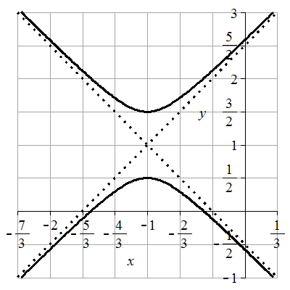
49. Equation has form $\frac{y^{2}}{a^{2}}-\frac{x^{2}}{b^{2}}=1$. Center at (0,0). Value of $a^{2}=6$and $b^{2}=19$. Substituting into $b^{2}=c^{2}-a^{2}$ gives $19=c^{2}-6$. Value of $c=\sqrt{25}=5.$ Foci at (0,±c) or (0,±5) .
51. Equation has form $\frac{{(x-h)}^{2}}{a^{2}}-\frac{{(y-k)}^{2}}{b^{2}}=1$. h=-5 and k=3 gives center at (-5,3). Value of $a^{2}=15$and $b^{2}=1$. Substituting into $b^{2}=c^{2}-a^{2}$ gives $15=c^{2}-1$. Value of $c=\sqrt{16}=4.$ Foci at (h±c,k) or (5,6) and (-3,6).
53. $y=1±\frac{4}{3}\sqrt{x^{2}+8x+25}$ can be transformed into $y-1=±\frac{4}{3}\sqrt{x^{2}+8x+16+9}$ giving $y-1=±\frac{4}{3}\sqrt{{\left(x+4\right)}^{2}+9}$. Squaring yields ${\left(y-1\right)}^{2}=\frac{16}{9}\left({\left(x+4\right)}^{2}+9\right)$ giving ${(y-1)}^{2}-\frac{{16\left(x+4\right)}^{2}}{9}=16$ or $\frac{{(y-1)}^{2}}{16}-\frac{{\left(x+4\right)}^{2}}{9}=1$. Equation has form $\frac{{(y-k)}^{2}}{a^{2}}-\frac{{(x-h)}^{2}}{b^{2}}=1$. h=-4 and k=1 gives center at (-4,1). Value of $a^{2}=16$and $b^{2}=9$. Substituting into $b^{2}=c^{2}-a^{2}$ gives $9=c^{2}-16$. Value of $c=\sqrt{25}=5.$ Foci at (h,k±c) or (5,6) and (-3,6).
55. Transverse axis vertices (-4,0) and (4,0) on horizontal line y = 0. Hyperbola opens horizontally. Center at midpoint of vertices $\left(\frac{x_{1}+x_{2}}{2},\frac{y_{1}+y_{2}}{2}\right)=\left(\frac{4+(-4)}{2},\frac{0+0}{2}\right)=(0,0)$. Equation has form $\frac{x^{2}}{a^{2}}-\frac{y^{2}}{b^{2}}=1$. Using vertex (4,0) and center a=4-0=4. Using focus (5,0) and center c= 5-0=5. Substituting a and c into $b^{2}=c^{2}-a^{2}$ gives $b^{2}=5^{2}-4^{2}=8$. Equation is $\frac{x^{2}}{4^{2}}-\frac{y^{2}}{9}=1$ or $\frac{x^{2}}{16}-\frac{y^{2}}{9}=1$.
57. Transverse axis vertex (0,12) and focus (0,13) on vertical line x = 0. Hyperbola opens vertically. Center at $(0,0)$. Equation has form $\frac{y^{2}}{a^{2}}-\frac{x^{2}}{b^{2}}=1$. Using vertex and center a =12-0 = 12. Using focus and center c= 13-0=13. Substituting a and c into $b^{2}=c^{2}-a^{2}$ gives $b^{2}={13}^{2}-{12}^{2}=25$. Equation is $\frac{y^{2}}{{12}^{2}}-\frac{x^{2}}{25}=1$ or $\frac{y^{2}}{144}-\frac{x^{2}}{25}=1$.
59. Transverse axis foci (-17,0) and (17,0) on horizontal line y = 0. Hyperbola opens horizontally. Center at midpoint of foci $\left(\frac{x_{1}+x_{2}}{2},\frac{y_{1}+y_{2}}{2}\right)=\left(\frac{17+(-17)}{2},\frac{0+0}{2}\right)=(0,0)$. Equation has form $\frac{x^{2}}{a^{2}}-\frac{y^{2}}{b^{2}}=1$. Using focus (17,0) and center c=17-0=17. Slope of asymptote is m=8/15. Asymptote equation has form $=±\frac{b}{a}x$ . Setting $\frac{b}{a}=\frac{8}{15}$ gives $b=\frac{8}{15}a$. Substituting b and c into $b^{2}=c^{2}-a^{2}$ gives ${\left(\frac{8}{15}a\right)}^{2}={17}^{2}-a^{2}$. Solving shows a=15. Substituting a into $\frac{b}{a}=\frac{8}{15}$ gives b=8. The equation is $\frac{x^{2}}{{15}^{2}}-\frac{y^{2}}{8^{2}}=1$ or $\frac{x^{2}}{225}-\frac{y^{2}}{64}=1$.
61. Transverse axis foci (-10,0) and (10,0) on horizontal line y = 0. Hyperbola opens horizontally. Center at midpoint of foci $\left(\frac{x_{1}+x_{2}}{2},\frac{y_{1}+y_{2}}{2}\right)=\left(\frac{10+(-10)}{2},\frac{0+0}{2}\right)=(0,0)$. Equation has form $\frac{x^{2}}{a^{2}}-\frac{y^{2}}{b^{2}}=1$. Using focus (10,0) and center c=10-0-10. Value of a is half transverse axis length so a=1/2(16)=8. Substituting a and c into $b^{2}=c^{2}-a^{2}$ yields $b^{2}={10}^{2}-8^{2}=36$. Equation is$\frac{x^{2}}{8^{2}}-\frac{y^{2}}{36}=1$ or $\frac{x^{2}}{64}-\frac{y^{2}}{36}=1$.
63. Transverse axis foci at (1,7) and (1,-3) on vertical line x=1. Hyperbola opens vertically. Center at midpoint of foci $\left(\frac{x_{1}+x_{2}}{2},\frac{y_{1}+y_{2}}{2}\right)=\left(\frac{1+1}{2},\frac{7+(-3)}{2}\right)=(1,2)$. Equation has form $\frac{{(y-k)}^{2}}{a^{2}}-\frac{{\left(x-h\right)}^{2}}{b^{2}}=1$. Value of h=1 and k=2. Using focus (1,7) and center (1,2) c = 7-2=5. Using vertex (1,6) and center (1,2) a=6-2=4. Substituting a and c into $b^{2}=c^{2}-a^{2}$ yields $b^{2}=5^{2}-4^{2}=9$. Equation is $\frac{{\left(y-2\right)}^{2}}{4^{2}}-\frac{{\left(x-1\right)}^{2}}{9}=1$ or $\frac{{\left(y-2\right)}^{2}}{16}-\frac{{(x-1)}^{2}}{9}=1$.
65. Transverse axis center (-1,3) and vertex (4,3) on horizontal line y=3. Hyperbola opens horizontally. Equation has form $\frac{{(x-h)}^{2}}{a^{2}}-\frac{{(y-k)}^{2}}{b^{2}}=1$. Using focus (12,3) and center (-1,3) c=12-(-1)=13. Using vertex (4,3) and center (-1,3) a=4-(-1)=5. Substituting a and c into $b^{2}=c^{2}-a^{2}$ yields $b^{2}={13}^{2}-5^{2}=144$. Equation is $\frac{{\left(x+1\right)}^{2}}{5^{2}}-\frac{{(y-3)}^{2}}{144}=1$ or $\frac{{\left(x+1\right)}^{2}}{25}-\frac{{(y-3)}^{2}}{144}=1$
67. Simplify calculations by making the hyperbola horizontal and centered at the origin. Equation has form $\frac{x^{2}}{a^{2}}-\frac{y^{2}}{b^{2}}=1$. Since the center is the midpoint between the foci, the distance from a focus to the center is half the distance between the foci so c = ½ (100)=50. The difference in time the signal reaches the ship is related to the hyperbola constant k but must be converted to a distance. k = 300,000 km/s (0.0002 s) = 60 km. Since k = 2a, the value of a = 30. Substituting a and c into $b^{2}=c^{2}-a^{2}$ yields $b^{2}={50}^{2}-{30}^{2}=1600$. Equation is is $\frac{x^{2}}{{30}^{2}}-\frac{y^{2}}{1600}=1$ or $\frac{x^{2}}{900}-\frac{y^{2}}{1600}=1$.
69. Let’s place the origin in the center of the tower, where it is narrowest in diameter. We can use the standard form of a horizontal hyperbola, $\frac{x^{2}}{a^{2}}-\frac{y^{2}}{b^{2}}=1$. The diameter of the tower at the narrowest point is 60m, so the radius is 30m. That puts the vertices at (30,0) and (-30,0), and a = 30. To solve for b, we can plug in a known point for x and y. At the top of the tower when y=79.6m, x=36m. Solving $\frac{{36}^{2}}{{30}^{2}}-\frac{{79.6}^{2}}{b^{2}}=1$ for b gives 14400.3636 to four decimal places. The sides of the tower can be modeled by $\frac{x^{2}}{900}-\frac{y^{2}}{14400.3636}=1$
71. Simplify calculations by making the hyperbola horizontal and centered at the origin. The gun and the target are the foci. The value of c = ½ (200) = 100. Let t₁ be the time it takes for the bullet to travel from the gun to the target. Substituting into d = rt gives 200= 2000t₁. Solving shows t₁ = 0.1. Let t₂ be the time for the sound of the bullet hitting the target to travel to the person hearing it. The sound of the target travels a distance d_{target} =1100 t₂. The sound of the gun firing travels for a longer time. It travels the same amount of time as the sound of the target plus the 0.1 seconds it took the bullet to reach the target. The distance it travels is d_{gun} =1100 (t₂+0.1).
A
C
B
2000t₁

1100 t₂

1100(t₂+.1)

The positive difference of the distances gives the equation 2a=1100(t₂+.05) - 1100 t₂. Solving gives a = 55. Substitution of a and c into $b^{2}=c^{2}-a^{2}$ yields $b^{2}={100}^{2}-{55}^{2}=6975$. A person who hears the gun fire and the target hit at the same time is located on the hyperbola given by the equation $\frac{x^{2}}{{55}^{2}}-\frac{y^{2}}{6975}=1$ or $\frac{x^{2}}{3025}-\frac{y^{2}}{6975}=1$.
73. $5y^{2}-x^{2}+25=0$ can be put in the form ${\frac{y}{5}}^{2}-\frac{x^{2}}{25}=-1$. $x^{2}-5y^{2}+25=0$ can be put in the form ${\frac{y}{5}}^{2}-\frac{x^{2}}{25}=1$ showing they are conjugate.
75. Assume the hyperbola is centered at the origin. The distance to a vertex is $a$. Substituting $b=a$ into $b^{2}=c^{2}-a^{2}$ gives $c^{2}={2a}^{2}$ which simplifies to $c=a\sqrt{2}$. The eccentricity is $\frac{a\sqrt{2}}{a}=\sqrt{2}$.
77. Since k>0 , then $a^{2}=k$ and $b^{2}=6-k$. Substitution of a and b into $b^{2}=c^{2}-a^{2}$ which is equivalent to $c^{2}=a^{2}+b^{2}$ yields $c^{2}=k+6-k=6$. Since $c=\sqrt{6}$ the foci are $(±\sqrt{6},0)$ no matter the value of k.
Section 9.3 Solutions
1. Opens sideways, focus is positive: C
3. Opens upwards, focus is positive: A
5. ${(y-0)}^{2}=4⋅4\left(x-0\right)$, so horizontal parabola with p = 4.
Vertex: (0,0). Axis of symmetry: y = 0. Directrix: x = -4. Focus: (4,0)
7. $x^{2}=\frac{1}{2}y$, or ${(x-0)}^{2}=4⋅\frac{1}{8}\left(y-0\right)$ so vertical parabola with $p=\frac{1}{8}$.
Vertex: (0,0). Axis of symmetry: x = 0. Directrix: y = -1/8. Focus: (0,1/8)
9. $y^{2}=-\frac{1}{4}x$, or ${\left(y-0\right)}^{2}=4\left(-\frac{1}{16}\right)\left(x-0\right)$. , so horizontal parabola with $p=-\frac{1}{16}$.
Vertex: (0,0). Axis of symmetry: y = 0. Directrix: x = 1/16. Focus: (-1/16,0)
11. ${\left(x-2\right)}^{2}=4⋅2(y+1)$, so vertical parabola with $p=2$.
Vertex: (2,-1). Axis of symmetry: x = 2. Directrix: y = -1-2 = -3. Focus: (2,-1+2) = (2,1).
13. ${\left(x+1\right)}^{2}=4⋅1(y-4)$, xo vertical parabola with $p=1$.
Vertex: (-1,4). Axis of symmetry: x = -1. Directrix: y = 4-1 = 3. Focus: (-1,4+1) = (-1,5)
15. Using the vertex (3,1) and the form for a horizontal parabola we can write ${\left(y-1\right)}^{2}=4p\left(x-3\right).$ Plugging in the point (2,2) we can solve to find $p=-\frac{1}{4}$, giving $(y-1)^{2}=-(x-3)$
17. p = 3, so $(y-3)^{2}=12(x-2)$
19. Focus is above vertex, so the parabola is vertical, opening upward
Distance from vertex to focus is p = 1. $x^{2}=4(y-3)$
21. At the focus. p=1 and the vertex is (0,0), so the focus is at (0,1)
23. Start with the general form for a vertical parabola with vertex at the origin, $x^{2}=4py$. Since the dish is 12 feet wide (6 ft on either side of the vertex) and 4 feet deep, the equation describing it would pass through the point (6, 4). Plugging into our equation, $6^{2}=4p(4)$, giving $p=\frac{36}{16}=2.25$. The focus is located 2.25 feet above the vertex.
25. Position the searchlight so it forms a vertical parabola with vertex at the origin. Since the light at the focus is 1 foot from the base, p=1, giving equation $x^{2}=4y$. The opening is 2 feet across, so 1 foot on either side of the vertex. When x=1, $1^{2}=4y$, giving y=0.25. The depth of the searchlight is 0.25 ft.
27. Substitute $y=2x$ into the second equation: ${\left(2x\right)}^{2}-x^{2}=1$. This simplifies to $3x^{2}=1$, so $x=±\sqrt{\frac{1}{3}}=±\frac{1}{\sqrt{3}}$. We can substitute those into $y=2x$ to find the corresponding y-values.
$\left(\frac{1}{\sqrt{3}},\frac{2}{\sqrt{3}}\right), \left(\frac{-1}{\sqrt{3}},\frac{-2}{\sqrt{3}}\right)$
29. We can solve the top equation for $x^{2}$, giving $x^{2}=11-y^{2}$, then substitute this into the second equation. $\left(11-y^{2}\right)-4y^{2}=1$. This simplifies to $-5y^{2}=-10$, then $y^{2}=2$, giving $y=±\sqrt{2}$.
When $y=\sqrt{2}$, then $x^{2}=11-{\left(\sqrt{2}\right)}^{2}=9$, so $x=±3$. Repeat for $y=-\sqrt{2}$. The solutions are:
$\left(3,\sqrt{2}\right), \left(3,-\sqrt{2}\right), \left(-3,\sqrt{2}\right), \left(-3,-\sqrt{2}\right)$
31. Substitute $y=x^{2}$ into the second equation, giving ${\left(x^{2}\right)}^{2}-6x^{2}=16$. Simplify, and rearrange to set equal to zero: $x^{4}-6x^{2}-16=0$. This can be factored like a quadratic: $\left(x^{2}-8\right)\left(x^{2}+2\right)=0$. Using the zero-product principle, one of these factors must be zero. $x^{2}-8=0$ when $x=±\sqrt{8}=±2\sqrt{2}$. $x^{2}+2=0$ has no real solutions. Substituting $x=±\sqrt{8}$ back into $y=x^{2}$ gives our solutions:
$\left(2\sqrt{2},8\right), \left(-2\sqrt{2},8\right)$

33. We could again use substitution, like we did in #29, or we could use an elimination technique, and add the left sides of the two equations and the right sides of the two equations, noting that $x^{2}$ will cancel out when we do so, leaving $4y^{2}-y^{2}=1+1$, or $3y^{2}=2$. This gives $y=±\sqrt{\frac{2}{3}}$. Substituting each of these into either equation allows us to solve for the corresponding x-values. Solutions:
$\left(\sqrt{\frac{5}{3}},\sqrt{\frac{2}{3}}\right), \left(-\sqrt{\frac{5}{3}},\sqrt{\frac{2}{3}}\right), \left(\sqrt{\frac{5}{3}},-\sqrt{\frac{2}{3}}\right), \left(-\sqrt{\frac{5}{3}},-\sqrt{\frac{2}{3}}\right)$

35. Stations A and B at foci (125,0) and (-125,0) on horizontal line y=0. Hyperbola opens horizontally. Center at midpoint of foci $\left(\frac{x_{1}+x_{2}}{2},\frac{y_{1}+y_{2}}{2}\right)=\left(\frac{125+(-125)}{2},\frac{0+0}{2}\right)=(0,0)$. Equation has form $\frac{x^{2}}{a^{2}}-\frac{y^{2}}{b^{2}}=1$. From the difference in the distance, k=2a=100 or a=50. Using foci (125,0) and center c=125-0=125. Substituting a and c into $b^{2}=c^{2}-a^{2}$ yields $b^{2}={125}^{2}-{50}^{2}=13125$. Equation (1) is $\frac{x^{2}}{{50}^{2}}-\frac{y^{2}}{13125}=1$. Stations C and D at foci (0,250) and (0,-250) on vertical line x=0. Hyperbola opens vertically. Center at midpoint of foci $\left(\frac{x_{1}+x_{2}}{2},\frac{y_{1}+y_{2}}{2}\right)=\left(\frac{0+0}{2},\frac{250+(-250)}{2}\right)=(0,0)$. Equation has form $\frac{y^{2}}{a^{2}}-\frac{x^{2}}{b^{2}}=1$. From the difference in the distance, k=2a=180 or a=90. Using foci (0,250) and center c=250-0=250. Substituting a and c into $b^{2}=c^{2}-a^{2}$ yields $b^{2}={250}^{2}-{90}^{2}=54400$. Equation (2) is $\frac{y^{2}}{{90}^{2}}-\frac{x^{2}}{54400}=1$. Solving equation (1) for $x^{2}$ gives $x^{2}={50}^{2}\left(\frac{y^{2}}{13125}+1\right)$ and substituting for $x^{2}$ in equation (2) gives $\frac{y^{2}}{{90}^{2}}-\frac{1}{54400}\left({50}^{2}\left(\frac{y^{2}}{13125}+1\right)\right)=1$. Solving for y= ±93.37848007. Substituting for y in equation (1) gives $\frac{x^{2}}{{50}^{2}}-\frac{{\left(±93.37848007\right)}^{2}}{13125}=1$. Solving for x=±64.50476622. Since the ship is in quadrant two, the coordinates are (-64.50, 93.38) rounded to two decimals.

Section 9.4 Solutions
1. e = 3. Directrix: x = 4. Hyperbola. 3. e = 3/4. Directrix: y = -2/3. Ellipse.
5. e = 1. Directrix: x = -1/5. Parabola. 7. e = 2/7. Directrix: x = 2. Ellipse.

9. Directrix is x=, so we use cos. Directrix of -4 means p=4 and the sign on cos is negative.
$r=\frac{5⋅4}{1-5cos(θ)}=\frac{20}{1-5cos(θ)}$
11. Directrix is y=, so we use sin. Directrix of +3 means p=3 and the sign on sin is positive.
$r=\frac{\frac{1}{3}⋅3}{1+\frac{1}{3}sin(θ)}=\frac{1}{1+\frac{1}{3}sin(θ)}$, or multiply top and bottom by 3 to get $r=\frac{3}{3+sin(θ)}$
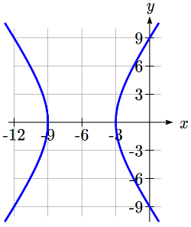
13. Directrix is y=, so we use sin. Directrix of -2 means p=2 and the sign on sin is negative.
$r=\frac{2}{1-sin(θ)}$

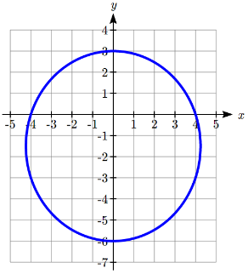
15. Hyperbola. Vertices at (-9,0) and (-3,0)
Center at (-6,0). a = 3. c = 6, so b = $\sqrt{6^{2}-3^{2}}=\sqrt{27}$
$\frac{(x+6)^{2}}{9}-\frac{y^{2}}{27}=1$

17. Ellipse. Vertices at (0,3) and (0,-6)
Center at (0,-1.5). a = 4.5, c = 1.5, $b=\sqrt{{4.5}^{2}-{1.5}^{2}}=\sqrt{18}$
$\frac{x^{2}}{18}+\frac{(y+1.5)^{2}}{20.25}=1$

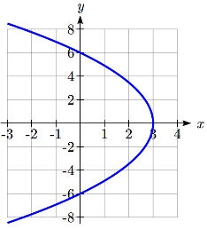
19. Parabola. Vertex at (3,0). p = 3.
$y^{2}=-12(x-3)$

21. a)
x
y
d(Q,F₁)
d(Q,F₂)
Q=(x,y)
F₁
F₂
L₁
L₂
(c,0)
(a,0)
x = p
b) $d\left(Q,L_{1}\right)=x-(-p)=x+p$, $d\left(Q,L_{2}\right)=p-x$
c) $d\left(Q,F_{1}\right)=ed\left(Q,L_{1}\right)=e(x+p)$. $d\left(Q,F_{2}\right)=ed\left(Q,L_{2}\right)=e(p-x)$
d) $d\left(Q,F_{1}\right)+d\left(Q,F_{2}\right)=e(x+p)+e(p-x)=2ep$, a constant.
e) At Q = (a, 0), $d\left(Q,F_{1}\right)=a-(-c)=a+c$, and $d\left(Q,F_{2}\right)=a-c$, so
$d\left(Q,F_{1}\right)+d\left(Q,F_{2}\right)=(a+c)+(a-c)=2a$
Combining with the result above, $2ep=2a$, so $p=\frac{a}{e}$.
f) $d\left(Q,F_{2}\right)=a-c$, and $d\left(Q,L_{2}\right)=p-a$
$\frac{d\left(Q,F_{2}\right)}{d\left(Q,L_{2}\right)}=e$, so $\frac{a-c}{p-a}=e$.
$a-c=e(p-a)$. Using the result from (e),
$a-c=e\left(\frac{a}{e}-a\right)$
$a-c=a-ea$
$e=\frac{c}{a}$

