Chapter 3: Polynomial and Rational Functions
Section 3.1 Power Functions & Polynomial Functions 155
Section 3.2 Quadratic Functions 163
Section 3.3 Graphs of Polynomial Functions 176
Section 3.4 Rational Functions 188
Section 3.5 Inverses and Radical Functions 206

Section 3.1 Power Functions & Polynomial Functions
A square is cut out of cardboard, with each side having length L. If we wanted to write a function for the area of the square, with L as the input and the area as output, you may recall that the area of a rectangle can be found by multiplying the length times the width. Since our shape is a square, the length & the width are the same, giving the formula:
$$A(L)=L⋅L=L^{2}$$

Likewise, if we wanted a function for the volume of a cube with each side having some length L, you may recall volume of a rectangular box can be found by multiplying length by width by height, which are all equal for a cube, giving the formula:
$$V(L)=L⋅L⋅L=L^{3}$$

These two functions are examples of power functions, functions that are some power of the variable.

Power Function
A power function is a function that can be represented in the form
$$f(x)=x^{p}$$
Where the base is a variable and the exponent, p, is a number.

Example 1
Which of our toolkit functions are power functions?

The constant and identity functions are power functions, since they can be written as $f(x)=x^{0}$ and $f(x)=x^{1}$ respectively.
The quadratic and cubic functions are both power functions with whole number powers: $f(x)=x^{2}$ and $f(x)=x^{3}$.

The reciprocal and reciprocal squared functions are both power functions with negative whole number powers since they can be written as $f(x)=x^{−1}$and $f(x)=x^{−2}$.

The square and cube root functions are both power functions with fractional powers since they can be written as $f(x)=x^{1/2}$or $f(x)=x^{1/3}$.
Try it Now
1. What point(s) do the toolkit power functions have in common?
$$f(x)=x^{6}$$
$$f(x)=x^{4}$$

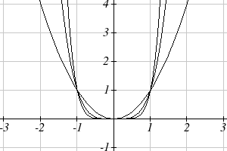
Characteristics of Power Functions
$$f(x)=x^{2}$$
Shown to the right are the graphs of $f(x)=x^{2}, f(x)=x^{4}, \text{and} f(x)=x^{6}$, all even whole number powers. Notice that all these graphs have a fairly similar shape, very similar to the quadratic toolkit, but as the power increases the graphs flatten somewhat near the origin, and become steeper away from the origin.

To describe the behavior as numbers become larger and larger, we use the idea of infinity. The symbol for positive infinity is $∞$, and $−∞$ for negative infinity. When we say that “x approaches infinity”, which can be symbolically written as $x→∞$, we are describing a behavior – we are saying that x is getting large in the positive direction.

With the even power function, as the input becomes large in either the positive or negative direction, the output values become very large positive numbers. Equivalently, we could describe this by saying that as x approaches positive or negative infinity, the f(x) values approach positive infinity. In symbolic form, we could write: as $x→±∞$, $f(x)→∞$.
$$f(x)=x^{7}$$
$$f(x)=x^{5}$$
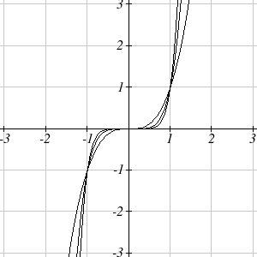
Shown here are the graphs of $f(x)=x^{3}, f(x)=x^{5}, \text{and} f(x)=x^{7}$, all odd whole number powers. Notice all these graphs look similar to the cubic toolkit, but again as the power increases the graphs flatten near the origin and become steeper away from the origin.
$$f(x)=x^{3}$$

For these odd power functions, as x approaches negative infinity, f(x) approaches negative infinity. As x approaches positive infinity, f(x) approaches positive infinity. In symbolic form we write: as $x→−∞$, $f(x)→−∞$ and as $x→∞$, $f(x)→∞$.

Long Run Behavior
The behavior of the graph of a function as the input takes on large negative values ($x→−∞$) and large positive values ($x→∞$) as is referred to as the long run behavior of the function.

Example 2
Describe the long run behavior of the graph of $f(x)=x^{8}$.

Since $f(x)=x^{8}$ has a whole, even power, we would expect this function to behave somewhat like the quadratic function. As the input gets large positive or negative, we would expect the output to grow without bound in the positive direction. In symbolic form, as $x→±∞$, $f(x)→∞$.

Example 3
Describe the long run behavior of the graph of $f(x)=−x^{9}$

Since this function has a whole odd power, we would expect it to behave somewhat like the cubic function. The negative in front of the $x^{9}$ will cause a vertical reflection, so as the inputs grow large positive, the outputs will grow large in the negative direction, and as the inputs grow large negative, the outputs will grow large in the positive direction. In symbolic form, for the long run behavior we would write: as $x→∞$, $f(x)→−∞$and as $x→−∞$, $f(x)→∞$.

You may use words or symbols to describe the long run behavior of these functions.

Try it Now
2. Describe in words and symbols the long run behavior of $f(x)=−x^{4}$

Treatment of the rational and radical forms of power functions will be saved for later.

Polynomials

An oil pipeline bursts in the Gulf of Mexico, causing an oil slick in a roughly circular shape. The slick is currently 24 miles in radius, but that radius is increasing by 8 miles each week. If we wanted to write a formula for the area covered by the oil slick, we could do so by composing two functions together. The first is a formula for the radius, r, of the spill, which depends on the number of weeks, w, that have passed. Hopefully you recognized that this relationship is linear:
$$r(w)=\text{24}+8w$$

We can combine this with the formula for the area, A, of a circle:
$$A(r)={πr}^{2}$$

Composing these functions gives a formula for the area in terms of weeks:
$$A(w)=A(r(w))=A(\text{24}+8w)=π(\text{24}+8w)^{2}$$
Multiplying this out gives the formula
$$A(w)=\text{576}π+\text{384}πw+\text{64}{πw}^{2}$$

This formula is an example of a polynomial. A polynomial is simply the sum of terms each consisting of a transformed power function with positive whole number power.

Terminology of Polynomial Functions
A polynomial is function that can be written as $f(x)=a_{0}+a_{1}x+a_{2}x^{2}+⋯+a_{n}x^{n}$

Each of the a_{i} constants are called coefficients and can be positive, negative, or zero, and be whole numbers, decimals, or fractions.

A term of the polynomial is any one piece of the sum, that is any $a_{i}x^{i}$. Each individual term is a transformed power function.

The degree of the polynomial is the highest power of the variable that occurs in the polynomial.

The leading term is the term containing the highest power of the variable: the term with the highest degree.

The leading coefficient is the coefficient of the leading term.

Because of the definition of the “leading” term we often rearrange polynomials so that the powers are descending.
$$f(x)=a_{n}x^{n}+\text{.}\text{.}\text{.}\text{.}\text{.}+a_{2}x^{2}+a_{1}x+a_{0}$$

Example 4
Identify the degree, leading term, and leading coefficient of these polynomials:
$$f(x)=3+2x^{2}−4x^{3}$$
$$g(t)=5t^{5}−2t^{3}+7t$$
$$h(p)=6p−p^{3}−2$$

For the function f(x), the degree is 3, the highest power on x. The leading term is the term containing that power, $−4x^{3}$. The leading coefficient is the coefficient of that term, -4.

For g(t), the degree is 5, the leading term is $5t^{5}$, and the leading coefficient is 5.

For h(p), the degree is 3, the leading term is $−p^{3}$, so the leading coefficient is -1.

Long Run Behavior of Polynomials
For any polynomial, the long run behavior of the polynomial will match the long run behavior of the leading term.

Example 5
What can we determine about the long run behavior and degree of the equation for the polynomial graphed here?
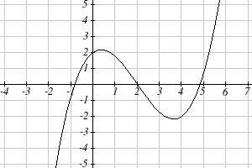

Since the output grows large and positive as the inputs grow large and positive, we describe the long run behavior symbolically by writing: as $x→∞$, $f(x)→∞$. Similarly, as $x→−∞$, $f(x)→−∞$.

In words, we could say that as x values approach infinity, the function values approach infinity, and as x values approach negative infinity the function values approach negative infinity.

We can tell this graph has the shape of an odd degree power function which has not been reflected, so the degree of the polynomial creating this graph must be odd, and the leading coefficient would be positive.

Try it Now
3. Given the function$f(x)=0\text{.}2(x−2)(x+1)(x−5)$use your algebra skills to write the function in standard polynomial form (as a sum of terms) and determine the leading term, degree, and long run behavior of the function.

Short Run Behavior
Characteristics of the graph such as vertical and horizontal intercepts and the places the graph changes direction are part of the short run behavior of the polynomial.

Like with all functions, the vertical intercept is where the graph crosses the vertical axis, and occurs when the input value is zero. Since a polynomial is a function, there can only be one vertical intercept, which occurs at the point $(0,a_{0})$. The horizontal intercepts occur at the input values that correspond with an output value of zero. It is possible to have more than one horizontal intercept.

Example 6
Given the polynomial function $f(x)=(x−2)(x+1)(x−4)$, written in factored form for your convenience, determine the vertical and horizontal intercepts.

The vertical intercept occurs when the input is zero.
$f(0)=(0−2)(0+1)(0−4)=8$.

The graph crosses the vertical axis at the point (0, 8).

The horizontal intercepts occur when the output is zero.
$0=(x−2)(x+1)(x−4)$ when x = 2, -1, or 4

The graph crosses the horizontal axis at the points (2, 0), (-1, 0), and (4, 0)

Notice that the polynomial in the previous example, which would be degree three if multiplied out, had three horizontal intercepts and two turning points – places where the graph changes direction. We will now make a general statement without justifying it – the reasons will become clear later in this chapter.

Intercepts and Turning Points of Polynomials
A polynomial of degree n will have:
At most n horizontal intercepts. An odd degree polynomial will always have at least one.
At most n-1 turning points

Example 7
What can we conclude about the graph of the polynomial shown here?
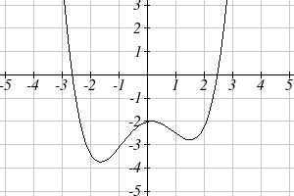
Based on the long run behavior, with the graph becoming large positive on both ends of the graph, we can determine that this is the graph of an even degree polynomial. The graph has 2 horizontal intercepts, suggesting a degree of 2 or greater, and 3 turning points, suggesting a degree of 4 or greater. Based on this, it would be reasonable to conclude that the degree is even and at least 4, so it is probably a fourth degree polynomial.

Try it Now
4. Given the function$f(x)=0\text{.}2(x−2)(x+1)(x−5)$determine the short run behavior.

Important Topics of this Section
Power Functions
Polynomials
Coefficients
Leading coefficient
Term
Leading Term
Degree of a polynomial
Long run behavior
Short run behavior

Try it Now Answers
1. (0, 0) and (1, 1) are common to all power functions.
2. As x approaches positive and negative infinity, f(x) approaches negative infinity: as $x→±∞$, $f(x)→−∞$ because of the vertical flip.
3. The leading term is $0\text{.}2x^{3}$, so it is a degree 3 polynomial.
As x approaches infinity (or gets very large in the positive direction) f(x) approaches infinity; as x approaches negative infinity (or gets very large in the negative direction) f(x) approaches negative infinity. (Basically the long run behavior is the same as the cubic function).
4. Horizontal intercepts are (2, 0) (-1, 0) and (5, 0), the vertical intercept is (0, 2) and there are 2 turns in the graph.

Section 3.1 Exercises

Find the long run behavior of each function as $x→∞$ and $x→−∞$
1. $f\left(x\right)=x^{4}$ 2. $f\left(x\right)=x^{6}$ 3. $f\left(x\right)=x^{3}$ 4. $f\left(x\right)=x^{5}$
5. $f\left(x\right)=−x^{2}$ 6. $f\left(x\right)=−x^{4}$ 7. $f\left(x\right)=−x^{7}$ 8. $f\left(x\right)=−x^{9}$

Find the degree and leading coefficient of each polynomial
9. $4x^{7}$ 10. $5x^{6}$
11. $5−x^{2}$ 12. $6+3x−4x^{3}$
13. $−2x^{4}−3x^{2}+x−1$ 14. $6x^{5}−2x^{4}+x^{2}+3$
15. $\left(2x+3\right)\left(x−4\right)(3x+1)$ 16. $\left(3x+1\right)\left(x+1\right)(4x+3)$

Find the long run behavior of each function as $x→∞$ and $x→−∞$
17. $−2x^{4}−3x^{2}+x−1$ 18. $6x^{5}−2x^{4}+x^{2}+3$
19. $3x^{2}+x−2$ 20. $−2x^{3}+x^{2}−x+3$

21. What is the maximum number of x-intercepts and turning points for a polynomial of degree 5?

22. What is the maximum number of x-intercepts and turning points for a polynomial of degree 8?

What is the least possible degree of the polynomial function shown in each graph?
23. 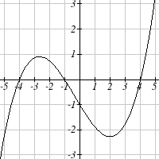 24.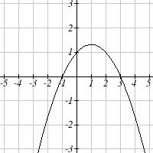 25.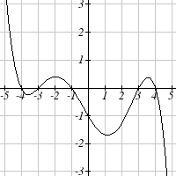 26.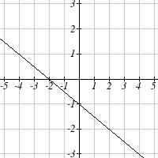

27.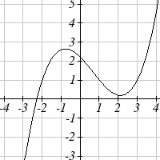 28. 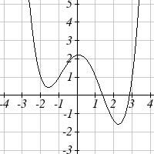 29.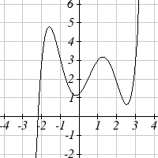 30.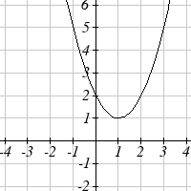

Find the vertical and horizontal intercepts of each function.
31. $f\left(t\right)=2\left(t−1\right)\left(t+2\right)(t−3)$ 32. $f\left(x\right)=3\left(x+1\right)\left(x−4\right)(x+5)$
33. $g\left(n\right)=−2\left(3n−1\right)(2n+1)$ 34. $k\left(u\right)=−3\left(4−n\right)(4n+3)$

Section 3.2 Quadratic Functions

In this section, we will explore the family of 2nd degree polynomials, the quadratic functions. While they share many characteristics of polynomials in general, the calculations involved in working with quadratics is typically a little simpler, which makes them a good place to start our exploration of short run behavior. In addition, quadratics commonly arise from problems involving area and projectile motion, providing some interesting applications.

Example 1
A backyard farmer wants to enclose a rectangular space for a new garden. She has purchased 80 feet of wire fencing to enclose 3 sides, and will put the 4th side against the backyard fence. Find a formula for the area enclosed by the fence if the sides of fencing perpendicular to the existing fence have length L.
Backyard
Garden
W
L
In a scenario like this involving geometry, it is often helpful to draw a picture. It might also be helpful to introduce a temporary variable, W, to represent the side of fencing parallel to the 4th side or backyard fence.

Since we know we only have 80 feet of fence available, we know that $L+W+L=\text{80}$, or more simply, $2L+W=\text{80}$. This allows us to represent the width, W, in terms of L: $W=\text{80}−2L$

Now we are ready to write an equation for the area the fence encloses. We know the area of a rectangle is length multiplied by width, so
$$A=\text{LW}=L(\text{80}−2L)$$
$A(L)=\text{80}L−2L^{2}$
This formula represents the area of the fence in terms of the variable length L.

Short run Behavior: Vertex

We now explore the interesting features of the graphs of quadratics. In addition to intercepts, quadratics have an interesting feature where they change direction, called the vertex. You probably noticed that all quadratics are related to transformations of the basic quadratic function$f(x)=x^{2}$.

Example 2
Write an equation for the quadratic graphed below as a transformation of $f(x)=x^{2}$, then expand the formula and simplify terms to write the equation in standard polynomial form.
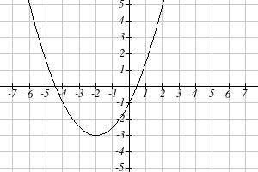
We can see the graph is the basic quadratic shifted to the left 2 and down 3, giving a formula in the form $g(x)=a(x+2)^{2}−3$. By plugging in a point that falls on the grid, such as (0,-1), we can solve for the stretch factor:
$$\begin{aligned}−1=a(0+2)^{2}−3 \\ 2=4a \\ a=\frac{1}{2}\end{aligned}$$

Written as a transformation, the equation for this formula is $g(x)=\frac{1}{2}(x+2)^{2}−3$. To write this in standard polynomial form, we can expand the formula and simplify terms:
$$\begin{aligned}g(x)=\frac{1}{2}(x+2)^{2}−3 \\ g(x)=\frac{1}{2}(x+2)(x+2)−3 \\ g(x)=\frac{1}{2}(x^{2}+4x+4)−3 \\ g(x)=\frac{1}{2}x^{2}+2x+2−3 \\ g(x)=\frac{1}{2}x^{2}+2x−1\end{aligned}$$

Notice that the horizontal and vertical shifts of the basic quadratic determine the location of the vertex of the parabola; the vertex is unaffected by stretches and compressions.

Try it Now
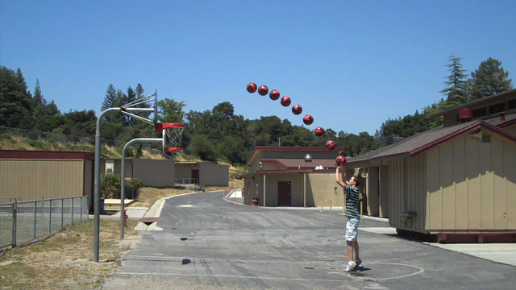
- A coordinate grid has been superimposed over the quadratic path of a basketball. Find an equation for the path of the ball. Does he make the basket?

Forms of Quadratic Functions
The standard form of a quadratic function is $f(x)={\text{ax}}^{2}+\text{bx}+c$
The transformation form of a quadratic function is $f(x)=a(x−h)^{2}+k$
The vertex of the quadratic function is located at (h, k), where h and k are the numbers in the transformation form of the function. Because the vertex appears in the transformation form, it is often called the vertex form.

In the previous example, we saw that it is possible to rewrite a quadratic function given in transformation form and rewrite it in standard form by expanding the formula. It would be useful to reverse this process, since the transformation form reveals the vertex.

Expanding out the general transformation form of a quadratic gives:
$$\begin{aligned}f(x)=a(x−h)^{2}+k=a(x−h)(x−h)+k \\ f(x)=a(x^{2}−2\text{xh}+h^{2})+k={\text{ax}}^{2}−2\text{ahx}+{\text{ah}}^{2}+k\end{aligned}$$

This should be equal to the standard form of the quadratic:
$${\text{ax}}^{2}−2\text{ahx}+{\text{ah}}^{2}+k={\text{ax}}^{2}+\text{bx}+c$$

The second degree terms are already equal. For the linear terms to be equal, the coefficients must be equal:
$−2\text{ah}=b$, so $h=−\frac{b}{2a}$
This provides us a method to determine the horizontal shift of the quadratic from the standard form. We could likewise set the constant terms equal to find:
${\text{ah}}^{2}+k=c$, so $k=c−{\text{ah}}^{2}=c−a{\left(−\frac{b}{2a}\right)}^{2}=c−a\frac{b^{2}}{4a^{2}}=c−\frac{b^{2}}{4a}$

In practice, though, it is usually easier to remember that k is the output value of the function when the input is h, so $k=f(h)$.
Finding the Vertex of a Quadratic
For a quadratic given in standard form, the vertex (h, k) is located at:
$h=−\frac{b}{2a}$, $k=f(h)=f\left(\frac{−b}{2a}\right)$

Example 3
Find the vertex of the quadratic $f(x)=2x^{2}−6x+7$. Rewrite the quadratic into transformation form (vertex form).

The horizontal coordinate of the vertex will be at $h=−\frac{b}{2a}=−\frac{−6}{2(2)}=\frac{6}{4}=\frac{3}{2}$
The vertical coordinate of the vertex will be at $f\left(\frac{3}{2}\right)=2{\left(\frac{3}{2}\right)}^{2}−6\left(\frac{3}{2}\right)+7=\frac{5}{2}$

Rewriting into transformation form, the stretch factor will be the same as the a in the original quadratic. Using the vertex to determine the shifts,
$$f(x)=2{\left(x−\frac{3}{2}\right)}^{2}+\frac{5}{2}$$

Try it Now
2. Given the equation $g(x)=\text{13}+x^{2}−6x$ write the equation in standard form and then in transformation/vertex form.

In addition to enabling us to more easily graph a quadratic written in standard form, finding the vertex serves another important purpose – it allows us to determine the maximum or minimum value of the function, depending on which way the graph opens.

Example 4
Returning to our backyard farmer from the beginning of the section, what dimensions should she make her garden to maximize the enclosed area?

Earlier we determined the area she could enclose with 80 feet of fencing on three sides was given by the equation $A(L)=\text{80}L−2L^{2}$. Notice that quadratic has been vertically reflected, since the coefficient on the squared term is negative, so the graph will open downwards, and the vertex will be a maximum value for the area.

In finding the vertex, we take care since the equation is not written in standard polynomial form with decreasing powers. But we know that a is the coefficient on the squared term, so a = -2, b = 80, and c = 0.
Finding the vertex:
$h=−\frac{\text{80}}{2(−2)}=\text{20}$, $k=A(\text{20})=\text{80}(\text{20})−2(\text{20})^{2}=\text{800}$

The maximum value of the function is an area of 800 square feet, which occurs when L = 20 feet. When the shorter sides are 20 feet, that leaves 40 feet of fencing for the longer side. To maximize the area, she should enclose the garden so the two shorter sides have length 20 feet, and the longer side parallel to the existing fence has length 40 feet.

Example 5
A local newspaper currently has 84,000 subscribers, at a quarterly charge of $30. Market research has suggested that if they raised the price to $32, they would lose 5,000 subscribers. Assuming that subscriptions are linearly related to the price, what price should the newspaper charge for a quarterly subscription to maximize their revenue?

Revenue is the amount of money a company brings in. In this case, the revenue can be found by multiplying the charge per subscription times the number of subscribers. We can introduce variables, C for charge per subscription and S for the number subscribers, giving us the equation
Revenue = CS

Since the number of subscribers changes with the price, we need to find a relationship between the variables. We know that currently S = 84,000 and C = 30, and that if they raise the price to $32 they would lose 5,000 subscribers, giving a second pair of values, C = 32 and S = 79,000. From this we can find a linear equation relating the two quantities. Treating C as the input and S as the output, the equation will have form $S=\text{mC}+b$. The slope will be
$$m=\frac{\text{79},\text{000}−\text{84},\text{000}}{\text{32}−\text{30}}=\frac{−5,\text{000}}{2}=−2,\text{500}$$

This tells us the paper will lose 2,500 subscribers for each dollar they raise the price. We can then solve for the vertical intercept

$S=−\text{2500}C+b$ Plug in the point S = 85,000 and C = 30
$\text{84},\text{000}=−\text{2500}(\text{30})+b$ Solve for b
$$b=\text{159},\text{000}$$

This gives us the linear equation $S=−2,\text{500}C+\text{159},\text{000}$ relating cost and subscribers. We now return to our revenue equation.

$\text{Revenue}=\text{CS}$ Substituting the equation for S from above
$\text{Revenue}=C(−2,\text{500}C+\text{159},\text{000})$ Expanding
$$\text{Revenue}=−2,\text{500}C^{2}+\text{159},\text{000}C$$
We now have a quadratic equation for revenue as a function of the subscription charge. To find the price that will maximize revenue for the newspaper, we can find the vertex:

$$h=−\frac{\text{159},\text{000}}{2(−2,\text{500})}=\text{31}\text{.}8$$

The model tells us that the maximum revenue will occur if the newspaper charges $31.80 for a subscription. To find what the maximum revenue is, we can evaluate the revenue equation:

Maximum Revenue = $−2,\text{500}(\text{31}\text{.}8)^{2}+\text{159},\text{000}(\text{31}\text{.}8)=$$2,528,100

Short run Behavior: Intercepts

As with any function, we can find the vertical intercepts of a quadratic by evaluating the function at an input of zero, and we can find the horizontal intercepts by solving for when the output will be zero. Notice that depending upon the location of the graph, we might have zero, one, or two horizontal intercepts.

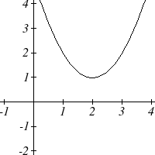 | 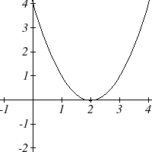 | 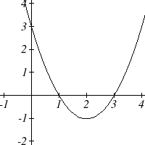
zero horizontal intercepts | one horizontal intercept | two horizontal intercepts

Example 6
Find the vertical and horizontal intercepts of the quadratic $f(x)=3x^{2}+5x−2$

We can find the vertical intercept by evaluating the function at an input of zero:
$f(0)=3(0)^{2}+5(0)−2=−2$ Vertical intercept at (0,-2)

For the horizontal intercepts, we solve for when the output will be zero
$$0=3x^{2}+5x−2$$

In this case, the quadratic can be factored easily, providing the simplest method for solution
$$0=(3x−1)(x+2)$$
$\begin{aligned}0=3x−1 \\ x=\frac{1}{3}\end{aligned}$ or $\begin{aligned}0=x+2 \\ x=−2\end{aligned}$ Horizontal intercepts at $\left(\frac{1}{3},0\right)$ and (-2,0)
Notice that in the standard form of a quadratic, the constant term c reveals the vertical intercept of the graph.

Example 7
Find the horizontal intercepts of the quadratic $f(x)=2x^{2}+4x−4$

Again we will solve for when the output will be zero
$$0=2x^{2}+4x−4$$

Since the quadratic is not easily factorable in this case, we solve for the intercepts by first rewriting the quadratic into transformation form.
$h=−\frac{b}{2a}=−\frac{4}{2(2)}=−1$ $k=f(−1)=2(−1)^{2}+4(−1)−4=−6$
$$f(x)=2(x+1)^{2}−6$$

Now we can solve for when the output will be zero
$\begin{aligned}0=2(x+1)^{2}−6 \\ 6=2(x+1)^{2} \\ 3=(x+1)^{2} \\ x+1=±\sqrt{3} \\ x=−1±\sqrt{3}\end{aligned}$

The graph has horizontal intercepts at $(−1−\sqrt{3},0)$and $(−1+\sqrt{3},0)$

Try it Now
3. In Try it Now problem 2 we found the standard & transformation form for the function $g(x)=\text{13}+x^{2}−6x$. Now find the Vertical & Horizontal intercepts (if any).

This process is done commonly enough that sometimes people find it easier to solve the problem once in general and remember the formula for the result, rather than repeating the process each time. Based on our previous work we showed that any quadratic in standard form can be written into transformation form as:

$$f(x)=a{\left(x+\frac{b}{2a}\right)}^{2}+c−\frac{b^{2}}{4a}$$

Solving for the horizontal intercepts using this general equation gives:
$0=a{\left(x+\frac{b}{2a}\right)}^{2}+c−\frac{b^{2}}{4a}$ start to solve for x by moving the constants to the other side $\frac{b^{2}}{4a}−c=a{\left(x+\frac{b}{2a}\right)}^{2}$ divide both sides by a
$\frac{b^{2}}{4a^{2}}−\frac{c}{a}={\left(x+\frac{b}{2a}\right)}^{2}$ find a common denominator to combine fractions
$\frac{b^{2}}{4a^{2}}−\frac{4\text{ac}}{4a^{2}}={\left(x+\frac{b}{2a}\right)}^{2}$ combine the fractions on the left side of the equation
$\frac{b^{2}−4\text{ac}}{4a^{2}}={\left(x+\frac{b}{2a}\right)}^{2}$ take the square root of both sides
$±\sqrt{\frac{b^{2}−4\text{ac}}{4a^{2}}}=x+\frac{b}{2a}$ subtract b/2a from both sides
$−\frac{b}{2a}±\frac{\sqrt{b^{2}−4\text{ac}}}{2a}=x$ combining the fractions
$x=\frac{−b±\sqrt{b^{2}−4\text{ac}}}{2a}$ Notice that this can yield two different answers for x

Quadratic Formula
For a quadratic function given in standard form $f(x)={\text{ax}}^{2}+\text{bx}+c$, the quadratic formula gives the horizontal intercepts of the graph of this function.
$$x=\frac{−b±\sqrt{b^{2}−4\text{ac}}}{2a}$$

Example 8
A ball is thrown upwards from the top of a 40 foot high building at a speed of 80 feet per second. The ball’s height above ground can be modeled by the equation $H(t)=−\text{16}t^{2}+\text{80}t+\text{40}$.
What is the maximum height of the ball?
When does the ball hit the ground?

To find the maximum height of the ball, we would need to know the vertex of the quadratic.
$h=−\frac{\text{80}}{2(−\text{16})}=\frac{\text{80}}{\text{32}}=\frac{5}{2}$, $k=H\left(\frac{5}{2}\right)=−\text{16}{\left(\frac{5}{2}\right)}^{2}+\text{80}\left(\frac{5}{2}\right)+\text{40}=\text{140}$

The ball reaches a maximum height of 140 feet after 2.5 seconds.

To find when the ball hits the ground, we need to determine when the height is zero – when H(t) = 0. While we could do this using the transformation form of the quadratic, we can also use the quadratic formula:
$$t=\frac{−\text{80}±\sqrt{{\text{80}}^{2}−4(−\text{16})(\text{40})}}{2(−\text{16})}=\frac{−\text{80}±\sqrt{\text{8960}}}{−\text{32}}$$

Since the square root does not simplify nicely, we can use a calculator to approximate the values of the solutions:
$t=\frac{−\text{80}−\sqrt{\text{8960}}}{−\text{32}}≈5\text{.}\text{458}$ or $t=\frac{−\text{80}+\sqrt{\text{8960}}}{−\text{32}}≈−0\text{.}\text{458}$

The second answer is outside the reasonable domain of our model, so we conclude the ball will hit the ground after about 5.458 seconds.

Try it Now
4. For these two equations determine if the vertex will be a maximum value or a minimum value.
a. $g(x)=−8x+x^{2}+7$
b. $g(x)=−3(3−x)^{2}+2$

Important Topics of this Section
Quadratic functions
Standard form
Transformation form/Vertex form
Vertex as a maximum / Vertex as a minimum
Short run behavior
Vertex / Horizontal & Vertical intercepts
Quadratic formula

Try it Now Answers
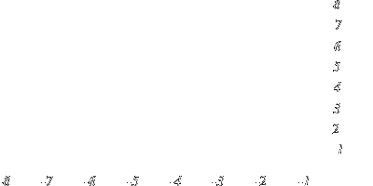
1. The path passes through the origin with vertex at (-4, 7). $h(x)=−\frac{7}{\text{16}}(x+4)^{2}+7$. To make the shot, h(-7.5) would need to be about 4. $h(−7\text{.}5)≈1\text{.}\text{64}$; he doesn’t make it.

2. $g(x)=x^{2}−6x+\text{13}$ in Standard form; $g(x)=(x−3)^{2}+4$in Transformation form

3. Vertical intercept at (0, 13), NO horizontal intercepts.

4. a. Vertex is a minimum value
b. Vertex is a maximum value

Section 3.2 Exercises

Write an equation for the quadratic function graphed.
1. 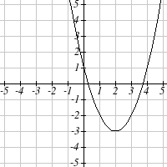 2. 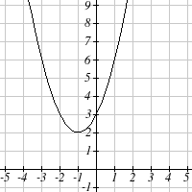

3. 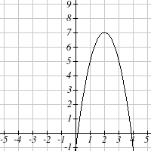 4. 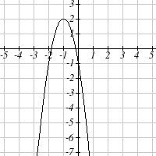

5. 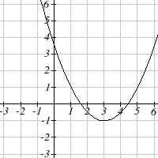 6. 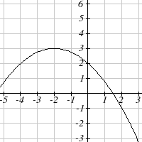

For each of the follow quadratic functions, find a) the vertex, b) the vertical intercept, and c) the horizontal intercepts.
7. $y\left(x\right)=2x^{2}+\text{10}x+\text{12}$ 8. $z\left(p\right)=3x^{2}+6x−9$
9. $f\left(x\right)=2x^{2}−\text{10}x+4$ 10. $g\left(x\right)=−2x^{2}−\text{14}x+\text{12}$
11. $h\left(t\right)=−4t^{2}+6t−1$ 12. $k\left(t\right)=2x^{2}+4x−\text{15}$

Rewrite the quadratic function into vertex form.
13. $f\left(x\right)=x^{2}−\text{12}x+\text{32}$ 14. $g\left(x\right)=x^{2}+2x−3$
15. $h\left(x\right)=2x^{2}+8x−\text{10}$ 16. $k\left(x\right)=3x^{2}−6x−9$
17. Find the values of b and c so $f\left(x\right)=−8x^{2}+\text{bx}+c$ has vertex $\left(2\text{, }−7\right)$
18. Find the values of b and c so $f\left(x\right)=6x^{2}+\text{bx}+c$ has vertex $(7\text{, }−9)$

Write an equation for a quadratic with the given features
- x-intercepts (-3, 0) and (1, 0), and y intercept (0, 2)
- x-intercepts (2, 0) and (-5, 0), and y intercept (0, 3)
- x-intercepts (2, 0) and (5, 0), and y intercept (0, 6)
- x-intercepts (1, 0) and (3, 0), and y intercept (0, 4)
- Vertex at (4, 0), and y intercept (0, -4)
- Vertex at (5, 6), and y intercept (0, -1)
- Vertex at (-3, 2), and passing through (3, -2)
- Vertex at (1, -3), and passing through (-2, 3)

- A rocket is launched in the air. Its height, in meters above sea level, as a function of time, in seconds, is given by $h\left(t\right)=−4\text{.}9t^{2}+\text{229}t+\text{234}$.
  - From what height was the rocket launched?
  - How high above sea level does the rocket reach its peak?
  - Assuming the rocket will splash down in the ocean, at what time does splashdown occur?

- A ball is thrown in the air from the top of a building. Its height, in meters above ground, as a function of time, in seconds, is given by $h\left(t\right)=−4\text{.}9t^{2}+\text{24}t+8$.
- From what height was the ball thrown?
- How high above ground does the ball reach its peak?
- When does the ball hit the ground?

- The height of a ball thrown in the air is given by $h\left(x\right)=−\frac{1}{\text{12}}x^{2}+6x+3$, where x is the horizontal distance in feet from the point at which the ball is thrown.
- How high is the ball when it was thrown?
- What is the maximum height of the ball?
- How far from the thrower does the ball strike the ground?

- A javelin is thrown in the air. Its height is given by $h\left(x\right)=−\frac{1}{\text{20}}x^{2}+8x+6$, where x is the horizontal distance in feet from the point at which the javelin is thrown.
- How high is the javelin when it was thrown?
- What is the maximum height of the javelin?
- How far from the thrower does the javelin strike the ground?
- A box with a square base and no top is to be made from a square piece of cardboard by cutting 6 in. squares out of each corner and folding up the sides. The box needs to hold 1000 in³. How big a piece of cardboard is needed?

- A box with a square base and no top is to be made from a square piece of cardboard by cutting 4 in. squares out of each corner and folding up the sides. The box needs to hold 2700 in³. How big a piece of cardboard is needed?

- A farmer wishes to enclose two pens with fencing, as shown. If the farmer has 500 feet of fencing to work with, what dimensions will maximize the area enclosed?

- A farmer wishes to enclose three pens with fencing, as shown. If the farmer has 700 feet of fencing to work with, what dimensions will maximize the area enclosed?

- You have a wire that is 56 cm long. You wish to cut it into two pieces. One piece will be bent into the shape of a square. The other piece will be bent into the shape of a circle. Let A represent the total area enclosed by the square and the circle. What is the circumference of the circle when A is a minimum?

- You have a wire that is 71 cm long. You wish to cut it into two pieces. One piece will be bent into the shape of a right triangle with legs of equal length. The other piece will be bent into the shape of a circle. Let A represent the total area enclosed by the triangle and the circle. What is the circumference of the circle when A is a minimum?

- A soccer stadium holds 62,000 spectators. With a ticket price of $11, the average attendance has been 26,000. When the price dropped to $9, the average attendance rose to 31,000. Assuming that attendance is linearly related to ticket price, what ticket price would maximize revenue?

- A farmer finds that if she plants 75 trees per acre, each tree will yield 20 bushels of fruit. She estimates that for each additional tree planted per acre, the yield of each tree will decrease by 3 bushels. How many trees should she plant per acre to maximize her harvest?

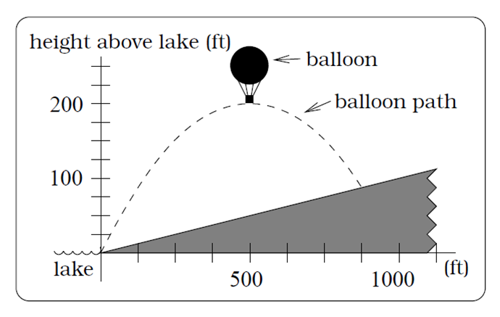
- A hot air balloon takes off from the edge of a mountain lake. Impose a coordinate system as pictured and assume that the path of the balloon follows the graph of $f\left(x\right)=−\frac{2}{\text{2500}}x^{2}+\frac{4}{5}x$. The land rises at a constant incline from the lake at the rate of 2 vertical feet for each 20 horizontal feet. [UW]
  - What is the maximum height of the balloon above water level?
  - What is the maximum height of the balloon above ground level?
  - Where does the balloon land on the ground?
  - Where is the balloon 50 feet above the ground?

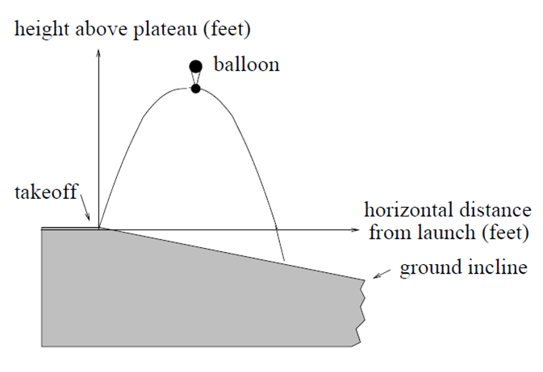
- A hot air balloon takes off from the edge of a plateau. Impose a coordinate system as pictured below and assume that the path the balloon follows is the graph of the quadratic function $f\left(x\right)=−\frac{4}{\text{2500}}x^{2}+\frac{4}{5}x$. The land drops at a constant incline from the plateau at the rate of 1 vertical foot for each 5 horizontal feet. [UW]
  - What is the maximum height of the balloon above plateau level?
  - What is the maximum height of the balloon above ground level?
  - Where does the balloon land on the ground?
  - Where is the balloon 50 feet above the ground?

Section 3.3 Graphs of Polynomial Functions

In the previous section we explored the short run behavior of quadratics, a special case of polynomials. In this section we will explore the short run behavior of polynomials in general.

Short run Behavior: Intercepts

As with any function, the vertical intercept can be found by evaluating the function at an input of zero. Since this is evaluation, it is relatively easy to do it for a polynomial of any degree.

To find horizontal intercepts, we need to solve for when the output will be zero. For general polynomials, this can be a challenging prospect. While quadratics can be solved using the relatively simple quadratic formula, the corresponding formulas for cubic and 4th degree polynomials are not simple enough to remember, and formulas do not exist for general higher-degree polynomials. Consequently, we will limit ourselves to three cases:
- The polynomial can be factored using known methods: greatest common factor and trinomial factoring.
- The polynomial is given in factored form.
- Technology is used to determine the intercepts.

Example 1
Find the horizontal intercepts of $f(x)=x^{6}−3x^{4}+2x^{2}$.

We can attempt to factor this polynomial to find solutions for f(x) = 0.
$x^{6}−3x^{4}+2x^{2}=0$ Factoring out the greatest common factor
$x^{2}\left(x^{4}−3x^{2}+2\right)=0$ Factoring the inside as a quadratic in x²
$x^{2}\left(x^{2}−1\right)\left(x^{2}−2\right)=0$ Then break apart to find solutions
$\begin{aligned}x^{2}=0 \\ x=0\end{aligned}$ or $\begin{aligned}\left(x^{2}−1\right)=0 \\ x^{2}=1 \\ x=±1\end{aligned}$ or $\begin{aligned}\left(x^{2}−2\right)=0 \\ x^{2}=2 \\ x=±\sqrt{2}\end{aligned}$

This gives us 5 horizontal intercepts.

Example 2
Find the vertical and horizontal intercepts of $g(t)=(t−2)^{2}(2t+3)$

The vertical intercept can be found by evaluating g(0).
$$g(0)=(0−2)^{2}(2(0)+3)=\text{12}$$
The horizontal intercepts can be found by solving g(t) = 0
$(t−2)^{2}(2t+3)=0$ Since this is already factored, we can break it apart:
$\begin{aligned}(t−2)^{2}=0 \\ t−2=0 \\ t=2\end{aligned}$ or $\begin{aligned}(2t+3)=0 \\ t=\frac{−3}{2}\end{aligned}$

We can always check our answers are reasonable by graphing the polynomial.

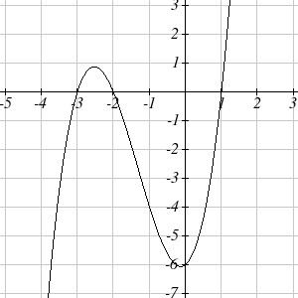
Example 3
Find the horizontal intercepts of $h(t)=t^{3}+4t^{2}+t−6$

Since this polynomial is not in factored form, has no common factors, and does not appear to be factorable using techniques we know, we can turn to technology to find the intercepts.

Graphing this function, it appears there are horizontal intercepts at t = -3, -2, and 1.

We could check these are correct by plugging in these values for t and verifying that $h(−3)=h(−2)=h(1)=0$.

Try it Now
1. Find the vertical and horizontal intercepts of the function$f(t)=t^{4}−4t^{2}$.

Graphical Behavior at Intercepts
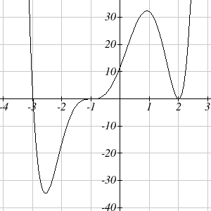
If we graph the function $f(x)=(x+3)(x−2)^{2}(x+1)^{3}$, notice that the behavior at each of the horizontal intercepts is different.

At the horizontal intercept x = -3, coming from the $(x+3)$ factor of the polynomial, the graph passes directly through the horizontal intercept. The factor is linear (has a power of 1), so the behavior near the intercept is like that of a line - it passes directly through the intercept. We call this a single zero, since the zero corresponds to a single factor of the function.
At the horizontal intercept x = 2, coming from the $(x−2)^{2}$ factor of the polynomial, the graph touches the axis at the intercept and changes direction. The factor is quadratic (degree 2), so the behavior near the intercept is like that of a quadratic – it bounces off of the horizontal axis at the intercept. Since $(x−2)^{2}=(x−2)(x−2)$, the factor is repeated twice, so we call this a double zero.

At the horizontal intercept x = -1, coming from the $(x+1)^{3}$ factor of the polynomial, the graph passes through the axis at the intercept, but flattens out a bit first. This factor is cubic (degree 3), so the behavior near the intercept is like that of a cubic, with the same “S” type shape near the intercept that the toolkit $x^{3}$ has. We call this a triple zero.

By utilizing these behaviors, we can sketch a reasonable graph of a factored polynomial function without needing technology.

Graphical Behavior of Polynomials at Horizontal Intercepts
If a polynomial contains a factor of the form $(x−h)^{p}$, the behavior near the horizontal intercept h is determined by the power on the factor.
p = 1 p = 2 p = 3
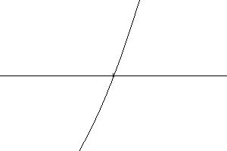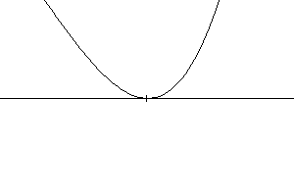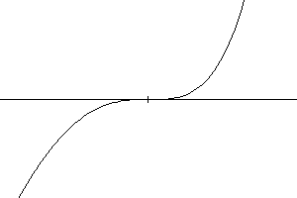
Single zero Double zero Triple zero

For higher even powers 4,6,8 etc.… the graph will still bounce off of the horizontal axis but the graph will appear flatter with each increasing even power as it approaches and leaves the axis.

For higher odd powers, 5,7,9 etc… the graph will still pass through the horizontal axis but the graph will appear flatter with each increasing odd power as it approaches and leaves the axis.

Example 4
Sketch a graph of $f(x)=−2(x+3)^{2}(x−5)$.

This graph has two horizontal intercepts. At x = -3, the factor is squared, indicating the graph will bounce at this horizontal intercept. At x = 5, the factor is not squared, indicating the graph will pass through the axis at this intercept.

Additionally, we can see the leading term, if this polynomial were multiplied out, would be $−2x^{3}$, so the long-run behavior is that of a vertically reflected cubic, with the outputs decreasing as the inputs get large positive, and the inputs increasing as the inputs get large negative.

To sketch this we consider the following:
As $x→−∞$ the function $f(x)→∞$ so we know the graph starts in the 2nd quadrant and is decreasing toward the horizontal axis.

At (-3, 0) the graph bounces off of the horizontal axis and so the function must start increasing.

At (0, 90) the graph crosses the vertical axis at the vertical intercept.

Somewhere after this point, the graph must turn back down or start decreasing toward the horizontal axis since the graph passes through the next intercept at (5,0).
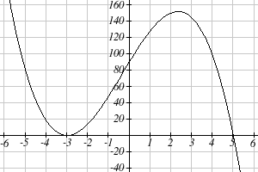
As $x→∞$ the function$f(x)→−∞$ so we know the graph continues to decrease and we can stop drawing the graph in the 4th quadrant.

Using technology we can verify that the resulting graph will look like:

Solving Polynomial Inequalities

One application of our ability to find intercepts and sketch a graph of polynomials is the ability to solve polynomial inequalities. It is a very common question to ask when a function will be positive and negative. We can solve polynomial inequalities by either utilizing the graph, or by using test values.

Example 5
Solve $(x+3)(x+1)^{2}(x−4)>0$

As with all inequalities, we start by solving the equality $(x+3)(x+1)^{2}(x−4)=0$, which has solutions at x = -3, -1, and 4. We know the function can only change from positive to negative at these values, so these divide the inputs into 4 intervals.
We could choose a test value in each interval and evaluate the function $f(x)=(x+3)(x+1)^{2}(x−4)$ at each test value to determine if the function is positive or negative in that interval

Interval | Test x in interval | f( test value) | >0 or <0?
x < -3 | -4 | 72 | > 0
-3 < x < -1 | -2 | -6 | < 0
-1 < x < 4 | 0 | -12 | < 0
x > 4 | 5 | 288 | > 0

On a number line this would look like:
0
0
0
positive
negative
negative
positive

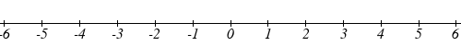

From our test values, we can determine this function is positive when x < -3 or x > 4, or in interval notation, $(−∞,−3)∪(4,∞)$

We could have also determined on which intervals the function was positive by sketching a graph of the function. We illustrate that technique in the next example

Example 6
Find the domain of the function $v(t)=\sqrt{6−5t−t^{2}}$.

A square root is only defined when the quantity we are taking the square root of, the quantity inside the square root, is zero or greater. Thus, the domain of this function will be when $6−5t−t^{2}≥0$.

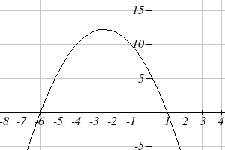
Again we start by solving the equality $6−5t−t^{2}=0$. While we could use the quadratic formula, this equation factors nicely to $(6+t)(1−t)=0$, giving horizontal intercepts t = 1 and t = -6. Sketching a graph of this quadratic will allow us to determine when it is positive.

From the graph we can see this function is positive for inputs between the intercepts. So $6−5t−t^{2}≥0$ for $−6≤t≤1$, and this will be the domain of the v(t) function.

Try it Now
2. Given the function $g(x)=x^{3}−x^{2}−6x$ use the methods that we have learned so far to find the vertical & horizontal intercepts, determine where the function is negative and positive, describe the long run behavior and sketch the graph without technology.

Writing Equations using Intercepts

Since a polynomial function written in factored form will have a horizontal intercept where each factor is equal to zero, we can form a function that will pass through a set of horizontal intercepts by introducing a corresponding set of factors.

Factored Form of Polynomials
If a polynomial has horizontal intercepts at $x=x_{1},x_{2},…,x_{n}$, then the polynomial can be written in the factored form
$$f(x)=a(x−x_{1})^{p_{1}}(x−x_{2})^{p_{2}}⋯(x−x_{n})^{p_{n}}$$
where the powers p_{i} on each factor can be determined by the behavior of the graph at the corresponding intercept, and the stretch factor a can be determined given a value of the function other than the horizontal intercept.

Example 7
Write a formula for the polynomial function graphed here.
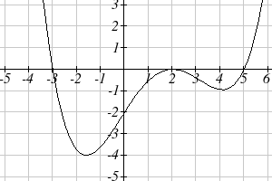

This graph has three horizontal intercepts: x = -3, 2, and 5. At x = -3 and 5 the graph passes through the axis, suggesting the corresponding factors of the polynomial will be linear. At x = 2 the graph bounces at the intercept, suggesting the corresponding factor of the polynomial will be 2nd degree (quadratic). Together, this gives us:
$$f(x)=a(x+3)(x−2)^{2}(x−5)$$

To determine the stretch factor, we can utilize another point on the graph. Here, the vertical intercept appears to be (0,-2), so we can plug in those values to solve for a:
$$\begin{aligned}−2=a(0+3)(0−2)^{2}(0−5) \\ −2=−\text{60}a \\ a=\frac{1}{\text{30}}\end{aligned}$$

The graphed polynomial appears to represent the function $f(x)=\frac{1}{\text{30}}(x+3)(x−2)^{2}(x−5)$.

Try it Now
3. Given the graph, write a formula for the function shown.

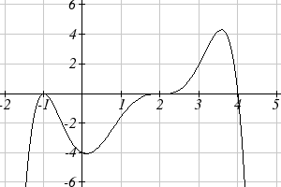

Estimating Extrema

With quadratics, we were able to algebraically find the maximum or minimum value of the function by finding the vertex. For general polynomials, finding these turning points is not possible without more advanced techniques from calculus. Even then, finding where extrema occur can still be algebraically challenging. For now, we will estimate the locations of turning points using technology to generate a graph.

Example 8
An open-top box is to be constructed by cutting out squares from each corner of a 14cm by 20cm sheet of plastic then folding up the sides. Find the size of squares that should be cut out to maximize the volume enclosed by the box.
w
w

We will start this problem by drawing a picture, labeling the width of the cut-out squares with a variable, w.

Notice that after a square is cut out from each end, it leaves a (14-2w) cm by (20-2w) cm rectangle for the base of the box, and the box will be w cm tall. This gives the volume:
$$V(w)=(\text{14}−2w)(\text{20}−2w)w=\text{280}w−\text{68}w^{2}+4w^{3}$$

Using technology to sketch a graph allows us to estimate the maximum value for the volume, restricted to reasonable values for w: values from 0 to 7.

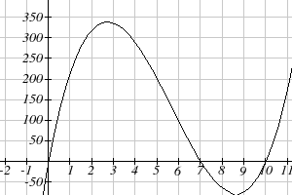

From this graph, we can estimate the maximum value is around 340, and occurs when the squares are about 2.75cm square. To improve this estimate, we could use advanced features of our technology, if available, or simply change our window to zoom in on our graph.

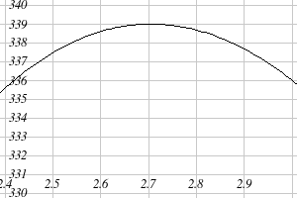
From this zoomed-in view, we can refine our estimate for the max volume to about 339, when the squares are 2.7cm square.

Try it Now
4. Use technology to find the maximum and minimum values on the interval [-1, 4] of the function$f(x)=−0\text{.}2(x−2)^{3}(x+1)^{2}(x−4)$.

Important Topics of this Section
Short Run Behavior
Intercepts (Horizontal & Vertical)
Methods to find Horizontal intercepts
Factoring Methods
Factored Forms
Technology
Graphical Behavior at intercepts
Single, Double and Triple zeros (or power 1, 2, and 3 behaviors)
Solving polynomial inequalities using test values & graphing techniques
Writing equations using intercepts
Estimating extrema

Try it Now Answers
1. Vertical intercept (0, 0), Horizontal intercepts (0, 0), (-2, 0), (2, 0)
2. Vertical intercept (0, 0), Horizontal intercepts (-2, 0), (0, 0), (3, 0)
The function is negative on ($−∞$, -2) and (0, 3)
The function is positive on (-2, 0) and (3,$∞$)
The leading term is $x^{3}$so as$x→−∞$, $g(x)→−∞$and as$x→∞$, $g(x)→∞$

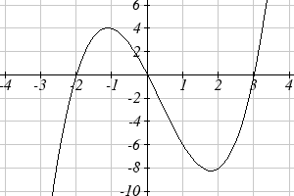

3. $f(x)=−\frac{1}{8}(x−2)^{3}(x+1)^{2}(x−4)$
4. The minimum occurs at approximately the point (0, -6.5), and the maximum occurs at approximately the point (3.5, 7).

Section 3.3 Exercises

Find the C and t intercepts of each function.
1. $C\left(t\right)=2\left(t−4\right)\left(t+1\right)(t−6)$ 2. $C\left(t\right)=3\left(t+2\right)\left(t−3\right)(t+5)$
3. $C\left(t\right)=4t{\left(t−2\right)}^{2}(t+1)$ 4. $C\left(t\right)=2t\left(t−3\right){\left(t+1\right)}^{2}$
5. $C\left(t\right)=2t^{4}−8t^{3}+6t^{2}$ 6. $C\left(t\right)=4t^{4}+\text{12}t^{3}−\text{40}t^{2}$

Use your calculator or other graphing technology to solve graphically for the zeros of the function.
7. $f\left(x\right)=x^{3}−7x^{2}+4x+\text{30}$ 8. $g\left(x\right)=x^{3}−6x^{2}+x+\text{28}$

Find the long run behavior of each function as $t→∞$ and $t→−∞$
9. $h\left(t\right)=3{\left(t−5\right)}^{3}{\left(t−3\right)}^{3}(t−2)$ 10. $k\left(t\right)=2{\left(t−3\right)}^{2}{\left(t+1\right)}^{3}(t+2)$
11. $p\left(t\right)=−2t\left(t−1\right){\left(3−t\right)}^{2}$ 12. $q\left(t\right)=−4t\left(2−t\right){\left(t+1\right)}^{3}$

Sketch a graph of each equation.
13. $f\left(x\right)={\left(x+3\right)}^{2}(x−2)$ 14. $g\left(x\right)=\left(x+4\right){\left(x−1\right)}^{2}$
15. $h\left(x\right)={\left(x−1\right)}^{3}{\left(x+3\right)}^{2}$ 16. $k\left(x\right)={\left(x−3\right)}^{3}{\left(x−2\right)}^{2}$
17. $m\left(x\right)=−2x\left(x−1\right)(x+3)$ 18. $n\left(x\right)=−3x\left(x+2\right)(x−4)$

Solve each inequality.
19. $\left(x−3\right){\left(x−2\right)}^{2}>0$ 20. $\left(x−5\right){\left(x+1\right)}^{2}>0$
21. $\left(x−1\right)\left(x+2\right)\left(x−3\right)<0$ 22. $\left(x−4\right)\left(x+3\right)\left(x+6\right)<0$

Find the domain of each function.
23. $f\left(x\right)=\sqrt{−\text{42}+\text{19}x−2x^{2}}$ 24. $g\left(x\right)=\sqrt{\text{28}−\text{17}x−3x^{2}}$
25. $h\left(x\right)=\sqrt{4−5x+x^{2}}$ 26. $k\left(x\right)=\sqrt{2+7x+3x^{2}}$
27. $n\left(x\right)=\sqrt{\left(x−3\right){\left(x+2\right)}^{2}}$ 28. $m\left(x\right)=\sqrt{{\left(x−1\right)}^{2}(x+3)}$
29. $p\left(t\right)=\frac{1}{t^{2}+2t−8}$ 30. $q\left(t\right)=\frac{4}{x^{2}−4x−5}$
Write an equation for a polynomial the given features.
- Degree 3. Zeros at x = -2, x = 1, and x = 3. Vertical intercept at (0, -4)
- Degree 3. Zeros at x = -5, x = -2, and x = 1. Vertical intercept at (0, 6)
- Degree 5. Roots of multiplicity 2 at x = 3 and x = 1, and a root of multiplicity 1 at x = -3. Vertical intercept at (0, 9)
- Degree 4. Root of multiplicity 2 at x = 4, and a roots of multiplicity 1 at x = 1 and x = -2. Vertical intercept at (0, -3)
- Degree 5. Double zero at x = 1, and triple zero at x = 3. Passes through the point (2, 15)
- Degree 5. Single zero at x = -2 and x = 3, and triple zero at x = 1. Passes through the point (2, 4)

Write a formula for each polynomial function graphed.

37.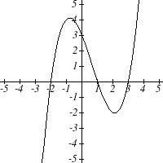 38.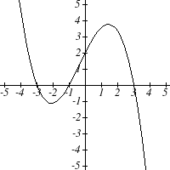 39.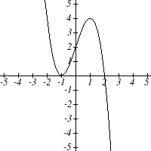
40.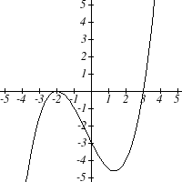41.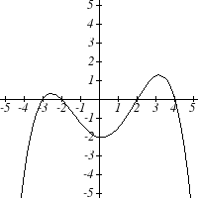 42.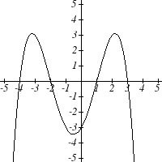

43.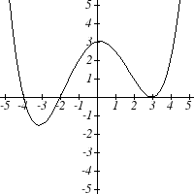 44.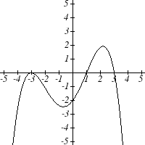

Write a formula for each polynomial function graphed.

45.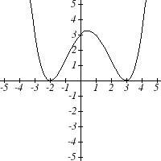 46.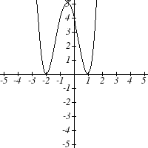

47.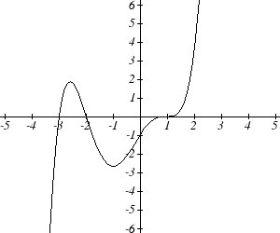 48. 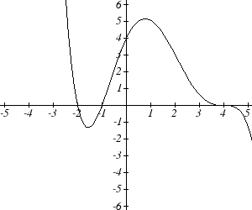

49.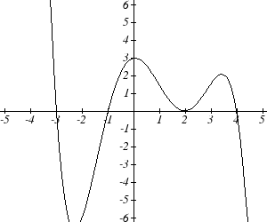 50. 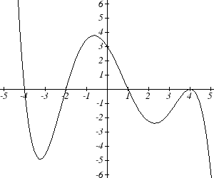

- A rectangle is inscribed with its base on the x axis and its upper corners on the parabola $y=5−x^{2}$. What are the dimensions of such a rectangle that has the greatest possible area?

- A rectangle is inscribed with its base on the x axis and its upper corners on the curve $y=\text{16}−x^{4}$. What are the dimensions of such a rectangle that has the greatest possible area?

Section 3.4 Rational Functions

In the last few sections, we have built polynomials based on the positive whole number power functions. In this section we explore functions based on power functions with negative integer powers, called rational functions.

Example 1
You plan to drive 100 miles. Find a formula for the time the trip will take as a function of the speed you drive.

You may recall that multiplying speed by time will give you distance. If we let t represent the drive time in hours, and v represent the velocity (speed or rate) at which we drive, then $\text{vt}=\text{distance}$. Since our distance is fixed at 100 miles, $\text{vt}=\text{100}$. Solving this relationship for the time gives us the function we desired:
$$t(v)=\frac{\text{100}}{v}=\text{100}v^{−1}$$

While this type of relationship can be written using the negative exponent, it is more common to see it written as a fraction.

This particular example is one of an inversely proportional relationship – where one quantity is a constant divided by the other quantity, like $y=\frac{5}{x}$.
Notice that this is a transformation of the reciprocal toolkit function, $f(x)=\frac{1}{x}$

Several natural phenomena, such as gravitational force and volume of sound, behave in a manner inversely proportional to the square of another quantity. For example, the volume, V, of a sound heard at a distance d from the source would be related by $V=\frac{k}{d^{2}}$ for some constant value k.
These functions are transformations of the reciprocal squared toolkit function $f(x)=\frac{1}{x^{2}}$.

We have seen the graphs of the basic reciprocal function and the squared reciprocal function from our study of toolkit functions. These graphs have several important features.

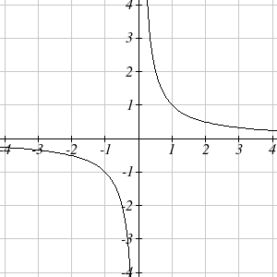
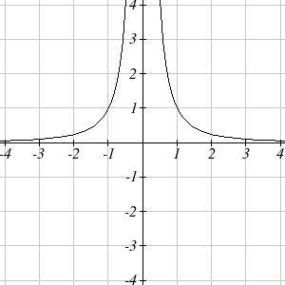

$f(x)=\frac{1}{x}$ $f(x)=\frac{1}{x^{2}}$

Let’s begin by looking at the reciprocal function, $f(x)=\frac{1}{x}$. As you well know, dividing by zero is not allowed and therefore zero is not in the domain, and so the function is undefined at an input of zero.

Short run behavior:
As the input values approach zero from the left side (taking on very small, negative values), the function values become very large in the negative direction (in other words, they approach negative infinity).
We write: as$x→0^{−}$, $f(x)→−∞$.

As we approach zero from the right side (small, positive input values), the function values become very large in the positive direction (approaching infinity).
We write: as$x→0^{+}$,$f(x)→∞$.

This behavior creates a vertical asymptote. An asymptote is a line that the graph approaches. In this case the graph is approaching the vertical line x = 0 as the input becomes close to zero.

Long run behavior:
As the values of x approach infinity, the function values approach 0.
As the values of x approach negative infinity, the function values approach 0.
Symbolically: as$x→±∞$,$f(x)→0$

Based on this long run behavior and the graph we can see that the function approaches 0 but never actually reaches 0, it just “levels off” as the inputs become large. This behavior creates a horizontal asymptote. In this case the graph is approaching the horizontal line $f(x)=0$as the input becomes very large in the negative and positive directions.

Vertical and Horizontal Asymptotes
A vertical asymptote of a graph is a vertical line x = a where the graph tends towards positive or negative infinity as the inputs approach a. As$x→a$,$f(x)→±∞$.

A horizontal asymptote of a graph is a horizontal line$y=b$ where the graph approaches the line as the inputs get large. As$x→±∞$,$f(x)→b$.
Try it Now:
1. Use symbolic notation to describe the long run behavior and short run behavior for the reciprocal squared function.

Example 2
Sketch a graph of the reciprocal function shifted two units to the left and up three units. Identify the horizontal and vertical asymptotes of the graph, if any.

Transforming the graph left 2 and up 3 would result in the function
$f(x)=\frac{1}{x+2}+3$, or equivalently, by giving the terms a common denominator, $f(x)=\frac{3x+7}{x+2}$
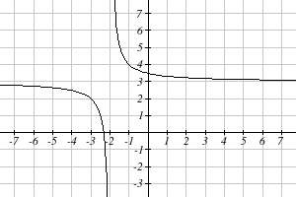
Shifting the toolkit function would give us this graph. Notice that this equation is undefined at x = -2, and the graph also is showing a vertical asymptote at x = -2.
As$x→−2^{−}$,$f(x)→−∞$, and as $x→−2^{+}$,$f(x)→∞$

As the inputs grow large, the graph appears to be leveling off at output values of 3, indicating a horizontal asymptote at $y=3$.
As $x→±∞$, $f(x)→3$.

Notice that horizontal and vertical asymptotes get shifted left 2 and up 3 along with the function.

Try it Now
2. Sketch the graph and find the horizontal and vertical asymptotes of the reciprocal squared function that has been shifted right 3 units and down 4 units.

In the previous example, we shifted a toolkit function in a way that resulted in a function of the form $f(x)=\frac{3x+7}{x+2}$. This is an example of a more general rational function.

Rational Function
A rational function is a function that can be written as the ratio of two polynomials, P(x) and Q(x).
$f(x)=\frac{P(x)}{Q(x)}=\frac{a_{0}+a_{1}x+a_{2}x^{2}+⋯+a_{p}x^{p}}{b_{0}+b_{1}x+b_{2}x^{2}+⋯+b_{q}x^{q}}$

Example 3
A large mixing tank currently contains 100 gallons of water, into which 5 pounds of sugar have been mixed. A tap will open pouring 10 gallons per minute of water into the tank at the same time sugar is poured into the tank at a rate of 1 pound per minute. Find the concentration (pounds per gallon) of sugar in the tank after t minutes.

Notice that the amount of water in the tank is changing linearly, as is the amount of sugar in the tank. We can write an equation independently for each:
$$\text{water}=\text{100}+\text{10}t$$
$$\text{sugar}=5+1t$$

The concentration, C, will be the ratio of pounds of sugar to gallons of water
$$C(t)=\frac{5+t}{\text{100}+\text{10}t}$$

Finding Asymptotes and Intercepts

Given a rational function, as part of investigating the short run behavior we are interested in finding any vertical and horizontal asymptotes, as well as finding any vertical or horizontal intercepts, as we have done in the past.

To find vertical asymptotes, we notice that the vertical asymptotes in our examples occur when the denominator of the function is undefined. With one exception, a vertical asymptote will occur whenever the denominator is undefined.

Example 4
Find the vertical asymptotes of the function $k(x)=\frac{5+2x^{2}}{2−x−x^{2}}$

To find the vertical asymptotes, we determine where this function will be undefined by setting the denominator equal to zero:
$$\begin{aligned}2−x−x^{2}=0 \\ (2+x)(1−x)=0 \\ x=−2, 1\end{aligned}$$

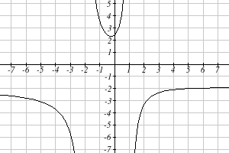
This indicates two vertical asymptotes, which a look at a graph confirms.

The exception to this rule can occur when both the numerator and denominator of a rational function are zero at the same input.

Example 5
Find the vertical asymptotes of the function $k(x)=\frac{x−2}{x^{2}−4}$.

To find the vertical asymptotes, we determine where this function will be undefined by setting the denominator equal to zero:
$$\begin{aligned}x^{2}−4=0 \\ x^{2}=4 \\ x=−2, 2\end{aligned}$$

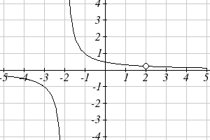
However, the numerator of this function is also equal to zero when x = 2. Because of this, the function will still be undefined at 2, since $\frac{0}{0}$ is undefined, but the graph will not have a vertical asymptote at x = 2.

The graph of this function will have the vertical asymptote at x = -2, but at x = 2 the graph will have a hole: a single point where the graph is not defined, indicated by an open circle.

Vertical Asymptotes and Holes of Rational Functions
The vertical asymptotes of a rational function will occur where the denominator of the function is equal to zero and the numerator is not zero.

A hole might occur in the graph of a rational function if an input causes both numerator and denominator to be zero. In this case, factor the numerator and denominator and simplify; if the simplified expression still has a zero in the denominator at the original input the original function has a vertical asymptote at the input, otherwise it has a hole.
To find horizontal asymptotes, we are interested in the behavior of the function as the input grows large, so we consider long run behavior of the numerator and denominator separately. Recall that a polynomial’s long run behavior will mirror that of the leading term. Likewise, a rational function’s long run behavior will mirror that of the ratio of the leading terms of the numerator and denominator functions.

There are three distinct outcomes when this analysis is done:

Case 1: The degree of the denominator > degree of the numerator
Example: $f(x)=\frac{3x+2}{x^{2}+4x−5}$
In this case, the long run behavior is $f(x)≈\frac{3x}{x^{2}}=\frac{3}{x}$. This tells us that as the inputs grow large, this function will behave similarly to the function $g(x)=\frac{3}{x}$. As the inputs grow large, the outputs will approach zero, resulting in a horizontal asymptote at $y=0$.
As $x→±∞$, $f(x)→0$

Case 2: The degree of the denominator < degree of the numerator
Example: $f(x)=\frac{3x^{2}+2}{x−5}$
In this case, the long run behavior is$f(x)≈\frac{3x^{2}}{x}=3x$. This tells us that as the inputs grow large, this function will behave similarly to the function$g(x)=3x$. As the inputs grow large, the outputs will grow and not level off, so this graph has no horizontal asymptote.
As$x→±∞$,$f(x)→±∞$, respectively.

Ultimately, if the numerator is larger than the denominator, the long run behavior of the graph will mimic the behavior of the reduced long run behavior fraction. As another example if we had the function $f(x)=\frac{3x^{5}−x^{2}}{x+3}$ with long run behavior $f(x)≈\frac{3x^{5}}{x}=3x^{4}$, the long run behavior of the graph would look similar to that of an even polynomial, and as $x→±∞$,$f(x)→∞$.

Case 3: The degree of the denominator = degree of the numerator
Example: $f(x)=\frac{3x^{2}+2}{x^{2}+4x−5}$
In this case, the long run behavior is $f(x)≈\frac{3x^{2}}{x^{2}}=3$. This tells us that as the inputs grow large, this function will behave like the function $g(x)=3$, which is a horizontal line. As $x→±∞$, $f(x)→3$, resulting in a horizontal asymptote at $y=3$.

Horizontal Asymptote of Rational Functions
The horizontal asymptote of a rational function can be determined by looking at the degrees of the numerator and denominator.
Degree of denominator > degree of numerator: Horizontal asymptote at $y=0$
Degree of denominator < degree of numerator: No horizontal asymptote
Degree of denominator = degree of numerator: Horizontal asymptote at ratio of leading coefficients.

Example 6
In the sugar concentration problem from earlier, we created the equation $C(t)=\frac{5+t}{\text{100}+\text{10}t}$.
Find the horizontal asymptote and interpret it in context of the scenario.

Both the numerator and denominator are linear (degree 1), so since the degrees are equal, there will be a horizontal asymptote at the ratio of the leading coefficients. In the numerator, the leading term is t, with coefficient 1. In the denominator, the leading term is 10t, with coefficient 10. The horizontal asymptote will be at the ratio of these values: As $t→∞$, $C(t)→\frac{1}{\text{10}}$. This function will have a horizontal asymptote at $y=\frac{1}{\text{10}}$.

This tells us that as the input gets large, the output values will approach 1/10. In context, this means that as more time goes by, the concentration of sugar in the tank will approach one tenth of a pound of sugar per gallon of water or 1/10 pounds per gallon.

Example 7
Find the horizontal and vertical asymptotes of the function
$$f(x)=\frac{(x−2)(x+3)}{(x−1)(x+2)(x−5)}$$

First, note this function has no inputs that make both the numerator and denominator zero, so there are no potential holes. The function will have vertical asymptotes when the denominator is zero, causing the function to be undefined. The denominator will be zero at x = 1, -2, and 5, indicating vertical asymptotes at these values.
The numerator has degree 2, while the denominator has degree 3. Since the degree of the denominator is greater than the degree of the numerator, the denominator will grow faster than the numerator, causing the outputs to tend towards zero as the inputs get large, and so as $x→±∞$, $f(x)→0$. This function will have a horizontal asymptote at $y=0$.

Try it Now
3. Find the vertical and horizontal asymptotes of the function
$$f(x)=\frac{(2x−1)(2x+1)}{(x−2)(x+3)}$$

Intercepts

As with all functions, a rational function will have a vertical intercept when the input is zero, if the function is defined at zero. It is possible for a rational function to not have a vertical intercept if the function is undefined at zero.

Likewise, a rational function will have horizontal intercepts at the inputs that cause the output to be zero (unless that input corresponds to a hole). It is possible there are no horizontal intercepts. Since a fraction is only equal to zero when the numerator is zero, horizontal intercepts will occur when the numerator of the rational function is equal to zero.

Example 8
Find the intercepts of $f(x)=\frac{(x−2)(x+3)}{(x−1)(x+2)(x−5)}$

We can find the vertical intercept by evaluating the function at zero
$$f(0)=\frac{(0−2)(0+3)}{(0−1)(0+2)(0−5)}=\frac{−6}{\text{10}}=−\frac{3}{5}$$

The horizontal intercepts will occur when the function is equal to zero:
$0=\frac{(x−2)(x+3)}{(x−1)(x+2)(x−5)}$ This is zero when the numerator is zero
$$\begin{aligned}0=(x−2)(x+3) \\ x=2, −3\end{aligned}$$

Try it Now
4. Given the reciprocal squared function that is shifted right 3 units and down 4 units, write this as a rational function and find the horizontal and vertical intercepts and the horizontal and vertical asymptotes.
From the previous example, you probably noticed that the numerator of a rational function reveals the horizontal intercepts of the graph, while the denominator reveals the vertical asymptotes of the graph. As with polynomials, factors of the numerator may have integer powers greater than one. Happily, the effect on the shape of the graph at those intercepts is the same as we saw with polynomials.

When factors of the denominator have integer powers greater than one, the behavior at the corresponding vertical asymptote will mirror one of the two toolkit reciprocal functions.
We get this behavior when the degree of the factor in the denominator is odd. The distinguishing characteristic is that on one side of the vertical asymptote the graph heads towards positive infinity, and on the other side the graph heads towards negative infinity.

We get this behavior when the degree of the factor in the denominator is even. The distinguishing characteristic is that the graph either heads toward positive infinity on both sides of the vertical asymptote, or heads toward negative infinity on both sides.

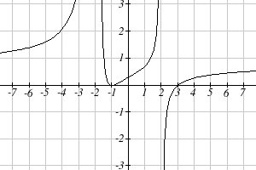
For example, the graph of $f(x)=\frac{(x+1)^{2}(x−3)}{(x+3)^{2}(x−2)}$ is shown here.

At the horizontal intercept x = -1 corresponding to the $(x+1)^{2}$factor of the numerator, the graph bounces at the intercept, consistent with the quadratic nature of the factor.

At the horizontal intercept x = 3 corresponding to the $(x−3)$factor of the numerator, the graph passes through the axis as we’d expect from a linear factor.

At the vertical asymptote x = -3 corresponding to the $(x+3)^{2}$ factor of the denominator, the graph heads towards positive infinity on both sides of the asymptote, consistent with the behavior of the $\frac{1}{x^{2}}$ toolkit.
At the vertical asymptote x = 2 corresponding to the $(x−2)$ factor of the denominator, the graph heads towards positive infinity on the left side of the asymptote and towards negative infinity on the right side, consistent with the behavior of the $\frac{1}{x}$ toolkit.

Example 9
Sketch a graph of $f(x)=\frac{(x+2)(x−3)}{(x+1)^{2}(x−2)}$.

We can start our sketch by finding intercepts and asymptotes. Evaluating the function at zero gives the vertical intercept:
$$f(0)=\frac{(0+2)(0−3)}{(0+1)^{2}(0−2)}=3$$

Looking at when the numerator of the function is zero, we can determine the graph will have horizontal intercepts at x = -2 and x = 3. At each, the behavior will be linear, with the graph passing through the intercept.

Looking at when the denominator of the function is zero, we can determine the graph will have vertical asymptotes at x = -1 and x = 2.

Finally, the degree of denominator is larger than the degree of the numerator, telling us this graph has a horizontal asymptote at y = 0.
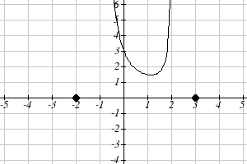
To sketch the graph, we might start by plotting the three intercepts. Since the graph has no horizontal intercepts between the vertical asymptotes, and the vertical intercept is positive, we know the function must remain positive between the asymptotes, letting us fill in the middle portion of the graph.

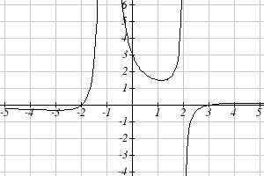
Since the factor associated with the vertical asymptote at x = -1 was squared, we know the graph will have the same behavior on both sides of the asymptote. Since the graph heads towards positive infinity as the inputs approach the asymptote on the right, the graph will head towards positive infinity on the left as well. For the vertical asymptote at x = 2, the factor was not squared, so the graph will have opposite behavior on either side of the asymptote.

After passing through the horizontal intercepts, the graph will then level off towards an output of zero, as indicated by the horizontal asymptote.
Try it Now
5. Given the function $f(x)=\frac{(x+2)^{2}(x−2)}{2(x−1)^{2}(x−3)}$, use the characteristics of polynomials and rational functions to describe its behavior and sketch the function .

Since a rational function written in factored form will have a horizontal intercept where each factor of the numerator is equal to zero, we can form a numerator that will pass through a set of horizontal intercepts by introducing a corresponding set of factors. Likewise, since the function will have a vertical asymptote where each factor of the denominator is equal to zero, we can form a denominator that will produce the vertical asymptotes by introducing a corresponding set of factors.

Writing Rational Functions from Intercepts and Asymptotes
If a rational function has horizontal intercepts at $x=x_{1},x_{2},…,x_{n}$, and vertical asymptotes at $x=v_{1},v_{2},…,v_{m}$ then the function can be written in the form
$$f(x)=a\frac{(x−x_{1})^{p_{1}}(x−x_{2})^{p_{2}}⋯(x−x_{n})^{p_{n}}}{(x−v_{1})^{q_{1}}(x−v_{2})^{q_{2}}⋯(x−v_{m})^{q_{n}}}$$
where the powers p_{i} or q_{i} on each factor can be determined by the behavior of the graph at the corresponding intercept or asymptote, and the stretch factor a can be determined given a value of the function other than the horizontal intercept, or by the horizontal asymptote if it is nonzero.

Example 10
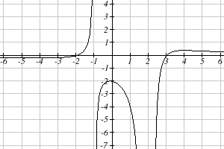
Write an equation for the rational function graphed here.

The graph appears to have horizontal intercepts at x = -2 and x = 3. At both, the graph passes through the intercept, suggesting linear factors.

The graph has two vertical asymptotes. The one at x = -1 seems to exhibit the basic behavior similar to $\frac{1}{x}$, with the graph heading toward positive infinity on one side and heading toward negative infinity on the other. The asymptote at x = 2 is exhibiting a behavior similar to $\frac{1}{x^{2}}$, with the graph heading toward negative infinity on both sides of the asymptote.

Utilizing this information indicates an function of the form
$$f(x)=a\frac{(x+2)(x−3)}{(x+1)(x−2)^{2}}$$

To find the stretch factor, we can use another clear point on the graph, such as the vertical intercept (0,-2):
$$\begin{aligned}−2=a\frac{(0+2)(0−3)}{(0+1)(0−2)^{2}} \\ −2=a\frac{−6}{4} \\ a=\frac{−8}{−6}=\frac{4}{3}\end{aligned}$$

This gives us a final function of $f(x)=\frac{4(x+2)(x−3)}{3(x+1)(x−2)^{2}}$

Important Topics of this Section
Inversely proportional; Reciprocal toolkit function
Inversely proportional to the square; Reciprocal squared toolkit function
Horizontal Asymptotes
Vertical Asymptotes
Rational Functions
Finding intercepts, asymptotes, and holes.
Given equation sketch the graph
Identifying a function from its graph

Try it Now Answers
1. Long run behavior, as $x→±∞$,$f(x)→0$
Short run behavior, as $x→0$,$f(x)→∞$ (there are no horizontal or vertical intercepts)

2.
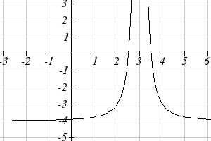
The function and the asymptotes are shifted 3 units right and 4 units down.
As $x→3$, $f(x)→∞$ and as $x→±∞$,$f(x)→−4$

3. Vertical asymptotes at x = 2 and x = -3; horizontal asymptote at y = 4

4. For the transformed reciprocal squared function, we find the rational form. $f(x)=\frac{1}{(x−3)^{2}}−4=\frac{1−4(x−3)^{2}}{(x−3)^{2}}=\frac{1−4(x^{2}−6x+9)}{(x−3)(x−3)}=\frac{−4x^{2}+\text{24}x−\text{35}}{x^{2}−6x+9}$
Since the numerator is the same degree as the denominator we know that as $x→±∞$,$f(x)→−4$. $y=−4$ is the horizontal asymptote. Next, we set the denominator equal to zero to find the vertical asymptote at x = 3, because as $x→3$, $f(x)→∞$. We set the numerator equal to 0 and find the horizontal intercepts are at (2.5,0) and (3.5,0), then we evaluate at 0 and the vertical intercept is at $\left(0,\frac{−\text{35}}{9}\right)$
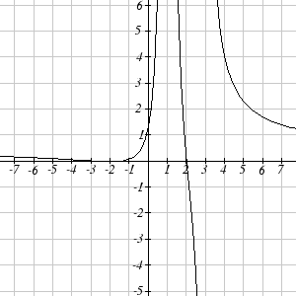
5.
Horizontal asymptote at y = 1/2.
Vertical asymptotes are at x = 1, and x = 3.
Vertical intercept at (0, 4/3),
Horizontal intercepts (2, 0) and (-2, 0)
(-2, 0) is a double zero and the graph bounces off the axis at this point.
(2, 0) is a single zero and crosses the axis at this point.

Section 3.4 Exercises

Match each equation form with one of the graphs.
1. $f\left(x\right)=\frac{x−A}{x−B}$ 2. $g\left(x\right)=\frac{{\left(x−A\right)}^{2}}{x−B}$ 3. $h\left(x\right)=\frac{x−A}{{\left(x−B\right)}^{2}}$ 4. $k\left(x\right)=\frac{{\left(x−A\right)}^{2}}{{\left(x−B\right)}^{2}}$

A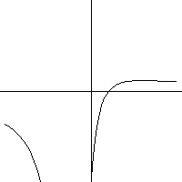 B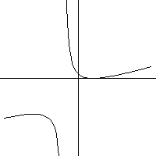 C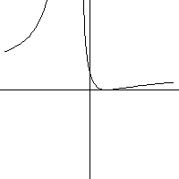 D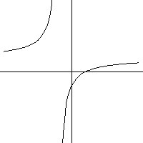

For each function, find the horizontal intercepts, the vertical intercept, the vertical asymptotes, and the horizontal asymptote. Use that information to sketch a graph.

5.$p\left(x\right)=\frac{2x−3}{x+4}$ 6. $q\left(x\right)=\frac{x−5}{3x−1}$

7. $s\left(x\right)=\frac{4}{{\left(x−2\right)}^{2}}$ 8. $r\left(x\right)=\frac{5}{{\left(x+1\right)}^{2}}$

9. $f\left(x\right)=\frac{3x^{2}−\text{14}x−5}{3x^{2}+8x−\text{16}}$ 10. $g\left(x\right)=\frac{2x^{2}+7x−\text{15}}{3x^{2}−\text{14}+\text{15}}$

11. $a\left(x\right)=\frac{x^{2}+2x−3}{x^{2}−1}$ 12. $b\left(x\right)=\frac{x^{2}−x−6}{x^{2}−4}$

13. $h\left(x\right)=\frac{2x^{2}+x−1}{x−4}$ 14. $k\left(x\right)=\frac{2x^{2}−3x−\text{20}}{x−5}$

15. $n\left(x\right)=\frac{3x^{2}+4x−4}{x^{3}−4x^{2}}$ 16. $m\left(x\right)=\frac{5−x}{2x^{2}+7x+3}$

17. $w\left(x\right)=\frac{\left(x−1\right)\left(x+3\right)\left(x−5\right)}{{\left(x+2\right)}^{2}(x−4)}$ 18. $z\left(x\right)=\frac{{\left(x+2\right)}^{2}\left(x−5\right)}{\left(x−3\right)\left(x+1\right)\left(x+4\right)}$

Write an equation for a rational function with the given characteristics.

- Vertical asymptotes at $x=5$ and $x=−5$
x intercepts at $(2\text{, }0)$ and $(−1\text{, }0)$ y intercept at $\left(0\text{, }4\right)$

- Vertical asymptotes at $x=−4$ and $x=−1$
x intercepts at $\left(1\text{, }0\right)$ and $\left(5\text{, }0\right)$ y intercept at $(0\text{, }7)$

- Vertical asymptotes at $x=−4$ and $x=−5$
x intercepts at $\left(4\text{, }0\right)$ and $\left(−6\text{, }0\right)$ Horizontal asymptote at $y=7$

- Vertical asymptotes at $x=−3$ and $x=6$
x intercepts at $\left(−2\text{, }0\right)$ and $\left(1\text{, }0\right)$ Horizontal asymptote at $y=−2$

- Vertical asymptote at $x=−1$
Double zero at $x=2$ y intercept at $(0\text{, }2)$

- Vertical asymptote at $x=3$
Double zero at $x=1$ y intercept at $(0\text{, }4)$

Write an equation for the function graphed.
25.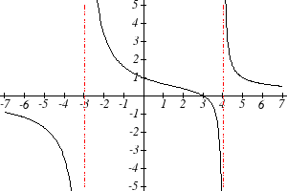 26.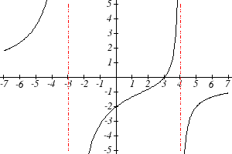\

27. 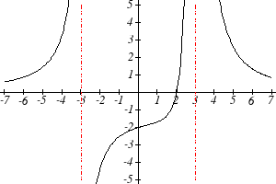 28.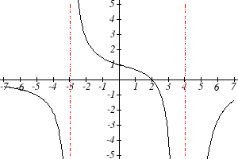
Write an equation for the function graphed.

29.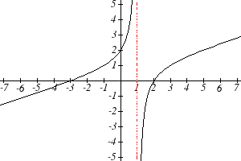 30.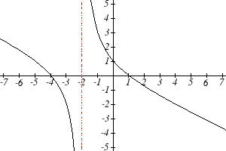

31.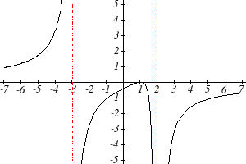 32.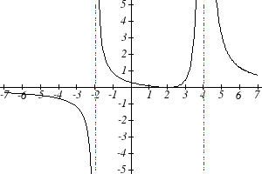

33.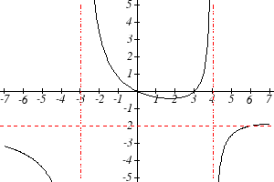 34.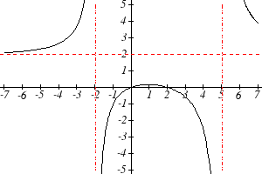

35.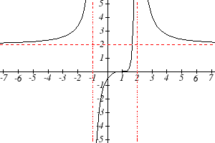 36.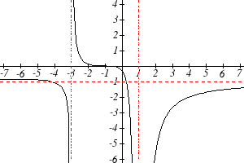

Write an equation for the function graphed.

37.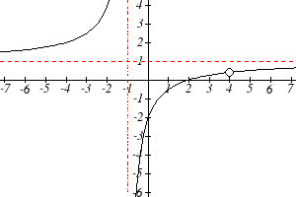 38.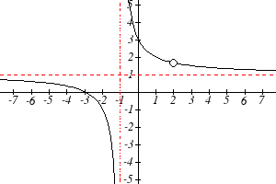

- A scientist has a beaker containing 20 mL of a solution containing 20% acid. To dilute this, she adds pure water.
  - Write an equation for the concentration in the beaker after adding n mL of water.
  - Find the concentration if 10 mL of water has been added.
  - How many mL of water must be added to obtain a 4% solution?
  - What is the behavior as $n→∞$, and what is the physical significance of this?

- A scientist has a beaker containing 30 mL of a solution containing 3 grams of potassium hydroxide. To this, she mixes a solution containing 8 milligrams per mL of potassium hydroxide.
  - Write an equation for the concentration in the tank after adding n mL of the second solution.
  - Find the concentration if 10 mL of the second solution has been added.
  - How many mL of water must be added to obtain a 50 mg/mL solution?
  - What is the behavior as $n→∞$, and what is the physical significance of this?

- Oscar is hunting magnetic fields with his gauss meter, a device for measuring the strength and polarity of magnetic fields. The reading on the meter will increase as Oscar gets closer to a magnet. Oscar is in a long hallway at the end of which is a room containing an extremely strong magnet. When he is far down the hallway from the room, the meter reads a level of 0.2. He then walks down the hallway and enters the room. When he has gone 6 feet into the room, the meter reads 2.3. Eight feet into the room, the meter reads 4.4. [UW]
  - Give a rational model of form $m\left(x\right)=\frac{\text{ax}+b}{\text{cx}+d}$ relating the meter reading $m(x)$ to how many feet x Oscar has gone into the room.
  - How far must he go for the meter to reach 10? 100?
  - Considering your function from part (a) and the results of part (b), how far into the room do you think the magnet is?
- The more you study for a certain exam, the better your performance on it. If you study for 10 hours, your score will be 65%. If you study for 20 hours, your score will be 95%. You can get as close as you want to a perfect score just by studying long enough. Assume your percentage score, $p(n)$, is a function of the number of hours, n, that you study in the form $p(n)=\frac{\text{an}+b}{\text{cn}+d}$. If you want a score of 80%, how long do you need to study? [UW]

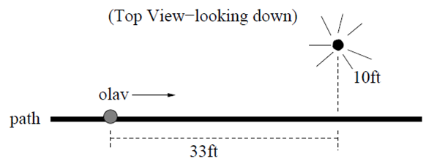
- A street light is 10 feet north of a straight bike path that runs east-west. Olav is bicycling down the path at a rate of 15 miles per hour. At noon, Olav is 33 feet west of the point on the bike path closest to the street light. (See the picture). The relationship between the intensity C of light (in candlepower) and the distance d (in feet) from the light source is given by $C=\frac{k}{d^{2}}$, where k is a constant depending on the light source. [UW]
  - From 20 feet away, the street light has an intensity of 1 candle. What is k?
  - Find a function which gives the intensity of the light shining on Olav as a function of time, in seconds.
  - When will the light on Olav have maximum intensity?
  - When will the intensity of the light be 2 candles?

Section 3.5 Inverses and Radical Functions

In this section, we will explore the inverses of polynomial and rational functions, and in particular the radical functions that arise in the process.

Example 1
A water runoff collector is built in the shape of a parabolic trough as shown below. Find the surface area of the water in the trough as a function of the depth of the water.

3ft
12 in
18 in

Since it will be helpful to have an equation for the parabolic cross-sectional shape, we will impose a coordinate system at the cross section, with x measured horizontally and y measured vertically, with the origin at the vertex of the parabola.
y
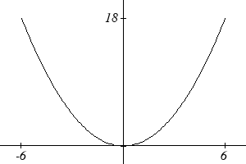
x

From this we find an equation for the parabolic shape. Since we placed the origin at the vertex of the parabola, we know the equation will have form $y(x)={\text{ax}}^{2}$. Our equation will need to pass through the point (6,18), from which we can solve for the stretch factor a:
$$\begin{aligned}\text{18}=a6^{2} \\ a=\frac{\text{18}}{\text{36}}=\frac{1}{2}\end{aligned}$$
Our parabolic cross section has equation $y(x)=\frac{1}{2}x^{2}$

Since we are interested in the surface area of the water, we are interested in determining the width at the top of the water as a function of the water depth. For any depth y the width will be given by 2x, so we need to solve the equation above for x. However notice that the original function is not one-to-one, and indeed given any output there are two inputs that produce the same output, one positive and one negative.
To find an inverse, we can restrict our original function to a limited domain on which it is one-to-one. In this case, it makes sense to restrict ourselves to positive x values. On this domain, we can find an inverse by solving for the input variable:
$$\begin{aligned}y=\frac{1}{2}x^{2} \\ 2y=x^{2}\end{aligned}$$
$x=±\sqrt{2y}$
This is not a function as written. Since we are limiting ourselves to positive x values, we eliminate the negative solution, giving us the inverse function we’re looking for
$$x(y)=\sqrt{2y}$$

Since x measures from the center out, the entire width of the water at the top will be 2x. Since the trough is 3 feet (36 inches) long, the surface area will then be 36(2x), or in terms of y:
$$\text{Area}=\text{72}x=\text{72}\sqrt{2y}$$

The previous example illustrated two important things:
- When finding the inverse of a quadratic, we have to limit ourselves to a domain on which the function is one-to-one.
- The inverse of a quadratic function is a square root function. Both are toolkit functions and different types of power functions.

Functions involving roots are often called radical functions.

Example 2
Find the inverse of $f(x)=(x−2)^{2}−3=x^{2}−4x+1$

From the transformation form of the function, we can see this is a transformed quadratic with vertex at (2,-3) that opens upwards. Since the graph will be decreasing on one side of the vertex, and increasing on the other side, we can restrict this function to a domain on which it will be one-to-one by limiting the domain to$x≥2$.

To find the inverse, we will use the vertex form of the quadratic. We start by replacing the f(x) with a simple variable y, then solve for x.
$y=(x−2)^{2}−3$ Add 3 to both sides
$y+3=(x−2)^{2}$ Take the square root
$±\sqrt{y+3}=x−2$ Add 2 to both sides
$$2±\sqrt{y+3}=x$$

Of course, as written this is not a function. Since we restricted our original function to a domain of $x≥2$, the outputs of the inverse should be the same, telling us to utilize the + case:
$$x=f^{−1}(y)=2+\sqrt{y+3}$$

If the quadratic had not been given in vertex form, rewriting it into vertex form is probably the best approach. Alternatively, we could have taken the standard equation and rewritten it equal to zero:
$$0=x^{2}−4x+1−y$$

We would then be able to use the quadratic formula with $a=1$, $b=−4$, and $c=(1−y)$, resulting in the same solutions we found above:
$$x=\frac{−(−4)±\sqrt{(−4)^{2}−4(1)(1−y)}}{2}=2±\frac{\sqrt{\text{12}+4y}}{2}=2±\sqrt{3+y}$$

Try it Now
1. Find the inverse of the function $f(x)=x^{2}+1$, on the domain $x≥0$.

While it is not possible to find an inverse of most polynomial functions, some other basic polynomials are invertible.

Example 3
Find the inverse of the function $f(x)=5x^{3}+1$.

This is a transformation of the basic cubic toolkit function, and based on our knowledge of that function, we know it is one-to-one. Solving for the inverse by solving for x
$$\begin{aligned}y=5x^{3}+1 \\ y−1=5x^{3} \\ \frac{y−1}{5}=x^{3} \\ x=f^{−1}(y)=\sqrt[3]{\frac{y−1}{5}}\end{aligned}$$

Notice that this inverse is also a transformation of a power function with a fractional power, x^{1/3}.

Try it Now
2. Which toolkit functions have inverse functions without restricting their domain?
Besides being important as an inverse function, radical functions are common in important physical models.

Example 4
The velocity, v in feet per second, of a car that slammed on its brakes can be determined based on the length of skid marks that the tires left on the ground. This relationship is given by
$$v(d)=\sqrt{2\text{gfd}}$$
In this formula, g represents acceleration due to gravity (32 ft/sec²), d is the length of the skid marks in feet, and f is a constant representing the friction of the surface. A car lost control on wet asphalt, with a friction coefficient of 0.5, leaving 200 foot skid marks. How fast was the car travelling when it lost control?

Using the given values of f = 0.5 and d = 200, we can evaluate the given formula:
$v(\text{200})=\sqrt{2(\text{32})(0\text{.}5)(\text{200})}=\text{80}\text{ ft/sec}$, which is about 54.5 miles per hour.

When radical functions are composed with other functions, determining domain can become more complicated.

Example 5
Find the domain of the function $f(x)=\sqrt{\frac{(x+2)(x−3)}{(x−1)}}$.

Since a square root is only defined when the quantity under the radical is non-negative, we need to determine where $\frac{(x+2)(x−3)}{(x−1)}≥0$. A rational function can change signs (change from positive to negative or vice versa) at horizontal intercepts and at vertical asymptotes. For this equation, the graph could change signs at x = -2, 1, and 3.

To determine on which intervals the rational expression is positive, we could evaluate the expression at test values, or sketch a graph. While both approaches work equally well, for this example we will use a graph.

This function has two horizontal intercepts, both of which exhibit linear behavior, where the graph will pass through the intercept. There is one vertical asymptote, corresponding to a linear factor, leading to a behavior similar to the basic reciprocal toolkit function. There is a vertical intercept at (0, 6). This graph does not have a horizontal asymptote, since the degree of the numerator is larger than the degree of the denominator.

From the vertical intercept and horizontal intercept at x = -2, we can sketch the left side of the graph. From the behavior at the asymptote, we can sketch the right side of the graph.
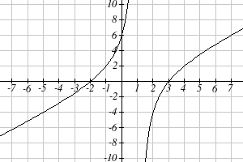

From the graph, we can now tell on which intervals this expression will be non-negative, so the original function f(x) will be defined.
f(x) has domain $−2≤x<1 \text{or} x≥3$, or in interval notation, $[−2,1)∪[3,∞)$.

Like with finding inverses of quadratic functions, it is sometimes desirable to find the inverse of a rational function, particularly of rational functions that are the ratio of linear functions, such as our concentration examples.

Example 6
The function $C(n)=\frac{\text{20}+0\text{.}4n}{\text{100}+n}$ was used in the previous section to represent the concentration of an acid solution after n mL of 40% solution has been added to 100 mL of a 20% solution. We might want to be able to determine instead how much 40% solution has been added based on the current concentration of the mixture.

To do this, we would want the inverse of this function:
$C=\frac{\text{20}+0\text{.}4n}{\text{100}+n}$ multiply both sides by the denominator
$C(\text{100}+n)=\text{20}+0\text{.}4n$ distribute
$\text{100}C+\text{Cn}=\text{20}+0\text{.}4n$ group everything with n on one side
$\text{100}C−\text{20}=0\text{.}4n−\text{Cn}$ factor out n
$\text{100}C−\text{20}=(0\text{.}4−C)n$ divide to find the inverse
$$n(C)=\frac{\text{100}C−\text{20}}{0\text{.}4−C}$$

If, for example, we wanted to know how many mL of 40% solution need to be added to obtain a concentration of 35%, we can simply evaluate the inverse rather than solving an equation involving the original function:
$n(0\text{.}\text{35})=\frac{\text{100}(0\text{.}\text{35})−\text{20}}{0\text{.}4−0\text{.}\text{35}}=\frac{\text{15}}{0\text{.}\text{05}}=\text{300}$mL of 40% solution would need to be added.

Try it Now
3. Find the inverse of the function $f(x)=\frac{x+3}{x−2}$.
Important Topics of this Section
Imposing a coordinate system
Finding an inverse function
Restricting the domain
Invertible toolkit functions
Radical Functions
Inverses of rational functions

Try it Now Answers
1. $x=f^{−1}(y)=\sqrt{y−1}$
2. identity, cubic, square root, cube root
3. $f^{−1}(y)=\frac{2y+3}{y−1}$

Section 3.5 Exercises

For each function, find a domain on which the function is one-to-one and non-decreasing, then find an inverse of the function on this domain.
1. $f\left(x\right)={\left(x−4\right)}^{2}$ 2. $f\left(x\right)={\left(x+2\right)}^{2}$
3. $f\left(x\right)=\text{12}−x^{2}$ 4. $f\left(x\right)=9−x^{2}$
5. $f\left(x\right)=3x^{3}+1$ 6. $f\left(x\right)=4−2x^{3}$

Find the inverse of each function.
7. $f\left(x\right)=9+\sqrt{4x−4}$ 8. $f\left(x\right)=\sqrt{6x−8}+5$
9. $f\left(x\right)=9+2\sqrt[3]{x}$ 10. $f\left(x\right)=3−\sqrt[3]{x}$
11. $f\left(x\right)=\frac{2}{x+8}$ 12. $f\left(x\right)=\frac{3}{x−4}$
13. $f\left(x\right)=\frac{x+3}{x+7}$ 14. $f\left(x\right)=\frac{x−2}{x+7}$
15. $f\left(x\right)=\frac{3x+4}{5−4x}$ 16. $f\left(x\right)=\frac{5x+1}{2−5x}$

Police use the formula $v=\sqrt{\text{20}L}$ to estimate the speed of a car, v, in miles per hour, based on the length, L, in feet, of its skid marks when suddenly braking on a dry, asphalt road.

- At the scene of an accident, a police officer measures a car's skid marks to be 215 feet long. Approximately how fast was the car traveling?

- At the scene of an accident, a police officer measures a car's skid marks to be 135 feet long. Approximately how fast was the car traveling?
The formula $v=\sqrt{2\text{.}7r}$ models the maximum safe speed, v, in miles per hour, at which a car can travel on a curved road with radius of curvature r, in feet.

- A highway crew measures the radius of curvature at an exit ramp on a highway as 430 feet. What is the maximum safe speed?

- A highway crew measures the radius of curvature at a tight corner on a highway as 900 feet. What is the maximum safe speed?
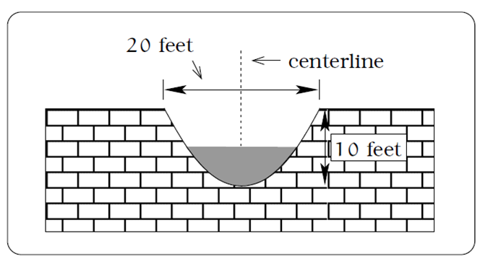
- A drainage canal has a cross-section in the shape of a parabola. Suppose that the canal is 10 feet deep and 20 feet wide at the top. If the water depth in the ditch is 5 feet, how wide is the surface of the water in the ditch? [UW]

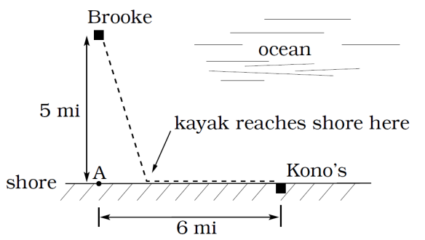
- Brooke is located 5 miles out from the nearest point A along a straight shoreline in her sea kayak. Hunger strikes and she wants to make it to Kono’s for lunch; see picture. Brooke can paddle 2 mph and walk 4 mph. [UW]
  - If she paddles along a straight line course to the shore, find an expression that computes the total time to reach lunch in terms of the location where Brooke beaches her kayak.
  - Determine the total time to reach Kono’s if she paddles directly to the point A.
  - Determine the total time to reach Kono’s if she paddles directly to Kono’s.
  - Do you think your answer to b or c is the minimum time required for Brooke to reach lunch?
  - Determine the total time to reach Kono’s if she paddles directly to a point on the shore half way between point A and Kono’s. How does this time compare to the times in parts b or c? Do you need to modify your answer to part d?

- Clovis is standing at the edge of a dropoff, which slopes 4 feet downward from him for every 1 horizontal foot. He launches a small model rocket from where he is standing. With the origin of the coordinate system located where he is standing, and the x-axis extending horizontally, the path of the rocket is described by the formula $y=−2x^{2}+\text{120}x$. [UW]
  - Give a function $h=f(x)$ relating the height h of the rocket above the sloping ground to its x-coordinate.
  - Find the maximum height of the rocket above the sloping ground. What is its x-coordinate when it is at its maximum height?
  - Clovis measures the height h of the rocket above the sloping ground while it is going up. Give a function $x=g\left(h\right)$ relating the x-coordinate of the rocket to h.
  - Does the function from (c) still work when the rocket is going down? Explain.
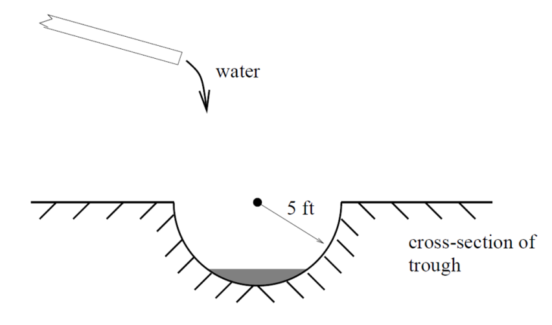
- A trough has a semicircular cross section with a radius of 5 feet. Water starts flowing into the trough in such a way that the depth of the water is increasing at a rate of 2 inches per hour. [UW]
  - Give a function $w=f\left(t\right)$ relating the width w of the surface of the water to the time t, in hours. Make sure to specify the domain and compute the range too.
  - After how many hours will the surface of the water have width of 6 feet?
  - Give a function $t=f^{−1}\left(w\right)$ relating the time to the width of the surface of the water. Make sure to specify the domain and compute the range too.

From http://blog.mrmeyer.com/?p=4778, © Dan Meyer, CC-BY

