Section 4.1 Exercises

For each table below, could the table represent a function that is linear, exponential, or neither?
1. |  | 2.
  x | 1 | 2 | 3 | 4
  f(x) | 70 | 40 | 10 | -20
  x | 1 | 2 | 3 | 4
  g(x) | 40 | 32 | 26 | 22
3. |  | 4.
  x | 1 | 2 | 3 | 4
  h(x) | 70 | 49 | 34.3 | 24.01
  x | 1 | 2 | 3 | 4
  k(x) | 90 | 80 | 70 | 60
5. |  | 6.
  x | 1 | 2 | 3 | 4
  m(x) | 80 | 61 | 42.9 | 25.61
  x | 1 | 2 | 3 | 4
  n(x) | 90 | 81 | 72.9 | 65.61

- A population numbers 11,000 organisms initially and grows by 8.5% each year. Write an exponential model for the population.

- A population is currently 6,000 and has been increasing by 1.2% each day. Write an exponential model for the population.
- The fox population in a certain region has an annual growth rate of 9 percent per year. It is estimated that the population in the year 2010 was 23,900. Estimate the fox population in the year 2018.
- The amount of area covered by blackberry bushes in a park has been growing by 12% each year. It is estimated that the area covered in 2009 was 4,500 square feet. Estimate area that will be covered in 2020.

- A vehicle purchased for $32,500 depreciates at a constant rate of 5% each year. Determine the approximate value of the vehicle 12 years after purchase.
- A business purchases $125,000 of office furniture which depreciates at a constant rate of 12% each year. Find the residual value of the furniture 6 years after purchase.

Find an equation for an exponential passing through the two points
13. $\left(0\text{, }6\right)\text{, }(3\text{, }\text{750})$ 14. $\left(0\text{, }3\right)\text{, }(2\text{, }\text{75})$
15. $\left(0\text{, }\text{2000}\right)\text{, }(2\text{, }\text{20})$ 16. $\left(0\text{, }\text{9000}\right)\text{, }(3\text{, }\text{72})$
17. $\left(−1,\frac{3}{2}\right)\text{, }\left(3\text{, }\text{24}\right)$ 18. $\left(−1,\frac{2}{5}\right)\text{, }\left(1,\text{10}\right)$
19. $\left(−2,6\right)\text{, }\left(3,1\right)$ 20. $\left(−3,4\right)\text{, }(3\text{, }2)$
21. $\left(3\text{, }1\right)\text{, }(5\text{, }4)$ 22. $\left(2,5\right)\text{, }(6\text{, }9)$

- A radioactive substance decays exponentially. A scientist begins with 100 milligrams of a radioactive substance. After 35 hours, 50 mg of the substance remains. How many milligrams will remain after 54 hours?
- A radioactive substance decays exponentially. A scientist begins with 110 milligrams of a radioactive substance. After 31 hours, 55 mg of the substance remains. How many milligrams will remain after 42 hours?

- A house was valued at $110,000 in the year 1985. The value appreciated to $145,000 by the year 2005. What was the annual growth rate between 1985 and 2005? Assume that the house value continues to grow by the same percentage. What will the value equal in the year 2010?
- An investment was valued at $11,000 in the year 1995. The value appreciated to $14,000 by the year 2008. What was the annual growth rate between 1995 and 2008? Assume that the value continues to grow by the same percentage. What will the value equal in the year 2012?

- A car was valued at $38,000 in the year 2003. The value depreciated to $11,000 by the year 2009. Assume that the car value continues to drop by the same percentage. What will the value be in the year 2013?
- A car was valued at $24,000 in the year 2006. The value depreciated to $20,000 by the year 2009. Assume that the car value continues to drop by the same percentage. What will the value be in the year 2014?
- If 4000 dollars is invested in a bank account at an interest rate of 7 per cent per year, find the amount in the bank after 9 years if interest is compounded annually, quarterly, monthly, and continuously.
- If 6000 dollars is invested in a bank account at an interest rate of 9 per cent per year, find the amount in the bank after 5 years if interest is compounded annually, quarterly, monthly, and continuously.

- Find the annual percentage yield (APY) for a savings account with annual percentage rate of 3% compounded quarterly.

- Find the annual percentage yield (APY) for a savings account with annual percentage rate of 5% compounded monthly.

- A population of bacteria is growing according to the equation $P(t)=\text{1600}e^{0\text{.}\text{21}t}$, with t measured in years. Estimate when the population will exceed 7569.

- A population of bacteria is growing according to the equation $P(t)=\text{1200}e^{0\text{.}\text{17}t}$, with t measured in years. Estimate when the population will exceed 3443.

- In 1968, the U.S. minimum wage was $1.60 per hour. In 1976, the minimum wage was $2.30 per hour. Assume the minimum wage grows according to an exponential model $w(t)$, where t represents the time in years after 1960. [UW]
  - Find a formula for $w(t)$.
  - What does the model predict for the minimum wage in 1960?
  - If the minimum wage was $5.15 in 1996, is this above, below or equal to what the model predicts.

- In 1989, research scientists published a model for predicting the cumulative number of AIDS cases (in thousands) reported in the United States: $a\left(t\right)=\text{155}{\left(\frac{t−\text{1980}}{\text{10}}\right)}^{3}$, where t is the year. This paper was considered a “relief”, since there was a fear the correct model would be of exponential type. Pick two data points predicted by the research model $a(t)$ to construct a new exponential model $b(t)$ for the number of cumulative AIDS cases. Discuss how the two models differ and explain the use of the word “relief.” [UW]

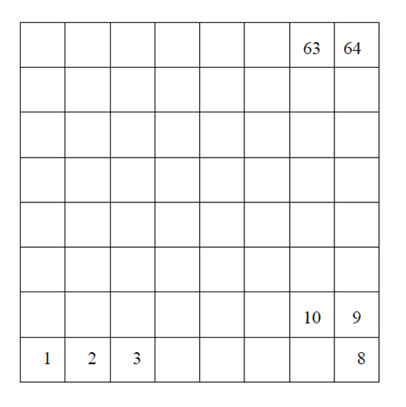
- You have a chess board as pictured, with squares numbered 1 through 64. You also have a huge change jar with an unlimited number of dimes. On the first square you place one dime. On the second square you stack 2 dimes. Then you continue, always doubling the number from the previous square. [UW]
  - How many dimes will you have stacked on the 10th square?
  - How many dimes will you have stacked on the nth square?
  - How many dimes will you have stacked on the 64th square?
  - Assuming a dime is 1 mm thick, how high will this last pile be?
  - The distance from the earth to the sun is approximately 150 million km. Relate the height of the last pile of dimes to this distance.

Section 4.2 Exercises

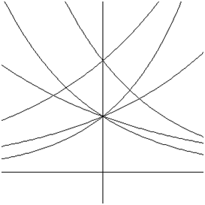
Match each equation with one of the graphs below
A
B
C
D
E
F
- $f\left(x\right)=2{\left(0\text{.}\text{69}\right)}^{x}$
- $f\left(x\right)=2{\left(1\text{.}\text{28}\right)}^{x}$
- $$f\left(x\right)=2{\left(0\text{.}\text{81}\right)}^{x}$$
- $f\left(x\right)=4{\left(1\text{.}\text{28}\right)}^{x}$
- $f\left(x\right)=2{\left(1\text{.}\text{59}\right)}^{x}$
- $f\left(x\right)=4{\left(0\text{.}\text{69}\right)}^{x}$
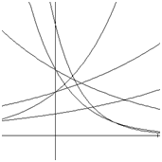
A
B
C
D
E
F
If all the graphs to the right have equations with form $f\left(x\right)={\text{ab}}^{x}$
- Which graph has the largest value for b?
- Which graph has the smallest value for b?
- Which graph has the largest value for a?
- Which graph has the smallest value for a?

Sketch a graph of each of the following transformations of $f\left(x\right)=2^{x}$
11. $f\left(x\right)=2^{−x}$ 12. $g\left(x\right)=−2^{x}$
13. $h\left(x\right)=2^{x}+3$ 14. $f\left(x\right)=2^{x}−4$
15. $f\left(x\right)=2^{x−2}$ 16. $k\left(x\right)=2^{x−3}$

Starting with the graph of $f\left(x\right)=4^{x}$, write the equation of the graph that results from
- Shifting $f(x)$ 4 units upwards
- Shifting $f(x)$ 3 units downwards
- Shifting $f(x)$ 2 units left
- Shifting $f(x)$ 5 units right
- Reflecting $f(x)$ about the x-axis
- Reflecting $f(x)$ about the y-axis

Describe the long run behavior, as $x→∞$ and $x→−∞$ of each function
23. $f\left(x\right)=−5\left(4^{x}\right)−1$ 24. $f\left(x\right)=−2\left(3^{x}\right)+2$
25. $f\left(x\right)=3{\left(\frac{1}{2}\right)}^{x}−2$ 26. $f\left(x\right)=4{\left(\frac{1}{4}\right)}^{x}+1$
27. $f\left(x\right)=3{\left(4\right)}^{−x}+2$ 28. $f\left(x\right)=−2{\left(3\right)}^{−x}−1$

Find an equation for each graph as a transformation of $f\left(x\right)=2^{x}$
29. 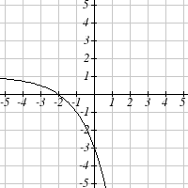 30. 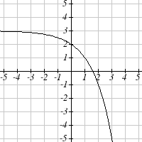

31. 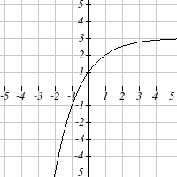 32. 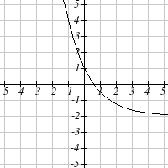

Find an equation for the exponential graphed.
33. 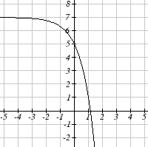 34. 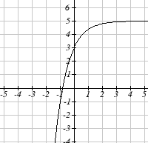

35. 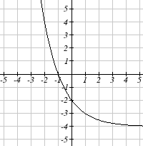 36. 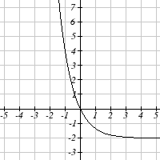

Section 4.3 Exercises

Rewrite each equation in exponential form
1. ${\text{log}}_{4}(q)=m$ 2. ${\text{log}}_{3}(t)=k$ 3. ${\text{log}}_{a}(b)=c$ 4. ${\text{log}}_{p}(z)=u$
$5\text{.}\text{log}\left(v\right)=t$ 6. $\text{log}\left(r\right)=s$ 7. $\text{ln}\left(w\right)=n$ 8. $\text{ln}\left(x\right)=y$

Rewrite each equation in logarithmic form.
9. $4^{x}=y$ 10. $5^{y}=x$ 11. $c^{d}=k$ 12. $n^{z}=L$
13. ${\text{10}}^{a}=b$ 14. ${\text{10}}^{p}=v$ 15. $e^{k}=h$ 16. $e^{y}=x$

Solve for x.
17. ${\text{log}}_{3}\left(x\right)=2$ 18. ${\text{log}}_{4}(x)=3$ 19. ${\text{log}}_{2}(x)=−3$ 20. ${\text{log}}_{5}(x)=−1$
21. $\text{log}\left(x\right)=3$ 22. $\text{log}\left(x\right)=5$ 23. $\text{ln}\left(x\right)=2$ 24. $\text{ln}\left(x\right)=−2$

Simplify each expression using logarithm properties
25. ${\text{log}}_{5}\left(\text{25}\right)$ 26. ${\text{log}}_{2}\left(8\right)$ 27. ${\text{log}}_{3}\left(\frac{1}{\text{27}}\right)$ 28. ${\text{log}}_{6}\left(\frac{1}{\text{36}}\right)$
29. ${\text{log}}_{6}\left(\sqrt{6}\right)$ 30. ${\text{log}}_{5}\left(\sqrt[3]{5}\right)$ 31. $\text{log}\left(\text{10},\text{000}\right)$ 32. $\text{log}\left(\text{100}\right)$
33. $\text{log}\left(0\text{.}\text{001}\right)$ 34. $\text{log}\left(0\text{.}\text{00001}\right)$ 35. $\text{ln}\left(e^{−2}\right)$ 36. $\text{ln}\left(e^{3}\right)$

Evaluate using your calculator
37. $\text{log}\left(0\text{.}\text{04}\right)$ 38. $\text{log}\left(\text{1045}\right)$ 39. $\text{ln}\left(\text{15}\right)$ 40. $\text{ln}\left(0\text{.}\text{02}\right)$

Solve each equation for the variable
41. $5^{x}=\text{14}$ 42. $3^{x}=\text{23}$ 43. $7^{x}=\frac{1}{\text{15}}$ 44. $3^{x}=\frac{1}{4}$
45. $e^{5x}=\text{17}$ 46. $e^{3x}=\text{12}$ 47. $3^{4x−5}=\text{38}$ 48. $4^{2x−3}=\text{44}$
49. $\text{1000}{\left(1\text{.}\text{03}\right)}^{t}=\text{5000}$ 50. $\text{200}{\left(1\text{.}\text{06}\right)}^{t}=\text{550}$
51. $3{\left(1\text{.}\text{04}\right)}^{3t}=8$ 52. $2{\left(1\text{.}\text{08}\right)}^{4t}=7$
53. $\text{50}e^{−0\text{.}\text{12}t}=\text{10}$ 54. $\text{10}e^{−0\text{.}\text{03}t}=4$
55. $\text{10}−8{\left(\frac{1}{2}\right)}^{x}=5$ 56. $\text{100}−\text{100}{\left(\frac{1}{4}\right)}^{x}=\text{70}$
Convert the equation into continuous growth $f\left(t\right)={\text{ae}}^{\text{kt}}$ form
57. $f\left(t\right)=\text{300}{\left(0\text{.}\text{91}\right)}^{t}$ 58. $f\left(t\right)=\text{120}{\left(0\text{.}\text{07}\right)}^{t}$
59. $f\left(t\right)=\text{10}{\left(1\text{.}\text{04}\right)}^{t}$ 60. $f\left(t\right)=\text{1400}{\left(1\text{.}\text{12}\right)}^{t}$

Convert the equation into annual growth $f\left(t\right)={\text{ab}}^{t}$ form
61. $f\left(t\right)=\text{150}e^{0\text{.}\text{06}t}$ 62. $f\left(t\right)=\text{100}e^{0\text{.}\text{12}t}$
63. $f\left(t\right)=\text{50}e^{−0\text{.}\text{012}t}$ 64. $f\left(t\right)=\text{80}e^{−0\text{.}\text{85}t}$

- The population of Kenya was 39.8 million in 2009 and has been growing by about 2.6% each year. If this trend continues, when will the population exceed 45 million?

- The population of Algeria was 34.9 million in 2009 and has been growing by about 1.5% each year. If this trend continues, when will the population exceed 45 million?

- The population of Seattle grew from 563,374 in 2000 to 608,660 in 2010. If the population continues to grow exponentially at the same rate, when will the population exceed 1 million people?

- The median household income (adjusted for inflation) in Seattle grew from $42,948 in 1990 to $45,736 in 2000. If it continues to grow exponentially at the same rate, when will median income exceed $50,000?

- A scientist begins with 100 mg of a radioactive substance. After 4 hours, it has decayed to 80 mg. How long will it take to decay to 15 mg?

- A scientist begins with 100 mg of a radioactive substance. After 6 days, it has decayed to 60 mg. How long will it take to decay to 10 mg?

- If $1000 is invested in an account earning 3% compounded monthly, how long will it take the account to grow in value to $1500?

- If $1000 is invested in an account earning 2% compounded quarterly, how long will it take the account to grow in value to $1300?

Section 4.4 Exercises

Simplify using logarithm properties to a single logarithm
1. ${\text{log}}_{3}\left(\text{28}\right)−{\text{log}}_{3}\left(7\right)$ 2. ${\text{log}}_{3}\left(\text{32}\right)−{\text{log}}_{3}\left(4\right)$
3. $−{\text{log}}_{3}\left(\frac{1}{7}\right)$ 4. $−{\text{log}}_{4}\left(\frac{1}{5}\right)$
5. ${\text{log}}_{3}\left(\frac{1}{\text{10}}\right)+{\text{log}}_{3}\left(\text{50}\right)$ 6. ${\text{log}}_{4}\left(3\right)+{\text{log}}_{4}(7)$
7. $\frac{1}{3}{\text{log}}_{7}\left(8\right)$ 8. $\frac{1}{2}{\text{log}}_{5}\left(\text{36}\right)$
9. $\text{log}\left(2x^{4}\right)+\text{log}\left(3x^{5}\right)$ 10. $\text{ln}\left(4x^{2}\right)+\text{ln}\left(3x^{3}\right)$
11. $\text{ln}\left(6x^{9}\right)−\text{ln}\left(3x^{2}\right)$ 12. $\text{log}\left(\text{12}x^{4}\right)−\text{log}\left(4x\right)$
13. $2\text{log}\left(x\right)+3\text{log}\left(x+1\right)$ 14. $3\text{log}\left(x\right)+2\text{log}\left(x^{2}\right)$
15. $\text{log}\left(x\right)−\frac{1}{2}\text{log}\left(y\right)+3\text{log}\left(z\right)$ 16. $2\text{log}\left(x\right)+\frac{1}{3}\text{log}\left(y\right)−\text{log}\left(z\right)$

Use logarithm properties to expand each expression
17. $\text{log}\left(\frac{x^{\text{15}}y^{\text{13}}}{z^{\text{19}}}\right)$ 18. $\text{log}\left(\frac{a^{2}b^{3}}{c^{5}}\right)$
19. $\text{ln}\left(\frac{a^{−2}}{b^{−4}c^{5}}\right)$ 20. $\text{ln}\left(\frac{a^{−2}b^{3}}{c^{−5}}\right)$
21. $\text{log}\left(\sqrt{x^{3}y^{−4}}\right)$ 22. $\text{log}\left(\sqrt{x^{−3}y^{2}}\right)$
23. $\text{ln}\left(y\sqrt{\frac{y}{1−y}}\right)$ 24. $\text{ln}\left(\frac{x}{\sqrt{1−x^{2}}}\right)$
25. $\text{log}\left(x^{2}y^{3}\sqrt[3]{x^{2}y^{5}}\right)$ 26. $\text{log}\left(x^{3}y^{4}\sqrt[7]{x^{3}y^{9}}\right)$

Solve each equation for the variable
27. $4^{4x−7}=3^{9x−6}$ 28. $2^{2x−5}=7^{3x−7}$
29. $\text{17}{\left(1\text{.}\text{14}\right)}^{x}=\text{19}{\left(1\text{.}\text{16}\right)}^{x}$ 30. $\text{20}{\left(1\text{.}\text{07}\right)}^{x}=8{\left(1\text{.}\text{13}\right)}^{x}$
31. $5e^{0\text{.}\text{12}t}=\text{10}e^{0\text{.}\text{08}t}$ 32. $3e^{0\text{.}\text{09}t}=e^{0\text{.}\text{14}t}$
33. ${\text{log}}_{2}\left(7x+6\right)=3$ 34. ${\text{log}}_{3}(2x+4)=2$
35. $2\text{ln}\left(3x\right)+3=1$ 36. $4\text{ln}\left(5x\right)+5=2$
37. $\text{log}\left(x^{3}\right)=2$ 38. $\text{log}\left(x^{5}\right)=3$
39. $\text{log}\left(x\right)+\text{log}\left(x+3\right)=3$ 40. $\text{log}\left(x+4\right)+\text{log}\left(x\right)=9$
41. $\text{log}\left(x+4\right)−\text{log}\left(x+3\right)=1$ 42. $\text{log}\left(x+5\right)−\text{log}\left(x+2\right)=2$
43. ${\text{log}}_{6}\left(x^{2}\right)−{\text{log}}_{6}(x+1)=1$ 44. ${\text{log}}_{3}(x^{2})−{\text{log}}_{3}(x+2)=5$
45. $\text{log}\left(x+\text{12}\right)=\text{log}\left(x\right)+\text{log}\left(\text{12}\right)$ 46. $\text{log}\left(x+\text{15}\right)=\text{log}\left(x\right)+\text{log}\left(\text{15}\right)$
47. $\text{ln}\left(x\right)+\text{ln}\left(x−3\right)=\text{ln}\left(7x\right)$ 48. $\text{ln}\left(x\right)+\text{ln}\left(x−6\right)=\text{ln}\left(6x\right)$

Section 4.5 Exercises

For each function, find the domain and the vertical asymptote
1. $f\left(x\right)=\text{log}\left(x−5\right)$ 2. $f\left(x\right)=\text{log}\left(x+2\right)$
3. $f\left(x\right)=\text{ln}\left(3−x\right)$ 4. $f\left(x\right)=\text{ln}\left(5−x\right)$
5. $f\left(x\right)=\text{log}\left(3x+1\right)$ 6. $f\left(x\right)=\text{log}\left(2x+5\right)$
7. $f\left(x\right)=3\text{log}\left(−x\right)+2$ 8. $f\left(x\right)=2\text{log}\left(−x\right)+1$

Sketch a graph of each pair of function
9. $f\left(x\right)=\text{log}\left(x\right)\text{, }g\left(x\right)=\text{ln}\left(x\right)$ 10. $f\left(x\right)={\text{log}}_{2}(x)\text{, }g\left(x\right)={\text{log}}_{4}\left(x\right)$

Sketch each transformation
11. $f\left(x\right)=2\text{log}\left(x\right)$ 12. $f\left(x\right)=3\text{ln}\left(x\right)$
13. $f\left(x\right)=\text{ln}\left(−x\right)$ 14. $f\left(x\right)=−\text{log}\left(x\right)$
15. $f\left(x\right)={\text{log}}_{2}(x+2)$ 16. $f\left(x\right)={\text{log}}_{3}\left(x+4\right)$

Write an equation for the transformed logarithm graph shown
17.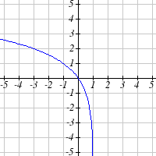 18.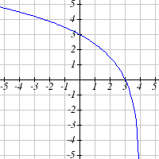

19.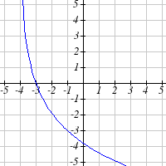 20.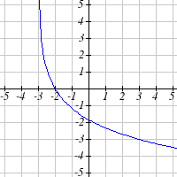

Write an equation for the transformed logarithm graph shown

21.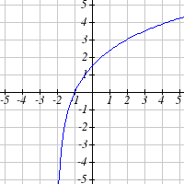 22.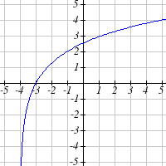

23.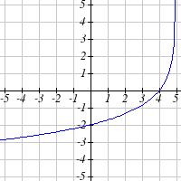 24.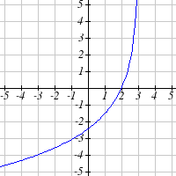

Section 4.6 Exercises

- You go to the doctor and he gives you 13 milligrams of radioactive dye. After 12 minutes, 4.75 milligrams of dye remain in your system. To leave the doctor's office, you must pass through a radiation detector without sounding the alarm. If the detector will sound the alarm if more than 2 milligrams of the dye are in your system, how long will your visit to the doctor take, assuming you were given the dye as soon as you arrived?

- You take 200 milligrams of a headache medicine, and after 4 hours, 120 milligrams remain in your system. If the effects of the medicine wear off when less than 80 milligrams remain, when will you need to take a second dose?

- The half-life of Radium-226 is 1590 years. If a sample contains 200 mg, how many milligrams will remain after 1000 years?

- The half-life of Fermium-253 is 3 days. If a sample contains 100 mg, how many milligrams will remain after 1 week?

- The half-life of Erbium-165 is 10.4 hours. After 24 hours a sample has been reduced to a mass of 2 mg. What was the initial mass of the sample, and how much will remain after 3 days?

- The half-life of Nobelium-259 is 58 minutes. After 3 hours a sample has been reduced to a mass of 10 mg. What was the initial mass of the sample, and how much will remain after 8 hours?

- A scientist begins with 250 grams of a radioactive substance. After 225 minutes, the sample has decayed to 32 grams. Find the half-life of this substance.

- A scientist begins with 20 grams of a radioactive substance. After 7 days, the sample has decayed to 17 grams. Find the half-life of this substance.

- A wooden artifact from an archeological dig contains 60 percent of the carbon-14 that is present in living trees. How long ago was the artifact made? (the half-life of carbon-14 is 5730 years)

- A wooden artifact from an archeological dig contains 15 percent of the carbon-14 that is present in living trees. How long ago was the artifact made? (the half-life of carbon-14 is 5730 years)
- A bacteria culture initially contains 1500 bacteria and doubles every half hour. Find the size of the population after: a) 2 hours, b) 100 minutes

- A bacteria culture initially contains 2000 bacteria and doubles every half hour. Find the size of the population after: a) 3 hours, b) 80 minutes

- The count of bacteria in a culture was 800 after 10 minutes and 1800 after 40 minutes.
  - What was the initial size of the culture?
  - Find the doubling period.
  - Find the population after 105 minutes.
  - When will the population reach 11000?

- The count of bacteria in a culture was 600 after 20 minutes and 2000 after 35 minutes.
  - What was the initial size of the culture?
  - Find the doubling period.
  - Find the population after 170 minutes.
  - When will the population reach 12000?

- Find the time required for an investment to double in value if invested in an account paying 3% compounded quarterly.

- Find the time required for an investment to double in value if invested in an account paying 4% compounded monthly

- The number of crystals that have formed after t hours is given by $n\left(t\right)=\text{20}e^{0\text{.}\text{013}t}$. How long does it take the number of crystals to double?

- The number of building permits in Pasco t years after 1992 roughly followed the equation $n\left(t\right)=\text{400}e^{0\text{.}\text{143}t}$. What is the doubling time?

- A turkey is pulled from the oven when the internal temperature is 165° Fahrenheit, and is allowed to cool in a 75° room. If the temperature of the turkey is 145° after half an hour,
  - What will the temperature be after 50 minutes?
  - How long will it take the turkey to cool to 110°?

- A cup of coffee is poured at 190° Fahrenheit, and is allowed to cool in a 70° room. If the temperature of the coffee is 170° after half an hour,
  - What will the temperature be after 70 minutes?
  - How long will it take the coffee to cool to 120°?

- The population of fish in a farm-stocked lake after t years could be modeled by the equation $P\left(t\right)=\frac{\text{1000}}{1+9e^{−0\text{.}6t}}$.
  - Sketch a graph of this equation
  - What is the initial population of fish?
  - What will the population be after 2 years?
  - How long will it take for the population to reach 900?

- The number of people in a town that have heard rumor after t days can be modeled by the equation $N\left(t\right)=\frac{\text{500}}{1+\text{49}e^{−0\text{.}7t}}$.
  - Sketch a graph of this equation
  - How many people started the rumor?
  - How many people have heard the rumor after 3 days??
  - How long will it take 300 people to have heard the rumor?

Find the value of the number shown on each logarithmic scale
23. 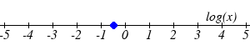 24.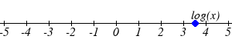
25. 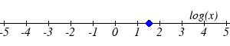 26.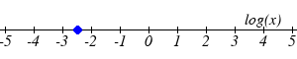

Plot each set of approximate values on a logarithmic scale
- Intensity of sounds: Whisper: ${\text{10}}^{−\text{10}}W/{m^{2}}$, Vacuum: ${\text{10}}^{−4}W/{m^{2}}$, Jet: ${\text{10}}^{2}W/{m^{2}}$

- Mass: Amoeba: ${\text{10}}^{−5}g$, Human: ${\text{10}}^{5}g$, Statue of Liberty: ${\text{10}}^{8}g$

- The 1906 San Francisco earthquake had a magnitude of 7.9 on the MMS scale. At the same time there was an earthquake with magnitude 4.7 that caused only minor damage. How many times more intense was the San Francisco earthquake than the second one?

- The 1906 San Francisco earthquake had a magnitude of 7.9 on the MMS scale. At the same time there was an earthquake with magnitude 6.5 that caused less damage. How many times more intense was the San Francisco earthquake than the second one?

- One earthquake has magnitude 3.9. If a second earthquake has 750 times as much energy as the first, find the magnitude of the second quake.

- One earthquake has magnitude 4.8. If a second earthquake has 1200 times as much energy as the first, find the magnitude of the second quake.

- A colony of yeast cells is estimated to contain 10⁶ cells at time t = 0. After collecting experimental data in the lab, you decide that the total population of cells at time t hours is given by the function $f\left(t\right)={\text{10}}^{6}e^{0\text{.}\text{495105}t}$ [UW]
  - How many cells are present after one hour?
  - How long does it take of the population to double?.
  - Cherie, another member of your lab, looks at your notebook and says: ...that formula is wrong, my calculations predict the formula for the number of yeast cells is given by the function. $f\left(t\right)={\text{10}}^{6}{\left(2\text{.}\text{042727}\right)}^{0\text{.}\text{693147}t}$. Should you be worried by Cherie’s remark?
  - Anja, a third member of your lab working with the same yeast cells, took these two measurements: $7\text{.}\text{246}×{\text{10}}^{6}$cells after 4 hours; $\text{16}\text{.}\text{504}×{\text{10}}^{6}$ cells after 6 hours. Should you be worried by Anja’s results? If Anja’s measurements are correct, does your model over estimate or under estimate the number of yeast cells at time t?

- As light from the surface penetrates water, its intensity is diminished. In the clear waters of the Caribbean, the intensity is decreased by 15 percent for every 3 meters of depth. Thus, the intensity will have the form of a general exponential function. [UW]
  - If the intensity of light at the water’s surface is$I_{0}$, find a formula for $I(d)$, the intensity of light at a depth of d meters. Your formula should depend on $I_{0}$and d.
  - At what depth will the light intensity be decreased to 1% of its surface intensity?

- Myoglobin and hemoglobin are oxygen carrying molecules in the human body. Hemoglobin is found inside red blood cells, which flow from the lungs to the muscles through the bloodstream. Myoglobin is found in muscle cells. The function $Y=M\left(p\right)=\frac{p}{1+p}$ calculates the fraction of myoglobin saturated with oxygen at a given pressure p torrs. For example, at a pressure of 1 torr, M(1) = 0.5, which means half of the myoglobin (i.e. 50%) is oxygen saturated. (Note: More precisely, you need to use something called the “partial pressure”, but the distinction is not important for this problem.) Likewise, the function $Y=H\left(p\right)=\frac{p^{2\text{.}8}}{{\text{26}}^{2\text{.}8}+p^{2\text{.}8}}$ calculates the fraction of hemoglobin saturated with oxygen at a given pressure p. [UW]
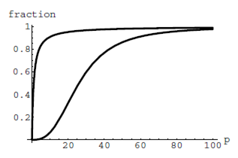
  - The graphs of $M(p)$ and $H(p)$ are given here on the domain
0 ≤ p ≤ 100; which is which?
  - If the pressure in the lungs is 100 torrs, what is the level of oxygen saturation of the hemoglobin in the lungs?

  - The pressure in an active muscle is 20 torrs. What is the level of oxygen saturation of myoglobin in an active muscle? What is the level of hemoglobin in an active muscle?
  - Define the efficiency of oxygen transport at a given pressure p to be $M(p)−H(p)$. What is the oxygen transport efficiency at 20 torrs? At 40 torrs? At 60 torrs? Sketch the graph of $M(p)−H(p)$; are there conditions under which transport efficiency is maximized (explain)?

- The length of some fish are modeled by a von Bertalanffy growth function. For Pacific halibut, this function has the form $L\left(t\right)=\text{200}\left(1−0\text{.}\text{957}e^{−0\text{.}\text{18}t}\right)$ where $L(t)$ is the length (in centimeters) of a fish t years old. [UW]
  - What is the length of a new-born halibut at birth?
  - Use the formula to estimate the length of a 6–year–old halibut.
  - At what age would you expect the halibut to be 120 cm long?
  - What is the practical (physical) significance of the number 200 in the formula for $L(t)$?

- A cancerous cell lacks normal biological growth regulation and can divide continuously. Suppose a single mouse skin cell is cancerous and its mitotic cell cycle (the time for the cell to divide once) is 20 hours. The number of cells at time t grows according to an exponential model. [UW]
  - Find a formula $C(t)$ for the number of cancerous skin cells after t hours.
  - Assume a typical mouse skin cell is spherical of radius 50×10⁻⁴ cm. Find the combined volume of all cancerous skin cells after t hours. When will the volume of cancerous cells be 1 cm³?

- A ship embarked on a long voyage. At the start of the voyage, there were 500 ants in the cargo hold of the ship. One week into the voyage, there were 800 ants. Suppose the population of ants is an exponential function of time. [UW]
  - How long did it take the population to double?
  - How long did it take the population to triple?
  - When were there be 10,000 ants on board?
  - There also was an exponentially-growing population of anteaters on board. At the start of the voyage there were 17 anteaters, and the population of anteaters doubled every 2.8 weeks. How long into the voyage were there 200 ants per anteater?

- The populations of termites and spiders in a certain house are growing exponentially. The house contains 100 termites the day you move in. After 4 days, the house contains 200 termites. Three days after moving in, there are two times as many termites as spiders. Eight days after moving in, there were four times as many termites as spiders. How long (in days) does it take the population of spiders to triple? [UW]

Section 4.7 Exercises

Graph each function on a semi-log scale, the find a formula for the linearized function in the form $\text{log}\left(f\left(x\right)\right)=\text{mx}+b$
1. $f\left(x\right)=4{\left(1\text{.}3\right)}^{x}$ 2. $f\left(x\right)=2{\left(1\text{.}5\right)}^{x}$
3. $f\left(x\right)=\text{10}{\left(0\text{.}2\right)}^{x}$ 4. $f\left(x\right)=\text{30}{\left(0\text{.}7\right)}^{x}$

The graph below is on a semi-log scale, as indicated. Find an equation for the exponential function $y(x)$.
5.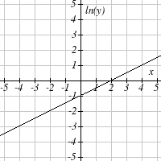 6.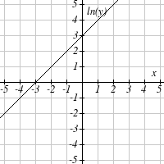

7. 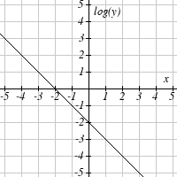 8. 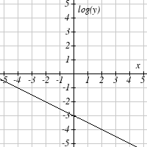

Use regression to find an exponential equation that best fits the data given.

9.
  x | 1 | 2 | 3 | 4 | 5 | 6
  y | 1125 | 1495 | 2310 | 3294 | 4650 | 6361
10.
  x | 1 | 2 | 3 | 4 | 5 | 6
  y | 643 | 829 | 920 | 1073 | 1330 | 1631
11.
  x | 1 | 2 | 3 | 4 | 5 | 6
  y | 555 | 383 | 307 | 210 | 158 | 122
12.
  x | 1 | 2 | 3 | 4 | 5 | 6
  y | 699 | 701 | 695 | 668 | 683 | 712

- Total expenditures (in billions of dollars) in the US for nursing home care are shown below. Use regression to find an exponential equation that models the data. What does the model predict expenditures will be in 2015?
Year | 1990 | 1995 | 2000 | 2003 | 2005 | 2008
Expenditure | 53 | 74 | 95 | 110 | 121 | 138

- Light intensity as it passes through decreases exponentially with depth. The data below shows the light intensity (in lumens) at various depths. Use regression to find an equation that models the data. What does the model predict the intensity will be at 25 feet?
Depth (ft) | 3 | 6 | 9 | 12 | 15 | 18
Lumen | 11.5 | 8.6 | 6.7 | 5.2 | 3.8 | 2.9

- The average price of electricity (in cents per kilowatt hour) from 1990-2008 is given below. Determine if a linear or exponential model better fits the data, and use the better model to predict the price of electricity in 2014.
Year | 1990 | 1992 | 1994 | 1996 | 1998 | 2000 | 2002 | 2004 | 2006 | 2008
Cost | 7.83 | 8.21 | 8.38 | 8.36 | 8.26 | 8.24 | 8.44 | 8.95 | 10.40 | 11.26

- The average cost of a loaf of white bread from 1986-2008 is given below. Determine if a linear or exponential model better fits the data, and use the better model to predict the price of a loaf of bread in 2016.
Year | 1986 | 1988 | 1990 | 1995 | 1997 | 2000 | 2002 | 2004 | 2006 | 2008
Cost | 0.57 | 0.66 | 0.70 | 0.84 | 0.88 | 0.99 | 1.03 | 0.97 | 1.14 | 1.42

