Section 5.1 Exercises

- Find the distance between the points (5,3) and (-1,-5)
- Find the distance between the points (3,3) and (-3,-2)
- Write the equation of the circle centered at (8 , -10) with radius 8.
- Write the equation of the circle centered at (-9, 9) with radius 16.
- Write the equation of the circle centered at (7, -2) that passes through (-10, 0).
- Write the equation of the circle centered at (3, -7) that passes through (15, 13).
- Write an equation for a circle where the points (2, 6) and (8, 10) lie along a diameter.
- Write an equation for a circle where the points (-3, 3) and (5, 7) lie along a diameter.
- Sketch a graph of ${\left(x−2\right)}^{2}+{\left(y+3\right)}^{2}=9$
- Sketch a graph of ${\left(x+1\right)}^{2}+{\left(y−2\right)}^{2}=\text{16}$
- Find the y intercept(s) of the circle with center (2, 3) with radius 3.
- Find the x intercept(s) of the circle with center (2, 3) with radius 4.
- At what point in the first quadrant does the line with equation $y=2x+5$ intersect a circle with radius 3 and center (0, 5)?
- At what point in the first quadrant does the line with equation $y=x+2$ intersect the circle with radius 6 and center (0, 2)?
- At what point in the second quadrant does the line with equation $y=2x+5$ intersect a circle with radius 3 and center (-2, 0)?
- At what point in the first quadrant does the line with equation $y=x+2$ intersect the circle with radius 6 and center (-1,0)?
- A small radio transmitter broadcasts in a 53 mile radius. If you drive along a straight line from a city 70 miles north of the transmitter to a second city 74 miles east of the transmitter, during how much of the drive will you pick up a signal from the transmitter?

- A small radio transmitter broadcasts in a 44 mile radius. If you drive along a straight line from a city 56 miles south of the transmitter to a second city 53 miles west of the transmitter, during how much of the drive will you pick up a signal from the transmitter?
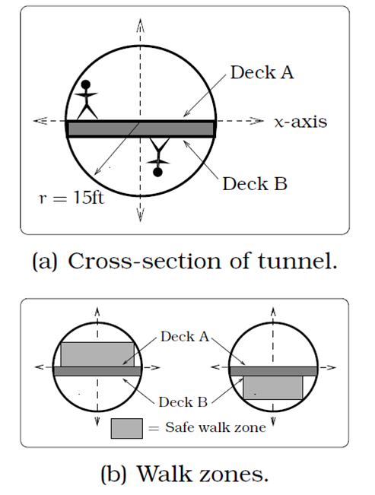
- A tunnel connecting two portions of a space station has a circular cross-section of radius 15 feet. Two walkway decks are constructed in the tunnel. Deck A is along a horizontal diameter and another parallel Deck B is 2 feet below Deck A. Because the space station is in a weightless environment, you can walk vertically upright along Deck A, or vertically upside down along Deck B. You have been assigned to paint “safety stripes” on each deck level, so that a 6 foot person can safely walk upright along either deck. Determine the width of the “safe walk zone” on each deck. [UW]

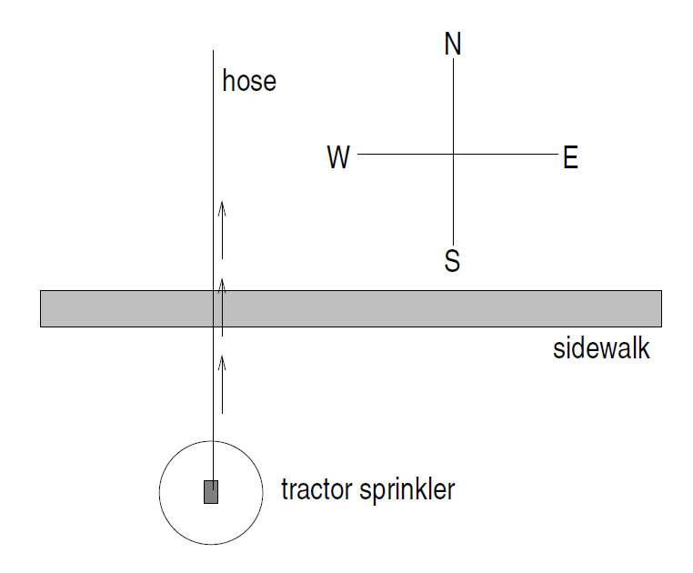
- A crawling tractor sprinkler is located as pictured here, 100 feet South of a sidewalk. Once the water is turned on, the sprinkler waters a circular disc of radius 20 feet and moves North along the hose at the rate of ½ inch/second. The hose is perpendicular to the 10 ft. wide sidewalk. Assume there is grass on both sides of the sidewalk. [UW]

- Impose a coordinate system. Describe the initial coordinates of the sprinkler and find equations of the lines forming and find equations of the lines forming the North and South boundaries of the sidewalk.
- When will the water first strike the sidewalks?
- When will the water from the sprinkler fall completely North of the sidewalk?
- Find the total amount of time water from the sprinkler falls on the sidewalk.
- Sketch a picture of the situation after 33 minutes. Draw an accurate picture of the watered portion of the sidewalk.
- Find the areas of GRASS watered after one hour.

- Erik’s disabled sailboat is floating stationary 3 miles East and 2 miles North of Kingston. A ferry leaves Kingston heading toward Edmonds at 12 mph. Edmonds is 6 miles due east of Kingston. After 20 minutes the ferry turns heading due South. Ballard is 8 miles South and 1 mile West of Edmonds. Impose coordinates with Ballard as the origin. [UW]
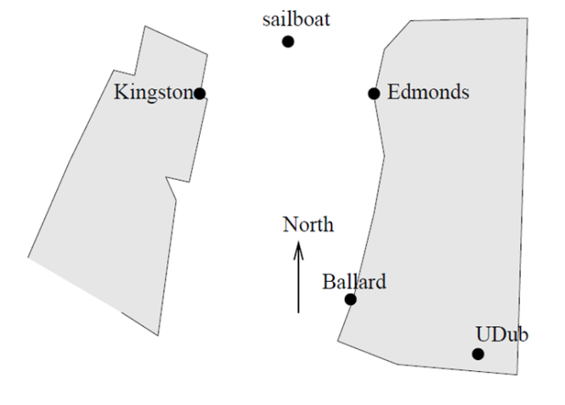

- Find the equations for the lines along which the ferry is moving and draw in these lines.
- The sailboat has a radar scope that will detect any object within 3 miles of the sailboat. Looking down from above, as in the picture, the radar region looks like a circular disk. The boundary is the “edge” pr circle around this disc, the interior is the inside of the disk, and the exterior is everything outside of the disk (i.e. outside of the circle). Give the mathematical (equation) description of the boundary, interior and exterior of the radar zone. Sketch an accurate picture of the radar zone. Sketch an accurate picture of the radar zone by determining where the line connecting Kingston and Edmonds would cross the radar zone.
- When does the ferry exit the radar zone?
- Where and when does the ferry exit the radar zone?
- How long does the ferry spend inside the radar zone?

- Nora spends part of her summer driving a combine during the wheat harvest. Assume she starts at the indicated position heading east at 10 ft/sec toward a circular wheat field or radius 200 ft. The combine cuts a swath 20 feet wide and beings when the corner of the machine labeled “a” is 60 feet north and 60 feet west of the western-most edge of the field. [UW]
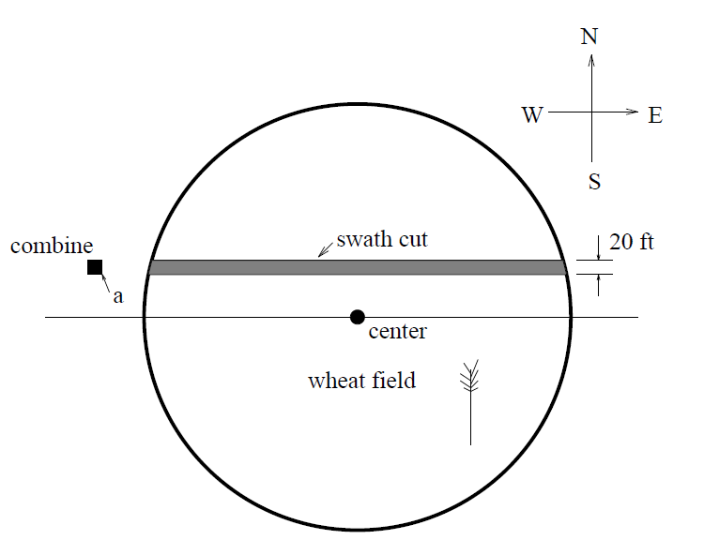
- When does Nora’s rig first start cutting the wheat?
- When does Nora’s first start cutting a swath 20 feet wide?
- Find the total amount of time wheat is being cut during this pass across the field?
- Estimate the area of the swath cut during this pass across the field?

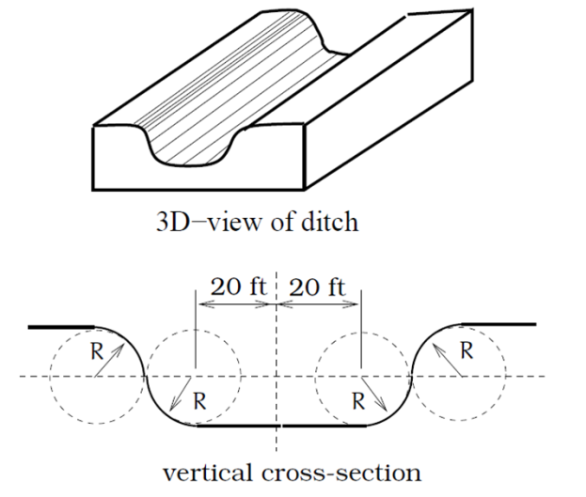
- The vertical cross-section of a drainage ditch is pictured below. Here, R indicates a circle of radius 10 feet and all of the indicated circle centers lie along the common horizontal line 10 feet above and parallel to the ditch bottom. Assume that water is flowing into the ditch so that the level above the bottom is rising 2 inches per minute. [UW]

- When will the ditch be completely full?
- Find a multipart function that models the vertical cross-section of the ditch.
- What is the width of the filled portion of the ditch after 1 hour and 18 minutes?
- When will the filled portion of the ditch be 42 feet wide? 50 feet wide? 73 feet wide?

Section 5.2 Exercises

- Indicate each angle on a circle: 30°, 300°, -135°, 70°, $\frac{2π}{3}$, $\frac{7π}{4}$

- Indicate each angle on a circle: 30°, 315°, -135°, 80°, $\frac{7π}{6}$, $\frac{3π}{4}$

- Convert the angle 180° to radians.

- Convert the angle 30° to radians.

- Convert the angle $\frac{5π}{6}$ from radians to degrees.

- Convert the angle $\frac{\text{11}π}{6}$ from radians to degrees.

- Find the angle between 0° and 360° that is coterminal with a 685° angle

- Find the angle between 0° and 360° that is coterminal with a 451° angle

- Find the angle between 0° and 360° that is coterminal with a -1746° angle

- Find the angle between 0° and 360° that is coterminal with a -1400° angle

- The angle between 0 and 2π in radians that is coterminal with the angle $\frac{\text{26}π}{9}$

- The angle between 0 and 2π in radians that is coterminal with the angle $\frac{\text{17}π}{3}$

- The angle between 0 and 2π in radians that is coterminal with the angle $−\frac{3π}{2}$

- The angle between 0 and 2π in radians that is coterminal with the angle $−\frac{7π}{6}$

- In a circle of radius 7 miles, find the length of the arc that subtends a central angle of 5 radians.

- In a circle of radius 6 feet, find the length of the arc that subtends a central angle of 1 radian.
- In a circle of radius 12 cm, find the length of the arc that subtends a central angle of 120 degrees.

- In a circle of radius 9 miles, find the length of the arc that subtends a central angle of 800 degrees.

- Find the distance along an arc on the surface of the earth that subtends a central angle of 5 minutes (1 minute = 1/60 degree). The radius of the earth is 3960 miles.

- Find the distance along an arc on the surface of the earth that subtends a central angle of 7 minutes (1 minute = 1/60 degree). The radius of the earth is 3960 miles.

- On a circle of radius 6 feet, what angle in degrees would subtend an arc of length 3 feet?

- On a circle of radius 5 feet, what angle in degrees would subtend an arc of length 2 feet?

- A sector of a circle has a central angle of 45°. Find the area of the sector if the radius of the circle is 6 cm.

- A sector of a circle has a central angle of 30°. Find the area of the sector if the radius of the circle is 20 cm.
- A truck with 32-in.-diameter wheels is traveling at 60 mi/h. Find the angular speed of the wheels in rad/min. How many revolutions per minute do the wheels make?

- A bicycle with 24-in.-diameter wheels is traveling at 15 mi/h. Find the angular speed of the wheels in rad/min. How many revolutions per minute do the wheels make?

- A wheel of radius 8 in. is rotating 15°/sec. What is the linear speed v, the angular speed in RPM, and the angular speed in rad/sec?

- A wheel of radius 14 in. is rotating 0.5 rad/sec. What is the linear speed v, the angular speed in RPM, and the angular speed in deg/sec?

- A CD has diameter of 120 millimeters. The angular speed varies to keep the linear speed constant where the disc is being read. When reading along the outer edge of the disc, the angular speed is about 200 RPM (revolutions per minute). Find the linear speed.

- When being burned in a writable CD-ROM drive, the angular speed is often much faster than when playing audio, but the angular speed still varies to keep the linear speed constant where the disc is being written. When writing along the outer edge of the disc, the angular speed of one drive is about 4800 RPM (revolutions per minute). Find the linear speed.

- You are standing on the equator of the earth (radius 3960 miles). What is your linear and angular speed?

- The restaurant in the Space Needle in Seattle rotates at the rate of one revolution per hour. [UW]
- Through how many radians does it turn in 100 minutes?
- How long does it take the restaurant to rotate through 4 radians?
- How far does a person sitting by the window move in 100 minutes if the radius of the restaurant is 21 meters?

Section 5.3 Exercises

- Find the quadrant in which the terminal point determined by t lies if
a. $\text{sin}(t)<0$ and $\text{cos}(t)<0$ b. $\text{sin}(t)>0$ and $\text{cos}(t)<0$

- Find the quadrant in which the terminal point determined by t lies if
a. $\text{sin}(t)<0$ and $\text{cos}(t)>0$ b. $\text{sin}(t)>0$ and $\text{cos}(t)>0$
- The point P is on the unit circle. If the y-coordinate of P is $\frac{3}{5}$, and P is in quadrant II, find the x coordinate.
- The point P is on the unit circle. If the x-coordinate of P is $\frac{1}{5}$, and P is in quadrant IV, find the y coordinate.
- If $\text{cos}\left(θ\right)=\frac{1}{7}$ and θ is in the 4th quadrant, find $\text{sin}\left(θ\right)$
- If $\text{cos}\left(θ\right)=\frac{2}{9}$ and θ is in the 1st quadrant, find $\text{sin}\left(θ\right)$
- If $\text{sin}\left(θ\right)=\frac{3}{8}$ and θ is in the 2nd quadrant, find $\text{cos}\left(θ\right)$
- If $\text{sin}\left(θ\right)=−\frac{1}{4}$ and θ is in the 3rd quadrant, find $\text{cos}\left(θ\right)$

- For each of the following angles, find the reference angle, and what quadrant the angle lies in. Then compute sine and cosine of the angle.
a. 225° b. 300° c. 135° d. 210°

- For each of the following angles, find the reference angle, and what quadrant the angle lies in. Then compute sine and cosine of the angle.
a. 120° b. 315° c. 250° d. 150°

- For each of the following angles, find the reference angle, and what quadrant the angle lies in. Then compute sine and cosine of the angle.
a. $\frac{5π}{4}$ b. $\frac{7π}{6}$ c. $\frac{5π}{3}$ d. $\frac{3π}{4}$

- For each of the following angles, find the reference angle, and what quadrant the angle lies in. Then compute sine and cosine of the angle.
a. $\frac{4π}{3}$ b. $\frac{2π}{3}$ c. $\frac{5π}{6}$ d. $\frac{7π}{4}$

- Give exact values for $\text{sin}\left(θ\right)$ and $\text{cos}\left(θ\right)$ for each of these angles.
a. $−\frac{3π}{4}$ b. $\frac{\text{23}π}{6}$ c. $−\frac{π}{2}$ d. $5π$

- Give exact values for $\text{sin}\left(θ\right)$ and $\text{cos}\left(θ\right)$ for each of these angles.
a. $−\frac{2π}{3}$ b. $\frac{\text{17}π}{4}$ c. $−\frac{π}{6}$ d. $\text{10}π$

- Find an angle theta with $0<θ<\text{360}°$ or $0<θ<2π$ that has the same sine value as:
a. $\frac{π}{3}$ b. 80° c. 140° d. $\frac{4π}{3}$ e. 305°
- Find an angle theta with $0<θ<\text{360}°$ or $0<θ<2π$ that has the same sine value as:
a. $\frac{π}{4}$ b. 15° c. 160° d. $\frac{7π}{6}$ e. 340°

- Find an angle theta with $0<θ<\text{360}°$ or $0<θ<2π$ that has the same cosine value as:
a. $\frac{π}{3}$ b. 80° c. 140° d. $\frac{4π}{3}$ e. 305°
- Find an angle theta with $0<θ<\text{360}°$ or $0<θ<2π$ that has the same cosine value as:
a. $\frac{π}{4}$ b. 15° c. 160° d. $\frac{7π}{6}$ e. 340°

- Find the coordinates of a point on a circle with radius 15 corresponding to an angle of 220°
- Find the coordinates of a point on a circle with radius 20 corresponding to an angle of 280°
21. Marla is running clockwise around a circular track. She runs at a constant speed of 3 meters per second. She takes 46 seconds to complete one lap of the track. From her starting point, it takes her 12 seconds to reach the northernmost point of the track. Impose a coordinate system with the center of the track at the origin, and the northernmost point on the positive y-axis. [UW]
- Give Marla’s coordinates at her starting point.
- Give Marla’s coordinates when she has been running for 10 seconds.
- Give Marla’s coordinates when she has been running for 901.3 seconds.

Section 5.4 Exercises

- If $θ=\frac{π}{4}$ , then find exact values for $\text{sec}\left(θ\right)\text{,csc}\left(θ\right)\text{, tan}\left(θ\right)\text{, cot}\left(θ\right)$
- If $θ=\frac{7π}{4}$ , then find exact values for $\text{sec}\left(θ\right)\text{,csc}\left(θ\right)\text{, tan}\left(θ\right)\text{, cot}\left(θ\right)$
- If $θ=\frac{5π}{6}$ , then find exact values for $\text{sec}\left(θ\right)\text{,csc}\left(θ\right)\text{, tan}\left(θ\right)\text{, cot}\left(θ\right)$
- If $θ=\frac{π}{6}$ , then find exact values for $\text{sec}\left(θ\right)\text{,csc}\left(θ\right)\text{, tan}\left(θ\right)\text{, cot}\left(θ\right)$
- If $θ=\frac{2π}{3}$ , then find exact values for $\text{sec}\left(θ\right)\text{,csc}\left(θ\right)\text{, tan}\left(θ\right)\text{, cot}\left(θ\right)$
- If $θ=\frac{4π}{3}$ , then find exact values for $\text{sec}\left(θ\right)\text{,csc}\left(θ\right)\text{, tan}\left(θ\right)\text{, cot}\left(θ\right)$
- Evaluate: a. $\text{sec}\left(\text{135}°\right)$ b. $\text{csc}\left(\text{210}°\right)$ c. $\text{tan}\left(\text{60}°\right)$ d. $\text{cot}\left(\text{225}°\right)$
- Evaluate: a. $\text{sec}\left(\text{30}°\right)$ b. $\text{csc}\left(\text{315}°\right)$ c. $\text{tan}\left(\text{135}°\right)$ d. $\text{cot}\left(\text{150}°\right)$
- If $\text{sin}\left(θ\right)=\frac{3}{4}$, and $θ$ is in quadrant II, then find $\text{cos}\left(θ\right)\text{, sec}\left(θ\right)\text{,csc}\left(θ\right)\text{, tan}\left(θ\right)\text{, cot}\left(θ\right)$
- If $\text{sin}\left(θ\right)=\frac{2}{7}$, and $θ$ is in quadrant II, then find $\text{cos}\left(θ\right)\text{, sec}\left(θ\right)\text{,csc}\left(θ\right)\text{, tan}\left(θ\right)\text{, cot}\left(θ\right)$
- If $\text{cos}\left(θ\right)=−\frac{1}{3}$, and $θ$ is in quadrant III, then find $\text{sin}\left(θ\right)\text{, sec}\left(θ\right)\text{,csc}\left(θ\right)\text{, tan}\left(θ\right)\text{, cot}\left(θ\right)$
- If $\text{cos}\left(θ\right)=\frac{1}{5}$, and $θ$ is in quadrant I, then find $\text{sin}\left(θ\right)\text{, sec}\left(θ\right)\text{,csc}\left(θ\right)\text{, tan}\left(θ\right)\text{, cot}\left(θ\right)$
- If $\text{tan}\left(θ\right)=\frac{\text{12}}{5}$, and $0≤θ<\frac{π}{2}$, then find $\text{sin}\left(θ\right)\text{, cos}\left(θ\right)\text{,sec}\left(θ\right)\text{, csc}\left(θ\right)\text{, cot}\left(θ\right)$
- If $\text{tan}\left(θ\right)=4$, and $0≤θ<\frac{π}{2}$, then find $\text{sin}\left(θ\right)\text{, cos}\left(θ\right)\text{,sec}\left(θ\right)\text{, csc}\left(θ\right)\text{, cot}\left(θ\right)$

- Use a calculator to find sine, cosine, and tangent of the following values:
a. 0.15 b. 4 c. 70° d. 283°
- Use a calculator to find sine, cosine, and tangent of the following values:
a. 0.5 b. 5.2 c. 10° d. 195°

Simplify each of the following to an expression involving a single trig function with no fractions.
- $$\text{csc}(t)\text{tan}\left(t\right)$$
- $$\text{cos}(t)\text{csc}\left(t\right)$$
- $$\frac{\text{sec}\left(t\right)}{\text{csc}\left(t\right)}$$
- $$\frac{\text{cot}\left(t\right)}{\text{csc}\left(t\right)}$$
- $$\frac{\text{sec}\left(t\right)−\text{cos}\left(t\right)}{\text{sin}\left(t\right)}$$
- $$\frac{\text{tan}\left(t\right)}{\text{sec}\left(t\right)−\text{cos}\left(t\right)}$$
- $$\frac{1+\text{cot}\left(t\right)}{1+\text{tan}\left(t\right)}$$
- $$\frac{1+\text{sin}\left(t\right)}{1+\text{csc}\left(t\right)}$$
- $\frac{{\text{sin}}^{2}\left(t\right)+{\text{cos}}^{2}\left(t\right)}{{\text{cos}}^{2}\left(t\right)}$
- $$\frac{1−{\text{sin}}^{2}\left(t\right)}{{\text{sin}}^{2}\left(t\right)}$$

Prove the identities
- $$\frac{{\text{sin}}^{2}\left(θ\right)}{1+\text{cos}\left(θ\right)}=1−\text{cos}\left(θ\right)$$
- $${\text{tan}}^{2}(t)=\frac{1}{{\text{cos}}^{2}\left(t\right)}−1$$
- $$\text{sec}\left(a\right)−\text{cos}\left(a\right)=\text{sin}\left(a\right)\text{tan}\left(a\right)$$
- $$\frac{1+{\text{tan}}^{2}\left(b\right)}{{\text{tan}}^{2}\left(b\right)}={\text{csc}}^{2}(b)$$
- $$\frac{{\text{csc}}^{2}\left(x\right)−{\text{sin}}^{2}\left(x\right)}{\text{csc}\left(x\right)+\text{sin}\left(x\right)}=\text{cos}\left(x\right)\text{cot}\left(x\right)$$
- $$\frac{\text{sin}\left(θ\right)−\text{cos}\left(θ\right)}{\text{sec}\left(θ\right)−\text{csc}\left(θ\right)}=\text{sin}\left(θ\right)\text{cos}\left(θ\right)$$
- $$\frac{{\text{csc}}^{2}\left(α\right)−1}{{\text{csc}}^{2}\left(α\right)−\text{csc}\left(α\right)}=1+\text{sin}\left(α\right)$$
- $$1+\text{cot}\left(x\right)=\text{cos}\left(x\right)\left(\text{sec}\left(x\right)+\text{csc}\left(x\right)\right)$$
- $$\frac{1+\text{cos}\left(u\right)}{\text{sin}\left(u\right)}=\frac{\text{sin}\left(u\right)}{1−\text{cos}\left(u\right)}$$
- $$2{\text{sec}}^{2}\left(t\right)=\frac{1−\text{sin}\left(t\right)}{{\text{cos}}^{2}\left(t\right)}+\frac{1}{1−\text{sin}\left(t\right)}$$
- $$\frac{{\text{sin}}^{4}\left(γ\right)−{\text{cos}}^{4}\left(γ\right)}{\text{sin}\left(γ\right)−\text{cos}\left(γ\right)}=\text{sin}\left(γ\right)+\text{cos}\left(γ\right)$$
- $$\frac{\left(1+\text{cos}\left(A\right)\right)\left(1−\text{cos}\left(A\right)\right)}{\text{sin}\left(A\right)}=\text{sin}\left(A\right)$$

Section 5.5 Exercises

Note: pictures may not be drawn to scale.

In each of the triangles below, find $\text{sin}\left(A\right)\text{,cos}\left(A\right)\text{,tan}\left(A\right)\text{,sec}\left(A\right)\text{,csc}\left(A\right)\text{,cot}\left(A\right)$

A
8
10
A
10
4
1. 2.

In each of the following triangles, solve for the unknown sides and angles.
3. 4.
60°
a
10
c
A
30°
7
c
B
b

62°
a
10
c
A
5. 6.
35°
7
c
B
b
65°
b
a
10
B
7. 8.
10°
b
a
12
B

- A 33-ft ladder leans against a building so that the angle between the ground and the ladder is 80°. How high does the ladder reach on the building?

- A 23-ft ladder leans against a building so that the angle between the ground and the ladder is 80°. How high does the ladder reach on the building?

- The angle of elevation to the top of a building in New York is found to be 9 degrees from the ground at a distance of 1 mile from the base of the building. Using this information, find the height of the building.

- The angle of elevation to the top of a building in Seattle is found to be 2 degrees from the ground at a distance of 2 miles from the base of the building. Using this information, find the height of the building.

- A radio tower is located 400 feet from a building. From a window in the building, a person determines that the angle of elevation to the top of the tower is 36° and that the angle of depression to the bottom of the tower is 23°. How tall is the tower?

- A radio tower is located 325 feet from a building. From a window in the building, a person determines that the angle of elevation to the top of the tower is 43° and that the angle of depression to the bottom of the tower is 31°. How tall is the tower?

- A 200 foot tall monument is located in the distance. From a window in a building, a person determines that the angle of elevation to the top of the monument is 15° and that the angle of depression to the bottom of the tower is 2°. How far is the person from the monument?

- A 400 foot tall monument is located in the distance. From a window in a building, a person determines that the angle of elevation to the top of the monument is 18° and that the angle of depression to the bottom of the tower is 3°. How far is the person from the monument?

- There is an antenna on the top of a building. From a location 300 feet from the base of the building, the angle of elevation to the top of the building is measured to be 40°. From the same location, the angle of elevation to the top of the antenna is measured to be 43°. Find the height of the antenna.

- There is lightning rod on the top of a building. From a location 500 feet from the base of the building, the angle of elevation to the top of the building is measured to be 36°. From the same location, the angle of elevation to the top of the lightning rod is measured to be 38°. Find the height of the lightning rod.

19. Find the length x 20. Find the length x
x
82
63°
39°
x
85
36°
50°

21. Find the length x 22. Find the length x
x
115
56°
35°
x
119
70°
26°

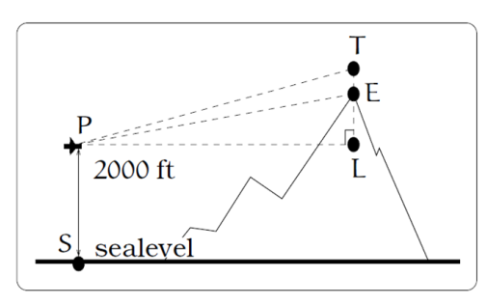
- A plane is flying 2000 feet above sea level toward a mountain. The pilot observes the top of the mountain to be 18º above the horizontal, then immediately flies the plane at an angle of 20º above horizontal. The airspeed of the plane is 100 mph. After 5 minutes, the plane is directly above the top of the mountain. How high is the plane above the top of the mountain (when it passes over)? What is the height of the mountain? [UW]

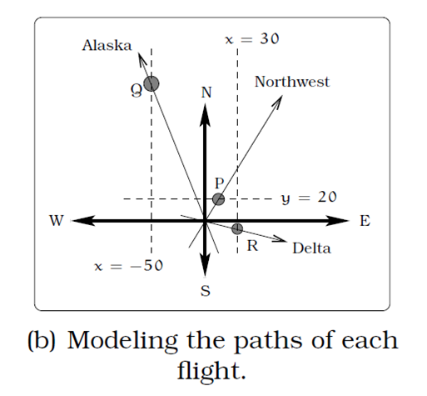
- Three airplanes depart SeaTac Airport. A NorthWest flight is heading in a direction 50° counterclockwise from East, an Alaska flight is heading 115° counterclockwise from East and a Delta flight is heading 20° clockwise from East. Find the location of the Northwest flight when it is 20 miles North of SeaTac. Find the location of the Alaska flight when it is 50 miles West of SeaTac. Find the location of the Delta flight when it is 30 miles East of SeaTac. [UW]
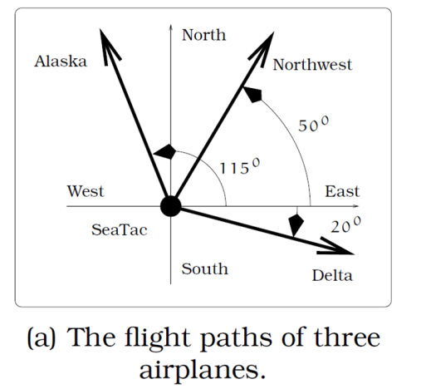

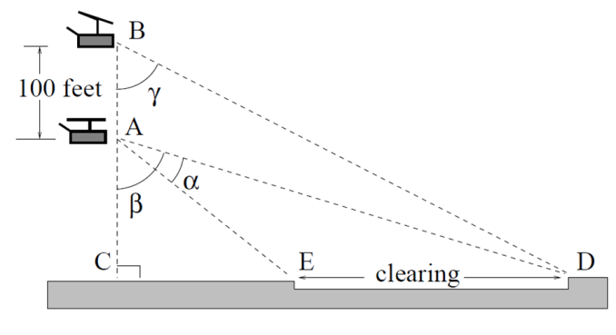
- The crew of a helicopter needs to land temporarily in a forest and spot a flat horizontal piece of ground (a clearing in the forest) as a potential landing site, but are uncertain whether it is wide enough. They make two measurements from A (see picture) finding α = 25° and β = 54°. They rise vertically 100 feet to B and measure γ = 47°. Determine the width of the clearing to the nearest foot. [UW]

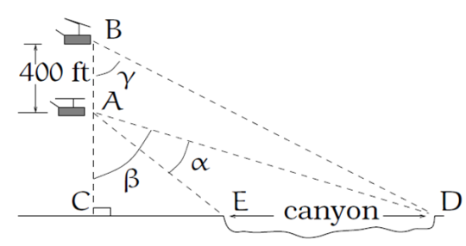
- A Forest Service helicopter needs to determine the width of a deep canyon. While hovering, they measure the angle γ = 48° at position B (see picture), then descend 400 feet to position A and make two measurements of α = 13° (the measure of $∠$EAD), β = 53° (the measure of $∠$CAD). Determine the width of the canyon to the nearest foot. [UW]

