Section 2.1 Exercises

- A town's population has been growing linearly. In 2003, the population was 45,000, and the population has been growing by 1700 people each year. Write an equation$P\left(t\right)\text{, }$for the population t years after 2003.
- A town's population has been growing linearly. In 2005, the population was 69,000, and the population has been growing by 2500 people each year. Write an equation$P\left(t\right)\text{, }$for the population t years after 2005.

- Sonya is currently 10 miles from home, and is walking further away at 2 miles per hour. Write an equation for her distance from home t hours from now.

- A boat is 100 miles away from the marina, sailing directly towards it at 10 miles per hour. Write an equation for the distance of the boat from the marina after t hours.

- Timmy goes to the fair with $40. Each ride costs $2. How much money will he have left after riding n rides?

- At noon, a barista notices she has $20 in her tip jar. If she makes an average of $0.50 from each customer, how much will she have in her tip jar if she serves n more customers during her shift?
Determine if each function is increasing or decreasing
7. $f\left(x\right)=4x+3$ 8. $g\left(x\right)=5x+6$
9. $a\left(x\right)=5−2x$ 10. $b\left(x\right)=8−3x$
11. $h\left(x\right)=−2x+4$ 12. $k\left(x\right)=−4x+1$
13. $j\left(x\right)=\frac{1}{2}x−3$ 14. $p\left(x\right)=\frac{1}{4}x−5$
15. $n\left(x\right)=−\frac{1}{3}x−2$ 16. $m\left(x\right)=−\frac{3}{8}x+3$

Find the slope of the line that passes through the two given points
17. (2, 4) and (4, 10) 18. (1, 5) and (4, 11)
19. (-1,4) and (5, 2) 20. (-2, 8) and (4, 6)
21. (6,11) and (-4,3) 22. (9,10) and (-6,-12)

Find the slope of the lines graphed
23. 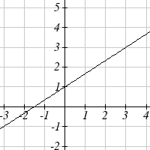 24. 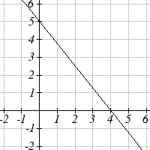

- Sonya is walking home from a friend’s house. After 2 minutes she is 1.4 miles from home. Twelve minutes after leaving, she is 0.9 miles from home. What is her rate?

- A gym membership with two personal training sessions costs $125, while gym membership with 5 personal training sessions costs $260. What is the rate for personal training sessions?

- A city's population in the year 1960 was 287,500. In 1989 the population was 275,900. Compute the slope of the population growth (or decline) and make a statement about the population rate of change in people per year.

- A city's population in the year 1958 was 2,113,000. In 1991 the population was 2,099,800. Compute the slope of the population growth (or decline) and make a statement about the population rate of change in people per year.

- A phone company charges for service according to the formula: $C(n)=\text{24}+0\text{.}1n$, where n is the number of minutes talked, and $C(n)$ is the monthly charge, in dollars.
Find and interpret the rate of change and initial value.

- A phone company charges for service according to the formula: $C(n)=\text{26}+0\text{.}\text{04}n$, where n is the number of minutes talked, and $C(n)$ is the monthly charge, in dollars.
Find and interpret the rate of change and initial value.

- Terry is skiing down a steep hill. Terry's elevation, $E(t)$, in feet after t seconds is given by $E(t)=\text{3000}−\text{70}t$. Write a complete sentence describing Terry’s starting point and how it is changing over time.

- Maria is climbing a mountain. Maria's elevation, $E(t)$, in feet after t minutes is given by $E\left(t\right)\text{1200}+\text{40}t$. Write a complete sentence describing Maria’s starting point and how it is changing over time.
Given each set of information, find a linear equation satisfying the conditions, if possible
33. $f(−5)=−4$, and $f(5)=2$ 34. $f(−1)=4$, and $f(5)=1$
35. Passes through (2, 4) and (4, 10) 36. Passes through (1, 5) and (4, 11)
37. Passes through (-1,4) and (5, 2) 38. Passes through (-2, 8) and (4, 6)
39. x intercept at (-2, 0) and y intercept at (0, -3)
40. x intercept at (-5, 0) and y intercept at (0, 4)

Find an equation for the function graphed
41. 42.

43. 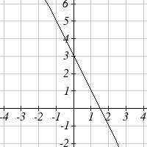 44. 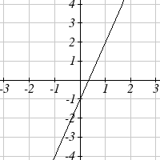

- A clothing business finds there is a linear relationship between the number of shirts, n, it can sell and the price, p, it can charge per shirt. In particular, historical data shows that $\text{1000}$ shirts can be sold at a price of $\$\text{30}$, while $\text{3000}$ shirts can be sold at a price of $\$\text{22}$. Find a linear equation in the form $p=\text{mn}+b$ that gives the price p they can charge for n shirts.

- A farmer finds there is a linear relationship between the number of bean stalks, n, she plants and the yield, y, each plant produces. When she plants 30 stalks, each plant yields 30 oz of beans. When she plants 34 stalks, each plant produces 28 oz of beans. Find a linear relationships in the form $y=\text{mn}+b$ that gives the yield when n stalks are planted.

- Which of the following tables which could represent a linear function? For each that could be linear, find a linear equation models the data.
  x | g(x)
  0 | 5
  5 | -10
  10 | -25
  15 | -40
  x | h(x)
  0 | 5
  5 | 30
  10 | 105
  15 | 230
  x | f(x)
  0 | -5
  5 | 20
  10 | 45
  15 | 70
  x | k(x)
  5 | 13
  10 | 28
  20 | 58
  25 | 73

- Which of the following tables which could represent a linear function? For each that could be linear, find a linear equation models the data.
  x | g(x)
  0 | 6
  2 | -19
  4 | -44
  6 | -69
  x | h(x)
  2 | 13
  4 | 23
  8 | 43
  10 | 53
  x | f(x)
  2 | -4
  4 | 16
  6 | 36
  8 | 56
  x | k(x)
  0 | 6
  2 | 31
  6 | 106
  8 | 231

- While speaking on the phone to a friend in Oslo, Norway, you learned that the current temperature there was -23 Celsius (-23ºC). After the phone conversation, you wanted to convert this temperature to Fahrenheit degrees ºF, but you could not find a reference with the correct formulas. You then remembered that the relationship between ºF and ºC is linear. [UW]
- Using this and the knowledge that 32ºF = 0 ºC and 212 ºF = 100 ºC, find an equation that computes Celsius temperature in terms of Fahrenheit; i.e. an equation of the form C = “an expression involving only the variable F.”
- Likewise, find an equation that computes Fahrenheit temperature in terms of Celsius temperature; i.e. an equation of the form F = “an expression involving only the variable C.”
- How cold was it in Oslo in ºF?

Section 2.2 Exercises

Match each linear equation with its graph
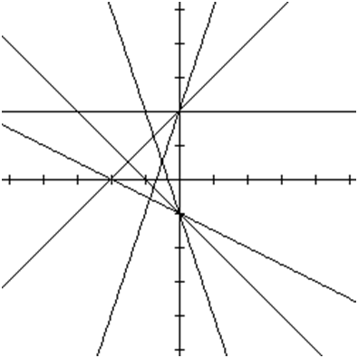
A
B
C
D
E
F
- $$f\left(x\right)=−x−1$$
- $$f\left(x\right)=−2x−1$$
- $$f\left(x\right)=−\frac{1}{2}x−1$$
- $$f\left(x\right)=2$$
- $$f\left(x\right)=2+x$$
- $$f\left(x\right)=3x+2$$

Sketch a line with the given features
- An x-intercept of (-4, 0) and y-intercept of (0, -2)
- An x-intercept of (-2, 0) and y-intercept of (0, 4)
- A vertical intercept of (0, 7) and slope $−\frac{3}{2}$
- A vertical intercept of (0, 3) and slope $\frac{2}{5}$
- Passing through the points (-6,-2) and (6,-6)
- Passing through the points (-3,-4) and (3,0)

Sketch each equation
13. $f\left(x\right)=−2x−1$ 14. $g\left(x\right)=−3x+2$
15. $h\left(x\right)=\frac{1}{3}x+2$ 16. $k\left(x\right)=\frac{2}{3}x−3$
17. $k\left(t\right)=3+2t$ 18. $p\left(t\right)=−2+3t$
19. $x=3$ 20. $x=−2$
21. $r\left(x\right)=4$ 22. $q\left(x\right)=3$

- If $g(x)$ is the $f(x)=x$ after a vertical compression by $3/4$, a shift left by 2, and a shift down by 4
  - Write an equation for $g\left(x\right)$
  - What is the slope of this line?
  - Find the vertical intercept of this line.

- If $g(x)$ is the $f(x)=x$ after a vertical compression by $1/3$, a shift right by 1, and a shift up by 3
  - Write an equation for $g\left(x\right)$
  - What is the slope of this line?
  - Find the vertical intercept of this line.

Write the equation of the line shown
25. 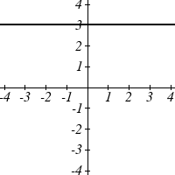 26. 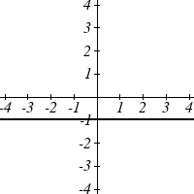

27. 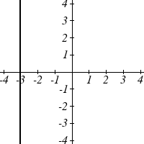 28. 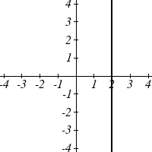
Find the horizontal and vertical intercepts of each equation
29. $f\left(x\right)=−x+2$ 30. $g\left(x\right)=2x+4$
31. $h\left(x\right)=3x−5$ 32. $k\left(x\right)=−5x+1$
33. $−2x+5y=\text{20}$ 34. $7x+2y=\text{56}$

Given below are descriptions of two lines. Find the slope of Line 1 and Line 2. Are each pair of lines parallel, perpendicular or neither?
- Line 1: Passes through $(0,6)$ and $(3,−\text{24})$
Line 2: Passes through $(−1,\text{19})$ and $(8,−\text{71})$
- Line 1: Passes through $(−8\text{, }−\text{55})$ and $(\text{10}\text{, }\text{89})$
Line 2: Passes through $(9\text{, }−\text{44})$ and $(4,−\text{14})$
- Line 1: Passes through $(2,3)$ and $(4,−1)$
Line 2: Passes through $(6,3)$ and $(8,5)$
- Line 1: Passes through $(1\text{, }7)$ and $(5,5)$
Line 2: Passes through $(−1,−3)$ and $(1,1)$
- Line 1: Passes through $(0\text{, }5)$ and $(3,3)$
Line 2: Passes through $(1,−5)$ and $(3,−2)$

- Line 1: Passes through $(2,5)$ and $(5,−1)$
Line 2: Passes through $(−3,7)$ and $(3,−5)$

- Write an equation for a line parallel to $f\left(x\right)=−5x−3$ and passing through the point (2,-12)
- Write an equation for a line parallel to $g(x)=3x−1$ and passing through the point (4,9)
- Write an equation for a line perpendicular to $h(t)=−2t+4$ and passing through the point (-4,-1)

- Write an equation for a line perpendicular to $p(t)=3t+4$ and passing through the point (3,1)
- Find the point at which the line $f(x)=−2x−1$ intersects the line $g(x)=−x$
- Find the point at which the line $f(x)=2x+5$ intersects the line $g(x)=−3x−5$

- Use algebra to find the point at which the line $f\left(x\right)=−\frac{4}{5}x+\frac{\text{274}}{\text{25}}$ intersects the line $h\left(x\right)=\frac{9}{4}x+\frac{\text{73}}{\text{10}}$
- Use algebra to find the point at which the line $f\left(x\right)=\frac{7}{4}x+\frac{\text{457}}{\text{60}}$ intersects the line $g\left(x\right)=\frac{4}{3}x+\frac{\text{31}}{5}$
- A car rental company offers two plans for renting a car.
Plan A: 30 dollars per day and 18 cents per mile
Plan B: 50 dollars per day with free unlimited mileage
For what range of miles will plan B save you money?

- A cell phone company offers two data options for its prepaid phones
Pay per use: $0.002 per Kilobyte (KB) used
Data Package: $5 for 5 Megabytes (5120 Kilobytes) + $0.002 per addition KB
Assuming you will use less than 5 Megabytes, for what range of use will the data package save you money?

- Sketch an accurate picture of the line having equation $f\left(x\right)=2−\frac{1}{2}x$. Let c be an unknown constant. [UW]
  - Find the point of intersection between the line you have graphed and the line $g\left(x\right)=1+\text{cx}$; your answer will be a point in the xy plane whose coordinates involve the unknown c.
  - Find c so that the intersection point in (a) has x-coordinate 10.
  - Find c so that the intersection point in (a) lies on the x-axis.

Section 2.3 Exercises

- In 2004, a school population was 1001. By 2008 the population had grown to 1697.
  - How much did the population grow between the year 2004 and 2008?
  - How long did it take the population to grow from 1001 students to 1697 students?
  - What is the average population growth per year?
  - What was the population in the year 2000?
  - Find an equation for the population, P, of the school t years after 2000.
  - Using your equation, predict the population of the school in 2011.

- In 2003, a town’s population was 1431. By 2007 the population had grown to 2134.
  - How much did the population grow between the year 2003 and 2007?
  - How long did it take the population to grow from 1431 people to 2134?
  - What is the average population growth per year?
  - What was the population in the year 2000?
  - Find an equation for the population, P, of the town t years after 2000.
  - Using your equation, predict the population of the town in 2014.

- A phone company has a monthly cellular plan where a customer pays a flat monthly fee and then a certain amount of money per minute used on the phone. If a customer uses 410 minutes, the monthly cost will be $71.50. If the customer uses 720 minutes, the monthly cost will be $118.
  - Find a linear equation for the monthly cost of the cell plan as a function of x, the number of monthly minutes used.
  - Interpret the slope and vertical intercept of the equation.
  - Use your equation to find the total monthly cost if 687 minutes are used.

- A phone company has a monthly cellular data plan where a customer pays a flat monthly fee and then a certain amount of money per megabyte (MB) of data used on the phone. If a customer uses 20 MB, the monthly cost will be $11.20. If the customer uses 130 MB, the monthly cost will be $17.80.
  - Find a linear equation for the monthly cost of the data plan as a function of x, the number of MB used.
  - Interpret the slope and vertical intercept of the equation.
  - Use your equation to find the total monthly cost if 250 MB are used.

- In 1991, the moose population in a park was measured to be 4360. By 1999, the population was measured again to be 5880. If the population continues to change linearly,
  - Find a formula for the moose population, P.
  - What does your model predict the moose population to be in 2003?

- In 2003, the owl population in a park was measured to be 340. By 2007, the population was measured again to be 285. If the population continues to change linearly,
  - Find a formula for the owl population, P.
  - What does your model predict the owl population to be in 2012?

- The Federal Helium Reserve held about 16 billion cubic feet of helium in 2010, and is being depleted by about 2.1 billion cubic feet each year.
  - Give a linear equation for the remaining federal helium reserves, R, in terms of t, the number of years since 2010.
  - In 2015, what will the helium reserves be?
  - If the rate of depletion isn’t change, when will the Federal Helium Reserve be depleted?

- Suppose the world's current oil reserves are 1820 billion barrels. If, on average, the total reserves is decreasing by 25 billion barrels of oil each year:
  - Give a linear equation for the remaining oil reserves, R, in terms of t, the number of years since now.
  - Seven years from now, what will the oil reserves be?
  - If the rate of depletion isn’t change, when will the world’s oil reserves be depleted?

- You are choosing between two different prepaid cell phone plans. The first plan charges a rate of 26 cents per minute. The second plan charges a monthly fee of $19.95 plus 11 cents per minute. How many minutes would you have to use in a month in order for the second plan to be preferable?

- You are choosing between two different window washing companies. The first charges $5 per window. The second charges a base fee of $40 plus $3 per window. How many windows would you need to have for the second company to be preferable?

- When hired at a new job selling jewelry, you are given two pay options:
Option A: Base salary of $17,000 a year, with a commission of 12% of your sales
Option B: Base salary of $20,000 a year, with a commission of 5% of your sales
How much jewelry would you need to sell for option A to produce a larger income?

- When hired at a new job selling electronics, you are given two pay options:
Option A: Base salary of $14,000 a year, with a commission of 10% of your sales
Option B: Base salary of $19,000 a year, with a commission of 4% of your sales
How much electronics would you need to sell for option A to produce a larger income?

- Find the area of a triangle bounded by the y axis, the line $f\left(x\right)=9−\frac{6}{7}x$, and the line perpendicular to $f(x)$ that passes through the origin.

- Find the area of a triangle bounded by the x axis, the line $f\left(x\right)=\text{12}−\frac{1}{3}x$, and the line perpendicular to $f(x)$ that passes through the origin.

- Find the area of a parallelogram bounded by the y axis, the line $x=3$, the line $f\left(x\right)=1+2x$, and the line parallel to $f(x)$ passing through (2, 7)

- Find the area of a parallelogram bounded by the x axis, the line $g(x)=2$, the line $f\left(x\right)=3x$, and the line parallel to $f(x)$ passing through (6, 1)

- If $b>0$ and $m<0$, then the line $f\left(x\right)=b+\text{mx}$ cuts off a triangle from the first quadrant. Express the area of that triangle in terms of m and b. [UW]

- Find the value of m so the lines $f\left(x\right)=\text{mx}+5$ and $g\left(x\right)=x$ and the y-axis form a triangle with an area of 10. [UW]

- The median home value in Mississippi and Hawaii (adjusted for inflation) are shown below. If we assume that the house values are changing linearly,
Year | Mississippi | Hawaii
1950 | 25200 | 74400
2000 | 71400 | 272700
  - In which state have home values increased at a higher rate?
  - If these trends were to continue, what would be the median home value in Mississippi in 2010?
  - If we assume the linear trend existed before 1950 and continues after 2000, the two states' median house values will be (or were) equal in what year? (The answer might be absurd)

- The median home value in Indiana and Alabama (adjusted for inflation) are shown below. If we assume that the house values are changing linearly,
Year | Indiana | Alabama
1950 | 37700 | 27100
2000 | 94300 | 85100
  - In which state have home values increased at a higher rate?
  - If these trends were to continue, what would be the median home value in Indiana in 2010?
  - If we assume the linear trend existed before 1950 and continues after 2000, the two states' median house values will be (or were) equal in what year? (The answer might be absurd)
- Pam is taking a train from the town of Rome to the town of Florence. Rome is located 30 miles due West of the town of Paris. Florence is 25 miles East, and 45 miles North of Rome. On her trip, how close does Pam get to Paris? [UW]

- You’re flying from Joint Base Lewis-McChord (JBLM) to an undisclosed location 226 km south and 230 km east. Mt. Rainier is located approximately 56 km east and 40 km south of JBLM. If you are flying at a constant speed of 800 km/hr, how long after you depart JBLM will you be the closest to Mt. Rainier?

Section 2.4 Exercises

- The following is data for the first and second Quiz scores for 8 students in a class. Plot the points, then sketch a line that best fits the data.

First Quiz | 11 | 20 | 24 | 25 | 33 | 42 | 46 | 49
Second Quiz | 10 | 16 | 23 | 28 | 30 | 39 | 40 | 49

- Eight students were asked to estimate their score on a 10 point quiz. Their estimated and actual scores are given. Plot the points, then sketch a line that best fits the data.

Predicted | 5 | 7 | 6 | 8 | 10 | 9 | 10 | 7
Actual | 6 | 6 | 7 | 8 | 9 | 9 | 10 | 6

Based on each set of data given, calculate the regression line using your calculator or other technology tool, and determine the correlation coefficient.
3. |  | 4. |  | 5. |  | 6.
  x | y
  5 | 4
  7 | 12
  10 | 17
  12 | 22
  15 | 24
  x | y
  8 | 23
  15 | 41
  26 | 53
  31 | 72
  56 | 103
  x | y
  3 | 21.9
  4 | 22.22
  5 | 22.74
  6 | 22.26
  7 | 20.78
  8 | 17.6
  9 | 16.52
  10 | 18.54
  11 | 15.76
  12 | 13.68
  13 | 14.1
  14 | 14.02
  15 | 11.94
  16 | 12.76
  17 | 11.28
  18 | 9.1
  x | y
  4 | 44.8
  5 | 43.1
  6 | 38.8
  7 | 39
  8 | 38
  9 | 32.7
  10 | 30.1
  11 | 29.3
  12 | 27
  13 | 25.8
  14 | 24.7
  15 | 22
  16 | 20.1
  17 | 19.8
  18 | 16.8

- A regression was run to determine if there is a relationship between hours of TV watched per day (x) and number of situps a person can do (y). The results of the regression are given below. Use this to predict the number of situps a person who watches 11 hours of TV can do.
y=ax+b
a=-1.341
b=32.234
r²=0.803
r=-0.896

- A regression was run to determine if there is a relationship between the diameter of a tree (x, in inches) and the tree’s age (y, in years). The results of the regression are given below. Use this to predict the age of a tree with diameter 10 inches.
y=ax+b
a=6.301
b=-1.044
r²=0.940
r=-0.970

Match each scatterplot shown below with one of the four specified correlations.
9. r = 0.95 10. r = -0.89 11. r = 0.26 12. r = -0.39
A B C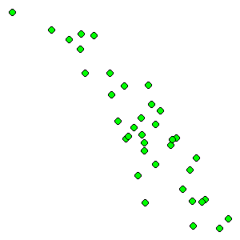 D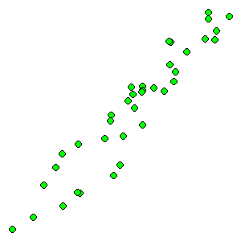
- The US census tracks the percentage of persons 25 years or older who are college graduates. That data for several years is given below. Determine if the trend appears linear. If so and the trend continues, in what year will the percentage exceed 35%?

Year | 1990 | 1992 | 1994 | 1996 | 1998 | 2000 | 2002 | 2004 | 2006 | 2008
Percent Graduates | 21.3 | 21.4 | 22.2 | 23.6 | 24.4 | 25.6 | 26.7 | 27.7 | 28 | 29.4

- The US import of wine (in hectoliters) for several years if given below. Determine if the trend appears linear. If so and the trend continues, in what year will imports exceed 12,000 hectoliters?

Year | 1992 | 1994 | 1996 | 1998 | 2000 | 2002 | 2004 | 2006 | 2008 | 2009
Imports | 2665 | 2688 | 3565 | 4129 | 4584 | 5655 | 6549 | 7950 | 8487 | 9462

Section 2.5 Exercises

Write an equation for each transformation of $f(x)=|x|$

1.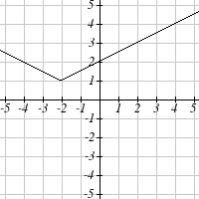 2.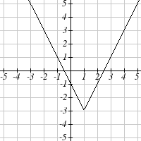

3.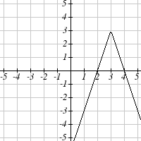 4.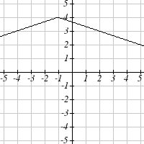

Sketch a graph of each function
5. $f(x)=−|x−1|−1$ 6. $f\left(x\right)=−\left|x+3\right|+4$
7. $f\left(x\right)=2\left|x+3\right|+1$ 8. $f\left(x\right)=3\left|x−2\right|−3$
9. $f\left(x\right)=\left|2x−4\right|−3$ 10. $f\left(x\right)=\left|3x+9\right|+2$

Solve each the equation
11. $|5x−2|=\text{11}$ 12. $|4x+2|=\text{15}$
13. $2|4−x|=7$ 14. $3|5−x|=5$
15. $3\left|x+1\right|−4=−2$ 16. $5\left|x−4\right|−7=2$

Find the horizontal and vertical intercepts of each function
17. $f(x)=2|x+1|−\text{10}$ 18. $f\left(x\right)=4\left|x−3\right|+4$
19. $f\left(x\right)=−3\left|x−2\right|−1$ 20. $f\left(x\right)=−2\left|x+1\right|+6$
Solve each inequality
21. $|x+5|<6$ 22. $|x−3|<7$
23. $|x−2|≥3$ 24. $|x+4|≥2$
25. $|3x+9|<4$ 26. $|2x−9|≤8$

