# Chapter 3: The Integral

The previous chapters dealt with **Differential Calculus**. We started with the "simple" geometrical idea of the **slope of a tangent line** to a curve, developed it into a combination of theory about derivatives and their properties, techniques for calculating derivatives, and applications of derivatives. This chapter deals with **Integral Calculus** and starts with the "simple" geometric idea of **area**. This idea will be developed into another combination of theory, techniques, and applications.

## PreCalculus Idea – The Area of a Rectangle

If you look on the inside cover of nearly any traditional math book, you’ll find a bunch of area and volume formulas – the area of a square, the area of a trapezoid, the volume of a right circular cone, and so on. Some of these formulas are pretty complicated. But you still won’t find a formula for the area of a jigsaw puzzle piece or the volume of an egg. There are lots of things for which there is no formula. Yet we might still want to find their areas.

One reason areas are so useful is that they can represent quantities other than simple geometric shapes. If the units for each side of the rectangle are *meters*, then the area will have the units *meters*× *meters* = *square meters* = m2. But if the units of the base of a rectangle are *hours* and the units of the height are *miles/hour*, then the units of the area of the rectangle are *hours* × *miles/hour* = *miles*, a measure of distance. Similarly, if the base units are *centimeters* and the height units are *grams*, then the area units are *gram-centimeters*, a measure of work.

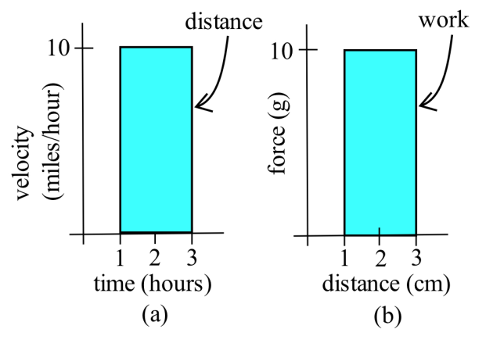

The basic shape we will use is the rectangle; the area of a rectangle is base × height. You should also know the area formulas for triangles,  and for circles,.

## Section 1: The Definite Integral

### Distance from Velocity

Example 1

Suppose a car travels on a straight road at a constant speed of 40 miles per hour for two hours. See the graph of its velocity below. How far has it gone?

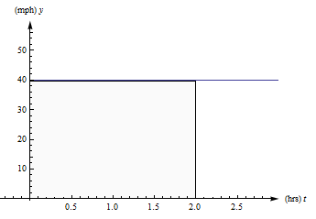

We all remember **distance = rate × time**, so this one is easy. The car has gone 40 miles per hour × 2 hours = 80 miles.

Example 2

Now suppose that a car travels so that its speed increases steadily from 0 to 40 miles per hour, for two hours. (Just be grateful you weren’t stuck behind this car on the highway.) See the graph of its velocity in below. How far has this car gone?

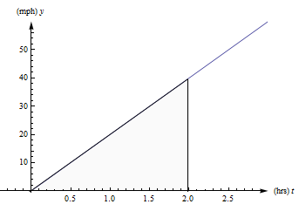

The trouble with our old reliable **distance = rate × time** relationship is that it only works if the rate is constant. If the rate is changing, there isn’t a good way to use this formula.

But look at graph from the last example again. Notice that **distance = rate × time** also describes the area between the velocity graph and the t-axis, between t = 0 and t = 2 hours. The **rate** is the height of the rectangle, the **time** is the length of the rectangle, and the **distance** is the **area** of the rectangle. This is the way we can extend our simple formula to handle more complicated velocities: And this is the way we can answer the second example.

The distance the car travels is the area between its velocity graph, the t-axis, t = 0 and t = 2. This region is a triangle, so its area is ½bh = ½(2 hours)(40 miles per hour) = 40 miles. So the car travels 40 miles during its annoying trip.

In our distance/velocity examples, the function represented a **rate** of travel (miles per hour), and the area represented the **total** distance traveled. This principle works more generally:

For functions representing other **rates** such as the production of a factory (bicycles per day), or the flow of water in a river (gallons per minute) or traffic over a bridge (cars per minute), or the spread of a disease (newly sick people per week), the area will still represent the **total** amount of something.

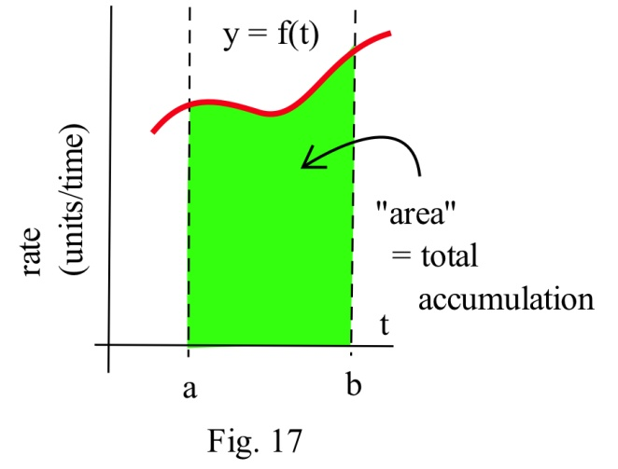

Example 3

The graph below shows the flow rate (cubic feet per second) of water in the Skykomish river at the town of Goldbar in Washington state.

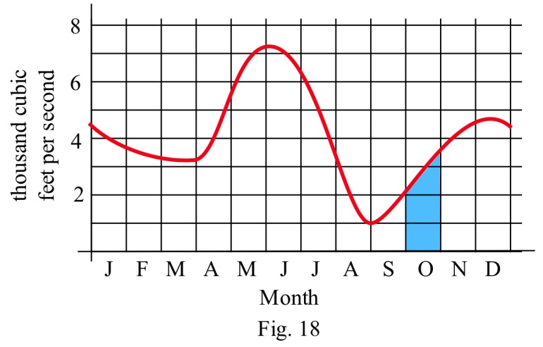

The area of the shaded region represents the total volume (cubic feet) of water flowing past the town during the month of October. We can approximate this area to approximate the total water by thinking of the shaded region as a rectangle with a triangle on top.

Total water = total area ≈ area of rectangle + area of the “triangle”

≈ (2000 cubic feet/sec)(30 days) + = (2750 cubic feet/sec)(30 days)

Note that we need to convert the units to make sense of our result:

Total water ≈ (2750 cubic feet/sec)(30 days) = (2750 cubic feet/sec)(2,592,000 sec)

≈ 7.128 x 109 cubic feet.

About 7 billion cubic feet of water flowed past Goldbar in October.

### Approximating with Rectangles

How do we approximate the area if the rate curve is, well, curvy? We could use rectangles and triangles, like we did in the last example. But it turns out to be more useful (and easier) to simply use rectangles. The more rectangles we use, the better our approximation is.

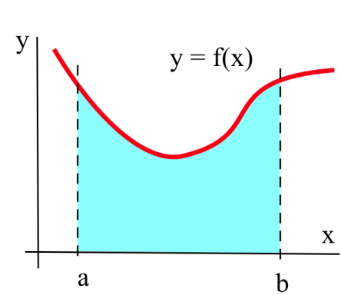

Suppose we want to calculate the area between the graph of a positive function *f* and the *x*–axis on the interval [a, b] (graphed above). The **Riemann Sum method** is to build several rectangles with bases on the interval [a, b] and sides that reach up to the graph of *f* (see below). Then the areas of the rectangles can be calculated and added together to get a number called a Riemann Sum of *f* on [a, b]. The area of the region formed by the rectangles is an **approximation** of the area we want.

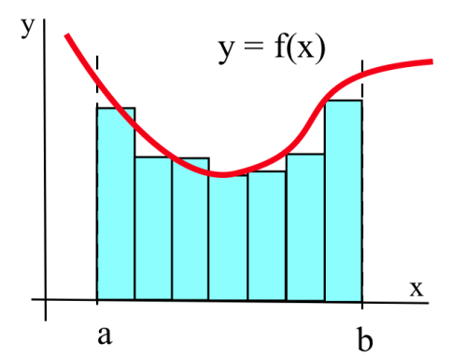

Example 4

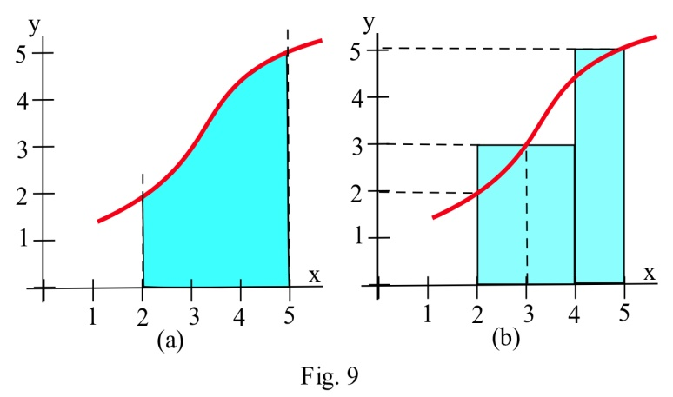Approximate the area in the graph on the left between the graph of f and the x–axis on the interval [2, 5] by summing the areas of the rectangles in the graph on the right.

The total area of rectangles is (2)(3) + (1)(5) = 11 square units.

Example 5

Let A be the region bounded by the graph of f(x) = 1/x, the x–axis, and vertical lines at x = 1 and x = 5. We can’t find the area exactly (with what we know now), but we can approximate it using rectangles.

When we make our rectangles, we have a lot of choices. We could pick any (non-overlapping) rectangles whose bottoms lie within the interval on the x-axis, and whose tops intersect with the curve somewhere. But it’s easiest to choose rectangles that – (a) have all the same width, and (b) take their heights from the function at one edge. Below you'll see two ways to use four rectangles to approximate this area. In the first graph, we used left-endpoints; the height of each rectangle comes from the function value at its left edge. In the second graph on the next page, we used right-hand endpoints.

**Left-hand endpoints:** The area is approximately the sum of the areas of the rectangles. Each rectangle gets its height from the function  and each rectangle has width = 1.

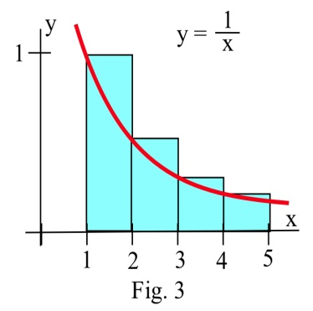

You can find the area of each rectangle using area = height × width. So the total area of the rectangles, the left-hand estimate of the area under the curve, is



Notice that because this function is decreasing, all the left endpoint rectangles stick out above the region we want – using left-hand endpoints will overestimate the area.

**Right-hand endpoints:** The right-hand estimate of the area is



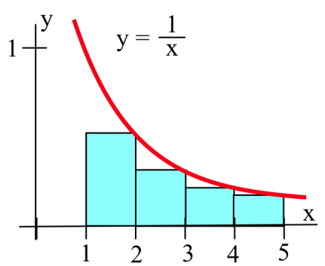

All the right-hand rectangles lie completely under the curve, so this estimate will be an underestimate.

We can see that the true area is actually in between these two estimates. So we could take their average:

**Average: **

In general, the average of the left-hand and right-hand estimates will be closer to the real area than either individual estimate.

My estimate of the area under the curve is about 1.68. (The actual area is about 1.61.)

If we wanted a better answer, we could use even more, even narrower rectangles. But there’s a limit to how much work we want to do by hand. In practice, it’s probably best to choose a manageable number of rectangles. We’ll have better methods to get more accurate answers before long.

These sums of areas of rectangles are called **Riemann sums**. You may see a shorthand notation used when people talk about sums. We won’t use it much in this book, but you should know what it means.

**Riemann sum:** A Riemann sum for a function f(x) over an interval [a, b] is a sum of areas of rectangles that approximates the area under the curve. Start by dividing the interval [a, b] into n subintervals; each subinterval will be the base of one rectangle. We usually make all the rectangles the same width Δx. The height of each rectangle comes from the function evaluated at some point in its sub interval. Then the Riemann sum is:



**Sigma Notation:** The upper-case Greek letter Sigma Σ is used to stand for Sum. Sigma notation is a way to compactly represent a sum of many similar terms, such as a Riemann sum.

Using the Sigma notation, the Riemann sum can be written .

This is read aloud as “the sum as i = 1 to n of f of x sub i Delta x.” The “i” is a counter, like you might have seen in a programming class.

### Definition of the Definite Integral

Because the area under the curve is so important, it has a special vocabulary and notation.

**The Definite Integral:**

The **definite integral** of a positive function f(x) over an interval [a, b] is the area

between f, the x-axis, x = a and x = b.

The **definite integral** of a positive function f(x) from a to b is the area under the curve between a and b.

If f(t) represents a positive rate (in y-units per t-units), then the **definite integral** of f from a to b is the total y-units that accumulate between t = a and t = b.

**Notation for the Definite Integral:**

The definite integral of f from a to b is written

**

The symbol is called an **integral sign**; it’s an elongated letter S, standing for sum.

(The corresponds to the Σ from the Riemann sum)

The dx on the end must be included; The dx tells what the variable is – in this example, the variable is x. (The dx corresponds to thefrom the Riemann sum)

The function f is called the **integrand**.

The a and b are called the limits **of integration**.

**Verb forms:**

We **integrate**, or **find the definite integral** of a function. This process is called **integration**.

**Formal Algebraic Definition:.**

**Practical Definition:**

The definite integral can be approximated with a Riemann sum (dividing the area into rectangles where the height of each rectangle comes from the function, computing the area of each rectangle, and adding them up). The more rectangles you use, the narrower the rectangles are, the better your approximation will be.

**Looking Ahead:**

We will have methods for computing exact values of some definite integrals from formulas soon. In many cases, including when the function is given to you as a table or graph, you will still need to approximate the definite integral with rectangles.

Example 6

The graph shows y = r(t), the number of telephone calls made per hours on a Tuesday. Approximately how many calls were made between 9 pm and 11 pm? Express this as a definite integral and approximate with a Riemann sum.

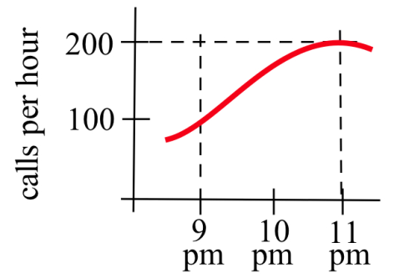

We know that the accumulated calls will be the area under this rate graph over that two-hour period, the definite integral of this rate from t = 9 to t = 11.

The total number of calls will be .

The top here is a curve, so we can’t get an exact answer. But we can approximate the area using rectangles. I’ll choose to use 4 rectangles, and I’ll choose left-endpoints:

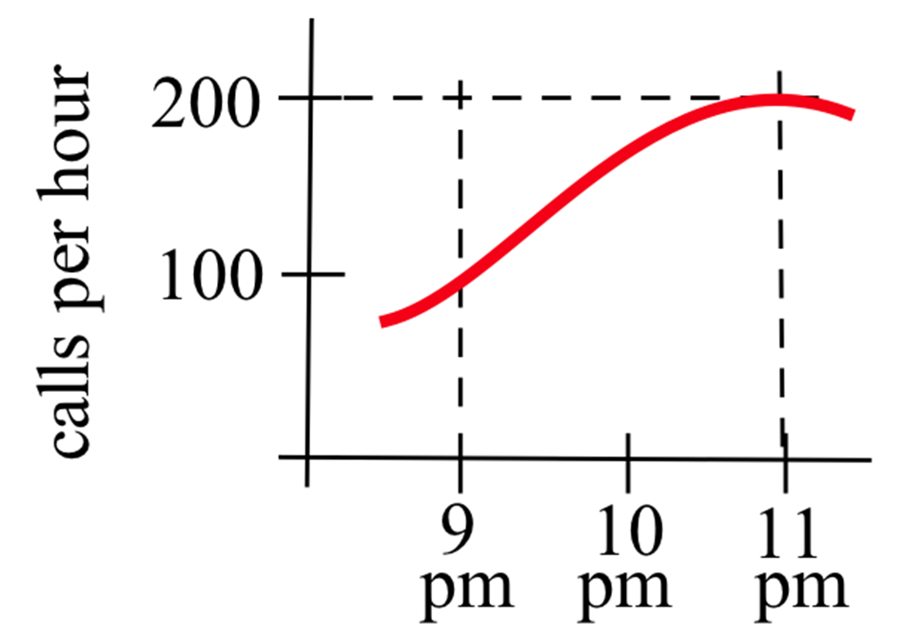



The units are *calls per hour* × *hours* = *calls*. My estimate is that about 312 calls were made between 9 pm and 11 pm. Is this an under-estimate or an over-estimate?

Example 7

Describe the area between the graph of f(*x*) = 1/*x*, the *x*–axis, and the vertical lines at *x* = 1 and *x* = 5 as a definite integral.

This is the same area we estimated to be about 1.68 before. Now we can use the notation of the definite integral to describe it. Our estimate of  was 1.68. The true value of  is about 1.61.

Example 8

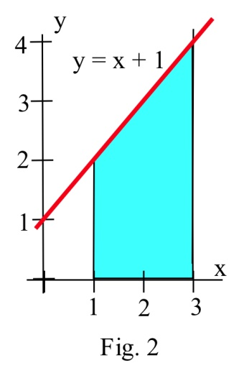Using the idea of area, determine the value of .

represents the area between the graph of f(*x*) = 1+*x*, the *x*–axis, and the vertical lines at 1 and 3.

Since this area can be broken into a rectangle and a triangle, we can find the area exactly. The area equals   
4 + ½ (2)(2) = 6 square units.

Example 9

The table shows rates of population growth for Berrytown for several years. Use this table to estimate the total population growth from 1970 to 2000:

|  |  |  |  |  |
| --- | --- | --- | --- | --- |
| Year (t) | 1970 | 1980 | 1990 | 2000 |
| Rate of population growth R(t)  (thousands of people per year) | 1.5 | 1.9 | 2.2 | 2.4 |

The definite integral of this rate will give the total change in population over the thirty-year period. We only have a few pieces of information, so we can only estimate. Even though I haven’t made a graph, we’re still approximating the area under the rate curve, using rectangles. How wide are the rectangles? I have information every 10 years, so the rectangles have a width of 10 years. How many rectangles? Be careful here – this is a thirty-year span, so there are three rectangles.

Using left-hand endpoints: (1.5)(10) + (1.9)(10) + (2.2)(10) = 56

Using right-hand endpoints: (1.9)(10) + (2.2)(10) + (2.4)(10) = 65

Taking the average of these two: 

Our best estimate of the total population growth from 1970 to 2000 is 60.5 thousand people.

### Signed Area

You may have noticed that until this point, we’ve insisted that the integrand (the function we’re integrating) be positive. That’s because we’ve been talking about area, which is always positive. If the “height” (from the function) is a negative number, then multiplying it by the width doesn’t give us actual area, it gives us the area with a negative sign.

But it turns out to be useful to think about the possibility of negative area. We’ll expand our idea of a definite integral now to include integrands that might not always be positive. The “heights” of the rectangles, the values from the function, now might not always be positive.

**The Definite Integral and Signed Area:**

The **definite integral** of a function f(x) over an interval [a, b] is the **signed area**

between f, the x-axis, x = a and x = b.

The **definite integral** of a function f(x) from a to b is the **signed area** under the curve between a and b.

If the function is positive, the signed area is positive, as before (and we can call it area.)

If the function dips below the x-axis, the areas of the regions below the x-axis come in with a negative sign. In this case, we cannot call it simply “area.” These negative areas take away from the definite integral.

= (Area above x-axis) – (Area below x-axis).

If f(t) represents a positive rate (in y-units per t-units), then the **definite integral** of f from a to b is the **total** y-units that accumulate between t = a and t = b.

If f(t) represents any rate (in y-units per t-units), then the **definite integral** of f from a to b is the **net** y-units that accumulate between t = a and t = b.

Example 10

Find the definite integral of of f(*x*) = –2 on the interval [1,4].

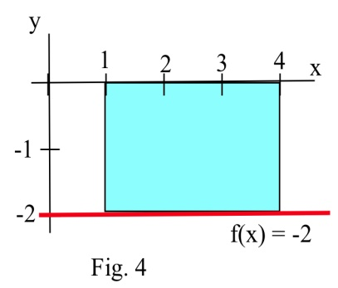

is the signed area of the region shown to the right. The region lies below the x-axis, so the area, 6, comes in with a negative sign. So the definite integral is = –6.

Negative rates indicate that the amount is decreasing. For example, if f(*t*) is the velocity of a car in the positive direction along a straight line at time *t* (miles/hour) , then negative values of f indicate that the car is traveling in the negative direction, backwards. The definite integral of f is the change in position of the car during the time interval. If the velocity is positive, positive distance accumulates. If the velocity is negative, distance in the negative direction accumulates.

This is true of any rate. For example, if f(*t*) is the rate of population change (people/year) for a town, then negative values of f would indicate that the population of the town was getting smaller, and the definite integral (now a negative number) would be the **change** in the population, a decrease, during the time interval.

Example 11

In 1980 there were 12,000 ducks nesting around a lake, and the **rate** of population change (in ducks per year) is shown in Fig. 15. Write a definite integral to represent the total change in the duck population from 1980 to 1990, and estimate the population in 1990.

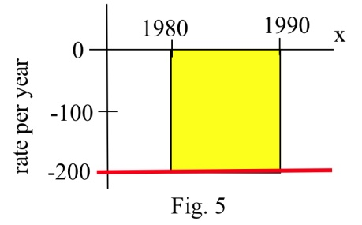

The **change** in population

= = – (area between f and axis)

≈ – (200 ducks/year)**.**(10 years) = – 2000 ducks.

Then (1990 duck population) = (1980 population) + (change from 1980 to 1990)

= (12,000) + ( –2000) = 10,000 ducks.

Example 12

A bug starts at the location x = 12 on the x–axis at 1 pm walks along the axis with the velocity *v*(*x*) shown in the graph. How far does the bug travel between 1 pm and 3 pm, and where is the bug at 3 pm?

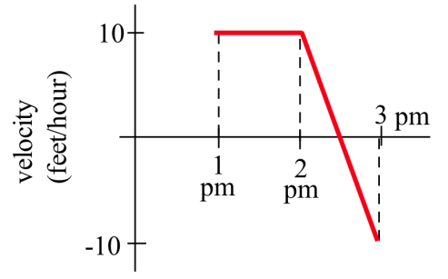

Note that the velocity is positive from 1 until 2:30, then becomes negative. So the bug moves in the positive direction from 1 until 2:30, then turns around and moves back toward where it started. The area under the velocity curve from 1 to 2:30 shows the total distance traveled by the bug in the positive direction; the bug moved 12.5 feet in the positive direction. The **area** between the velocity curve and the x-axis, between 2:30 and 3, shows the total distance traveled by the bug in the negative direction, back toward home; the bug traveled 2.5 feet in the negative direction. The definite integral of the velocity curve, , shows the net change in distance:



The bug ended up 10 feet further in the positive direction than he started. At 3 pm, the bug is at x = 22.

Example 13

Use the graph to calculate , , , and .

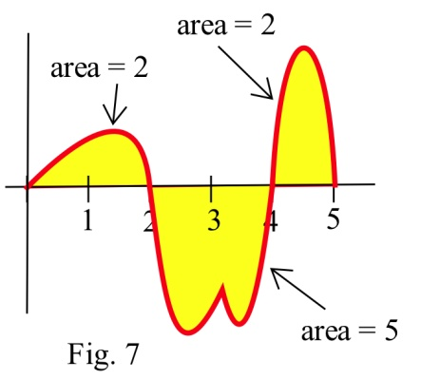

Using the given areas, = 2, = **– 5** , = 2, and

= (area above) – (area below) = (2+2) – (5) = –1.

### Approximating with Technology

If your function is given as a graph or table, you will still have to approximate definite integrals using areas, usually of rectangles. But if your function is given as a formula, you can turn to technology to get a better approximate answer. For example, most graphing calculators have some kind of numerical integration tool built in. You can also find many online tools that can do this; type numerical integration into any search engine to see a selection of these.

Most numerical integration tools use rectangles to estimate the signed area, just as you would do by hand. But they use many more rectangles than you would have the patience for, so they get a better answer. Some of them use computer algebra systems to find exact answers; we will learn how to do this ourselves later in this chapter.

When you turn to technology to find the value of a definite integral, be careful. Not every tool will be able to give you a correct answer for every integral. I have had good luck with my TI 84. You should make an estimate of the answer yourself first so you can judge whether the answer you get makes sense.

Example 14

Use technology to approximate the definite integral . (This is the same definite integral we approximated with rectangles before.)

I used my TI-84; the answer it gave me was 1.609437912. This agrees with the exact answer for all the decimal digits displayed. WebMath said the answer was 1.60944, which is accurate for all the decimal digits displayed. Microsoft Math said the answer was ln(5); that’s exactly correct. Wolfram|Alpha says the answer is log(5); that’s not how everyone writes the natural log, so that might trick you into writing the wrong answer.

Example 15

Use technology to approximate the definite integral 

I asked WebMath, and it said the answer was zero – I know this is not correct, because the function here is positive, so there must be some area under the curve here. I asked Microsoft Math, and it simply repeated the definite integral; that’s because there isn’t an algebraic way to find the exact answer. I asked my TI-84, and it said the answer was 86.83404047; that makes sense with what I expected. Wolfram|Alpha also says the answer is about 86.834. So I believe: 

### Accumulation in Real Life

We have already seen that the "area" under a graph can represent quantities whose units are not the usual geometric units of square meters or square feet. For example, if *t* is a measure of time in seconds and f(*t*) is a velocity with units feet/second, then the definite integral has units (feet/second) ∙ (seconds) = feet.

In general, the units for the definite integral are (*y*-units ) **.** (*x*-units). A quick check of the units can help avoid errors in setting up an applied problem.

In previous examples, we looked at a function represented a **rate** of travel (miles per hour); in that case, the area represented the **total** distance traveled. For functions representing other **rates** such as the production of a factory (bicycles per day), or the flow of water in a river (gallons per minute) or traffic over a bridge (cars per minute), or the spread of a disease (newly sick people per week), the area will still represent the **total** amount of something.

Example 16

Suppose MR(q) is the marginal revenue in dollars/item for selling q items. What does represent?

 has units (dollars/item) ∙ (items) = dollars, and represents the accumulated dollars for selling from 0 to 150 items. That is, , the total revenue from selling 150 items.

Example 17

Suppose *r*(*t*), in centimeters per year, represents how the diameter of a tree changes with time. What does  represent?

has units of (centimeters per year) ∙ (years) = centimeters, and represents the accumulated growth of the tree’s diameter from T1 to T2. That is, is the change in the diameter of the tree over this period of time.

### 3.1 Exercises

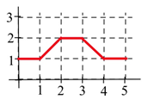

1. Let A(*x*) represent the area bounded by the graph and the horizontal axis and vertical lines at *t*=0 and *t*=*x* for the graph shown. Evaluate A(*x*) for *x* = 1, 2, 3, 4, and 5.

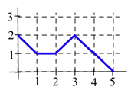

1. Let B(*x*) represent the area bounded by the graph and the horizontal axis and vertical lines at *t*=0 and *t*=*x* for the graph shown. Evaluate B(*x*) for *x* = 1, 2, 3, 4, and 5.

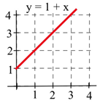

1. Let C(*x*) represent the area bounded by the graph and the horizontal axis and vertical lines at *t*=0 and *t*=*x* for the graph shown. Evaluate C(*x*) for *x* = 1, 2, and 3 and find a formula for C(*x*).

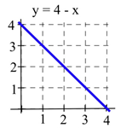

1. Let A(*x*) represent the area bounded by the graph and the horizontal axis and vertical lines at *t*=0 and *t*=*x* for the graph shown. Evaluate A(*x*) for *x* = 1, 2, and 3 and find a formula for A(*x*).

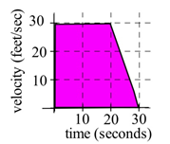

1. A car had the velocity shown in the graph to the right. How far did the car travel from *t*= 0 to *t* = 30 seconds?

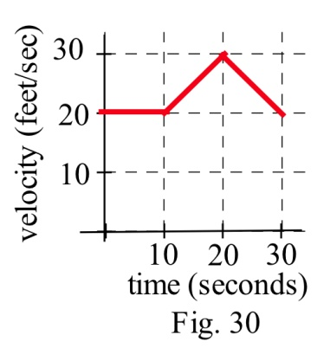6. A car had the velocity shown below. How afar did the car travel from *t* = 0 to *t* = 30 seconds?

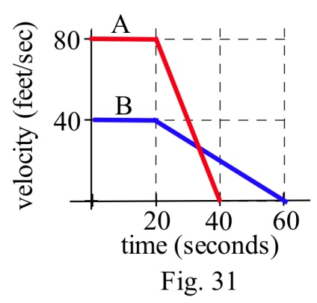

7. The velocities of two cars are shown in the graph.

(a) From the time the brakes were applied, how many seconds did it take each car to stop?

(b) From the time the brakes were applied, which car traveled farther until it came to a complete stop?

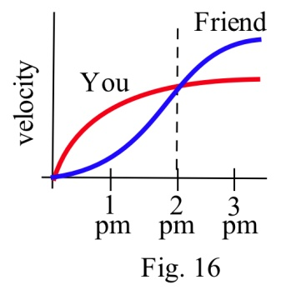

8. You and a friend start off at noon and walk in the same direction along the same path at the rates shown.

(a) Who is walking faster at 2 pm? Who is ahead at 2 pm?

(b) Who is walking faster at 3 pm? Who is ahead at 3 pm?

(c) When will you and your friend be together? (Answer in words.)

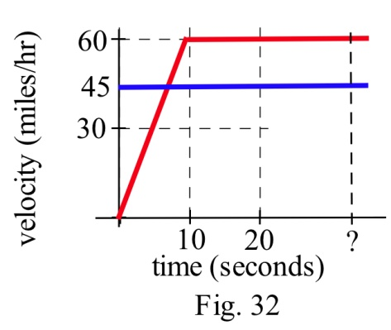

9.Police chase: A speeder traveling 45 miles per hour (in a 25 mph zone) passes a stopped police car which immediately takes off after the speeder. If the police car speeds up steadily to 60 miles/hour in 20 seconds and then travels at a steady 60 miles/hour, **how long** and **how far** before the police car catches the speeder who continued traveling at 45 miles/hour?

10. Water is flowing into a tub. The table shows the rate at which the water flows, in gallons per minute. The tub is initially empty.

|  |  |  |  |  |  |  |  |  |  |  |  |
| --- | --- | --- | --- | --- | --- | --- | --- | --- | --- | --- | --- |
| *t*, in minutes | 0 | 1 | 2 | 3 | 4 | 5 | 6 | 7 | 8 | 9 | 10 |
| Flow rate, in gal/min | 0.5 | 1.0 | 1.2 | 1.4 | 1.7 | 2.0 | 2.3 | 1.8 | 0.7 | 0.5 | 0.2 |

Use the table to estimate how much water is in the tub after

a. five minutes

b. ten minutes

11. The table shows the speedometer readings for a short car trip.

|  |  |  |  |  |  |
| --- | --- | --- | --- | --- | --- |
| , in minutes | 0 | 5 | 10 | 15 | 20 |
| Speed, in mph | 0 | 30 | 40 | 65 | 40 |

a. Use the table to estimate how far the car traveled over the twenty minutes shown.

b. How accurate would you expect your estimate to be?

12. The table shows values of . Use the table to estimate .

|  |  |  |  |  |  |
| --- | --- | --- | --- | --- | --- |
| *t* | 0 | 10 | 20 | 30 | 40 |
|  | 17 | 22 | 18 | 11 | 35 |

13. The table shows values of .

|  |  |  |  |  |  |  |  |
| --- | --- | --- | --- | --- | --- | --- | --- |
| *x* | 0 | 1 | 2 | 3 | 4 | 5 | 6 |
|  | 140 | 142 | 144 | 152 | 154 | 165 | 200 |

Use the table to estimate

a.  b.  c. 

14. What are the units for the "area" of a rectangle with the given

base and height units?

Base units Height units "Area" units

miles per second seconds

hours dollars per hour

square feet feet

kilowatts hours

houses people per house

meals meals

In problems 15 – 17 , represent the area of each bounded region as a definite integral, and use geometry to

determine the value of the definite integral.

15. The region bounded by y = 2*x* , the x–axis, the line *x* = 1, and *x* = 3.

16. The region bounded by y = 4 – 2*x* , the x–axis, and the y–axis.

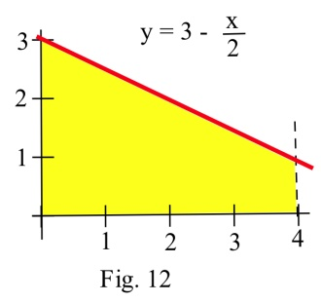

17. The shaded region in the graph to the right.

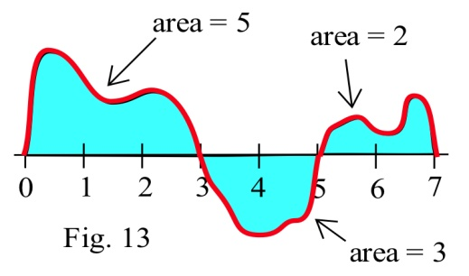18. Using the graph of f shown and the given areas of several regions, evaluate:

(a) (b) (c)

19. Using the graph of f shown and the given areas of several regions, evaluate:

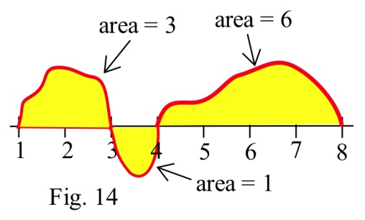(a) (b)

(c) (d)

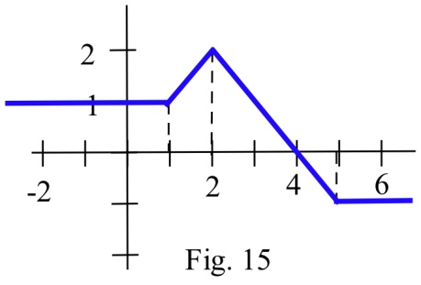20. Use the graph to evaluate:

(a) (b)

(c) (d)

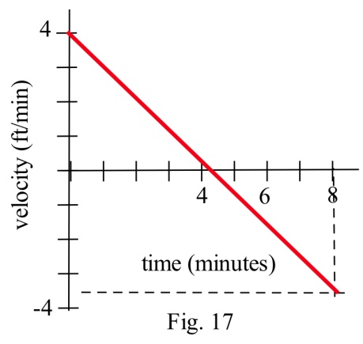

21. Your velocity along a straight road is shown to the right. How far did you travel in 8 minutes?

22. Your velocity along a straight road is shown below. How many feet did you walk in 8 minutes?

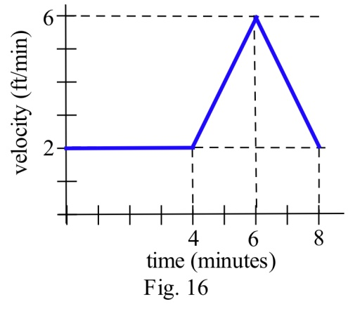

In problems 23 - 26, the units are given for *x* and for f(*x*) . Give the units of .

23. *x* is time in "seconds", and f(*x*) is velocity in "meters per second."

24. *x* is time in "hours", and f(*x*) is a flow rate in "gallons per hour."

25. *x* is a position in "feet", and f(*x*) is an area in "square feet."

26. *x* is a position in "inches", and f(*x*) is a density in "pounds per inch."

In problems 27 – 31, represent the area with a definite integral and use technology to find the approximate answer.

27. The region bounded by y = *x* 3, the x–axis, the line *x* = 1, and *x* = 5.

28. The region bounded by y = , the x–axis, and the line *x* = 9.

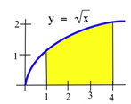

29. The shaded region shown to the right.

30. The shaded region below.

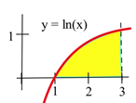

31. Consider the definite integral .

(a) Using six rectangles, find the left-hand Riemann sum for this definite integral.

(b) Using six rectangles, find the right-hand Riemann sum for this definite integral.

(c) Using geometry, find the exact value of this definite integral.

32. Consider the definite integral .

(a) Using four rectangles, find the left-hand Riemann sum for this definite integral.

(b) Using four rectangles, find the right-hand Riemann sum for this definite integral.

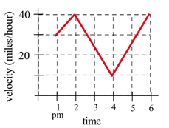

33. Write the total distance traveled by the car in the graph between 1 pm and 4 pm as a definite integral and estimate the value of the integral.

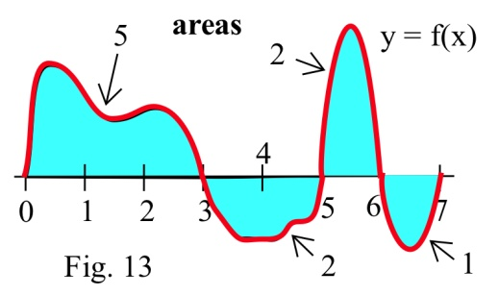Problems 34 – 41 refer to the graph of f shown. Use the graph to determine the values of the definite integrals. (The bold numbers represent the **area** of each region.)

34. 35. 36.

37. 38. 39. 40. 41.

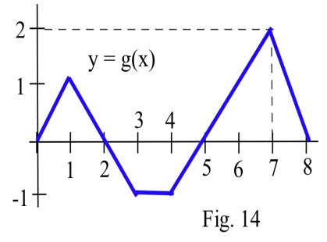

Problems 42 – 47 refer to the graph of g shown. Use the graph to evaluate the integrals.

42. 43. 44.

45. 46. 47.

## Section 2: The Fundamental Theorem and Antidifferentiation

### The Fundamental Theorem of Calculus

This section contains the most important and most used theorem of calculus, the Fundamental Theorem of Calculus. Discovered independently by Newton and Leibniz in the late 1600s, it establishes the connection between derivatives and integrals, provides a way of easily calculating many integrals, and was a key step in the development of modern mathematics to support the rise of science and technology. Calculus is one of the most significant intellectual structures in the history of human thought, and the Fundamental Theorem of Calculus is a most important brick in that beautiful structure.

**The Fundamental Theorem of Calculus:**



This is actually not new for us; we’ve been using this relationship for some time; we just haven’t written it this way. This says what we’ve said before: the definite integral of a rate from a to b is thenet y-units, the change in y, that accumulate between t = a and t = b. Here we’ve just made it plain that that the rate is a derivative.

Thinking about the relationship this way gives us the key to finding exact answers for some definite integrals. If the integrand is the derivative of some F, then maybe we could simply find F and subtract – that would be easier than approximating with rectangles. Going backwards through the differentiation process will help us evaluate definite integrals.

Example 1

Find f(x) if f ‘(x) = 2x.

Oooh, I know this one. It’s . Oh, wait, you were thinking something else? Yes, I guess you’re right -- works too. So does , and . In fact, there are lots of answers.

In fact, there are infinitely many functions that all have the same derivative. And that makes sense – the derivative tells us about the shape of the function, but it doesn’t tell about the location. We could shift the graph up or down and the shape wouldn’t be affected, so the derivative would be the same.

This leads to one of the trickier definitions – pay careful attention to the articles, because they’re important.

**Antiderivatives**

**An antiderivative** of a function f(x) is any function F(x) where F ‘(x) = f(x).

**The antiderivative** of a function f(x) is a whole family of functions, written F(x) + C, where F ‘(x) = f(x) and

C represents any constant.

The antiderivative is also called the **indefinite integral**.

**Notation for the antiderivative:**

The antiderivative of f is written

**

This notation resembles the definite integral, because the Fundamental Theorem of Calculus says antiderivatives and definite integrals are intimately related. But in this notation, there are no limits of integration.

The symbol is still called an **integral sign**; the dx on the end still must be included; you can still think of and dx as left and right parentheses. The function f is still called the **integrand**.

**Verb forms:**

We **antidifferentiate, or integrate**, or **find the indefinite integral** of a function. This process is called **antidifferentiation** or **integration**.

There are no small families in the world of antiderivatives: if f has one antiderivative F, then f has an infinite number of antiderivatives and every one of them has the form F(*x*) + C.

Example 2

Find **an** antiderivative of 2x.

I can choose any function I like as long as its derivative is 2x, so I’ll pick .

Example 3

Find **the** antiderivative of 2x.

Now I need to write the entire family of functions whose derivatives are 2x. I can use the notation:



Example 4

Find .

This is likely one you remember -- is its own derivative, so it is also its own antiderivative. The integral sign tells me that I need to include the entire family of functions, so I need that + *C* on the end:



### Antiderivatives Graphically or Numerically

Another way to think about the Fundamental Theorem of Calculus is to solve the expression for F(b):

**The Fundamental Theorem of Calculus (restated)**



The definite integral of a derivative from a to b gives the net change in the original function.



The amount we end up is the amount we start with plus the net change in the function.

This lets us get values for the antiderivative – as long as we have a starting point, and we know something about the area.

Example 5

Suppose F(t) has the derivative f(t) shown below, and suppose that we know F(0) = 5. Find values for F(1), F(2), F(3), and F(4).

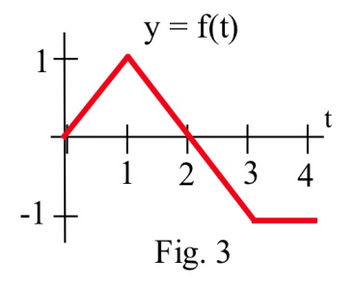

Using the second way to think about the Fundamental Theorem of Calculus, ****-- we can see that

****. We know the value of F(0), and we can easily find  from the graph – it’s just the area of a triangle.

So 



Note that we can start from any place we know the value of – now that we know F(2), we can use that:





Example 6

F ‘(t) = f(t) is shown below. Where does F(t) have maximum and minimum values on the interval [0, 4]?

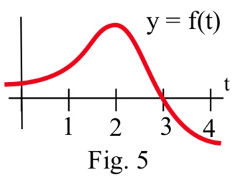

Since ****, we know that F is increasing as long as the area accumulating under F ’ = f is positive (until t = 3), and then decreases when the curve dips below the x-axis so that negative area starts accumulating. The area between t = 3 and t = 4 is much smaller than the positive area that accumulates between 0 and 3, so we know that F(4) must be larger than F(0). The maximum value is when t = 3; the minimum value is when t = 0.

Note that this is a different way to look at a problem we already knew how to solve – in Chapter 2, we would have found critical points of F, where f = 0 – there’s only one, when t = 3. f = F’ goes from positive to negative there, so F has a local max at that point. It’s the only critical point, so it must be a global max. Then we would look at the values of F at the endpoints to find which was the global min.

We can also attempt to sketch a function based on the graph of the derivative.

Example 7

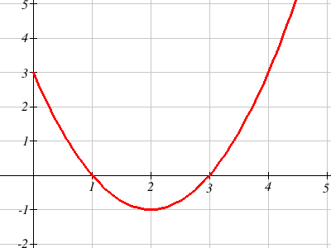The graph to the right shows *f'(x)* - the rate of change of *f(x)*. Use it sketch a graph of *f(x)* that satisfies *f*(0) = 0

Recall from the last chapter the relationships between the function graph and the derivative graph:

|  |  |  |  |  |
| --- | --- | --- | --- | --- |
| f(x) | increasing | Decreasing | Concave up | Concave down |
| f '(x) | + | - | Increasing | decreasing |
| f ''(x) |  |  | + | - |

In the graph shown, we can see the derivative is positive on the interval (0, 1) and (3, ∞), so the graph of *f* should be increasing on those intervals. Likewise, *f* should be decreasing on the interval (1,3).

In the graph, *f'* is decreasing on the interval (0, 2), so *f* should be concave down on that interval. Likewise, *f* should be concave up on the interval (2, ∞).

The derivative itself is not enough information to know where the function *f* starts, since there are a family of antiderivatives, but in this case we are given a specific point to start at.

To start the sketch, we might note first the shapes we need

0

1

2

3

4

increasing

conc down

decreasing

conc down

decreasing

conc up

increasing

conc up

increasing

conc up

then sketch the basic shapes.

0

1

2

3

4

Now we can attempt to sketch the graph, starting at the point (0, 0). Notice we are very roughly sketching this, as we don't have much information to work with. We can tell, though, from the graph that the area from *x* = 0 to *x* = 1 is about the same as the area from *x* = 1 to *x* = 3, so we would expect the net area from *x* = 0 to *x* = 3 to be close to 0.

0

1

2

3

4

It turns out this graph isn't horribly bad. Smoothing it out would give a graph closer to the actual antiderivative graph, shown below.

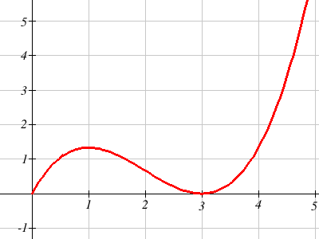

### Derivative of the Integral

There is another important connection between the integral and derivative.

**The Fundamental Theorem of Calculus (part 2):**

**I**f ****, then 

The derivative of the accumulation function is the original function.

Example 8

Let ****, where *f* is graphed below. Estimate **.**



The function *F* measures the area from *t* = 0 to some *t* = *x*. To estimate ****, we want to estimate how much the area is increasing when *t* = 3. Since the value of the function *f* is 0 at *t* = 3, the area will not be increasing or decreasing, so we can estimate 

Directly using the fundamental theorem of calculus part 2,

****, so



### 3.2 Exercises

In problems 1 – 5, verify that F(*x*) is an antiderivative of the integrand f(*x*) and use Part 2 of the

Fundamental Theorem to evaluate the definite integrals.

1. , F(*x*) = *x*2 + 5 2. , F(*x*) = *x*3 + 2 3. , F(*x*) = *x*3

4. dx , F(*x*) = *x*3 + 2*x*2 – 3*x* 5. , F(*x*) = ln( *x* )

6. Given A(x) = dt, find A'(x)

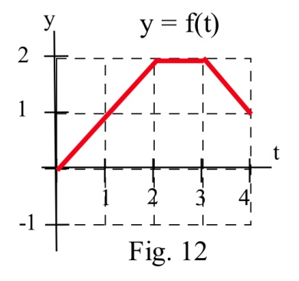7. Given A(x) = dt, find A'(x)

8. Let A(*x*) = dt for the function graphed here. Evaluate A'(1), A'(2), A'(3).

For problems 9-10, the graph provided shows *g*'(*x*). Use it sketch a graph of *g(x)* that satisfies *g*(0) = 0.

9. 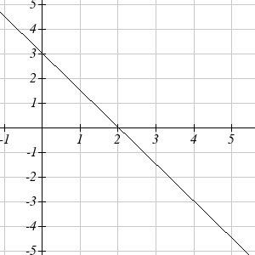 10. 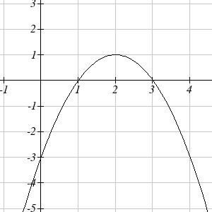

## Section 3: Antiderivatives of Formulas

Now we can put the ideas of areas and antiderivatives together to get a way of evaluating definite integrals that is exact and often easy. To evaluate a definite integral , we can find any antiderivative F of f and evaluate F(b) – F(a). The problem of finding the exact value of a definite integral reduces to finding some (any) antiderivative F of the integrand and then evaluating F(b) – F(a). Even finding one antiderivative can be difficult, and we will stick to functions that have easy antiderivatives.

### Building Blocks

Antidifferentiation is going backwards through the derivative process. So the easiest antiderivative rules are simply backwards versions of the easiest derivative rules. Recall from Chapter 2:

**Derivative Rules: Building Blocks**

In what follows, *f* and *g* are differentiable functions of *x* and *k* and *n* are constants.

(a) **Constant Multiple Rule:** 

(b) **Sum (or Difference) Rule:  (or )**

(c) **Power Rule: **

Special cases: (because )

(because )

(d) **Exponential Functions: **



(e) **Natural Logarithm:** 

Thinking about these basic rules was how we came up with the antiderivatives of 2x and before.

The corresponding rules for antiderivatives are next – each of the antiderivative rules is simply rewriting the derivative rule. All of these antiderivatives can be verified by differentiating.

There is one surprise – the antiderivative of 1/x is actually not simply ln(x), it’s ln|x|. This is a good thing – the antiderivative has a domain that matches the domain of 1/x, which is bigger than the domain of ln(x), so we don’t have to worry about whether our x’s are positive or negative. But you must be careful to include those absolute values – otherwise, you could end up with domain problems.

**Antiderivative Rules: Building Blocks**

In what follows, *f* and *g* are differentiable functions of *x* and *k*, *n,* and *C* are constants.

(a) **Constant Multiple Rule:** 

(b) **Sum (or Difference) Rule:** 

(c) **Power Rule: **, provided that n = −1

Special case: (because )

(d) **Exponential Functions: **



(e) **Natural Logarithm:** 

Example 1

Find the antiderivative of 



That’s a little hard to look at, so you might want to simplify a little:



Example 2

Find 



Example 3

Find *F(x*) so that and .

This time we are looking for a particular antiderivative; we need to find exactly the right constant. Let’s start by finding the antiderivative:



So we know that some constant; we just need to find which one. For that, we’ll use the other piece of information (the initial condition):



The particular constant we need is 9; 

The reason we are looking at antiderivatives right now is so we can evaluate definite integrals exactly. Recall the Fundamental Theorem of Calculus:



If we can find an antiderivative for the integrand, we can use that to evaluate the definite integral. The evaluation F(b) – F(a) is represented by the symbol or .

Example 4

Evaluate in two ways:

(i) By sketching the graph of *y* = *x* and geometrically finding the area.

(ii) By finding an antiderivative of F(x) of the integrand and evaluating F(3)–F(1).

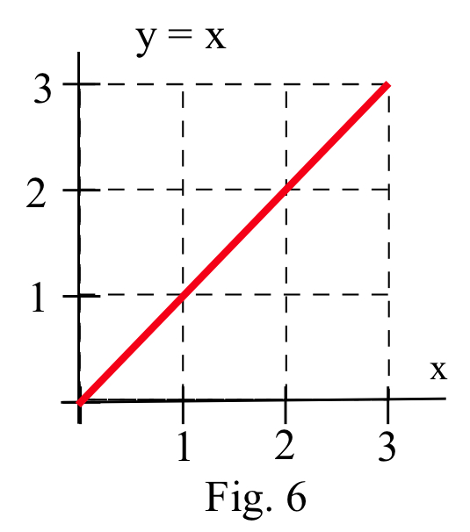

(i) The graph of *y* = *x* is shown to the right, and the shaded region corresponding to the integral has area 4.

(ii) One antiderivative of *x* is , and



Note that this answer agrees with the answer we got geometrically.

If we had used another antiderivative of *x*, say ,

then 

Whatever constant you choose, it gets subtracted away during the evaluation; we might as well always choose the easiest one, where the constant = 0.

Example 5

Find the area between the graph of *y* = 3*x*2 and the horizontal axis for *x* between 1 and 2.

This is 

Example 6

A robot has been programmed so that when it starts to move, its velocity after *t* seconds will be feet/second.

(a) How far will the robot travel during its first 4 seconds of movement?

(b) How far will the robot travel during its next 4 seconds of movement?

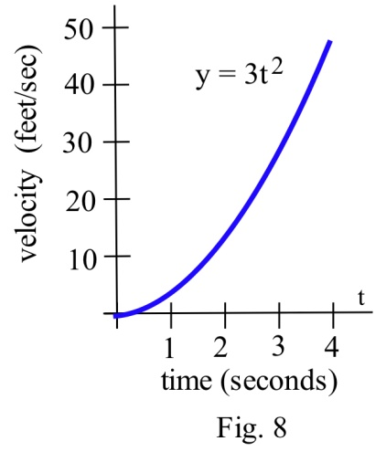

(a) The distance during the first 4 seconds will be the area under the graph of velocity, from *t* = 0 to *t* = 4.

That area is the definite integral . An antiderivative of  is  , so feet.

(b)  feet.

Example 7

Suppose that *t* minutes after putting 1000 bacteria on a Petri plate the rate of growth of the population is 6*t* bacteria per minute.

(a) How many new bacteria are added to the population during the first 7 minutes?

(b) What is the total population after 7 minutes?

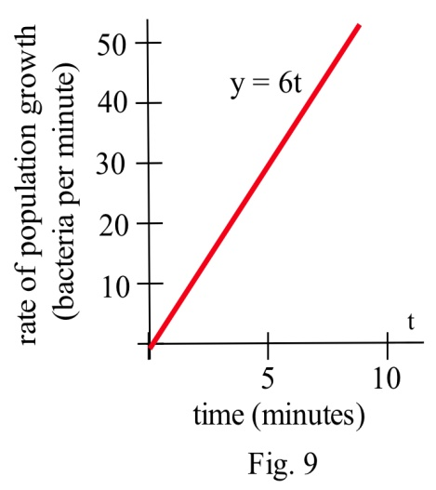

(a) The number of new bacteria is the area under the rate of growth graph, and one antiderivative of 6*t* is 3*t*2 .

So new bacteria = = 3*t*2 |= 3(7)2 – 3(0)2 = 147

(b) The new population = (old population) + (new bacteria) = 1000 + 147 = 1147 bacteria.

Example 8

A company determines their marginal cost for production, in dollars per item, is  when producing *x* thousand items. Find the cost of increasing production from 4 thousand items to 5 thousand items.

Remember that marginal cost is the rate of change of cost, and so the fundamental theorem tells us that . In other words, the integral of marginal cost will give us a net change in cost. To find the cost of increasing production from 4 thousand items to 5 thousand items, we need to integrate .

We can write the marginal cost as . We can then use the basic rules to find an antiderivative:

. Using this,

Net change in cost = 

It will cost 3.889 thousand dollars to increase production from 4 thousand items to 5 thousand items.

### 3.3 Exercises

For problems 1-10, find the indicated antiderivative.

1.  2. 

3.  4. 

5. 6.

7.  8.

9.  10. 

For problems 11-18, find an antiderivative of the integrand and use the Fundamental Theorem to evaluate the definite integral.

11. 12. 13. dx 14.

15.  16.  17.  18. 

For problems 19 - 21 find the area shown in the figure.

19. 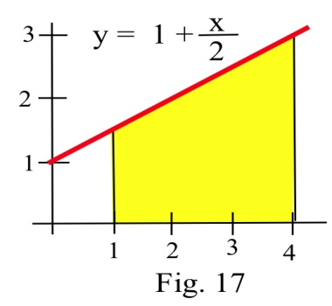 20. 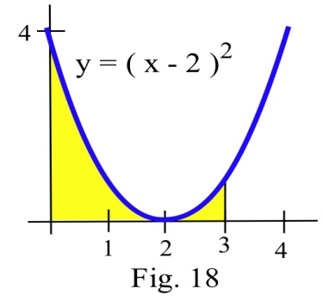 21.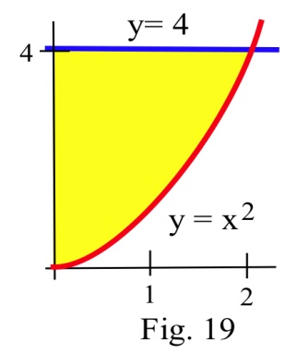

## Section 4: Substitution

We don’t have many integration rules. For quite a few of the problems we see, the rules won’t directly apply; we’ll have to do some algebraic manipulation first. In practice, it is much harder to write down the antiderivative of a function than it is to find a derivative. (In fact, it’s really easy to write a function that doesn’t have any antiderivative you can find with algebra.)

The Substitution Method is one way of algebraically manipulating an integrand so that the rules apply. This is a way to unwind the Chain Rule for derivatives. When you find the derivative of a function using the Chain Rule, you end up with a product of something like the original function TIMES a derivative. We can reverse this to write an integral:

, so 

With substitution, we will substitute . This means , so . Making this substitutions,  becomes , which will probably be easier to ingegrate.

Try Substitution when you see a product in your integral, especially if you recognize one factor as the derivative of some part of the other factor.

**The Substitution Method for Antiderivatives:**

The goal is to turn into , where *f(u)* is much less messy than *f(g(x))*.

1. Let *u* be some part of the integrand. A good first choice is “one step inside the messiest bit.”

2. Compute 

3. Translate all your x’s into u’s everywhere in the integral, including the dx. When you’re done, you should have a new integral that is entirely in u. If you have any x’s left, then that’s an indication that the substitution didn’t work or isn't complete; you may need to go back to step 1 and try a different choice for u.

4. Integrate the new u-integral, if possible. If you still can’t integrate it, go back to step 1 and try a different choice for u.

5. Finally, substitute back x’s for u’s everywhere in your answer.

Example 1

Evaluate .

This integrand is more complicated than anything in our list of basic integral formulas, so we’ll have to try something else. The only tool we have is substitution, so let’s try that!

1. Let *u* be some part of the integrand. A good first choice is “one step inside the messiest bit.”

In this case, the square root in the denominator is the messiest part, so let’s let u be one step inside:

Let 

2. Compute 



There is *x dx* in the integrand, so that’s a good sign; that will be −½*du*.

3. Translate all your x’s into u’s everywhere in the integral, including the dx.



Alternatively, we could have solved  for *dx* and substituted that and simplified:

, so



4. Integrate the new u-integral, if possible.



5. Finally, undo our  substitution, putting back x’s for u’s everywhere in your answer.

. So we have found

.

How would we check this? By differentiating:

.

Example 2

Evaluate 

This integral is not in our list of building blocks. But notice that the derivative of (that we see in the denominator) is just (which I see in the numerator), so substitution will be a good choice for this.

Let . Then , and this integral becomes .

Luckily, that is on our list of building block formulas: 

Finally, translating back:



Example 3

Evaluate a)  b) 

a) This is not a basic integral, but the composition is less obvious. Here, we can treat the denominator as the inside of the 1/x function.

Let . Then . Solving for *dx*, . Substituting,

.

Using our basic formulas,



Undoing the substitution,



b) It is tempting to start this problem the same way we did the last, but if we try it will not work, since the numerator of this fraction is not the derivative of the denominator. Instead, we need to try a different approach. For this problem, we can use some basic algebra.



We can integrate this using our basic rules, without needing substitution.



### Substitution and Definite Integrals

When you use substitution to help evaluate a definite integrals, you have a choice for how to handle the limits of integration. You can do either of these, whichever seems better to you. The important thing to remember is – the original limits of integration were values of the original variable (say, x), not values of the new variable (say, u).

(a) You can solve the antiderivative as a side problem, translating back to x’s, and then use the antiderivative with the original limits of integration. Or

(b) You can substitute for the limits of integration at the same time as you’re substituting for everything inside the integral, and then skip the “translate back into x” step. If the original integral had endpoints *x* =a and   
*x* =b, and we make the substitution *u* = g(*x* ) and du = g'(*x* )dx, then the new integral will have endpoints

*u*= g(a) and *u*=g(b) and

becomes .

Method (a) seems more straightforward for most students. But it can involve some messy algebra. Method (b) is often neater and usually involves fewer steps.

Example 4

Evaluate

We’ll need substitution to find an antiderivative, so we’ll need to handle the limits of integration carefully. Let's solve this example both ways.

(a) Doing the antiderivative as a side problem:

Step One – find the antiderivative, using substitution:



Let . Then and 

Translating back to x: 

Step Two – evaluate the definite integral:

.

(b) Substituting for the limits of integration:



Let . Then , and (substituting for the limits of integration) when x = 0,

u = -1, when x = 1, u = 2.

.

Example 5

Evaluate 

I can see the derivative of in the integrand, so I can tell that substitution is a good choice. Let . Then . When , . When , . So the new definite integral is



### 3.4 Exercises

For problems 1-8, find the indicated antiderivative.

1.  2. 

3.  4. 

5.  6. 

7.  8. 

For problems 9-12, find an antiderivative of the integrand and use the Fundamental Theorem to evaluate the definite integral.

9.  10.  11. 12. *x* dx

## Section 5: Additional Integration Techniques

### Integration By Parts

Integration by parts is an integration method which enables us to find antiderivatives of some new functions such as  as well as antiderivatives of products of functions such as and .

If the function we're trying to integrate can be written as a product of two functions, *u*, and *dv*, then integration by parts lets us trade out a complicated integral for hopefully simpler one.

**Integration By Parts Formula**



For definite integrals,



Example 1

Integrate 

To use the By Parts method, we break apart the product into two parts:

 and 

We now calculate *du*, the derivative of *u*, and *v*, the integral of *dv*.

 and .

Using the By Parts formula,



Notice the remaining integral is simpler that the original, and one we can easily evaluate.



We could have chosen either *x* or  as our *u* in the last example, but had we chosen , the second integral would have become messier, rather than simpler.

**Rule of Thumb**

When selecting the *u* for By Parts, select a logarithmic expression if one is present. If not, select an algebraic expression (like *x* or *dx*).

Example 2

Integrate 

Since this contains a logarithmic expression, we'll use it for our *u*.

 and 

We now calculate *du* and *v*.

 and .

Using the By Parts formula,



We can simplify the expression in the integral on the right:



The remaining integral is a basic one we can now evaluate.



Finally, we can evaluate the expressions



### Integration Using Tables of Integrals

There are many techniques of integration we will not be studying. Many of them lead to general formulas which can be compiled into a Table of Integrals - a type of cheat-sheet for integration.

For example, here are two entries you might find in a table of integrals:

**Table of Integral Examples**





Example 3

Integrate 

This integral looks very similar to the form of the first integral in the examples table. By employing the rule that allows us to pull out constants, and by rewriting 9 as 32, we can better see the match.



Now we simply use the formula from the table, with *a* = 3.



Sometimes we have to combine the table with other techniques we've learned, like substitution.

Example 4

Integrate 

This integral looks somewhat like the second integral in the example table, but the power of *x* is incorrect, and there is an *x*2 in the numerator which does not match. Trying to utilize this rule, we can try to rewrite the denominator to look like (something)2. Luckily, 

 =

Now we can use substitution, letting , so .

Making the subsitution,



Now we can use the table entry.



Undoing the substitution,



### 3.5 Exericses

In problems 1–4, a function u or dv is given. Find the piece u or dv which is not given, calculate du and v, and apply the Integration by Parts Formula.

1. 12x**.**ln(x) dx u = ln(x) 2. x**.**e–x dx u = x

3. x4 ln(x) dx dv = x4 dx 4. x**.**(5x + 1)19 dx u = x

In problems 5 - 10 evaluate the integrals

5. dx 6. 10x**.**e3x dx 7. ln(2x + 5) dx

8. x3 ln(5x) dx 9. x ln(x + 1) dx 10. dx

For problems 11 - 14 integrate each function.

11. 12. 13. 14.

## Section 6: Area, Volume, and Average Value

### Area

We have already used integrals to find the area between the graph of a function and the horizontal axis. Integrals can also be used to find the area between two graphs.

If f(x) ≥ g(x) for all x in [a,b], then we can approximate the area between f and g by partitioning the interval [a,b] and forming a Riemann sum, as shown in the picture. The height of each rectangle is top – bottom, f(ci) – g(ci) so the area of the ith rectangle is

(height)**.**(base) = (f(ci) – g(ci))**.**∆x . Adding up this rectangles gives an approximation of the total area as ****, a Riemann sum.

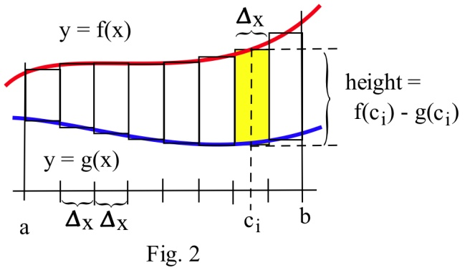

The limit of this Riemann sum, as the number of rectangles gets larger and their width gets smaller, is the definite integral ****.

**The area between two curves f(x) and g(x), where f(x) ≥ g(x), between x = a and x = b is**



The integrand is “top – bottom.” Make a graph to be sure which curve is which.

Example 1

Find the area bounded between the graphs of f(x) = x and g(x) = 3 for 1 ≤ x ≤ 4.

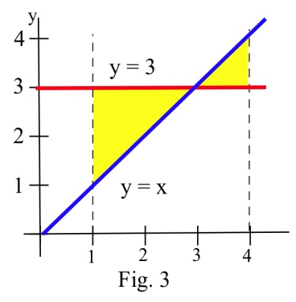

Always start with a graph so you can see which graph is the top and which is the bottom. In this example, the two curves cross, and they change positions; we’ll need to split the area into two pieces. Geometrically, we can see that the area is 2 + ½ = 2.5.

Writing the area as a sum of definite integrals, we get:

Area = 

These integrals are easy to evaluate using antiderivatives:





The two integrals also tell us that the total area between f and g is 2.5 square units, which we already knew.

Note that the single integral  is not the **area** we want in the last example. The value of the **integral is 1.5**, and the value of the **area is 2.5**. That’s because for the triangle on the right, the graph of y = x is above the graph of y = 3, so the integrand 3 – x is negative; in the definite integral, the area of that triangle comes in with a negative sign.

In this example, it was easy to see exactly where the two curves crossed so we could break the region into the two pieces to figure separately. In other examples, you might need to solve an equation to find where the curves cross.

Example 2

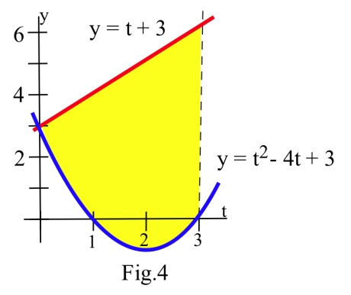Two objects start from the same location and travel along the same path with velocities  and  meters per second. How far ahead is A after 3 seconds?

Since  , the "area" between the graphs of  and represents the distance between the objects.

After 3 seconds, the distance apart



meters.

### Volume

Just as we can partition an interval and imagine approximating an area with rectangles to find a formula for the area between curves, we can partition an interval and imagine approximating a volume with simple shapes to find a formula for the volume of a solid. While this approach works for a variety of shapes, our focus will be on shapes formed by revolving a curve around the horizontal axis.

We start with an area, the region below a function on the interval *a* ≤ *x* ≤ *b*. We are going to take that region, and rotate it around the *x* axis, creating the solid shape shown.

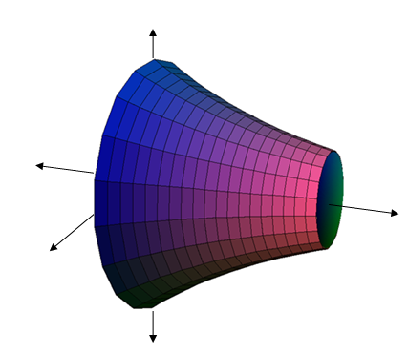

a

b

a

b

Rotate about the axis

To find the volume of this solid, we can start by partitioning the interval [0,1] and approximating the area with rectangles. As before, the width of each rectangle would be ∆x and the height f(ci).

If we took just one of these rectangles and rotated it about the horizontal axis, it would form a cylindrical shape. The radius of that cylinder would be f(ci), so the volume would be 

a

b

The volume of the whole solid could be approximated by rotating each of the rectangles about the *x* axis. Adding up the volume of each of the little cylindrical discs gives an approximation of the total volume as ****, a Riemann sum.

The limit of this sum as the width of the rectanges becomes small is the definite integral **.**

**The volume of the solid obtained by rotating about the x-axis the area bounded by the curve f(x), the x-axis, x = a, and x = b is**



Example 3

Find the volume of the solid formed by rotating the area under**** on the interval [0,1] about the *x*-axis.

0

1

1

This is the region pictured in the earlier example. We substitute in the function and bounds into the formula we derived to set up the definite integral.

Volume = 

Using exponent rules, the integrand can be simplified. The constant π can be pulled out of the integral.



Using the substitution *u* = -2*x*, we can integrate this function.

****cubic units

### Average Value

We know the average of n numbers, a1, a2, . . . , an , is their sum divided by n. But what if we need to find the average temperature over a day’s time -- there are too many possible temperatures to add them up. This is a job for the definite integral.

**The average value of a function f(x) on the interval [a, b] is given by**



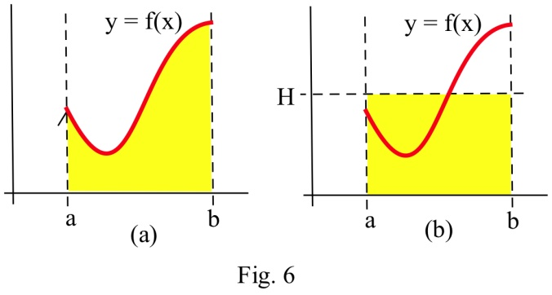

The average value of a positive *f* has a nice geometric interpretation. Imagine that the area under *f* (Fig. a) is a liquid that can "leak" through the graph to form a rectangle with the same area (Fig. b).

If the height of the rectangle is  *H*, then the area of the rectangle is  . We know the area of the rectangle is the same as the area under *f* so . Then , the average value of *f* on [a,b].

The average value of a positive function *f* is the height H of the rectangle whose area is the same as the area under f.

Example 4

During a 9 hour work day, the production rate at time *t* hours after the start of the shift was given by the function  cars per hour. Find the average hourly production rate.

The average hourly production is cars per hour.

A note about the units – remember that the definite integral has units (cars per hour) ∙ (hours) = cars. But the 1/(b-a) in front has units 1/hours – the units of the average value are cars per hour, just what we expect an average rate to be.

**In general, the average value of a function will have the same units as the integrand.**

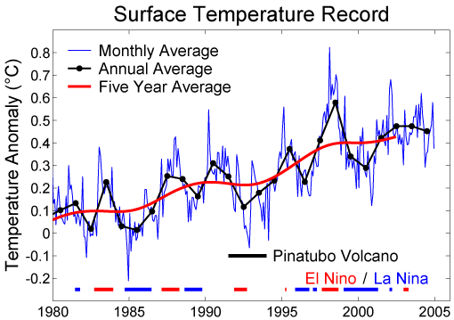Function averages, involving means and more complicated averages, are used to "smooth" data so that underlying patterns are more obvious and to remove high frequency "noise" from signals. In these situations, the original function f is replaced by some "average of f." If f is rather jagged time data, then the ten year average of f is the integral  , an average of f over 5 units on each side of x. For example, the figure here[1] shows the graphs of a Monthly Average (rather “noisy” data) of surface temperature data, an Annual Average (still rather “jagged), and a Five Year Average (a much smoother function). Typically the average function reveals the pattern much more clearly than the original data. This use of a “moving average” value of “noisy” data (weather information, stock prices) is a very common.

Example 5

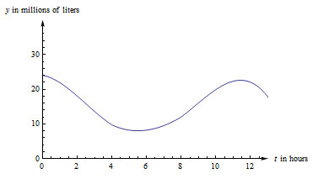The graph to the right shows the amount of water in a reservoir over a 12 hour period. Estimate the average amount of water in the reservoir over this period.

If is the volume of the water (in millions of liters) after *t* hours, then the average amount is  . In order to find the definite integral, we’ll have to estimate. I’ll use 6 rectangles, and I’ll take the heights from their right edges.

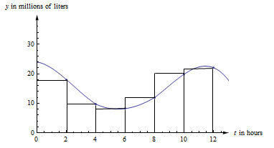

My estimate of the integral is .

The units of this integral are millions of liters × feet. So my estimate of the average volume is millions of liters. Your estimate might be a little different.

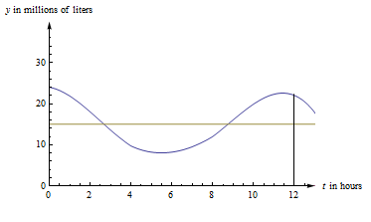In the figure below, you can see the same graph with the line drawn in. The area under the curve and the area under the rectangle are (approximately) the same.

In fact, that would be a different way to estimate the average value. We could have estimated the placement of the horizontal line so that the area under the curve and under the line were equal.

### 3.6 Exercises

In problems 1 – 4, use the values in the table to estimate the areas.

|  |  |  |  |
| --- | --- | --- | --- |
|  |  |  |  |
| 0 | 5 | 2 | 5 |
| 1 | 6 | 1 | 6 |
| 2 | 6 | 2 | 8 |
| 3 | 4 | 2 | 6 |
| 4 | 3 | 3 | 5 |
| 5 | 2 | 4 | 4 |
| 6 | 2 | 0 | 2 |

1. Estimate the area between *f* and *g*, between *x* = 0 and *x* = 4.

2. Estimate the area between *g* and *h*, between *x* = 0 and *x* = 6.

3. Estimate the area between *f* and *h*, between *x* = 0 and *x* = 4.

4. Estimate the area between *f* and *g*, between *x* = 0 and *x* = 6.

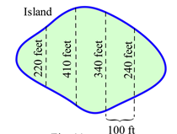

5. Estimate the area of the island shown

In problems 6 – 15, find the **area** between the graphs of f and g for x in the given interval. Remember to draw the graph!

6. f(*x*) = *x*2 + 3 , g(*x*) = 1 and –1 ≤ *x* ≤ 2.

7. f(*x*) = *x*2 + 3 , g(*x*) = 1 + *x* and 0 ≤ *x* ≤ 3.

8. f(*x*) = *x*2 , g(*x*) = *x* and 0 ≤ *x* ≤ 2.

9. f(*x*) = (*x* –1)2 , g(*x*) = *x* + 1 and 0 ≤ *x* ≤ 3.

10. f(*x*) = , g(*x*) = *x* and 1 ≤ *x* ≤ e.

11. f(*x*) = , g(*x*) = *x* and 0 ≤ *x* ≤ 4.

12. f(*x*) = 4 – *x* 2 , g(*x*) = *x* + 2 and 0 ≤ *x* ≤ 2.

13. f(*x*) = e*x* , g(*x*) = *x* and 0 ≤ *x* ≤ 2.

14. f(*x*) = 3 , g(*x*) = and 0 ≤ *x* ≤ 1.

15. f(*x*) = 2 , g(*x*) = and –2 ≤ *x* ≤ 2.

For problems 16-18, find the volume of the solid obtained by rotating the specified region about the *x* axis.

16. Region under f(*x*) = *x*2 + 3 for –1 ≤ *x* ≤ 2.

17. Region under f(*x*) = 4 – *x* 2 for 0 ≤ *x* ≤ 2.

18. Region under f(*x*) = for 1 ≤ *x* ≤ 2.

In problems 19 and 20 use the values in the table to estimate the average values.

|  |  |  |
| --- | --- | --- |
|  |  |  |
| 0 | 5 | 2 |
| 1 | 6 | 1 |
| 2 | 6 | 2 |
| 3 | 4 | 2 |
| 4 | 3 | 3 |
| 5 | 2 | 4 |
| 6 | 2 | 0 |

19. Estimate the average value of f on the interval [0, 6].

20. Estimate the average value of g on the interval [0, 6].

In problems 21 – 26, find the **average value** of f on the given interval.

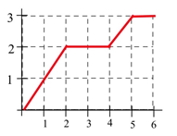

21. f(*x*) from the graph for 0 ≤ *x* ≤ 2.

22. f(*x*) from the graph for 0 ≤ *x* ≤ 4.

23. f(*x*) from the graph for 1 ≤ *x* ≤ 6.

24. f(*x*) from the graph for 4 ≤ *x* ≤ 6.

25. f(*x*) = 2*x* + 1 for 0 ≤ *x* ≤ 4.

26. f(*x*) = *x* 2 for 0 ≤ *x* ≤ 2.

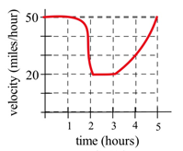

27. The graph shows the velocity of a car during a 5 hour trip.

(a) Estimate how far the car traveled during the 5 hours.

(b) At what **constant** velocity should you drive in order to travel the same distance in 5 hours?

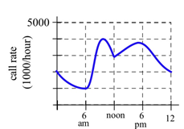28. The graph shows the number of telephone calls per minute at a large company. Estimate the average number of calls per minute

(a) From 8 am to 5 pm.

(b) From 9 am to 1 pm.

## Section 7: Applications to Business

### Consumer and Producer Surplus

Here are a demand and a supply curve for a product. Which is which?

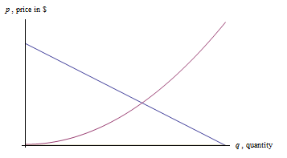

The demand curve is decreasing – lower prices are associated with higher quantities demanded, higher prices are associated with lower quantities demanded. Demand curves are often shown as if they were linear, but there’s no reason they have to be.

The supply curve is increasing – lower prices are associated with lower supply, and higher prices are associated with higher quantities supplied.

The point where the demand and supply curve cross is called the equilibrium point (q*, p*).

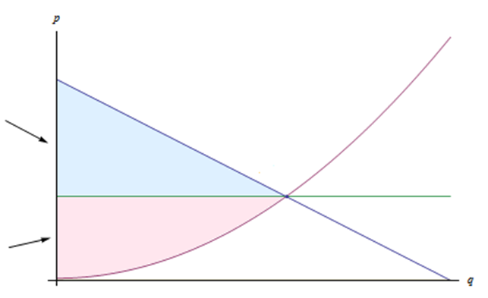

supply

*p*=*s(q)*

demand

*p*=*d(q)*

Consumer Surplus

Producer Surplus

(*q*\*, *p*\*)

Suppose that the price is set at the equilibrium price, so that the quantity demanded equals the quantity supplied. Now think about the folks who are represented on the left of the equilibrium point. The consumers on the left would have been willing to pay a higher price than they ended up having to pay, so the equilibrium price saved them money. On the other hand, the producers represented on the left would have been willing to supply these goods for a lower price – they made more money than they expected to. Both of these groups ended up with extra cash in their pockets!

Graphically, the amount of extra money that ended up in consumers’ pockets is the area between the demand curve and the horizontal line at p*. This is the difference in price, summed up over all the consumers who spent less than they expected to – a definite integral. Notice that since the area under the horizontal line is a rectangle, we can simplify the area integral:



The amount of extra money that ended up in producers’ pockets is the area between the supply curve and the horizontal line at p*. This is the difference in price, summed up over all the producers who received more than they expected to. Similar to consumer surplus, this integral can be simplified:



**Consumer and Producer Surplus**

Given a demand function p = d(q) and a supply function p = s(q), and the equilibrium point (q*, p*)

The **consumer surplus** = 

The **producer surplus** = 

The sum of the consumer surplus and producer surplus is the **total gains from trade**.

What are the units of consumer and producer surplus?

The units are (price per item)(quantity of items) = money!

Example 1

Suppose the demand for a product is given by and the supply for the same product is given by . For both functions, *q* is the quantity and *p* is the price, in dollars.

a. Find the equilibrium point.

b. Find the consumer surplus at the equilibrium price.

c. Find the producer surplus at the equilibrium price.

a. The equilibrium point is where the supply and demand functions are equal. Solving  gives *q* = 25.

The price when *q* = 25 is *p* = 130; the equilibrium point is (25, 130).

b. The consumer surplus is: 

c. The producer surplus is: 

Example 2

The tables below show information about the demand and supply functions for a product. For both functions, *q* is the quantity and *p* is the price, in dollars.

|  |  |  |  |  |  |  |  |  |
| --- | --- | --- | --- | --- | --- | --- | --- | --- |
|  | 0 | 100 | 200 | 300 | 400 | 500 | 600 | 700 |
|  | 70 | 61 | 53 | 46 | 40 | 35 | 31 | 28 |

|  |  |  |  |  |  |  |  |  |
| --- | --- | --- | --- | --- | --- | --- | --- | --- |
|  | 0 | 100 | 200 | 300 | 400 | 500 | 600 | 700 |
|  | 14 | 21 | 28 | 33 | 40 | 47 | 54 | 61 |

a. Which is which? That is, which table represents demand and which represents supply?

b. What is the equilibrium price and quantity?

c. Find the consumer and producer surplus at the equilibrium price.

a. The first table shows decreasing price associated with increasing quantity; that is the demand function.

b. For both functions, *q* = 400 is associated with *p* = 40; the equilibrium price is $40 and the equilibrium quantity is 400 units. Notice that we were lucky here, because the equilibrium point is actually one of the points shown. In many cases with a table, we would have to estimate.

c. The consumer surplus uses the demand function, which comes from the first table. We’ll have to approximate the value of the integral using rectangles. There are 4 rectangles, and I choose to use left endpoints.

The consumer surplus = .

The consumer surplus is about $7,000.

The producer surplus uses the supply function, which comes from the second table. I choose to use left endpoints for this integral also.

The producer surplus = .

The producer surplus is about $6400.

### Continuous Income Stream

In precalculus, you learned about compound interest in that really simple situation where you made a single deposit into an interest-bearing account and let it sit undisturbed, earning interest, for some period of time. Recall:

**Compound Interest Formulas**

Let P = the principal (initial investment), r = the annual interest rate expressed as a decimal, and let A(t) be the amount in the account at the end of t years.

**Compounding *n* times per year:** 

**Compounded continuously:** 

If you’re using this formula to find what an account will be worth in the future, t > 0 and A(t) is called the **future value**.

If you’re using the formula to find what you need to deposit today to have a certain value P sometime in the future, t < 0 and A(t) is called the **present value.**

You may also have learned somewhat more complicated annuity formulas to deal with slightly more complicated situations – where you make equal deposits equally spaced in time.

But real life is not usually so neat.

Calculus allows us to handle situations where “deposits” are flowing continuously into an account that earns interest. As long as we can model the flow of income with a function, we can use a definite integral to calculate the present and future value of a continuous income stream. The idea is – each little bit of income in the future needs to be multiplied by the exponential function to bring it back to the present, and then we’ll add them all up (a definite integral).

**Continuous Income Stream**

Suppose money can earn interest at an annual interest rate of r, compounded continuously. Let F(t) be a continuous income function (in dollars per year) that applies between

year 0 and year T.

Then the present value of that income stream is given by .

The future value can be computed by the ordinary compound interest formula 

This is a useful way to compare two investments – find the present value of each to see which is worth more today.

Example 3

You have an opportunity to buy a business that will earn $75,000 per year continuously over the next eight years. Money can earn 2.8% per year, compounded continuously. Is this business worth its purchase price of $630,000?

First, please note that we still have to make some simplifying assumptions. We have to assume that the interest rates are going to remain constant for that entire eight years. We also have to assume that the $75,000 per year is coming in continuously, like a faucet dripping dollars into the business. Neither of these assumptions might be accurate.

But moving on:

The present value of the $630,000 is, well, $630,000. This is one investment, where we put our $630,000 in the bank and let it sit there.

To find the present value of the business, we think of it as an income stream. The function F(t) in this case is a constant $75,000 dollars per year, so F(t) = 75,000 . The interest rate is 2.8% and the term we're interested in is 8 years, so r = .028, and T = 8:



The present value of the business is about $672,500, which is more than the $630,000 asking price – this is a good deal.

While this integral could have been done using substitution, for many of the integrals in this section, we don't have the techniques to use antiderivatives, or in some cases no antiderivative exists. Technology will work quickly, and it will give you an answer that’s good enough.

Example 4

A company is considering purchasing a new machine for its production floor. The machine costs $65,000. The company estimates that the additional income from the machine will be a constant $7000 for the first year, then will increase by $800 each year after that. In order to buy the machine, the company needs to be convinced that it will pay for itself by the end of 8 years with this additional income. Money can earn 1.7% per year, compounded continuously. Should the company buy the machine?

We’ll assume that the income will come in continuously over the 8 years. We’ll also assume that interest rates will remain constant over that 8-year time period.

We’re interested in the present value of the machine, which we will compare to its $65,000 price tag. Let *t*  be the time, in years, since the purchase of the machine. The income from the machine is different depending on the time.

From *t* = 0 to *t* = 1 (the first year), the income is constant $7000 per year. From *t* = 1 to *t* = 8, the income is increasing by $800 each year; the income flow function *F*(*t*) will be . To find the present value, we’ll have to divide the integral into the two pieces, one for each of the functions:

.

The present value is greater than the cost of the machine, so the company should buy the machine.

### 3.7 Exercises

1. The demand and supply functions for a certain product are given by and , where *p* is in dollars and *q* is the number of items.

(a) Which is the demand function?

(b) Find the equilibrium price and quantity

(c) Find the total gains from trade at the equilibrium price.

2. Still thinking about the product from Exercise 1, with its demand and supply functions, suppose the price is set artificially at $70 (which is above the equilibrium price).

(a) Find the quantity supplied and the quantity demanded at this price.

(b) Compute the consumer surplus at this price, using the quantity demanded.

(c) Compute the producer surplus at this price, using the quantity demanded (why?).

(d) Find the total gains from trade at this price.

(e) What do you observe?

3. When the price of a certain product is $40, 25 items can be sold. When the price of the same product costs $20, 185 items can be sold. On the other hand, when the price of this product is $40, 200 items will be produced. But when the price of this product is $20, only 100 items will be produced. Use this information to find supply and demand functions (assume for simplicity that the functions are linear), and compute the consumer and producer surplus at the equilibrium price.

4. Find the present and future values of a continuous income stream of $5000 per year for 12 years if money can earn 1.3% annual interest compounded continuously.

5. Find the present value of a continuous income stream of $40,000 per year for 35 years if money can earn

(a) 0.8% annual interest, compounded continuously,

(b) 2.5% annual interest, compounded continuously,

(c) 4.5% annual interest, compounded continuously.

6. Find the present value of a continuous income stream , where *t* is in years and *F* is in tens of thousands of dollars per year, for 10 years, if money can earn 2% annual interest, compounded continuously.

7. Find the present value of a continuous income stream , where *t* is in years and *F* is in thousands of dollars per year, for 8 years, if money can earn 3.7% annual interest, compounded continuously.

8. Find the future value of a continuous income stream , where *t* is in years and *F* is in dollars per year, for 15 years, if money can earn 6% annual interest, compounded continuously.

9. A business is expected to generate income at a continuous rate of $25,000 per year for the next eight years. Money can earn 3.4% annual interest, compounded continuously. The business is for sale for $153,000. Is this a good deal?

## Section 8: Differential Equations

A **differential equation** is an equation involving the derivative of a function. They allow us to express with a simple equation the relationship between a quantity and it's rate of change.

Example 1

A bank pays 2% interest on its certificate of deposit accounts, but charges a $20 annual fee. Write an equation for the rate of change of the balance, .

If the balance  has units of dollars, then  has units of dollars per year. When we think of what is changing the balance of the account, there are two factors:

1) The interest, which increases the balance, and

2) The fee, which decreases the balance.

Considering the interest, we know each year the balance will increase by 2%, but 2% of what? Each year that will change, since we earn interest on whatever the current balance is. We can represent the amount of increase as 2% of the balance:  dollars/year.

The fee already has the units of dollars/year. Since everything now has the same units, we can put the two together, and create the equation:



The result is an example of a differential equation. Notice this particular equation involves both the derivative *and* the original function, and so we can't simplify find  using basic integration.

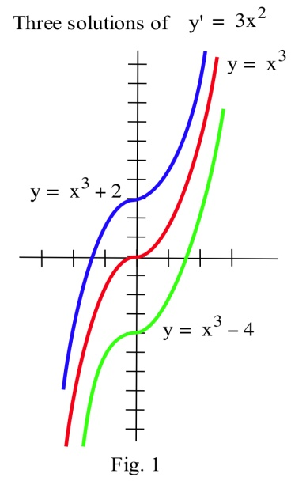

Algebraic equations contain constants and variables, and the solutions of an algebraic equation are typically numbers. For example, x = 3 and x = –2 are solutions of the algebraic equation x2 = x + 6. Differential equations contain derivatives or differentials of functions. Solutions of differential equations are functions. The differential equation y' = 3x2 has infinitely many solutions, and two of those solutions are the functions y = x3 + 2 and y = x3 – 4.

You have already solved lots of differential equations: every time you found an antiderivative of a function f(x), you solved the differential equation y' = f(x) to get a solution y. The differential equation

y' = f(x) , however, is just the beginning. Other applications generate different differential equations, like in the bank balance example above.

### Checking Solutions of Differential Equations

Whether a differential equation is easy or difficult to solve, it is important to be able to check that a possible solution really satisfies the differential equation.

A possible solution of an algebraic equation can be checked by putting the solution into the equation to see if the result is true: x = 3 is a solution of 5x + 1 = 16 since 5(3) + 1 = 16 is true. Similarly, a solution of a differential equation can be checked by substituting the function and the appropriate derivatives into the equation to see if the result is true: y = x2 is a solution of xy' = 2y since y' = 2x and x(2x) = 2(x2) is true.

Example 2

Check (a) that y = x2 + 5 is a solution of y'' + y = x2 + 7 and

(b) that y = x + 5/x is a solution of y' + = 2.

(a) y = x2 + 5 so y' = 2x and y'' = 2. Substituting these functions for y and y'' into the differential equation y'' + y = x2 + 7, we have y'' + y = (2) + (x2 + 5) = x2 + 7, so y = x2 + 5 is a solution of the differential equation.

(b) y = x + 5/x so y' = 1 – 5/x2 . Substituting these functions for y and y ' in the differential equation y' + = 2 , we have

y' + = (1 – 5/x2) + = 1 – 5/x2 + 1 + 5/x2 = 2, the result we wanted to verify.

### Separable Differential Equations

A differential equation is called **separable** if the variables can be separated algebraically so that all the x's and dx are one one side of the equation, and all the y's and dy are on the other side of the equation. In other words, so the equation has the form .

Once separated, separable differential equations can be solved by integrating both sides of the equation.

Example 3

Find the solution of 

Rewriting *y'* is a helpful first step.



Now we can multiply both sides by *dx* and by 2*y* to separate the variables.



Integrating each side,





Notice that we can combine the two constants to create a new, consolidated constant *C*, so we usually only bother to put a constant on the right side.



As expected, there is a whole family of solutions to this differential equation.

An **initial value problem** is a differential equation that provides additional information about the initial, or starting, value of the function. This allows us to then solve for the constant and find a single solution.

Example 4

Find the solution of , which satisfies 

In the previous example we found the general solution, .

Substituting in the initial condition, *y* = 3 when *x* = 2,

, so , giving .

The solution is . Sometimes it is desirable to solve for *y*.

, but since the initial condition had a positive *y* value, we isolate the solution



Example 5

A bank pays 2% interest on its certificate of deposit accounts, but charges a $20 annual fee. If you initially invest $3,000, how much will you have after 10 years?

You may recognize this as the example from the beginning of the section, for which we set up the equation , or more simply, 

We can separate this equation by multiply by *dt* and dividing by the entire expression on the right.



Integrating the left side of this equation requires substitution. Let, so . Making the substitution,



Integrating on the right side of the differential equation is comparably easier:



Together, this gives us the general solution to the differential equation:



Now we would like to solve for *B*. Start by multiplying by 0.02.

 We can rename D = 0.02C for simplicity

 Exponentiate both sides: *e*left = *e*right

 Use the log rule: 

 Since the right side is always positive, we can drop

the absolute value sign.

 Using the rule 

 Rename *k* = *eD*

 Add 20 and divide by 0.02

 Rename *A* = *k*/0.02



Finally, we can substitute our initial value of *B* = 3000 when *t* = 0 to solve for the constant *A*:





This gives us the equation for the account balance after *t* years: 

To find the balance after 10 years, we can evaluate this equation at *t* = 10.



It's worth noting that this answer isn't exactly right. Differential equations assume *continuous* changes, and it is unlikely interest is compounded continuously or the fee is extracted continuously. However, the answer is likely close to the actual answer, and differential equations provide a relatively simple model of a complicated situation.

### Models of Growth

The bank account example demonstrated one basic model of growth: growth proportional to the existing quantity. Bank accounts and populations both tend to grow this way if not constrained. This type of growth is called **unlimited growth**.

**Unlimited Growth**

If a quantity or population *y* grows at a rate proportional that quantity's size, it can be modeled with **unlimited growth**, which has the differential equation:

, where *r* is a constant

Example 6

A population grows by 8% each year. If the current population is 5,000, find an equation for the population after *t* years.

The population is growing by a percent of the current population, so this is unlimited growth.

 Separate the variables

 Integrate both sides

 Exponentiate both sides

 Simplify both sides, using the tricks we used in the bank example



Now substitute in the initial condition

, so *A* = 5000.

The population will grow following the equation .

Notice that the solution to the unlimited growth equation is an exponential equation.

When a product is advertised heavily, sales will tend to grow very quickly, but eventually the market will reach saturation, and sales will slow. In this type of growth, called **limited growth**, the population grows at a rate proportional to the distance from the maximum value.

**Limited Growth**

If a quantity grows at a rate proportional to the distance from the maximum value, *M*, it can be modeled with **limited growth**, which has the differential equation:

, where *k* is a constant, and *M* is the maximum size of *y*.

Example 7

A new cell phone is introduced. The company estimates they will sell 200 thousand phones. After 1 month they have sold 20 thousand. How many will they have sold after 9 months?

In this case there is a maximum amount of phones they expect to sell, so *M* = 200 thousand. Modeling the sales, *y*, in thousands of phones, we can write the differential equation



Since it was a new phone, . We also know the sales after one month, .

Solving the differential equation,

 Separate the variables

 Integrate both sides. On the left use the substitution 

 Multiply both sides by -1, and exponentiate both sides

 Simplify

 Subtract 200, divide by -1, and simplify



Using the initial condition ,

, so , giving 

Using the value ,

 Subtract 200 and divide by -200

 Take the ln of both sides

 Divide by -1



As a quick sanity check, this value is positive as we would expect, indicating that the sales are growing over time. We now have the equation for the sales of phones over time:



Finally, we can evaluate this at *t* = 9 to find the sales after 9 months.

thousand phones.

Limited growth is also commonly used for learning models, since when learning a new skill, people typically learn quickly at first, then their rate of improvement slows down as they approach mastery.

Earlier we used unlimited growth to model a population, but often a population will be constrained by food, space, and other resources. When a population grows both proportional to its size, and relative to the distance from some maximum, that is called **logistic growth**. This leads to the differential equation , which is accurate but not always convenient to use. We will use a slight modification. Since solving this differential equation requires integration techniques we haven't learned, the solution form is given.

**Logistic Growth**

If a quantity grows at a rate proportional to its size and to the distance from the maximum value, *M*, it can be modeled with **logistic growth**, which has the differential equation:



*r* can be interpreted as "the growth rate absent constraints" - how the population would grow if there wasn't a maximum value.

This differential equation has solutions of the form



Example 8

A colony of 100 rabbits is introduced to a reclaimed forest. After 1 year, the population has grown to 300. It is estimated the forest can sustain 5000 rabbits. The forest service plans to reintroduce wolves to the forest when the rabbit population reaches 3000 rabbits. When will that occur?

The maximum sustainable population was given as *M* = 5000. Using the solution form,



Using the , we can solve for *A*

 Simplify

 Multiply both sides by 1+*A*

 Divide by 100





Now, using , we can solve for *r*.













We now have the equation for the population after *t* years.



To answer the original equation, of when the rabbit population will reach 3000, we need to solve for *t* when *y* = 3000.









years.

Logistic growth is also a good model for unadvertised sales. A new product that is not advertised will have sales increase slowly at first, then grow as word of mouth spreads and people become familiar with the product. Sales will level off as they approach market saturation.

### 3.8 Exercises

In problems 1 – 4, check that the function y is a solution of the given differential equation.

1. y' + 3y = 6. y = e–3x + 2. 2. y' – 2y = 8. y = e2x – 4.

3. y' = – x/y. y = . 4. y' = x – y. y = x – 1 + 2e–x .

In problems 5 – 8 check that the function y is a solution of the given initial value problem.

5. y' = 6x2 – 3 and y(1) = 2 . y = 2x3 – 3x + 3.

6. y' = 6x + 4 and y(2) = 3. y = 3x2 + 4x – 17.

7. y' = 5y and y(0) = 7. y = 7e5x.

8. y' = –2y and y(0) = 3. y = 3e–2x.

In problems 9 – 12, a family of solutions of a differential equation is given. Find the value of the constant C so the solution satisfies the initial value condition.

9. y' = 2x and y(3) = 7. y = x2 + C. 10. y' = 3x2 – 5 and y(1) = 2. y = x3 – 5x + C.

11. y' = 3y and y(0) = 5. y = Ce3x. 11. y' = –2y and y(0) = 3. y = Ce–2x.

In problems 13 – 18, solve the differential equation. (Assume that x and y are restricted so that division by zero does not occur.)

13. y' = 2xy 14. y' = x/y 15. xy' = y + 3

16. y' = x2y + 3y 17. y' = 4y 18. y' = 5(2 – y)

In problems 19 – 22, solve the initial value separable differential equations.

19. y' = 2xy for y(0) = 3, y(0) = 5, and y(1) = 2.

20. y' = x/y for y(0) = 3, y(0) = 5, and y(1) = 2.

21. y' = 3y for y(0) = 4, y(0) = 7, and y(1) = 3.

22. y' = –2y for y(0) = 4, y(0) = 7, and y(1) = 3.

23. The rate of growth of a population P(t) which starts with 3,000 people and increases by 4% per year is P '(t) = 0.0392**.**P(t). Solve the differential equation and use the solution to estimate the population in 20 years.

24. The rate of growth of a population P(t) which starts with 5,000 people and increases by 3% per year is P '(t) = 0.0296**.**P(t). Solve the differential equation and use the solution to estimate the population in 20 years.

25. A manufacturer estimates that she can sell a maximum of 130 thousand cell phones in a city. By advertising heavily, her total sales grow at a rate proportional to the distance below this upper limit. If she enters a new market, and after 6 months her total sales are 59 thousand phones, find a formula for the total sales (in thousands) t months after entering the market, and use this to estimate the total sales at the end of the first year.

26. The temperature of a turkey in the oven will grow like limited growth. The turkey starts out at 40 degrees Fahrenheit, and is placed into a 350 degree oven. After 30 minutes, the turkey's temperature has risen to 55 degrees. How long will it take until the turkey's temperature reaches 165 degrees?

27. A new cell phone is introduced into the market. It is predicted that sales will grow logistically. The manufacturer estimates that they can sell a maximum of 100 thousand cell phones. After 44 thousand cell phones have been sold, sales are increasing by 4 thousand phones per month. Use this to estimate the total sales at the end of the first year.

28. Biologists stocked a lake with 400 fish and estimated the carrying capacity of the lake to be 8000 fish. The number of fish tripled in the first year. How long will it take the population to increase to 4000?

1. <http://commons.wikimedia.org/wiki/File:Short_Instrumental_Temperature_Record.png>, CC-BY