# Chapter 2: The Derivative

## Precalculus Idea: Slope and Rate of Change

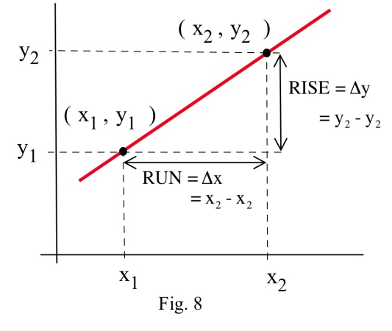The slope of a line measures how fast a line rises or falls as we move from left to right along the line. It measures the rate of change of the y-coordinate with respect to changes in the x-coordinate. If the line represents the distance traveled over time, for example, then its slope represents the velocity. In the figure, you can remind yourself of how we calculate slope using two points on the line:



We would like to be able to get that same sort of information (how fast the curve rises or falls, velocity from distance) even if the graph is not a straight line. But what happens if we try to find the slope of a curve, as in Figure 2? We need two points in order to determine the slope of a line. How can we find a slope of a curve, at just one point?

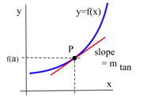

Figure 2

The answer, as suggested in Figure 2 is to find the slope of the tangent line to the curve at that point. Most of us have an intuitive idea of what a tangent line is. Unfortunately, “tangent line” is hard to define precisely.

**Definition:** A **secant line** is a line between two points on a curve.

**Can’t-quite-do-it-yet Definition:** A **tangent line** is a line at one point on a curve …. that does its best to be the curve at that point?

It turns out that the easiest way to define the tangent line is to define its slope.

## Section 1: Instantaneous Rate of Change and Tangent Lines

### Instantaneous Velocity

Suppose we drop a tomato from the top of a 100 foot building and time its fall. picture and table giving heights of a falling tomato at various times

Figure 3

Some questions are easy to answer directly from the table:

(a) How long did it take for the tomato n to drop 100 feet? (2.5 seconds)

(b) How far did the tomato fall during the first second? (100 – 84 = 16 feet)

(c) How far did the tomato fall during the last second? (64 – 0 = 64 feet)

(d) How far did the tomato fall between t =.5 and t = 1? (96 – 84 = 12 feet)

Some other questions require a little calculation:

(e) What was the average velocity of the tomato during its fall?

**Average velocity = =** = = –40 ft/s .

(f) What was the average velocity between t=1 and t=2 seconds?

Average velocity = = = = –48 ft/s .

Some questions are more difficult.

(g) How fast was the tomato falling 1 second after it was dropped?

This question is significantly different from the previous two questions about average velocity. Here we want the **instantaneous velocity,** the velocity at an instant in time. Unfortunately the tomato is not equipped with a speedometer so we will have to give an approximate answer.

One crude approximation of the instantaneous velocity after 1 second is simply the average velocity during the entire fall, –40 ft/s . But the tomato fell slowly at the beginning and rapidly near the end so the "–40 ft/s" estimate may or may not be a good answer.

We can get a better approximation of the instantaneous velocity at t=1 by calculating the average velocities over a short time interval near t = 1 . The average velocity between t = 0.5 and t = 1 is  = –24 ft/s, and the average velocity between t = 1 and t = 1.5 is = –40 ft/s so we can be reasonably sure that the instantaneous velocity is between –24 ft/s and –40 ft/s.

In general, the shorter the time interval over which we calculate the average velocity, the better the average velocity will approximate the instantaneous velocity. The average velocity over a time interval is , which is the slope of the **secant line** through two points on the graph of height versus time. The instantaneous velocity at a particular time and height is the slope of the **tangent line** to the graph at the point given by that time and height.

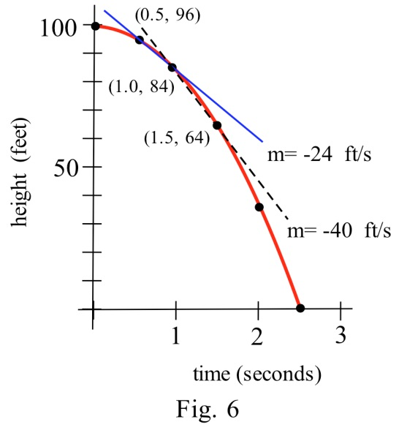

**Average velocity = = slope of the secant line through 2 points.**

**Instantaneous velocity = slope of the line tangent to the graph.**

### Tangent Lines

Do this!

The graph below is the graph of . We want to find the slope of the tangent line at the point (1, 2).

First, draw the secant line between (1, 2) and (2, −1) and compute its slope.

Now draw the secant line between (1, 2) and (1.5, 1) and compute its slope.

Compare the two lines you have drawn. Which would be a better approximation of the tangent line to the curve at (1, 2)?

Now draw the secant line between (1, 2) and (1.3, 1.5) and compute its slope. Is this line an even better approximation of the tangent line?

Now draw your best guess for the tangent line and measure its slope. Do you see a pattern in the slopes?

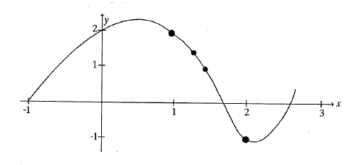

You should have noticed that as the interval got smaller and smaller, the secant line got closer to the tangent line and its slope got closer to the slope of the tangent line. That’s good news – we know how to find the slope of a secant line.

In some applications, we need to know where the graph of a function f(x) has horizontal tangent lines (slopes = 0).

Example 1

At right is the graph of y = g(x). At what values of x does the graph of y = g(x) below have horizontal tangent lines?

**curve for reader to find points with horizontal tangents**

The tangent lines to the graph of g(x) are horizontal (slope = 0) when x ≈ –1, 1, 2.5, and 5.

### 2.1 Exercises

1. What is the slope of the line through (3,9) and (x, y) for y = x2 and x = 2.97? x = 3.001?

x = 3+h? What happens to this last slope when h is very small (close to 0)? Sketch the graph of y = x2 for x near 3.

2. What is the slope of the line through (–2,4) and (x, y) for y = x2 and x = –1.98? x = –2.03? x = –2+h? What happens to this last slope when h is very small (close to 0)? Sketch the graph of y = x2 for x near –2.

3. What is the slope of the line through (2,4) and (x, y) for y = x2 + x – 2 and x = 1.99?

x = 2.004? x = 2+h? What happens to this last slope when h is very small? Sketch the graph of y = x2 + x – 2 for x near 2.

4. What is the slope of the line through (–1,–2) and (x, y) for y = x2 +x – 2 and x = –.98?

x = –1.03? x = –1+h? What happens to this last slope when h is very small? Sketch the graph of y = x2 + x – 2 for x near –1.

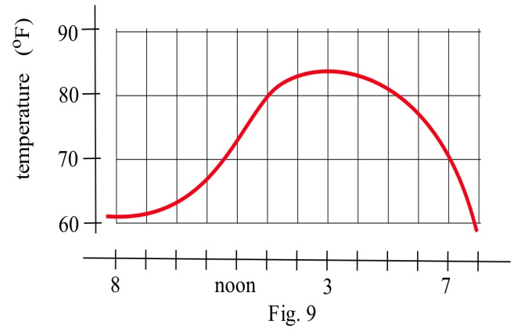

5. The graph to the right shows the temperature during a day in Ames.

(a) What was the average change in temperature from 9 am to 1 pm?

(b) Estimate how fast the temperature was rising **at** 10 am and **at** 7 pm?

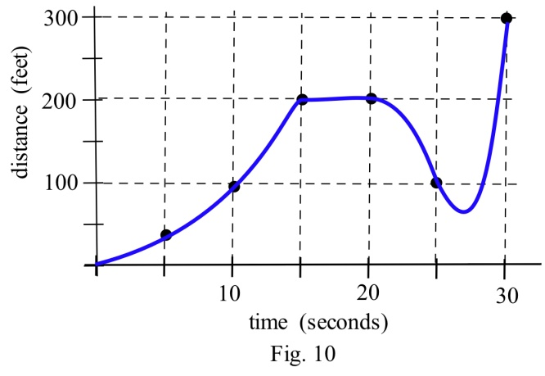6. The graph shows the distance of a car from a measuring position located on the edge of a straight road.

(a) What was the average velocity of the car from t = 0 to t = 30 seconds?

(b) What was the average velocity of the car from t = 10 to t = 30 seconds?

(c) About how fast was the car traveling **at** t = 10 seconds? **at** t = 20 s ? **at** t = 30 s ?

(d) What does the horizontal part of the graph between t = 15 and t = 20 seconds mean?

(e) What does the negative velocity at t = 25 represent?

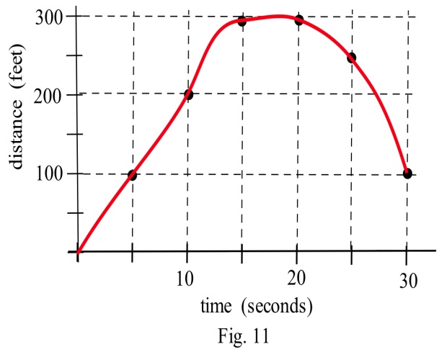7. The graph shows the distance of a car from a measuring

position located on the edge of a straight road.

(a) What was the average velocity of the car from t = 0 to t = 20 seconds?

(b) What was the average velocity from t = 10 to t = 30 seconds?

(c) About how fast was the car traveling **at** t = 10

seconds? **at** t = 20 s ? **at** t = 30 s ?

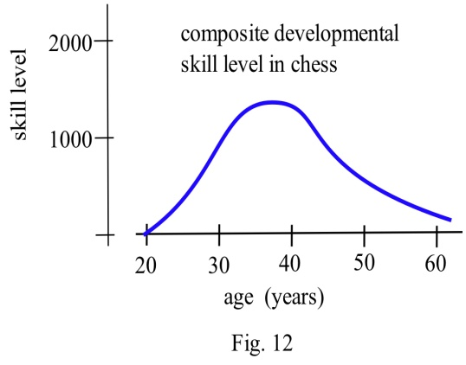8. The graph shows the composite developmental skill level of chessmasters at different ages as determined by their performance against other chessmasters. (From "Rating Systems for Human Abilities", by W.H. Batchelder and R.S. Simpson, 1988. UMAP Module 698.)

(a) At what age is the "typical" chessmaster playing the best chess?

(b) At approximately what age is the chessmaster's skill level increasing most rapidly?

(c) Describe the development of the "typical" chessmaster's skill in words.

(d) Sketch graphs which you **think** would reasonably describe the performance levels versus age for an athlete, a classical pianist, a rock singer, a mathematician, and a professional in your major field.

## Section 2: Limits and Continuity

In the last section, we saw that as the interval over which we calculated got smaller, the secant slopes approached the tangent slope. The **limit** gives us better language with which to discuss the idea of “approaches.”

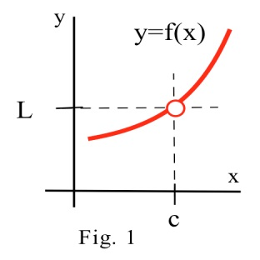

The limit of a function describes the behavior of the function when the variable is near, **but does not equal** , a specified number (Fig. 1). If the values of f(x) get closer and closer , as close as we want, to one number L as we take values of x very close to (but not equal to) a number c, then

We say **"the limit of f(x), as x approaches c, is L "** and we write

 **= L.** (The symbol "  " means "approaches" or "gets very close to.")

**f(c)** is a single number that describes the behavior (value) of f(x) **AT** the point x = c.

 **f(x)** is a single number that describes the behavior of f(x) **NEAR, BUT NOT AT,** the point x = c.

If we have a graph of the function near x = c , then it is usually easy to determine .

Example 1

Use the graph of y = f(x) in Fig. 2 to determine the following limits:

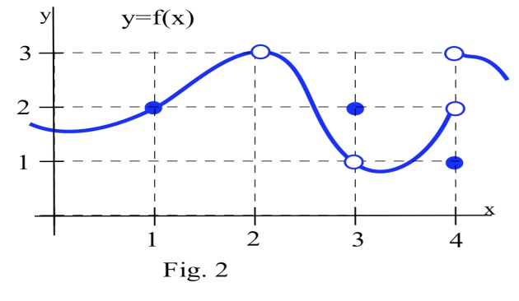

(a)  f(x) (b)  f(x)

(c)  f(x) (d)  f(x)

(a)  f(x) = 2 .

When x is very close to 1, the values of f(x) are very close to y = 2. In this example, it happens that f(1) = 2, but that is irrelevant for the limit. The only thing that matters is what happens for x close to 1 but x ≠ 1.

(b) f(2) is undefined, but we only care about the behavior of f(x) for x close to 2 and not equal to 2. When x is close to 2, the values of f(x) are close to 3. If we restrict x close enough to 2, the values of y will be as close to 3 as we want, so  f(x) = 3.

(c) When x is close to 3 (or as x approaches the value 3), the values of f(x) are close to 1 (or approach the value 1), so  f(x) = 1. For this limit it is completely irrelevant that f(3) = 2, We only care about what happens to f(x) for x close to and not equal to 3.

(d) This one is harder and we need to be careful. When x is close to 4 and slightly **less than** 4 (x  is just to the left of 4 on the x–axis), then the values of f(x) are close to 2. But if x is close to 4 and slightly **larger than** 4 then the values of f(x) are close to 3. If we only know that x is very close to 4, then we cannot say whether y = f(x) will be close to 2 or close to 3 –– it depends on whether x is on the right or the left side of 4. In this situation, the f(x) values are not close to a single number so we say  f(x) **does not exist**. It is irrelevant that f(4) = 1. The limit, as x approaches 4, would still be undefined if f(4) was 3 or 2 or anything else.

We can also explore limits using tables and using algebra.

Example 2

Find .

Solution: You might try to evaluate  at x = 1, but f(x) is not defined at x = 1. It is tempting, **but wrong**, to conclude that this function does not have a limit as x approaches 1.

Using Tables: Trying some "test" values for x which get closer and closer to 1 from both the left and the right, we get

|  |  |  |  |  |
| --- | --- | --- | --- | --- |
| x | f(x) |  | x | f(x) |
| 0.9 | 2.82 |  | 1.1 | 3.2 |
| 0.9998 | 2.9996 |  | 1.003 | 3.006 |
| 0.999994 | 2.999988 |  | 1.0001 | 3.0002 |
| 0.9999999 | 2.9999998 |  | 1.000007 | 3.000014 |
| ✵   | ✵   |  | ✵   | ✵   |

The function f is not defined at x = 1, but when x is **close to** 1, the values of f(x) are getting very close to 3. We can get f(x) as close to 3 as we want by taking x very close to 1 so  = 3.

Using algebra: We could have found the same result by noting that = 2x+1 as long as x ≠ 1. (If x≠1, then x–1 ≠ 0 so it is valid to divide the numerator and denominator by the factor x–1.) The "x1" part of the limit means that x is close to 1 but **not equal to 1**, so our division step is valid and

 =  2x + 1 = 3 , the correct answer.

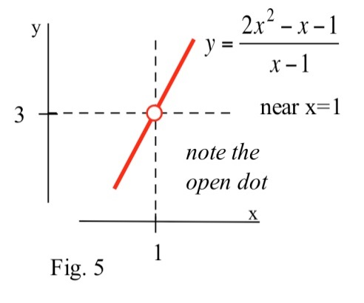Using a graph: We can graph y =  for x close to 1, and notice that whenever x is close to 1, the values of y = f(x) are close to 3. f is not defined at x = 1, so the graph has a hole above x = 1, but we only care about what f(x) is doing for x close to but **not equal to** 1.

### One Sided Limits

Sometimes, what happens to us at a place depends on the direction we use to approach that place. If we approach Niagara Falls from the upstream side, then we will be 182 feet higher and have different worries than if we approach from the downstream side. Similarly, the values of a function near a point may depend on the direction we use to approach that point.

**Definition of Left and Right Limits:**

The **left limit** as x approaches c of f(x) is L if the values of f(x) get as close to L as we want when x is very close to and **left of c**, x **< c**:  f(x) = L .

The **right limit**, written with **x  c+** , requires that x lie to the **right of c**, x **> c**:



Example 3

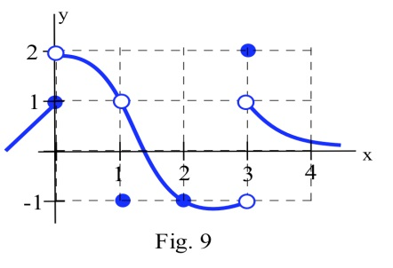Evaluate the one sided limits of the function f(x) graphed here at *x* = 0 and *x* = 1.

As *x* approach 0 from the *left*, the value of the function is getting closer to 1, so .

As *x* approaches 0 from the *right*, the value of the function is getting closer to 2, so 

Notice that since the limit from the left and limit from the right are different, the general limit, , does not exit.

At *x* approaches 1 from either direction, the value of the function is approaching 1, so .

### Continuity

A function that is “friendly” and doesn’t have any breaks or jumps in it is called **continuous**. More formally,

**Definition of Continuity at a Point**

A function **f is continuous at x = a** if and only if **f(x) = f(a)** .

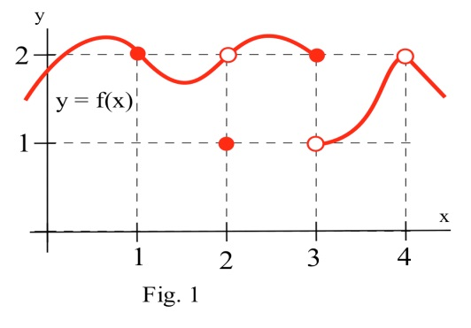

The graph to the right illustrates some of the different ways a

function can behave at and near a point, and the table contains

some numerical information about the function and its behavior. Based on the information in the table, we can conclude that f is continuous at 1 since f(x) = 2 = f(1).

We can also conclude from the information in the table that

f is not continuous at 2 or 3 or 4, because



f(x) ≠ f(2) , f(x) ≠ f(3) , and f(x) ≠ f(4).

The behaviors at *x* = 2 and *x* = 4 exhibit a **hole** in the graph, sometimes called a **removable discontinuity**, since the graph could be made continuous by changing the value of a single point. The behavior at *x* = 3 is called a **jump discontinuity**, since the graph jumps between two values.

So which functions are continuous? It turns out pretty much every function you’ve studied is continuous where it is defined: polynomial, radical, rational, exponential, and logarithmic functions are all continuous where they are defined. Moreover, any combination of continuous functions is also continuous.

This is helpful, because the definition of continuity says that for a continuous function, . That means for a continuous function, we can find the limit by direct substitution (evaluating the function) if the function is continuous at *a*.

Example 4

Evaluate using continuity, if possible:

a)  b)  b) 

a) The given function is polynomial, and is defined for all values of *x*, so we can find the limit by direct substitution:



b) The given function is rational. It is not defined at *x* = -3, but we are taking the limit as *x* approaches 2, and the function is defined at that point, so we can use direct substitution:



c) This function is not defined at *x* = 2, and so is not continuous at *x* = 2. We cannot use direct substitution.

### 2.2 Exercises

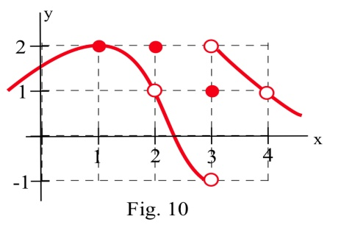

1. Use the graph to determine the following limits.

(a)  (b) 

(c)  (d) 

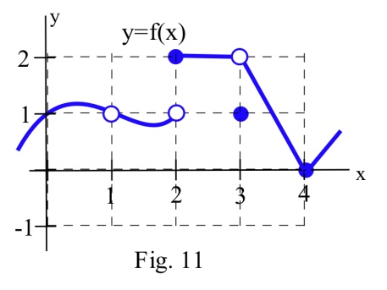2. Use the graph to determine the following limits.

(a)  (b) 

(c)  (d) 

5. Evaluate (a)  (b) 

6. Evaluate (a)  (b) 

(c)  (d) 

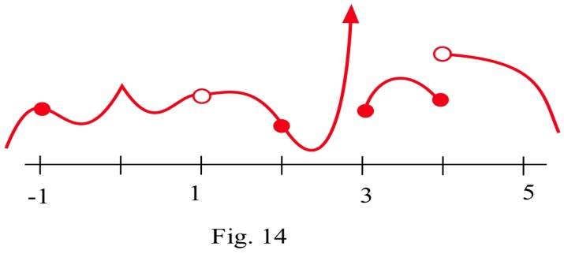

7. At which points is the function shown discontinuous?

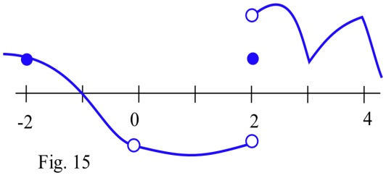

8. At which points is the function shown discontinuous?

9. Find at least one point at which each function is not continuous and state which of the 3 conditions in the definition of continuity is

violated at that point.

(a) (b) (c)

(d) (e) ln( x2 )

## Section 3: The Derivative

### Definition of the Derivative

Returning to the tangent slope problem from the first section, let's look at the problem of finding the slope of the line L in the graph below which is tangent to f(x) = x2 at the point (2,4).

We could estimate the slope of L from the graph, but we won't. Instead, we will use the idea that secant lines over tiny intervals approximate the tangent line.

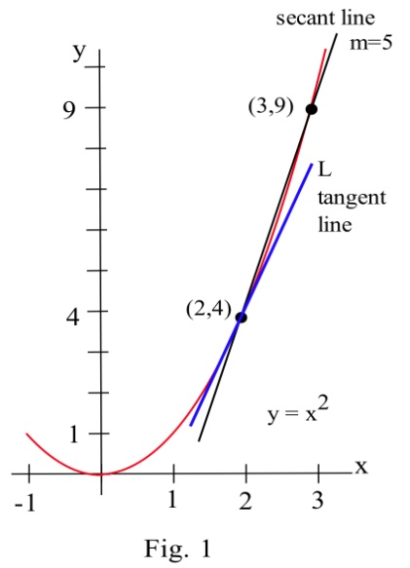 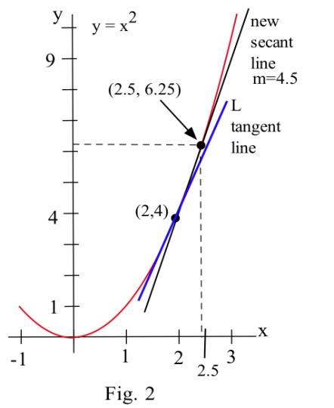

We can see that the line through (2,4) and (3,9) on the graph of f is an approximation of the slope of the tangent line, and we can calculate that slope exactly: m = ∆y/∆x = (9–4)/(3–2) = 5. But m = 5 is only an estimate of the slope of the tangent line and not a very good estimate. It's too big. We can get a better estimate by picking a second point on the graph of f which is closer to (2,4) –– the point (2,4) is fixed and it must be one of the points we use.

From the second figure, we can see that the slope of the line through the points (2,4) and (2.5,6.25) is a better approximation of the slope of the tangent line at (2,4): m = ∆y/∆x = (6.25 – 4)/(2.5 – 2) = 2.25/.5 = 4.5 , a better estimate, but still an approximation. We can continue picking points closer and closer to (2,4) on the graph of f, and then calculating the slopes of the lines through each of these points and the point (2,4):

Points to the left of (2,4) Points to the right of (2,4)

x y = x2 slope of line through x y = x2 slope of line through

(x,y) and (2,4) (x,y) and (2,4)

1.5 2.25 3.5 3 9 5

1.9 3.61 3.9 2.5 6.25 4.5

1.99 3.9601 3.99 2.01 4.0401 4.01

The only thing special about the x–values we picked is that they are numbers which are close, and very close, to x = 2. Someone else might have picked other nearby values for x. As the points we pick get closer and closer to the point (2,4) on the graph of y = x2 , the slopes of the lines through the points and (2,4) are better approximations of the slope of the tangent line, and these slopes are getting closer and closer to 4.

We can bypass much of the calculating by not picking the points one at a time: let's look at a general point near (2,4). Define x = 2 + h so h is the increment from 2 to x. If h is small, then x = 2 + h is close to 2 and the point (2+h, f(2+h) ) = (2+h, (2+h)2 ) is close to (2,4). The slope m of the line through the points (2,4) and (2+h, (2+h)2 ) is a good approximation of the slope of the tangent line at the point (2,4):

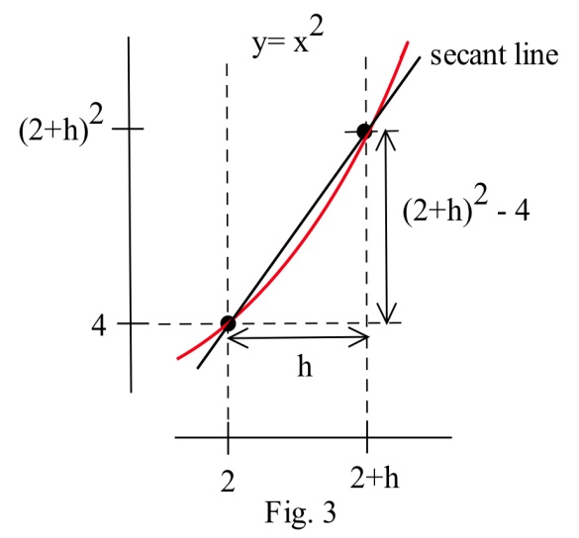

m = = = = = = 4 + h .

The value m = 4 + h is the slope of the secant line through the two points (2,4) and ( 2+h, (2+h)2 ). As h gets smaller and smaller, this slope approaches the slope of the tangent line to the graph of f at (2,4).

More formally, we could write: Slope of the tangent line = 

We can easily evaluate this limit using direct substitution, finding that as the interval *h* shrinks towards 0, the secant slope approaches the tangent slope, 4.

The tangent line problem and the instantaneous velocity problem are the same problem. In each problem we wanted to know how rapidly something was **changing at an instant in time**, and the answer turned out to be finding the **slope of a tangent line,** which we approximated with the **slope of a secant line**. This idea is the key to defining the slope of a curve.

**The Derivative:**

The **derivative** of a function f at a point (x, f(x)) is the instantaneous rate of change.

The **derivative** is the slope of the tangent line to the graph of f at the point (x, f(x)).

The **derivative** is the slope of the curve f(x) at the point (x, f(x)).

A function is called **differentiable** at (x, f(x)) if its derivative exists at (x, f(x)).

**Notation for the Derivative:**

The **derivative of y = f(x) with respect to x** is written as

 (read aloud as “f prime of x”), or (“y prime”)

or (read aloud as “dee why dee ex”), or 

The notation that resembles a fraction is called **Leibniz notation**. It displays not only the name of the function (f or y), but also the name of the variable (in this case, x). It looks like a fraction because the derivative is a slope. In fact, this is simply written in Roman letters instead of Greek letters.

**Verb forms:**

We **find the derivative** of a function, or **take the derivative** of a function, or **differentiate** a function.

We use an adaptation of the notation to mean “find the derivative of f(x):”



**Formal Algebraic Definition:**



**Practical Definition:**

The derivative can be approximated by looking at an average rate of change, or the slope of a secant line, over a very tiny interval. The tinier the interval, the closer this is to the true instantaneous rate of change, slope of the tangent line, or slope of the curve.

**Looking Ahead:**

We will have methods for computing exact values of derivatives from formulas soon. If the function is given to you as a table or graph, you will still need to approximate this way.

This is the foundation for the rest of this chapter. It’s remarkable that such a simple idea (the slope of a tangent line) and such a simple definition (for the derivative f ' ) will lead to so many important ideas and applications.

### The Derivative as a Function

We now know how to find (or at least approximate) the derivative of a function for any x-value; this means we can think of the derivative as a function, too. The inputs are the same x’s; the output is the value of the derivative at that *x* value.

Example 1

Below is the graph of a function. We can use the information in the graph to fill in a table showing values of:

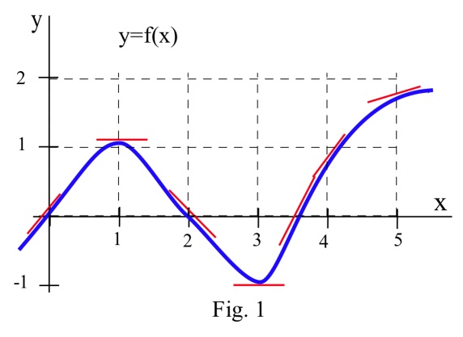

At various values of *x*, draw your best guess at the tangent line and measure its slope. You might have to extend your lines so you can read some points. In general, your estimate of the slope will be better if you choose points that are easy to read and far away from each other. Here are my estimates for a few values of *x* (parts of the tangent lines I used are shown):

|  |  |  |
| --- | --- | --- |
|  |  | = the estimated SLOPE  of the tangent line to the curve  at the point . |
| 0 | 0 | 1 |
| 1 | 1 | 0 |
| 2 | 0 | −1 |
| 3 | −1 | 0 |
| 3.5 | 0 | 2 |
| 4 | 1 | 1 |
| 5 | 2 | 0.5 |

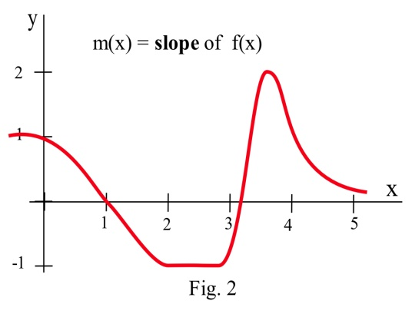We can estimate the values of f’(x) at some non-integer values of x, too: f’(.5) ≈ 0.5 and f’(1.3) ≈ –0.3.

We can even think about entire intervals. For example, if 0 < x < 1, then f(x) is increasing, all the slopes are positive, and so f’(x) is positive.

The values of f’(x) definitely depend on the values of x , and f’(x) is a function of x. We can use the results in the table to help sketch the graph of f’(x) .

Example 2

Shown is the graph of the height h(t) of a rocket at time t. Sketch the graph of the **velocity** of the rocket at time t. (Velocity is the **derivative** of the height function, so it is the **slope of the tangent** to the graph of position or height.)

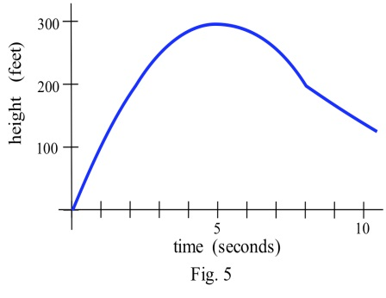

We can estimate the slope of the function at several points. The lower graph below shows the velocity of the rocket. This is v(t) = h’(t).

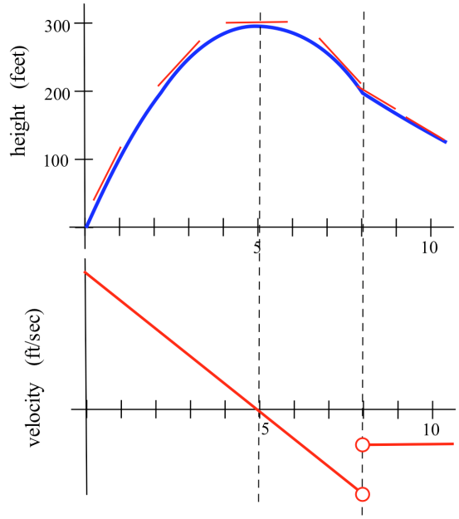

### 2.3 Exercises

1. Use the function in the graph to fill in the table and then graph m(x).

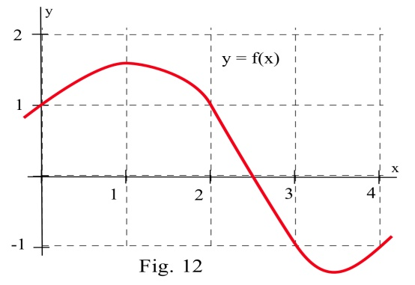 x y = f(x) m(x) = the estimated slope of the tangent

line to y=f(x) at the point (x,y)

0

0.5

1.0

1.5

2.0

2.5

3.0

3.5

4.0

2. Use the function in the graph to fill in the table and then graph m(x).

x y = g(x) m(x) = the estimated slope of the tangent

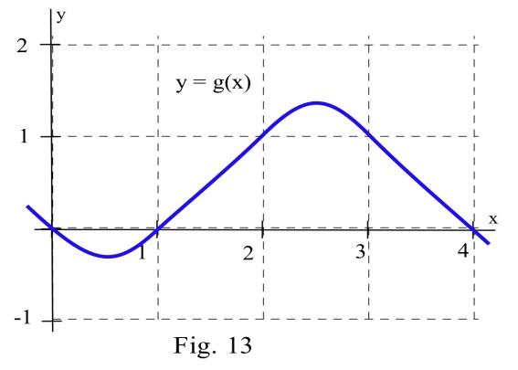 line to y=g(x) at the point (x,y)

0

0.5

1.0

1.5

2.0

2.5

3.0

3.5

4.0

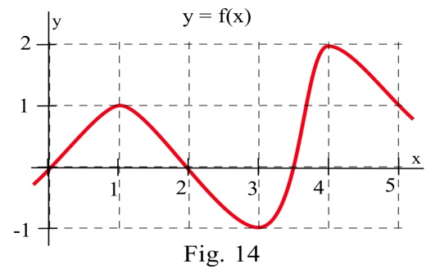

3. (a) At what values of x does the graph of f in the graph have a horizontal tangent line?

(b) At what value(s) of x is the value of f the largest? smallest?

(c) Sketch the graph of m(x) = the slope of the line tangent to the graph

of f at the point (x,y).

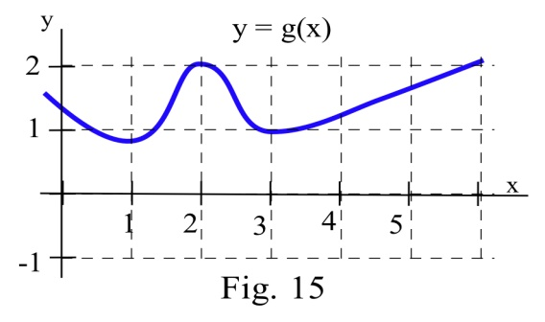4. (a) At what values of x does the graph of g have a

horizontal tangent line?

(b) At what value(s) of x is the value of g the largest? smallest?

(c) Sketch the graph of m(x) = the slope of the line tangent to the graph of g at the point (x,y).

5. Match the situation descriptions with the corresponding **time–velocity** graph.

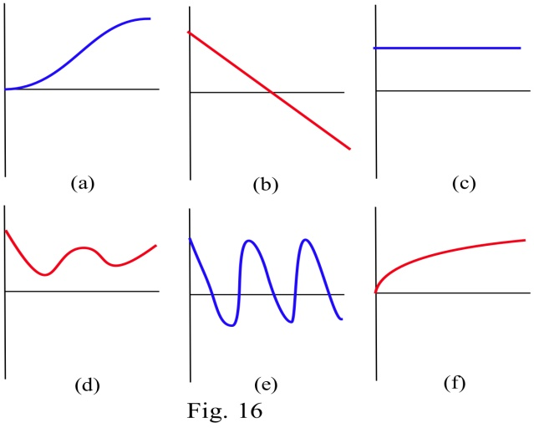 (a) A car quickly leaving from a stop sign.

(b) A car sedately leaving from a stop sign.

(c) A student bouncing on a trampoline.

(d) A ball thrown straight up.

(e) A student confidently striding across campus

to take a calculus test.

(f) An unprepared student walking across campus

to take a calculus test.

For each function f(x) in problems 6 – 11, perform steps (a) – (d):

(a) calculate msec = and simplify (b) determine mtan =   msec

(c) evaluate mtan at x = 2 , (d) find the equation of the line tangent to the graph of f at (2, f(2) )

6. f(x) = 3x – 7 7. f(x) = 2 – 7x 8. f(x) = ax + b where a and b are constants

9. f(x) = x2 + 3x 10. f(x) = 8 – 3x2 11. f(x) = ax2 + bx + c where a, b and c are constants

12. Match the graphs of the three functions below with the graphs of their derivatives.

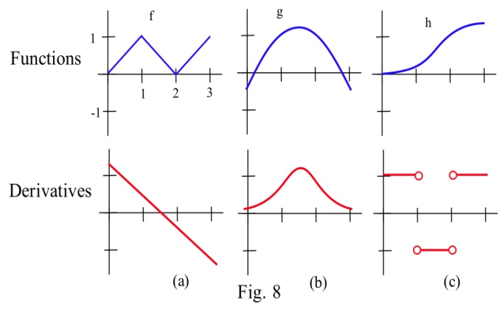

13. Below are six graphs, three of which are derivatives of the other three. Match the functions with their derivatives.

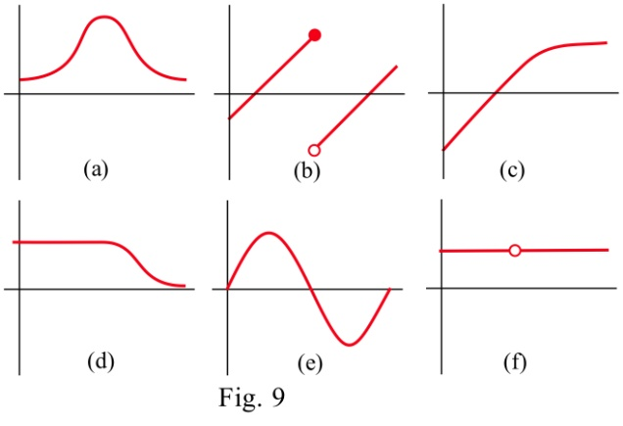

14. The graph below shows the temperature during a summer day in Chicago. Sketch the graph of the **rate** at which the temperature is changing. (This is just the graph of the **slopes** of the lines which are tangent to the temperature graph.)

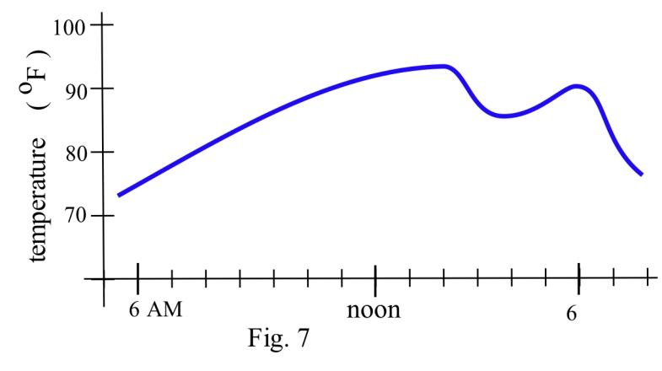

## Section 4: Rates in Real Life

So far we have emphasized the derivative as the slope of the line tangent to a graph. That interpretation is very visual and useful when examining the graph of a function, and we will continue to use it. Derivatives, however, are used in a wide variety of fields and applications, and some of these fields use other interpretations. The following are a few interpretations of the derivative that are commonly used.

**General**

Rate of Change: f '(x) is the **rate of change** of the function at x. If the units for x are years and the units for f(x) are people, then the units for are , a rate of change in population.

**Graphical**

Slope: f '(x) is the **slope of the line tangent to the graph of f at the point ( x, f(x) ).**

**Physical**

Velocity: If f(x) is the position of an object at time x, then f '(x) is the **velocity** of the object at time x. If the units for x are hours and f(x) is distance measured in miles, then the units for **f '**(x) =   are  , miles per hour, which is a measure of velocity.

Acceleration: If f(x) is the velocity of an object at time x, then f '(x) is the **acceleration** of the object at time x. If the units are for x are hours and f(x) has the units  , then the units for the acceleration **f '(x)** = are = , miles per hour per hour.

**Business**

Marginal Cost, Marginal Revenue, and Marginal Profit: We'll explore these terms in more depth later in the section. Basically, the marginal cost is approximately the additional cost of making one more object once we have already made x objects. If the units for x are bicycles and the units for f(x) are dollars, then the units for f '(x) = are  , the cost per bicycle.

In business contexts, the word "marginal" usually means the derivative or rate of change of some quantity.

One of the strengths of calculus is that it provides a unity and economy of ideas among diverse applications. The vocabulary and problems may be different, but the ideas and even the notations of calculus are still useful.

### Business and Economics Terms

Suppose you are producing and selling some item. The profit you make is the amount of money you take in minus what you have to pay to produce the items. Both of these quantities depend on how many you make and sell. (So we have functions here.) Here is a list of definitions for some of the terminology, together with their meaning in algebraic terms and in graphical terms.

Your **cost** is the money you have to spend to produce your items.

The **Fixed Cost (FC)** is the amount of money you have to spend regardless of how many items you produce. FC can include things like rent, purchase costs of machinery, and salaries for office staff. You have to pay the fixed costs even if you don’t produce anything.

The **Total Variable Cost (TVC)** for q items is the amount of money you spend to actually produce them. TVC includes things like the materials you use, the electricity to run the machinery, gasoline for your delivery vans, maybe the wages of your production workers. These costs will vary according to how many items you produce.

The **Total Cost (TC**, or sometimes just **C)** for q items is the total cost of producing them. It’s the sum of the fixed cost and the total variable cost for producing q items.

The **Average Cost (AC)** for q items is the total cost divided by q, or TC/q. You can also talk about the average fixed cost, FC/q, or the average variable cost, TVC/q.

The **Marginal Cost (MC)** at q items is the cost of producing the *next* item. Really, it’s

**MC(q) = TC(q + 1) – TC(q).**

In many cases, though, it’s easier to approximate this difference using calculus (see Example below). And some sources define the marginal cost directly as the derivative,

**MC(q) = TC'(q)**.

In this course, we will use both of these definitions as if they were interchangeable.

The units on marginal cost is cost per item.

Why is it OK that are there two definitions for Marginal Cost (and Marginal Revenue, and Marginal Profit)?

We have been using slopes of secant lines over tiny intervals to approximate derivatives. In this example, we’ll turn that around – we’ll use the derivative to approximate the slope of the secant line.

Notice that the “cost of the next item” definition is actually the slope of a secant line, over an interval of 1 unit:



So this is approximately the same as the derivative of the cost function at *q*:



In practice, these two numbers are so close that there’s no practical reason to make a distinction. For our purposes, the marginal cost **is** the derivative **is** the cost of the next item.

Example 1

The table shows the total cost (TC) of producing *q* items.

|  |  |
| --- | --- |
| Items, *q* | Total Cost, TC |
| 0 | $20,000 |
| 100 | $35,000 |
| 200 | $45,000 |
| 300 | $53,000 |

1. What is the fixed cost?
2. When 200 items are made, what is the total variable cost? The average variable cost?
3. When 200 items are made, estimate the marginal cost.

a) The fixed cost is $20,000, the cost even when no items are made.

b) When 200 items are made, the total cost is $45,000. Subtracting the fixed cost, the total variable cost is $45,000 - $20,000 = $25,000.

The average variable cost is the total variable cost divided by the number of items, so we would divide the $25,000 total variable cost by the 200 items made. $25,000 ÷ 200= $125. On average, each item had a variable cost of $125.

c) We need to estimate the value of the derivative, or the slope of the tangent line at *q* = 200. Finding the secant line from *q*=100 to *q*=200 gives a slope of . Finding the secant line from *q*=200 to *q*=300 gives a slope of . We could estimate the tangent slope by averaging these secant slopes, giving us an estimate of $90/item.

This tells us that after 200 items have been made, it will cost about $90 to make one more item.

**Demand** is the functional relationship between the price **p** and the quantity **q** that can be sold (that is demanded). Depending on your situation, you might think of **p** as a function of **q**, or of **q** as a function of **p**.

Your **revenue** is the amount of money you actually take in from selling your products. Revenue is price × quantity.

The **Total Revenue (TR**, or just **R)** for q items is the total amount of money you take in for selling q items.

The **Average Revenue (AR)** for q items is the total revenue divided by q, or TR/q.

The **Marginal Revenue (MR)** at q items is the cost of producing the *next* item,

**MR(q) = TR(q + 1) – TR(q)**.

Just as with marginal cost, we will use both this definition and the derivative definition

**MR(q) = TR’(q).**

Your **profit** is what’s left over from total revenue after costs have been subtracted.

The **Profit (P)** for q items is TR(q) – TC(q), the difference between total revenue and total costs

The average profit for q items is **P**/q. The marginal profit at q items is P(q + 1) – P(q), or 

### Graphical Interpretations of the Basic Business Math Terms

**Illustration/Example:**

Here are the graphs of TR and TC for producing and selling a certain item. The horizontal axis is the number of items, in thousands. The vertical axis is the number of dollars, also in thousands.

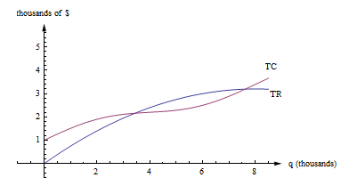

First, notice how to find the fixed cost and variable cost from the graph here. **FC is the y-intercept of the TC graph.** (FC = TC(0).) The graph of TVC would have the same shape as the graph of TC, shifted down. (TVC = TC – FC.)

We already know that we can find average rates of change by finding slopes of secant lines. AC, AR, MC, and MR are all rates of change, and we can find them with slopes, too.

**AC(q) is the slope of a diagonal line, from (0, 0) to (q, TC(q)).**

**AR(q) is the slope of the line from (0, 0) to (q, TR(q)).**

MC(q) = TC(q + 1) – TC(q), but that’s impossible to read on this graph. How could you distinguish between TC(4022) and TC(4023)? On this graph, that interval is too small to see, and our best guess at the secant line is actually the tangent line to the TC curve at that point. (This is the reason we want to have the derivative definition handy.)

**MC(q) is the slope of the tangent line to the TC curve at (q, TC(q)).**

**MR(q) is the slope of the tangent line to the TR curve at (q, TR(q)).**

**Profit is the distance between the TR and TC curve.** If you experiment with your clear plastic ruler, you’ll see that the biggest profit occurs exactly when the tangent lines to the TR and TC curves are parallel. This is the rule **“profit is maximized when MR = MC.”** which we'll explore later in the chapter.

### Rates in Real Life

Example 2

You can estimate a tree’s age in years by multiplying its diameter (measured in inches) by its growth factor (a number that depends on the species). According to the Missouri Department of Conservation, the Growth factor for a cottonwood tree is 2.

1. Suppose you find a cottonwood tree in Missouri that is 6 inches in diameter. How old would you estimate it to be?
2. What are the units of the growth factor?
3. Is this growth factor a derivative?

a. The cottonwood tree should be about 6 × 2 = 12 years old.

b. The units of the growth factor are years per inch (because when we multiply the growth factor by inches, we get years).

c. Yes, the growth factor is a derivative. It has fractional units (years per inch), so it represents a rate. In this case, it’s the derivative of the function that gives the age of a tree as a function of its diameter. The function is linear, so the derivative in this case is the constant slope, 2 years per inch.

Example 3

The length of day (that is, daylight) in Seattle is a function of the day of the year. For example, on August 12th, 2012, there were about 14 hours 24 minutes of daylight. In Seattle, August is the summer, approaching the autumnal equinox. The days are decreasing in length by about three minutes per day. So the derivative of this function is about −3 minutes per day. On January 15, 2012, which is wintertime in Seattle, there were about 8 hours 52 minutes of daylight, and the derivative was about (positive) 2 minutes per day; the length of the day was increasing by about 2 minutes a day.

### 2.4 Exercises

1. Fill in the table with the appropriate units for f '(x).

units for x units for f(x) units for f '(x)

hours miles

people automobiles

dollars pancakes

days trout

seconds miles per second

seconds gallons

study hours test points

## Section 5: Derivatives of Formulas

In this section, we’ll get the derivative rules that will let us find formulas for derivatives when our function comes to us as a formula. This is a very algebraic section, and you should get lots of practice. When you tell someone you have studied calculus, this is the one skill they will expect you to have. There’s not a lot of deep meaning here – these are strictly algebraic rules.

### Building Blocks

These are the simplest rules – rules for the basic functions. We won’t prove these rules; we’ll just use them. But first, let’s look at a few so that we can see they make sense.

Example 1

Find the derivative of 

This is a linear function, so its graph is its own tangent line! The slope of the tangent line, the derivative, is the slope of the line: 

**Rule: The derivative of a linear function is its slope**

Example 2

Find the derivative of 

Think about this one graphically, too. The graph of *f*(*x*) is a horizontal line. So its slope is zero.



**Rule: The derivative of a constant is zero**

Example 3

Find the derivative of 

This question is challenging using limits. We will show you the long way to do it, then give you a shorthand rule to bypass all this.

Recall the formal definition of the derivative: .

Using our function , . Then



From all that, we find the 

Luckily, there is a handy rule we use to skip using the limit:

**Power Rule: The derivative**  is 

Example 4

Find the derivative of .

Using the power rule, we know that if , then . Notice that *g* is 4 times the function *f*. Think about what this change means to the graph of *g* – it’s now 4 times as tall as the graph of *f*. If we find the slope of a secant line, it will be ; each slope will be 4 times the slope of the secant line on the *f* graph. This property will hold for the slopes of tangent lines, too:



**Rule: Constants come along for the ride;** 

Here are all the basic rules in one place.

**Derivative Rules: Building Blocks**

In what follows, *f* and *g* are differentiable functions of *x*.

(a) **Constant Multiple Rule:** 

(b) **Sum (or Difference) Rule:  (or )**

(c) **Power Rule: **

Special cases: (because )

(because )

(d) **Exponential Functions: **



(e) **Natural Logarithm:** 

The sum, difference, and constant multiple rule combined with the power rule allow us to easily find the derivative of any polynomial.

Example 5

Find the derivative of 

****

You don’t have to show every single step. Do be careful when you’re first working with the rules, but pretty soon you’ll be able to just write down the derivative directly:

Example 6

Find 

Writing out the rules, we'd write



Once you're familiar with the rules, you can, in your head, multiply the 2 times the 17 and the 33 times 1, and just write



The power rule works even if the power is negative or a fraction. In order to apply it, first translate all roots and basic rational expressions into exponents:

Example 7

Find the derivative of 

First step – translate into exponents:



Now you can take the derivative:



If there is a reason to, you can rewrite the answer with radicals and positive exponents:



Be careful when finding the derivatives with negative exponents.

Example 8

Find the equation of the line tangent to  when *t* = 2.

The slope of the tangent line is the value of the derivative. We can compute . To find the slope of the tangent line when *t* = 3, evaluate the derivative at that point.

. The slope of the tangent line is -4.

To find the equation of the tangent line, we also need a point on the tangent line. Since the tangent line touches the original function at *t* = 2, we can find the point by evaluating the original function: . The tangent line must pass through the point (2, 6).

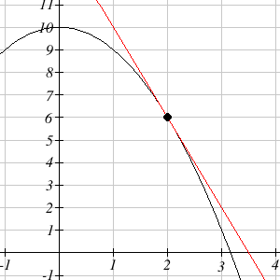

Using the point-slope equation of a line, the tangent line will have equation .

Simplifying to slope-intercept form, the equation is .

Graphing, we can verify this line is indeed tangent to the curve.

Example 9

The cost to produce x items is  hundred dollars.

(a) What is the cost for producing 100 items? 101 items? What is cost of the 101st item?

(b) For f(x) = , calculate f '(x) and evaluate f ' at x = 100. How does f '(100) compare with the last answer in part (a)?

(a) Put f(x) = = x1/2 hundred dollars, the cost for x items. Then f(100) = $1000 and f(101) = $1004.99, so it costs $4.99 for that 101st item. Using this definition, the marginal cost is $4.99.

(b)  so  hundred dollars = $5.00.

Note how close these answers are! This shows (again) why it’s OK that we use both definitions for marginal cost.

### Product and Quotient Rules

The basic rules will let us tackle simple functions. But what happens if we need the derivative of a combination of these functions?

Example 10

Find the derivative of 

This function is not a simple sum or difference of polynomials. It’s a product of polynomials. We can simply multiply it out to find its derivative:



Now suppose we wanted to find the derivative of 

This function is not a simple sum or difference of polynomials. It’s a product of polynomials. We **could** simply multiply it out to find its derivative as before – who wants to volunteer? Nobody?

We’ll need a rule for finding the derivative of a product so we don’t have to multiply everything out.

It would be great if we can just take the derivatives of the factors and multiply them, but unfortunately that won’t give the right answer. to see that, consider finding derivative of . We already worked out the derivative. It’s . What if we try differentiating the factors and multiplying them? We’d get , which is totally different from the correct answer.

The rules for finding derivatives of products and quotients are a little complicated, but they save us the much more complicated algebra we might face if we were to try to multiply things out. They also let us deal with products where the factors are not polynomials. We can use these rules, together with the basic rules, to find derivatives of many complicated looking functions.

**Derivative Rules: Product and Quotient Rules**

In what follows, *f* and *g* are differentiable functions of *x*.

(f) **Product Rule:**



The derivative of the first factor times the second left alone, plus the first left alone times the derivative of the second.

The product rule can extend to a product of several functions; the pattern continues – take the derivative of each factor in turn, multiplied by all the other factors left alone, and add them up.

(g) **Quotient Rule:**



The numerator of the result resembles the product rule, but there is a minus instead of a plus; the minus sign goes with the g’. The denominator is simply the square of the original denominator – no derivatives there.

Example 11

Find the derivative of 

This is a product, so we need to use the product rule. I like to put down empty parentheses to remind myself of the pattern; that way I don’t forget anything.



Then I fill in the parentheses – the first set gets the derivative of , the second gets left alone, the third gets left alone, and the fourth gets the derivative of .



Notice that this was one we couldn’t have done by “multiplying out.”

Example 12

Find the derivative of 

This is a quotient, so we need to use the quotient rule. Again, you find it helpful to put down the empty parentheses as a template:



Then fill in all the pieces:



Now for goodness’ sakes don’t try to simplify that! Remember that “simple” depends on what you will do next; in this case, we were asked to find the derivative, and we’ve done that. Please STOP, unless there is a reason to simplify further.

### Chain Rule

There is one more type of complicated function that we will want to know how to differentiate: composition. The Chain Rule will let us find the derivative of a composition. (This is the last derivative rule we will learn!)

Example 13

Find the derivative of .

This is not a simple polynomial, so we can’t use the basic building block rules yet. It is a product, so we could write it as  and use the product rule. Or we could multiply it out and simply differentiate the resulting polynomial. I’ll do it the second way:



Now suppose we want to find the derivative of . We **could** write it as a product with 20 factors and use the product rule, or we **could** multiply it out. But I don’t want to do that, do you?

We need an easier way, a rule that will handle a composition like this. The Chain Rule is a little complicated, but it saves us the much more complicated algebra of multiplying something like this out. It will also handle compositions where it wouldn’t be possible to “multiply it out.”

The Chain Rule is the most common place for students to make mistakes. Part of the reason is that the notation takes a little getting used to. And part of the reason is that students often forget to use it when they should. When should you use the Chain Rule? Almost every time you take a derivative.

**Derivative Rules: Chain Rule**

In what follows, *f* and *g* are differentiable functions with  and 

(h) **Chain Rule (Leibniz notation):**



Notice that the du’s seem to cancel. This is one advantage of the Leibniz notation; it can remind you of how the chain rule chains together.

(h) **Chain Rule (using prime notation):**



(h) **Chain Rule (in words):**

The derivative of a composition is the derivative of the outside, with the inside staying the same, TIMES the derivative of what’s inside.

I recite the version in words each time I take a derivative, especially if the function is complicated.

Example 14

Find the derivative of .

This is the same one we did before by multiplying out. This time, let’s use the Chain Rule: The inside function is what appears inside the parentheses: . The outside function is the first thing we find as we come in from the outside – it’s the square function, (inside)2.

The derivative of this outside function is (2\*inside). Now using the chain rule, the derivative of our original function is:  
(2\*inside) TIMES the derivative of what’s inside (which is ):



If you multiply this out, you get the same answer we got before. Hurray! Algebra works!

Example 15

Find the derivative of 

Now we have a way to handle this one. It’s the derivative of the outside TIMES the derivative of what’s inside.

The outside function is (inside)20, which has the derivative 20(inside)19.



Example 16

Differentiate  .

This isn’t a simple exponential function; it’s a composition. Typical calculator or computer syntax can help you see what the “inside” function is here. On a TI calculator, for example, when you push the key, it opens up parentheses:  This tells you that the “inside” of the exponential function is the exponent. Here, the inside is the exponent. Now we can use the Chain Rule: We want the derivative of the outside TIMES the derivative of what’s inside. The outside is the “e to the something” function, so its derivative is the same thing. The derivative of what’s inside is 2x. So



Example 17

The table gives values for f , f ' , g and g ' at a number of points. Use these values to determine ( fg )(x) and **(** fg **) '**(x) at x = –1 and 0.

|  |  |  |  |  |  |  |
| --- | --- | --- | --- | --- | --- | --- |
| x | f(x) | g(x) | f'(x) | g'(x) | ( fg )(x) | ( gf )(x) |
| -1 | 2 | 3 | 1 | 0 |  |  |
| 0 | -1 | 1 | 3 | 2 |  |  |
| 1 | 1 | 0 | -1 | 3 |  |  |
| 2 | 3 | -1 | 0 | 1 |  |  |
| 3 | 0 | 2 | 2 | -1 |  |  |

( fg )(–1) = f( g(–1) ) = f( 3 ) = 0

( fg )(0) = f( g(0) ) = f( 1 ) = 1.

**(** fg **) '**(–1) = **f '(** g(–1) **).g '(** –1 **)** = **f '(** 3 **).**(0) = (2)(0) = 0 and

**(** fg **) '**( 0 ) = **f '(** g( 0 ) **).g '(** 0 **)**  = **f '(** 1 **).**( 2 ) = (–1)(2) = –2 .

### Derivatives of Complicated Functions

You’re now ready to take the derivative of some mighty complicated functions. But how do you tell what rule applies first? Come in from the outside – what do you encounter first? That’s the first rule you need. Use the Product, Quotient, and Chain Rules to peel off the layers, one at a time, until you’re all the way inside.

Example 18

Find 

Coming in from the outside, I see that this is a product of two (complicated) functions. So I’ll need the Product Rule first. I’ll fill in the pieces I know, and then I can figure the rest as separate steps and substitute in at the end:



Now as separate steps, I’ll find

 (using the Chain Rule) and

(also using the Chain Rule).

Finally, to substitute these in their places:



(And please don’t try to simplify that!)

Example 19

Differentiate 

Don’t panic! As you come in from the outside, what’s the first thing you encounter? It’s that 4th power. That tells you that this is a composition, a (complicated) function raised to the 4th power.

**Step One:** Use the Chain Rule. The derivative of the outside TIMES the derivative of what’s inside.



Now we’re one step inside, and we can concentrate on just the part. Now, as you come in from the outside, the first thing you encounter is a quotient – this is the quotient of two (complicated) functions.

**Step Two:** Use the Quotient Rule. The derivative of the numerator is straightforward, so we can just calculate it. The derivative of the denominator is a bit trickier, so we'll leave it for now.



Now we’ve gone one more step inside, and we can concentrate on just the  part. Now we have a product.

**Step Three:** Use the Product Rule:



And now we’re all the way in – no more derivatives to take.

**Step Four:** Now it’s just a question of substituting back – be careful now!

, so

, so

.

**Phew!**

### What if the Derivative Doesn’t Exist?

A function is called **differentiable** at a point if its derivative exists at that point.

We’ve been acting as if derivatives exist everywhere for every function. This is true for most of the functions that you will run into in this class. But there are some common places where the derivative doesn’t exist.

Remember that the derivative is the slope of the tangent line to the curve. That’s what to think about.

**Where can a slope not exist?** If the tangent line is vertical, the derivative will not exist.

Example 20

Show that  is not differentiable at *x* = 0.

Finding the derivative, . At *x* = 0, this function is undefined. From the graph, we can see that the tangent line to this curve at *x* = 0 is vertical with undefined slope, which is why the derivative does not exist at *x* = 0.

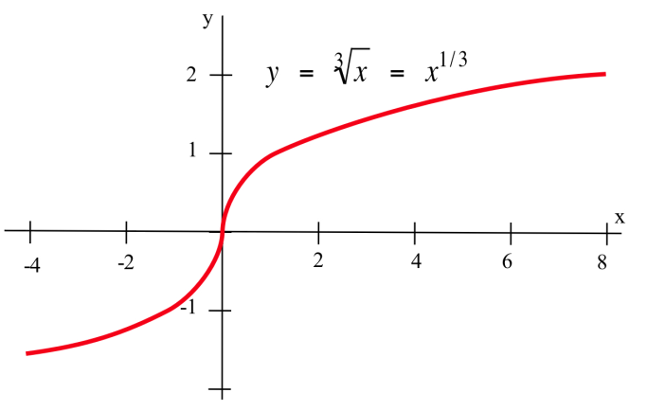

**Where can a tangent line not exist?** If there is a sharp corner (cusp) in the graph, the derivative will not exist at that point because there is no well-defined tangent line (a teetering tangent, if you will). If there is a jump in the graph, the tangent line will be different on either side and the derivative can’t exist.

Example 21

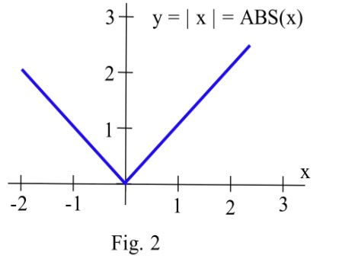Show that  is not differentiable at *x* = 0.

On the left side of the graph, the slope of the line is -1. On the right side of the graph, the slope is +1. There is no well-defined tangent line at the sharp corner at *x* = 0, so the function is not differentiable at that point.

## CC_2_2_figs6Exercises

1. The graph of y = f(x) is shown.

(a) At which integers is f continuous?

(b) At which integers is f differentiable?

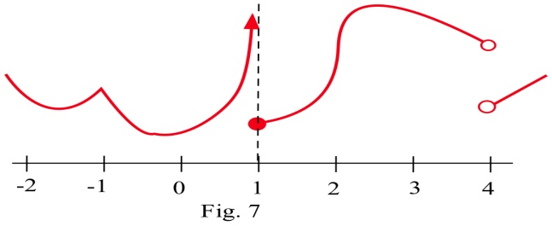

2. The graph of y = g(x) is shown.

(a) At which integers is g continuous?

(b) At which integers is g differentiable?

3.Fill in the values in the table for , , and .

x f(x) f '(x) g(x) g '(x)  

0 3 –2 –4 3

1 2 –1 1 0

2 4 2 3 1

4.Use the values in the table to fill in the rest of the table.

x f(x) f '(x) g(x) g '(x) **  **

0 3 –2 –4 3

1 2 –1 1 0

2 4 2 3 1

Problems 5 and 6 refer to the values given in this table:

x f(x) g(x) f '(x) g '(x) ( fg )(x) ( fg )' (x)

–2 2 –1 1 1

–1 1 2 0 2

0 –2 1 2 –1

1 0 –2 –1 2

2 1 0 1 –1

5. Use the table of values to determine ( fg )(x) and ( fg )' (x) at x = 1 and 2.

6. Use the table of values to determine ( fg )(x) and ( fg )' (x) at x = –2, –1 and 0.

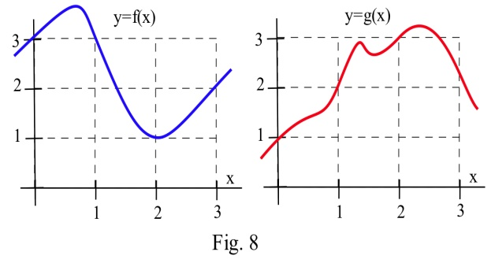7. Use the information in the graph to plot the values of the functions f + g, f**.**g and f/g and their derivatives at x = 1, 2 and 3 .

8. Use the information in the graph to plot the values of the functions 2f, f – g and g/f and their derivatives at x = 1, 2 and 3 .

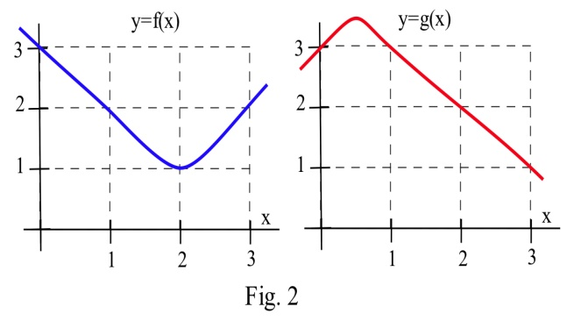9. Use the graphs to estimate the values of g(x), **g '(x)**, (fg)(x), **f '(** g(x) **)**, and **( fg ) '(** x **)** at x = 1.

10. Use the graphs to estimate the values of g(x), **g '(x)**, (fg)(x), **f '(** g(x) **)**, and **( fg ) '(** x **)** for x = 2.

11. Find (a) D( x12 ) (b) (c) D( ) (d)

12. Find (a) D( x9 ) (b) (c) D( ) (d) D( xπ )

13. Calculate **** by (a) using the product rule and (b) expanding the product and then differentiating. Verify that both methods give the same result.

14. If the product of f and g is a constant ( f(x) ∙ g(x) = k for all x), then how are 

and  related?

15. If the quotient of f and g is a constant (  for all x), then how are g . f ' and f . g ' related?

In problems 16 – 21, (a) calculate f '(1) and (b) determine when f '(x) = 0.

16. f(x) = x2 – 5x + 13

17. f(x) = 5x2 – 40x + 73

18. f(x) = x3 + 9x2 + 6

19. f(x) = x3 + 3x2 + 3x – 1

20. f(x) = x3 + 2x2 + 2x – 1

21. f(x) =

22.Determine  and .

23. Find (a)  and (b) .

24. Find (a) , (b) 

In problems 25 – 30 , find the derivative of each function.

25. f(x) = (2x – 8)5 26. f(x) = (6x – x2)10 27. f(x) = x **.**(3x + 7)5

28. f(x) = (2x + 3)6**.**(x – 2)4 29. f(x) = 30. f(x) =

31. If f is a differentiable function,

(a) how are the graphs of y = f(x) and y = f(x) + k related?

(b) how are the derivatives of f(x) and f(x) + k related?

32. Where do f(x) = x2 – 10x + 3 and g(x) = x3 – 12x have horizontal tangent lines ?

33. It takes T(x) = x2 hours to weave x small rugs. What is the marginal production time to weave a rug? (Be sure to include the units with your answer.)

34. It costs C(x) = dollars to produce x golf balls. What is the marginal production cost to make a golf ball? What is the marginal production cost when x = 25? when x= 100? (Include units.)

35. A manufacturer has determined that an employee with d days of production experience will be able to

produce approximately P(d) = 3 + 15( 1 – e–0.2d ) items per day. Graph P(d).

(a) Approximately how many items will a beginning employee be able to produce each day?

(b) How many items will an experienced employee be able to produce each day?

(c) What is the marginal production rate of an employee with 5 days of experience? (What are the units of your answer, and what does this answer mean?)

36. An arrow shot straight up from ground level with an initial velocity of 128 feet per second will be at height h(x) = –16x2 + 128x feet at x seconds.

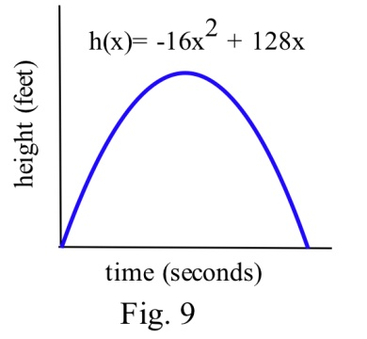 (a) Determine the velocity of the arrow when x = 0, 1 and 2 seconds.

(b) What is the velocity of the arrow, v(x), at any time x?

(c) At what time x will the velocity of the arrow be 0?

(d) What is the greatest height the arrow reaches?

(e) How long will the arrow be aloft?

(f) Use the answer for the velocity in part (b) to determine the

acceleration, a(x) = v '(x), at any time x.

37. If an arrow is shot straight up from ground level on the moon with an initial velocity of 128 feet per second, its height will be h(x) = –2.65x2 + 128x feet at x seconds. Do parts (a) – (e) of problem 40 using this new equation for h.

38. f(x) = x3 + A x2 + B x + C with constants A, B and C. Can you find conditions on the

constants A, B and C which will guarantee that the graph of y = f(x) has two distinct "vertices"? (Here a "vertex" means a place where the curve changes from increasing to decreasing or from decreasing to increasing.)

## Section 6: Second Derivative and Concavity

### Second Derivative and Concavity

Graphically, a function is **concave up** if its graph is curved with the opening upward (a in the figure). Similarly, a function is **concave down** if its graph opens downward (b in the figure).

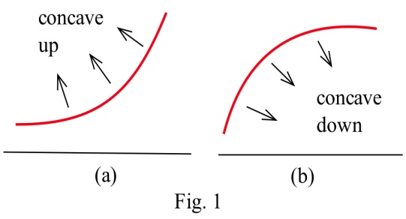

This figure shows the concavity of a function at several points. Notice that a function can be concave up regardless of whether it is increasing or decreasing.

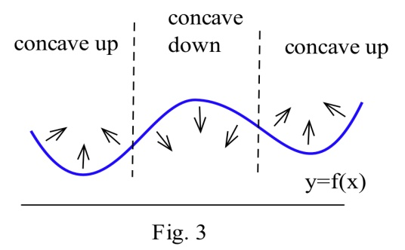

For example, **An Epidemic:** Suppose an epidemic has started, and you, as a member of congress, must decide whether the current methods are effectively fighting the spread of the disease or whether more drastic measures and more money are needed. In the figure below, f(x) is the number of people who have the disease at time x, and two different situations are shown. In both (a) and (b), the number of people with the disease, f(now), and the rate at which new people are getting sick, f '(now), are the same. The difference in the two situations is the concavity of f, and that difference in concavity might have a big effect on your decision.

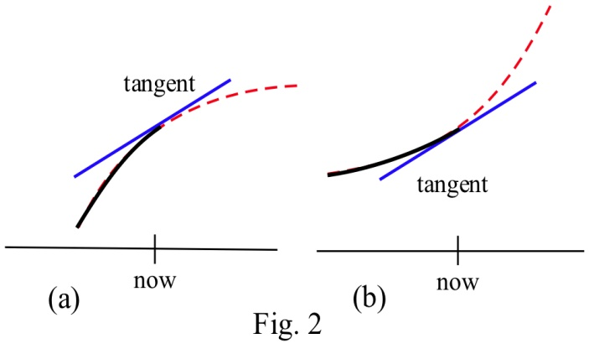

In (a), f is concave down at "now", the slopes are decreasing, and it looks as if it’s tailing off. We can say “f is increasing at a decreasing rate.” It appears that the current methods are starting to bring the epidemic under control.

In (b), f is concave up, the slopes are increasing, and it looks as if it will keep increasing faster and faster. It appears that the epidemic is still out of control.

The differences between the graphs come from whether the *derivative* is increasing or decreasing.

The derivative of a function f is a function that gives information about the slope of f. **The derivative tells us if the original function is increasing or decreasing.**

Because f ' is a function, we can take its derivative. This second derivative also gives us information about our original function f. The second derivative gives us a mathematical way to tell how the graph of a function is curved. **The second derivative tells us if the original function is concave up or down.**

**Second Derivative**  Let ****

The **second derivative of f** is the derivative of ****.

Using prime notation, this is  or . You can read this aloud as “y double prime.”

Using Leibniz notation, the second derivative is written or . This is read aloud as “the second derivative of f.

If  is positive on an interval, the graph of **** is **concave up** on that interval**.** We can say that *f* is increasing (or decreasing) **at an increasing rate**.

If  is negative on an interval, the graph of **** is **concave up** on that interval**.** We can say that *f* is increasing (or decreasing) **at a decreasing rate.**

Example 1

Find  for 

First, we need to find the first derivative:



Then we take the derivative of that function:



If f(x) represents the position of a particle at time x, then v(x) = f '(x) will represent the velocity (rate of change of the position) of the particle and a(x) = v '(x) = f ''(x) will represent the acceleration (the rate of change of the velocity) of the particle.

You are probably familiar with acceleration from driving or riding in a car. The speedometer tells you your velocity (speed). When you leave from a stop and press down on the accelerator, you are accelerating - increasing your speed.

Example 2

The height (feet) of a particle at time t seconds is f(t) = t3 – 4t2 + 8t . Find the height, velocity and acceleration of the particle when t = 0, 1, and 2 seconds.

f(t) = t3 – 4t2 + 8t so f(0) = 0 feet, f(1) = 5 feet, and f(2) = 8 feet.

The velocity is v(t) = f '(t) = 3t2 – 8t + 8 so v(0) = 8 ft/s , v(1) = 3 ft/s, and v(2) = 4 ft/s. At each of these times the velocity is positive and the particle is moving upward, increasing in height.

The acceleration is a(t) = f ''(t) = 6t – 8 so a(0) = –8 ft/s2 , a(1) = –2 ft/s2 and a(2) = 4 ft/s2 .

At time 0 and 1, the acceleration is negative, so the particle's velocity would be decreasing at those points - the particle was slowing down. At time 2, the velocity is positive, so the particle was increasing in speed.

### Inflection Points

**Definition:** An **inflection point** is a point on the graph of a function where the concavity of the

function changes, from concave up to down or from concave down to up.

Example 3

Which of the labeled points in the graph below are inflection points?

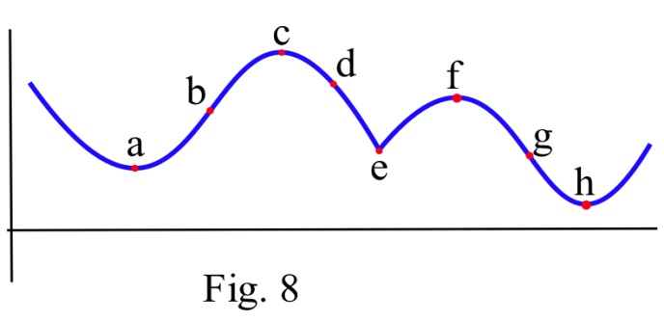

The concavity changes at points b and g. At points a and h, the graph is concave up on both sides, so the concavity does not change. At points c and f, the graph is concave down on both sides. At point e, even though the graph looks strange there, the graph is concave down on both sides – the concavity does not change.

Inflection points happen when the concavity changes. Because we know the connection between the concavity of a function and the sign of its second derivative, we can use this to find inflection points.

**Working Definition:** An **inflection point** is a point on the graph where the second derivative changes sign.

In order for the second derivative to change signs, it must either be zero or be undefined. So to find the inflection points of a function we only need to check the points where f ''(x) is 0 or undefined.

Note that it is not enough for the second derivative to be zero or undefined. We still need to check that the sign of f’’ changes sign. The functions in the next example illustrate what can happen.

Example 4

Let f(x) = x3 , g(x) = x4 and h(x) = x1/3. For which of these functions is the point (0,0) an inflection point?

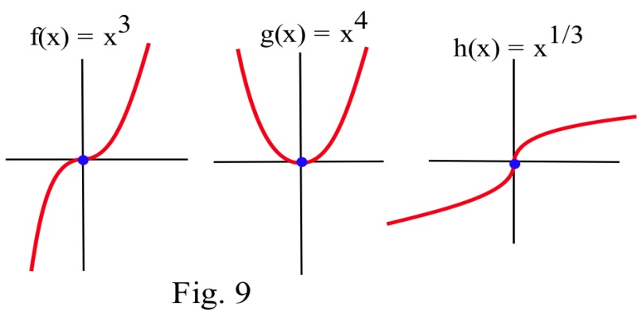

Graphically, it is clear that the concavity of f(x) = x3 and h(x) = x1/3 changes at (0,0), so (0,0) is an inflection point for f and h. The function g(x) = x4 is concave up everywhere so (0,0) is not an inflection point of g.

We can also compute the second derivatives and check the sign change.

If f(x) = x3 , then f '(x) = 3x2 and f ''(x) = 6x . The only point at which f ''(x) = 0 or is undefined (f ' is not differentiable) is at x = 0. If x < 0, then f ''(x) < 0 so f is concave down. If x > 0 , then f ''(x) > 0 so f is concave up. At x = 0 the concavity changes so the point (0,f(0)) = (0,0) is an inflection point of x3 .

If g(x) = x4 , then g '(x) = 4x3 and g ''(x) = 12x2 . The only point at which g ''(x) = 0 or is undefined is at x = 0. If x < 0, then g ''(x) > 0 so g is concave up. If x > 0 , then g ''(x) > 0 so g is also concave up. At x = 0 the concavity **does not change** so the point (0, g(0)) = (0,0) is **not an inflection point** of x4 . Keep this example in mind!.

If h(x) = x1/3 , then h '(x) = x–2/3 and h ''(x) = – x–5/3 . h'' is not defined if x = 0, but h ''(negative number) > 0 and h ''(positive number) < 0 so h changes concavity at (0,0) and (0,0) is an inflection point of h.

Example 5

Sketch the graph of a function with f(2) = 3, f '(2) = 1, and an inflection point at (2,3).

Two possible solutions are shown here.

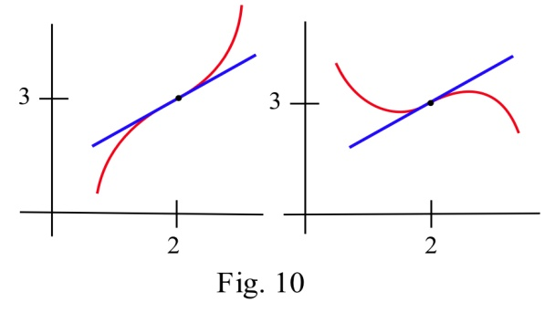

### 2.6 Exercises

In problems 1 and 2, each quotation is a statement about a quantity of something changing over time. Let f(t) represent the quantity at time t. For each quotation, tell what f represents and whether the first and second derivatives of f are positive or negative.

1. (a) "Unemployment rose again, but the rate of increase is smaller than last month."

(b) "Our profits declined again, but at a slower rate than last month."

(c) "The population is still rising and at a faster rate than last year."

2. (a) "The child's temperature is still rising, but slower than it was a few hours ago."

(b) "The number of whales is decreasing, but at a slower rate than last year."

(c) "The number of people with the flu is rising and at a faster rate than last month."

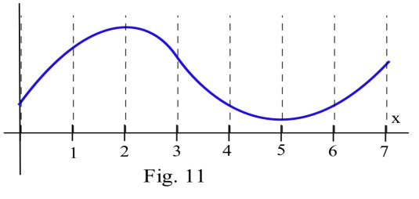

4. On which intervals is the function in the graph

(a) concave up? (b) concave down?

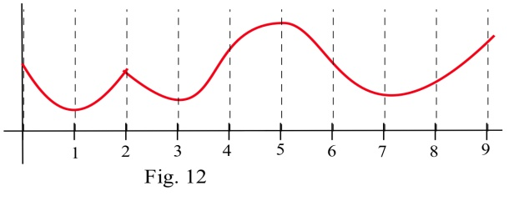

5. On which intervals is the function in graph

(a) concave up? (b) concave down?

6. Sketch the graphs of functions which are defined and concave up everywhere and which have

(a) no roots. (b) exactly 1 root. (c) exactly 2 roots. (d) exactly 3 roots.

In problems 7 – 10, a function and values of x so that f '(x) = 0 are given. Use the Second Derivative Test to determine whether each point (x, f(x)) is a local maximum, a local minimum or neither

7. f(x) = 2x3 – 15x2 + 6 , x = 0 , 5 .

8. g(x) = x3 – 3x2 – 9x + 7 , x = –1 , 3 .

9. h(x) = x4 – 8x2 – 2 , x = –2, 0, 2 .

10. f(x) = x.ln(x) , x = 1/e .

11. Which of the labeled points in the graph are inflection points?

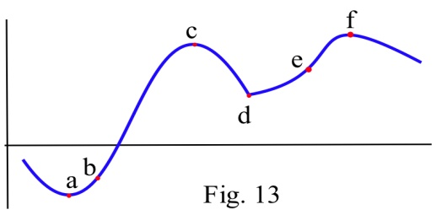

12. Which of the labeled points in the graph are inflection points?

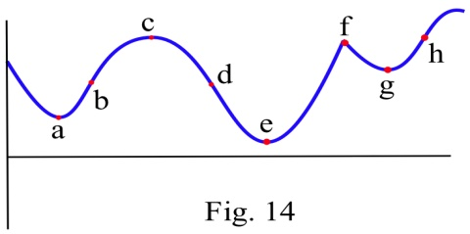

13. How many inflection points can a (a) quadratic polynomial have? (b) cubic polynomial have? (c) polynomial of degree n have?

14. Fill in the table with "+", "–", or "0" for the function shown.

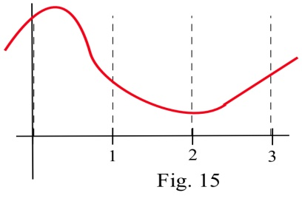

x f(x) f '(x) f ''(x)

0

1

2

3

15. Fill in the table with "+", "–", or "0" for the function shown.

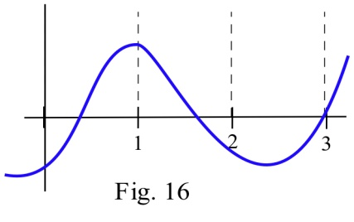

x g(x) g '(x) g ''(x)

0

1

2

3

In problems 16 – 22 , find the derivative and second derivative of each function.

16. f(x) = 7x2 + 5x – 3

17. f(x) = (2x – 8)5

18. f(x) = (6x – x2)10

19. f(x) = x .(3x + 7)5

20. f(x) = (2x3 + 3)6

21. f(x) =

22. f(x) = 

## Section 7: Optimization

In theory and applications, we often want to maximize or minimize some quantity. An engineer may want to maximize the speed of a new computer or minimize the heat produced by an appliance. A manufacturer may want to maximize profits and market share or minimize waste. A student may want to maximize a grade in calculus or minimize the hours of study needed to earn a particular grade.

Without calculus, we only know how to find the optimum points in a few specific examples (for example, we know how to find the vertex of a parabola). But what if we need to optimize an unfamiliar function?

The best way we have without calculus is to examine the graph of the function, perhaps using technology. But our view depends on the viewing window we choose – we might miss something important. In addition, we’ll probably only get an approximation this way. (In some cases, that will be good enough.)

Calculus provides ways of drastically narrowing the number of points we need to examine to find the exact locations of maximums and minimums, while at the same time ensuring that we haven’t missed anything important.

### Local Maxima and Minima

Before we examine how calculus can help us find maximums and minimums, we need to define the concepts we will develop and use.

**Definitions:** f has a **local** **maximum** at a if f(a) ≥ f(x) for all x near a

f has a **local** **minimum** at a if f(a) **≤** f(x) for all x near a

f has a **local extreme** at a if f(a) is a **local maximum or minimum.**

The plurals of these are maxima and minima. We often simply say “max” or “min;” it saves a lot of syllables.

Some books say “relative” instead of “local.”

The process of finding maxima or minima is called **optimization.**

A point is a local max (or min) if it is higher (lower) than all the **nearby points**. These points come from the shape of the graph.

**Definitions:** f has a **global maximum** at a if f(a) ≥ f(x) for all x in the domain of f.

f has a **global minimum** at a if f(a) **≤** f(x) for all x in the domain of f.

f has a **global extreme** at a if f(a) is a **global maximum or minimum.**

Some books say “absolute” instead of “global”

A point is a global max (or min) if it is higher (lower) than every point on the graph. These points come from the shape of the graph **and** the window through which we view the graph.

The local and global extremes of the function in Fig. 22 are labeled. You should notice that every global extreme is also a local extreme, but there are local extremes that are not global extremes.

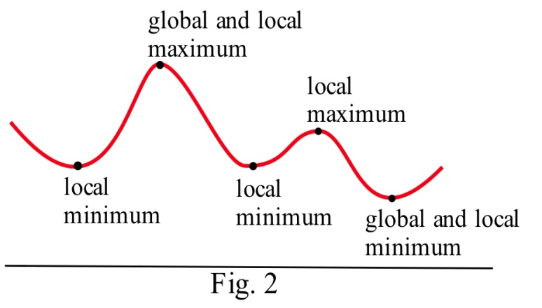

If h(x) is the height of the earth above sea level at the location x, then the global maximum of h is h(summit of Mt. Everest) = 29,028 feet. The local maximum of h for the United States is h(summit of Mt. McKinley) = 20,320 feet. The local minimum of h for the United States is h(Death Valley) = – 282 feet.

Example 1

The table shows the annual calculus enrollments at a large university. Which years had local maximum or minimum calculus enrollments? What were the global maximum and minimum enrollments in calculus?

|  |  |  |  |  |  |  |  |  |  |  |  |
| --- | --- | --- | --- | --- | --- | --- | --- | --- | --- | --- | --- |
| year | 2000 | 2001 | 2002 | 2003 | 2004 | 2005 | 2006 | 20070 | 2008 | 2009 | 2010 |
| enrollment | 1257 | 1324 | 1378 | 1336 | 1389 | 1450 | 1523 | 1582 | 1567 | 1545 | 1571 |

There were local maxima in 2002 and 2007; the global maximum was 1582 students in 2007. There were local minima in 2003 and 2009; the global minimum was 1336 students in 2003. I choose not to think of 2000 as a local minimum or 2010 as a local maximum. However, some books would include the endpoints.

### Finding Maxima and Minima of a Function

What must the tangent line look like at a local max or min? Look at these two graphs again – you’ll see that at all the extreme points, the tangent line is horizontal (so f’ = 0). There is one cusp in the blue graph – the tangent line if vertical there (so f’ is undefined).

That gives us the clue how to find extreme values.

 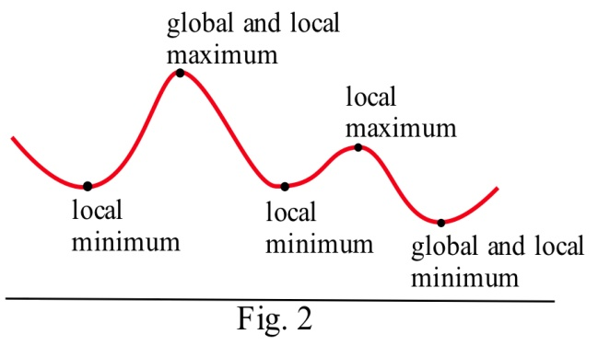

**Definition:** A **critical number** for a function f is a value x = a in the domain of f where either **f ’(a) = 0** or **f ‘(a) is undefined.**

**Definition:** A **critical point**  for a function f is a point (a, f(a)) where a is a critical number of f.

**Useful Fact: A local max or min of f can only occur at a critical point.**

Example 2

Find the critical points of f(x) = x3 – 6x2 + 9x + 2.

A critical number of f can occur only where f '(x) = 0 or where f’ does not exist.

f '(x) = 3x2 – 12x + 9 = 3(x2 – 4x + 3) = 3(x – 1)(x – 3)

f '(x) = 0 only at x = 1 and x = 3. There are no places where f’ is undefined.

The critical numbers are x = 1 and x= 3. So the critical points are (1, 6) and (3, 2).

These are the only possible locations of local extremes of f. We haven’t discussed yet how to tell whether either of these points is actually a local extreme of f, or which kind it might be. But we can be certain that no other point is a local extreme.

The graph of f (Fig. 23) shows that (1, f(1) ) = (1, 6) is a local maximum and (3, f(3) ) = (3, 2) is a local minimum. This function does not have a global maximum or minimum. 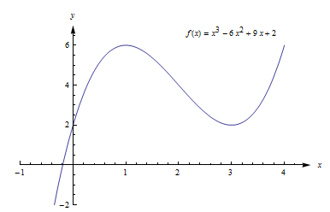

Example 3

Find all local extremes of f(x) = x3 .

f(x) = x3 is differentiable for all x, and f '(x) = 3x2. The only place where f '(x) = 0 is at x = 0, so the only candidate is the critical point (0,0).

If x > 0 then f(x) = x3 **>** 0 = f(0), so f(0) is not a local maximum.

Similarly, if x < 0 then f(x) = x3 **<** 0 = f(0) so f(0) is not a local minimum.

The critical point (0,0) is the only candidate to be a local extreme of f, and this candidate did not turn out to be a local extreme of f. The function f(x) = x3 does not have any local extremes.

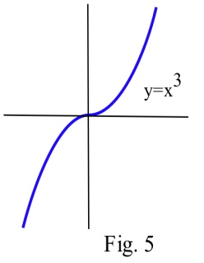

Remember this example! It is not enough to find the critical points -- we can only say that f **might have** a local extreme at the critical points.

### First and Second Derivative Tests

**Is that critical point a Maximum or Minimum (or Neither)?**

Once we have found the critical points of *f*, we still have the problem of determining whether these points are maxima, minima or neither.

All of the graphs in Fig. 25 have a critical point at (2, 3). It is clear from the graphs that the point (2,3) is a local maximum in (a) and (d), (2,3) is a local minimum in (b) and (e), and (2,3) is not a local extreme in (c) and (f).

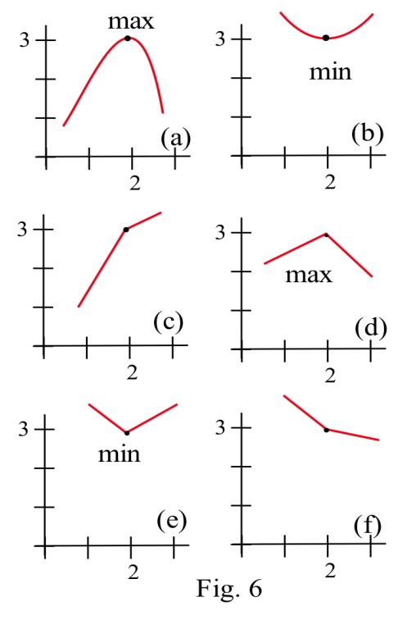

The critical numbers only give the **possible** locations of extremes, and some critical numbers are not the locations of extremes. The critical numbers are the **candidates** for the locations of maxima and minima.

**f ' and Extreme Values of f**

Four possible shapes of graphs are shown here – in each graph, the point marked by an arrow is a critical point, where f ‘(x) = 0. What happens to the derivative near the critical point?

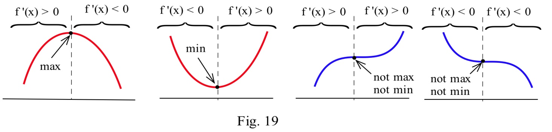

At a local max, such as in the graph on the left, the function increases on the left of the local max, then decreases on the right. The derivative is first positive, then negative at a local max. At a local min, the function decreases to the left and increases to the right, so the derivative is first negative, then positive. When there isn’t a local extreme, the function continues to increase (or decrease) right past the critical point – the derivative doesn’t change sign.

**The First Derivative Test for Extremes:**

Find the critical points of f.

For each critical number c, examine the sign of f’ to the left and to the right of c. What happens to the sign as you move from left to right?

**If f '(x) changes from positive to negative** at x = c, then f has a local **maximum** at (c, f(c)).

**If f '(x) changes from negative to positive** at x = c, then f has a local **minimum** at (c, f(c)).

**If f '(x) does not change sign** at x = c, then (c, f(c)) is **neither** a local max nor a local min.

Example 4

Find the critical points of f(x) = x3 – 6x2 + 9x + 2 and classify them as local max, local min, or neither..

We already found the critical points; they are (1, 6) and (3, 2).

Now we can use the first derivative test to classify each. Recall that f’(x) = f '(x) = 3x2 – 12x + 9 = 3(x2 – 4x + 3) = 3(x – 1)(x – 3). The factored form is easiest to work with here, so let’s use that.

(1, 6) – You could choose a number slightly less than 1 to plug into the formula for f’ – perhaps use x = 0, or x = 0.9. Then you could examine its sign. But I don’t care about the numerical value, all I’m interested in is its sign. And for that, you don’t have to do any plugging in:

If x is a little less than 1, then x – 1 is negative, and x – 3 is negative.

So f’ = 3(x – 1)(x – 3) will be pos(neg)(neg) = positive.

For x a little more than 1, you can evaluate f’ at a number more than 1 (but less than 3, you don’t want to go past the next critical point!) – perhaps x = 2. Or you can make a quick sign argument like what I did above.

For x a little more than 1, f’ = 3(x – 1)(x – 3) will be pos(pos)(neg) = negative.

f’ changes from positive to negative, so there is a local max at (1, 6)

As another approach, we could draw a number line, and mark the critical numbers.

1

3

We already know the derivative is zero or undefined at the critical numbers. On each interval between these values, the derivative will stay the same sign. To determine the sign, we could pick a test value in each interval, and evaluate the derivative at those points (or use the sign approach used above).

1

3

0

2

4

f'

+

–

+

(3, 2) – f’ changes from negative to positive, so there is a local min at (3, 2).

This confirms what we saw before in the graph.



**f '' and Extreme Values of f**

The concavity of a function can also help us determine whether a critical point is a maximum or minimum or neither. For example, if a point is at the bottom of a concave up function, then the point is a minimum.

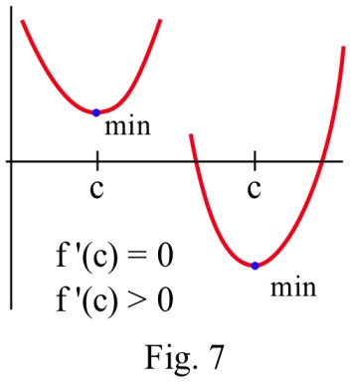

**The Second Derivative Test for Extremes:**

Find all critical points of f. For those critical points where f’(c) = 0, find f’’(c).

(a) If f ''(c) < 0 then f is concave down and has a local maximum at x = c.

(b) If f ''(c) > 0 then f is concave up and has a local minimum at x = c.

(c) If f ''(c) = 0 then f may have a local maximum, a minimum or neither at x = c.

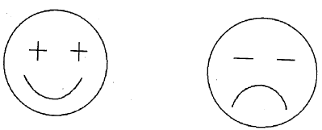

The cartoon faces can help you remember the Second Derivative Test.

Example 5

f(x) = 2x3 – 15x2 + 24x – 7 has critical numbers x = 1 and 4. Use the Second Derivative Test for Extremes to determine whether f(1) and f(4) are maximums or minimums or neither.

We need to find the second derivative:

****

Then we just need to evaluate f '' at each critical number:

x = 1: ; there is a local maximum at x = 1.

x = 4: ; there is a local minimum at x = 4.

Many students like the Second Derivative Test. The Second Derivative Test is often easier to use than the First Derivative Test. You only have to find the sign of one number for each critical number rather than two. And if your function is a polynomial, its second derivative will probably be a simpler function than the derivative.

However, if you needed a product rule, quotient rule, or chain rule to find the first derivative, finding the second derivative can be a lot of work. Also, even if the second derivative is easy, the Second Derivative Test doesn’t always give an answer. The First Derivative Test will always give you an answer.

Use whichever test you want to. But remember – you have to do some test to be sure that your critical point actually is a local max or min.

### Global Maxima and Minima

In applications, we often want to find the global extreme; knowing that a critical point is a local extreme is not enough.

For example, if we want to make the greatest profit, we want to make the absolutely greatest profit of all. How do we find global max and min?

There are just a few additional things to think about.

**Endpoint Extremes**

The local extremes of a function occur at critical points – these are points in the function that we can find by thinking about the shape (and using the derivative to help us). But if we’re looking at a function on a closed interval, the endpoints could be extremes. These endpoint extremes are not related to the shape of the function; they have to do with the interval, the window through which we’re viewing the function.

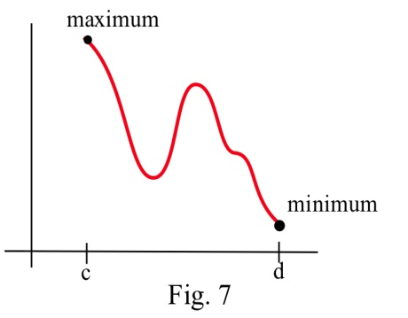

In the graph above, it appears that there are three critical points – one local min, one local max, and one that is neither one. But the global max, the highest point of all, is at the left endpoint. The global min, the lowest point of all, is at the right endpoint.

How do we decide if endpoints are global max or min? It’s easier than you expected – simply plug in the endpoints, along with all the critical numbers, and compare y-values.

Example 6

Find the global max and min of f(x) = x3 – 3x2 – 9x + 5 for –2 ≤ x ≤ 6 .

f '(x) = 3x2 – 6x – 9 = 3(x + 1)(x – 3). We need to find critical points, and we need to check the endpoints.

f'(x) = 3(x + 1)(x – 3) = 0 when x = **–1** and x = **3**.

The endpoints of the interval are x = **–2** and x = **6**.

Now we simply compare the values of f at these 4 values of x:

|  |  |
| --- | --- |
| x | f(x) |
| -2 | 3 |
| -1 | 10 |
| 3 | -22 |
| 6 | 59 |

The global minimum of f on [ –2, 6] is –22, when x = 3,

and the global maximum of f on [ –2, 6] is 59, when x = 6.

**If there’s only one critical point**

If the function has only one critical point and it’s a local max (or min), then it must be the global max (or min). To see this, think about the geometry. Look at the graph on the left – there is a local max, and the graph goes down on either side of the critical point. Suppose there was some other point that was higher – then the graph would have to turn around. But that turning point would have shown up as another critical point. If there’s only one critical point, then the graph can never turn back around.

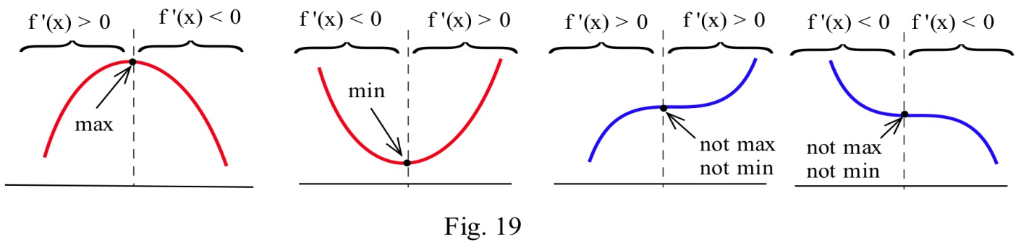

**When in doubt, graph it and look.**

If you are trying to find a global max or min on an open interval (or the whole real line), and there is more than one critical point, then you need to look at the graph to decide whether there is a global max or min. Be sure that all your critical points show in your graph, and that you go a little beyond – that will tell you what you want to know.

Example 7

Find the global max and min of f(x) = x3 – 6x2 + 9x + 2.

We have previously found that (1, 6) is a local max and (3, 2) is a local min. This is not a closed interval, and there are two critical points, so we must turn to the graph of the function to find global max and min.

The graph of f shows that points to the left of x = 4 have y-values greater than 6, so (1, 6) is not a global max. Likewise, if x is negative, y is less than 2, so (3, 2) is not a global min. There are no endpoints, so we’ve exhausted all the possibilities. This function does not have a global maximum or minimum.



**To find Global Extremes:**

The only places where a function can have a global extreme are critical points or endpoints.

(a)If the function has only one critical point, and it’s a local extreme, then it is also the global extreme.

(b) If there are endpoints, find the global extremes by comparing y-values at all the critical points and at the endpoints.

(c) When in doubt, graph the function to be sure.

### 2.7 Exercises

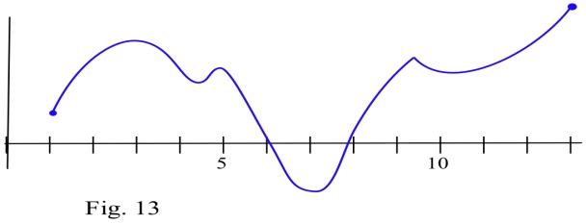

1. Find all of the critical points of the function shown and identify them as local max, local min, or neither. Find the global max and min on the interval.

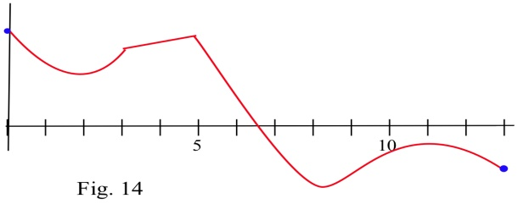

2. Find all of the critical points of the function shown and identify them as local max, local min, or neither. Find the global max and min on the interval.

In problems 3 – 8, find all of the critical points and local maximums and minimums of each function.

3. f(x) = x2 + 8x + 7 4. f(x) = 2x2 – 12x + 7

5. f(x) = x3 – 6x2 + 5 6. f(x) = (x – 1)2 (x – 3)

7. f(x) = ln( x2 – 6x + 11 ) 8**.** f(x) = 2x3 – 96x + 42

In problems 9 – 16 , find all critical points and global extremes of each function on the given intervals.

9. f(x) = x2 – 6x + 5 on the entire real number line.

10. f(x) = 2 – x3 on the entire real number line.

11. f(x) = x3 – 3x + 5 on the entire real number line.

12. on the entire real number line.

13. f(x) = x2 – 6x + 5 on [ –2, 5] .

14. f(x) = 2 – x3 on [ –2, 1] .

15. f(x) = x3 – 3x + 5 on [ –2, 1] .

16.  on [ 1, 2] .

17.Suppose f(1) = 5 and f '(1) = 0. What can we conclude about the point (1,5) if

(a) f '(x) < 0 for x < 1, and f '(x) > 0 for x > 1?

(b) f '(x) < 0 for x < 1, and f '(x) < 0 for x > 1?

(c) f '(x) > 0 for x < 1, and f '(x) < 0 for x > 1?

(d) f '(x) > 0 for x < 1, and f '(x) > 0 for x > 1?

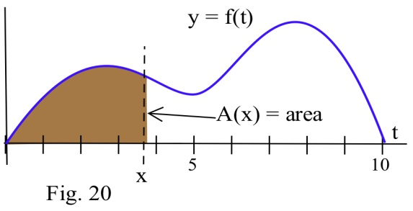

18. Define A(x) to be the **area** bounded between the x–axis, the graph of f, and a vertical line at x.

(a) At what value of x is A(x) minimum?

(b) At what value of x is A(x) maximum?

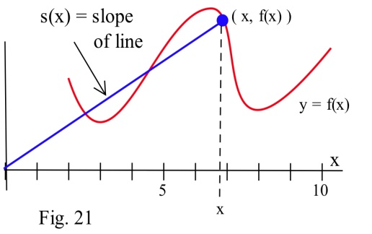19. Define S(x) to be the **slope** of the line through the points (0,0) and ( x, f(x) ) based on the graph of f shown.

(a) At what value of x is S(x) minimum?

(b) At what value of x is S(x) maximum?

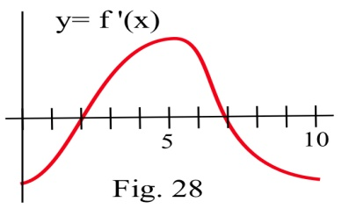20. The graph of the **derivative** of a continuous function f.

(a) List the critical numbers of f.

(b) For what values of x does f have a local maximum?

(c) For what values of x does f have a local minimum?

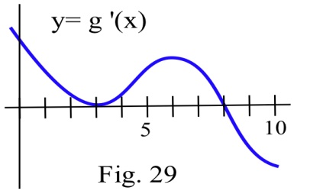21. The graph of the **derivative** of a continuous function g.

(a) List the critical numbers of g.

(b) For what values of x does g have a local maximum?

(c) For what values of x does g have a local minimum?

In problems 22 – 24, a function and values of x so that f '(x) = 0

are given. Use the Second Derivative Test to determine whether each point (x, f(x)) is a local maximum, a local minimum or neither

22. f(x) = 2x3 – 15x2 + 6 , x = 0 , 5 .

23. g(x) = x3 – 3x2 – 9x + 7 , x = –1 , 3 .

24. h(x) = x4 – 8x2 – 2 , x = –2, 0, 2 .

## Section 8: Curve Sketching

This section examines some of the interplay between the shape of the graph of f and the behavior of f '. If we have a graph of f , we will see what we can conclude about the values of f '. If we know values of f ', we will see what we can conclude about the graph of f. We will also utilize the information from f '' that we learning in the last section

### First Derivative Information

**Definitions:** The function f is **increasing on (a,b)** if a < x1 < x2 < b implies f( x1 ) **<** f( x2 ).

The function f is **decreasing on (a,b)** if a < x1 < x2 < b implies f( x1 ) **>** f( x2 ).

Graphically, f is **increasing**  (decreasing) if, as we move from left to right along the graph of f, the height of the graph **increases** (decreases).

These same ideas make sense if we consider h(t) to be the height (in feet) of a rocket at time t seconds. We naturally say that the rocket is rising or that its height is increasing if the height h(t) increases over a period of time, as t increases.

Example 1

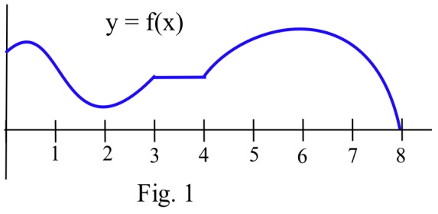List the intervals on which the function shown increasing or decreasing.

f is increasing on the intervals [0,1] , [ 2,3] and [4,6]. f is decreasing on [1,2] and [6,8].

On the interval [3,4] the function is not increasing or decreasing, it is constant.

**First Derivative Information about Shape**

For a function f which is differentiable on an interval (a,b);

(i) if f is increasing on (a,b) , then f '(x) ≥ 0 for all x in (a,b)

(ii) if f is decreasing on (a,b) , then f '(x) ≤ 0 for all x in (a,b)

(iii) if f is constant on (a,b) , then f '(x) = 0 for all x in (a,b).

Example 2

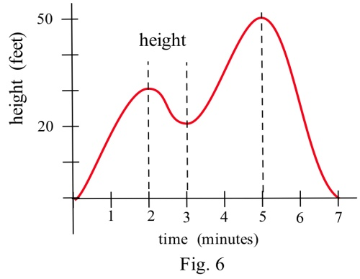The graph shows the height of a helicopter during a period of time. Sketch the graph of the upward velocity of the helicopter, dh/dt.

Notice that the h(t) has a local maximum when t = 2 and t = 5, and so v(2) = 0 and v(5) = 0. Similarly, h(t) has a local minimum when t = 3, so v(3) = 0.

When h is increasing, v is positive. When h is decreasing, v is negative.

Using this information, we can sketch a graph of v(t) = dh/dt.

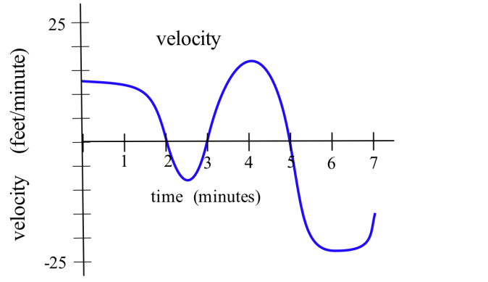

The next theorem is almost the converse of the First Shape Theorem and explains the relationship between the values of the derivative and the graph of a function from a different perspective. It says that if we know something about the values of f ' , then we can draw some conclusions about the shape of the graph of f .

**First Derivative Information about Shape (part 2)**

For a function f which is differentiable on an interval I;

(i) if f '(x) > 0 for all x in the interval I , then f is increasing on I,

(ii) if f '(x) < 0 for all x in the interval I , then f is decreasing on I,

(iii) if f '(x) = 0 for all x in the interval I , then f is constant on I.

Example 3

Use information about the values of f ' to help graph f(x) = x3 – 6x2 + 9x + 1 .

f '(x) = 3x2 – 12x + 9 = 3(x – 1)(x – 3) so f '(x) = 0 only when x = 1 or x = 3.

f ' is a polynomial so it is always defined.

The only critical numbers for f are x = 1 and x = 3, and they divide the real number line into three intervals: (–∞ , 1) , (1,3) and (3, ∞). On each of these intervals, the function is either always increasing or always decreasing.

If x < 1, then f '(x) = 3(negative number)(negative number) > 0 so f is increasing.

If 1 < x < 3, then f '(x) = 3(positive number)(negative number) < 0 so f is decreasing.

If 3 < x, then f '(x) = 3(positive number)(positive number) > 0 so f is increasing.

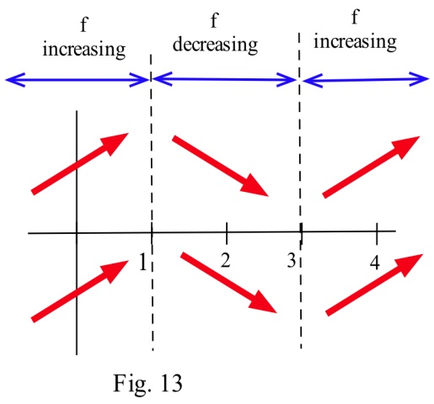

Even though we don't know the value of f anywhere yet, we do know a lot about the shape of the graph of f : as we move from left to right along the x–axis, the graph of f increases until x = 1, then the graph decreases until x = 3, and then the graph increases again. The graph of f makes "turns" when x = 1 and x = 3; it has a local maximum at x = 1, and a local minimum at x = 3.

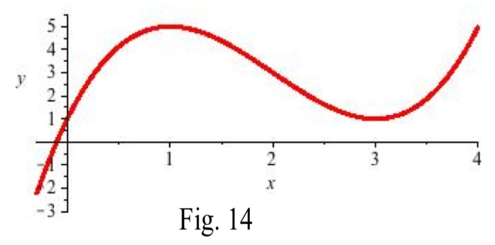To plot the graph of f, we still need to evaluate f at a few values of x, but only at a very few values. f(1) = 5 , and (1,5) is a local maximum of f. f(3) = 1 , and (3,1) is a local minimum of f. The resulting graph of f is shown here.

### Second Derivative Information

Until now, we've only used first derivative information, but we could also use information from the second derivative to provide more information about the shape of the function.

**Second Derivative Information about Shape**

(i) if f is concave up on (a,b) , then f ''(x) ≥ 0 for all x in (a,b)

(ii) if f is concave down on (a,b) , then f ''(x) ≤ 0 for all x in (a,b)

The converse of both of these are also true:

(i) if f ''(x) ≥ 0 for all x in (a,b), then f is concave up on (a,b)

(ii) if f ''(x) ≤ 0 for all x in (a,b), then f is concave down on (a,b)

Example 4

Use information about the values of f '' to help determine the intervals on which the function f(x) = x3 – 6x2 + 9x + 1 is concave up and concave down.

For concavity, we need the second derivative: , so .

To find possible inflection points, set the second derivative equal to zero.

, so *x* = 2. This divides the real number line into two intervals:  and 

For *x* < 2, the second derivative is negative (for example, ), so *f* is concave down. For *x* > 2, the second derivative is positive , so *f* is concave up.

We could have incorporated this concavity information when sketching the graph for the previous example, and indeed we can see the concavity reflected in the graph shown.

Example 5

Use information about the values of f ' and f '' to help graph .

. This is undefined at *x* = 0.

. This is also undefined at *x* = 0.

This creates two intervals: *x* < 0, and *x* > 0.

On the interval *x* < 0, we could test out a value like *x* = -1.  and .

is negative and  is negative, so we can conclude that the function is decreasing and concave down on this interval.

On the interval *x* > 0, we could test out a value like *x* = 1.  and .

is positive and  is negative, so we can conclude that the function is increasing and concave down on this interval.

We can also calculate that , giving us a base point for the graph. Using this information, we can conclude the graph must look like this:

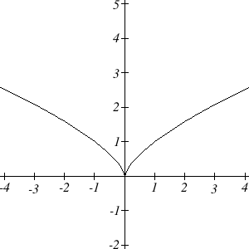

### Sketching without an Equation

Of course, graphing calculators and computers are great at graphing functions. Calculus provides a way to illuminate what may be hidden or out of view when we graph using technology. More importantly, calculus gives us a way to look at the derivatives of functions for which there is no equation given. We already saw the idea of this back in Section 3 where we sketched the derivative of two graphs by estimating slopes on the curves.

We can summarize all the derivative information about shape in a table.

**Summary of Derivative Information about the Graph**

|  |  |  |  |  |
| --- | --- | --- | --- | --- |
| f(x) | increasing | Decreasing | Concave up | Concave down |
| f '(x) | + | - | Increasing | decreasing |
| f ''(x) |  |  | + | - |

When f'(x) = 0, the graph of *f* may have a local max or min.

When f''(x) = 0, the graph of *f* may have an inflection point.

Example 6

A company's bank balance, *B*, in millions of dollars, *t* weeks after releasing a new product is shown in the graph below. Sketch a graph of the marginal balance - the rate at which the bank balance was changing over time.

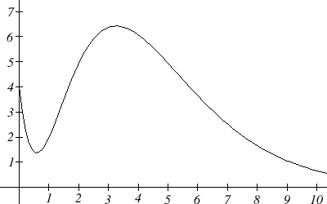

Notice that since the tangent line will be horizontal at about *t* = 0.6 and *t* = 3.2, the derivative will be 0 at those points.

We can then identifying intervals on which the original function is increasing or decreasing. This will tell us when the derivative function is positive or negative.

|  |  |  |
| --- | --- | --- |
| Interval | B(t) | B'(t) |
| 0<t<0.6 | Decreasing | Negative |
| 0.6<t<3.2 | Increasing | Positive |
| t>3.2 | Decreasing | Negative |

There appear to be inflection points at about *t* =1.5 and *t* = 5.5. At these points, the derivative will be changing from increasing to decreasing or vice versa, so the derivative will have a local max or min at those points.

Looking at the intervals of concavity:

|  |  |  |
| --- | --- | --- |
| Interval | B(t) | B'(t) |
| 0<t<1.5 | Concave up | Increasing |
| 1.5<t<5.5 | Concave down | Decreasing |
| t>5.5 | Concave up | Increasing |

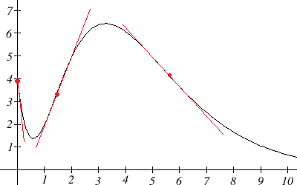

If we wanted a more accurate sketch of the derivative function, we could also estimate the derivative at a few points:

|  |  |
| --- | --- |
| *t* | B'(t) |
| 0 | -10 |
| 1.5 | 3 |
| t>5.5 | -1 |

Now we can sketch the derivative. We know a few values for the derivative function, and on each interval we know the shape we need. We can use this to create a rough idea of what the graph should look like.

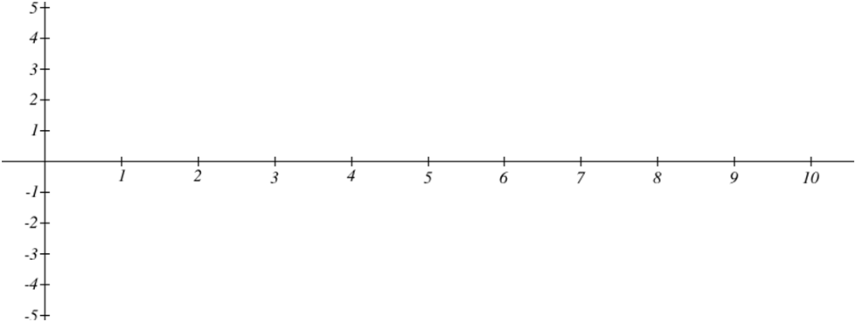

Neg,

Inc

Pos,

Inc

Pos,

Dec

Neg,

Dec

Neg,

Inc

Smoothing this out gives us a good estimate for the graph of the derivative.

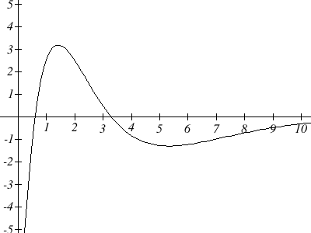

### 2.8 Exercises

1. Sketch the graph of a continuous function f so that

(a) f(1) = 3, f '(1) = 0 , and the point (1,3) is a local maximum of f .

(b) f(2) = 1, f '(2) = 0 , and the point (2,1) is a local minimum of f .

(c) f(5) = 4, f '(5) = 0, and the point (5,4) is not a local minimum or maximum of f .

In problems 2–4, sketch the graph of the derivative of each function.

2. 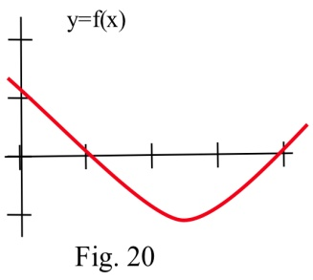 3. 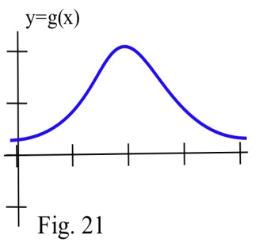 4. 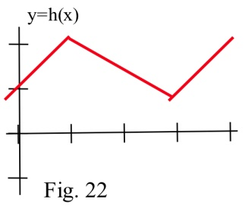

In problems 5–7, the graph of the height of a helicopter is shown. Sketch the graph of the upward velocity of the helicopter.

6. 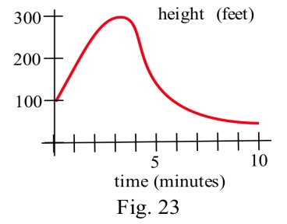 6. 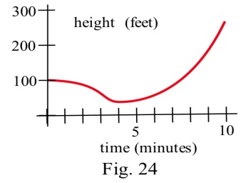 7. 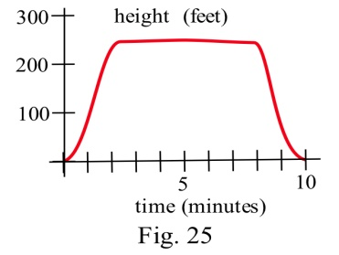

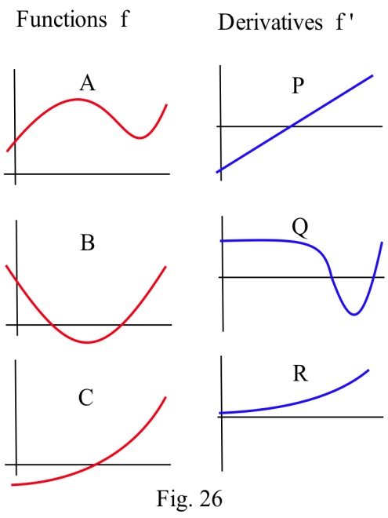

8. In the graphs to the right, match the graphs of the functions with those of their derivatives

9. In the graphs below, match the graphs showing

the heights of rockets with those

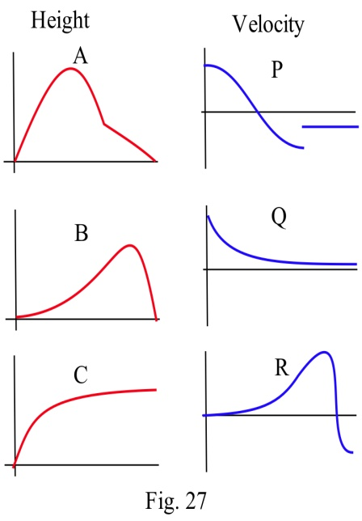 showing their velocities.

In problems 10 – 14 , use information from the derivatives of each function to help you graph the function. Find all local maximums and minimums of each function.

10. f(x) = x3 – 3x2 – 9x – 5 11. g(x) = 2x3 – 15x2 + 6 12. h(x) = x4 – 8x2 + 3

13. r(t) = 14. f(x) =

## Section 9: Applied Optimization

We have used derivatives to help find the maximums and minimums of some functions given by equations, but it is very unlikely that someone will simply hand you a function and ask you to find its extreme values. More typically, someone will describe a problem and ask your help in maximizing or minimizing something: "What is the largest volume package which the post office will take?"; "What is the quickest way to get from here to there?"; or "What is the least expensive way to accomplish some task?" In this section, we’ll discuss how to find these extreme values using calculus.

### Max/Min Applications

**Example:** The manager of a garden store wants to build a 600 square foot rectangular enclosure on the store’s parking lot in order to display some equipment. Three sides of the enclosure will be built of redwood fencing, at a cost of $7 per running foot. The fourth side will be built of cement blocks, at a cost of $14 per running foot. Find the dimensions of the least costly such enclosure.

The process of finding maxima or minima is called optimization. The function we’re optimizing is called the *objective function.* The objective function can be recognized by its proximity to “est” words (greatest, least, highest, farthest, most, …) Look at the garden store example; the cost function is the objective function.

In many cases, there are two (or more) variables in the problem. In the garden store example again, the length and width of the enclosure are both unknown. If there is an equation that relates the variables we can solve for one of them in terms of the others, and write the objective function as a function of just one variable. Equations that relate the variables in this way are called *constraint equations.* The constraint equations are always equations, so they will have equals signs. For the garden store, the fixed area relates the length and width of the enclosure. This will give us our constraint equation.

**Max-Min Story Problem Technique:**

**(a)** Translate the English statement of the problem line by line into a picture (if that applies) and into math. This is often the hardest step!

**(b)** Identify the objective function. Look for words indicating a largest or smallest value.

**(b1)** If you seem to have two or more variables, find the constraint equation. Think about the English meaning of the word “constraint,” and remember that the constraint equation will have an equals sign.

**(b2)** Solve the constraint equation for one variable and substitute into the objective function. Now you have an equation of one variable.

**(c)** Use calculus to find the optimum values. (Take derivative, find critical points, test. Don’t forget to check the endpoints!)

**(d)** Look back at the question to make sure you answered what was asked. Translate your number answer back into English.

Example 1

The manager of a garden store wants to build a 600 square foot rectangular enclosure on the store’s parking lot in order to display some equipment. Three sides of the enclosure will be built of redwood fencing, at a cost of $7 per running foot. The fourth side will be built of cement blocks, at a cost of $14 per running foot. Find the dimensions of the least costly such enclosure.

First, translate line by line into math and a picture:

|  |  |
| --- | --- |
| ***Text*** | ***Translation*** |
| The manager of a garden store wants to build a *600 square foot rectangular* enclosure on the store’s parking lot in order to display some equipment.  *Three sides of the enclosure* will be built  of redwood fencing, at a *cost of $7 per running foot*. *The fourth side* will be built of cement blocks, at a *cost of $14 per running foot.*  Find the dimensions of the least costly such enclosure. | Let *x* and *y* be the dimensions of the enclosure, with *y* being the length of the side made of blocks. Then:  *Area = A = xy = 600*  *2x + y costs $7 per foot*  *y costs $14 per foot*  So  *Cost = C = 7(2x + y) + 14y = 14x + 21y*  Find *x* and *y* so that *C* is minimized. |

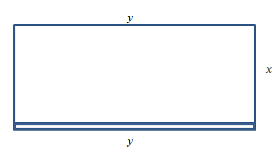

The objective function is the cost function, and we want to minimize it. As it stands, though, it has two variables, so we need to use the constraint equation. The constraint equation is the fixed area *A = xy = 600.* Solve *A* for *x* to get , and then substitute into *C*:



Now we have a function of just one variable, so we can find the minimum using calculus. 

*C’* is undefined for *y* = 0, and *C’* = 0 when *y* = 20 or *y* = −20.

Of these three critical numbers, only *y* = 20 makes sense (is in the domain of the actual function) – remember that *y* is a length, so it can’t be negative, and *y* = 0 would mean there was no enclosure at all, so it couldn’t have an area of 600 square feet.

Test *y* = 20: (I chose the second derivative test)

, so this is a local minimum.

Since this is the only critical point in the domain, this must be the global minimum. Going back to our constraint function, we can find that when *y* = 20, *x* = 30. The dimensions of the enclosure that minimize the cost are 20 feet by 30 feet.

When trying to maximize their revenue, businesses also face the constraint of consumer demand. While a business would love to see lots of products at a very high price, typically demand decreases as the price of goods increases. In simple cases, we can construct that demand curve to allow us to maximize revenue.

Example 2

A concert promoter has found that if she sells tickets for $50 each, she can sell 1200 tickets, but for each $5 she raises the price, 50 less people attend. What price should she sell the tickets at to maximize her revenue?

We are trying to maximize revenue, and we know that , where *p* is the price per ticket, and *q* is the quantity of tickets sold.

The problem provides information about the demand relationship between price and quantity - as price increases, demand decreases. We need to find a formula for this relationship. To investigate, let's calculate what will happen to attendance if we raise the price:

|  |  |  |  |  |
| --- | --- | --- | --- | --- |
| Price, *p* | 50 | 55 | 60 | 65 |
| Quantity, *q* | 1200 | 1150 | 1100 | 1050 |

You might recognize this as a linear relationship. We can find the slope for the relationship by using two points: . You may notice that the second step in that calculation corresponds directly to the statement of the problem: the attendance drops 50 people for every $5 the price increases.

Using the point-slope form of the line, we can write the equation relating price and quantity:



Simplifying to slope-intercept form gives the demand equation 

Substituting this into our revenue equation, we get an equation for revenue involving only one variable:



Now, we can find the maximum of this function by finding critical numbers.

, so  when *p* = 85.

Using the second derivative test, , so the critical number is a local maximum. Since it's the only critical number, we can also conclude it's the global maximum.

The promoter will be able to maximize revenue by charging $85 per ticket. At this price, she will sell  tickets, generating $72,250 in revenue.

### “Marginal Revenue = Marginal Cost”

You may have heard before that “profit is maximized when marginal cost and marginal revenue are equal.” Now you can see why people say that! (Even though it’s not completely true.)

General Example 3

Suppose we want to maximize profit.

Now we know what to do – find the profit function, find its critical points, test them, etc.

But remember that Profit = Revenue – Cost. So Profit’ = Revenue’ – Cost’.

That is, the derivative of the profit function is MR – MC.

Now let’s find the critical points – those will be where Profit’ = 0 or is undefined.

Profit’ = 0 when MR – MC = 0, or where MR = MC.

That’s where the saying comes from! Here’s a more accurate way to express this:

**Profit has critical points when Marginal Revenue and Marginal Cost are equal.**

In all the cases we’ll see in this class, Profit will be very well behaved, and we won’t have to worry about looking for critical points where Profit’ is undefined. But remember that not all critical points are local max! The places where MR = MC could represent local max, local min, or neither one.

Example 4

A company sells *q* ribbon winders per year at $*p* per ribbon winder. The demand function for ribbon winders is given by: . The ribbon winders cost $30 apiece to manufacture, plus there are fixed costs of $9000 per year. Find the quantity where profit is maximized.

We want to maximize profit, but there isn’t a formula for profit given. So let’s make one. We can find a function for Revenue = *pq* using the demand function for *p*.



We can also find a function for Cost, using the variable cost of $30 per ribbon winder, plus the fixed cost:



Putting them together, we get a function for Profit:

.

Now we have two choices. We can find the critical points of Profit by taking the derivative of *P*(*q*) directly, or we can find MR and MC and set them equal. (Naturally, you’ll get the same answer either way.)

I’ll use MR = MC this time.



The only critical point is at *q* = 6750. Now we need to be sure this is a local max and not a local min. In this case, I’ll look to the graph of *P*(*q*) – it’s a downward opening parabola, so this must be a local max. And since it’s the only critical point, it must also be the global max.

Profit is maximized when they sell 6750 ribbon winders.

### “Average Cost = Marginal Cost”

“Average cost is minimized when average cost = marginal cost” is another saying that isn’t quite true; in this case, the correct statement is:

**Average Cost has critical points when Average Cost and Marginal Cost are equal.**

Let’s look at a geometric argument here:

Remember that the average cost is the slope of the diagonal line, the line from the origin to the point on the total cost curve. If you move your clear plastic ruler around, you’ll see (and feel) that the slope of the diagonal line is smallest when the diagonal line just touches the cost curve – when the diagonal line is actually a tangent line – when the average cost is equal to the marginal cost.

Example 5

The cost in dollars to produce *q* gift baskets is given by  Find the quantity where the average cost is minimum.

. We could find the critical points by finding , or by setting average cost to marginal cost; I’ll do the latter this time.

. So I want to solve:



The critical point of average cost is when *q* = 40.

Notice that we still have to confirm that the critical point is a minimum. For this, we can use the first or second derivative test on .

**

The second derivative is positive for all positive *q*, so that means this is a local min. Average cost is minimized when they produce 40 gift baskets; at that quantity, the average cost is $10 per basket.

### 2.9 Exercises

1. (a) You have 200 feet of fencing available to construct a rectangular pen with a fence divider down the middle (see below). What dimensions of the pen enclose the largest total area?

(b) If you need 2 dividers, what dimensions of the pen enclose the largest area?

(c) What are the dimensions in parts (a) and (b) if one edge of the pen borders on a river and does not require any fencing?

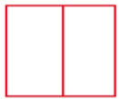

2. You have 120 feet of fencing to construct a pen with 4 equal sized stalls. If the pen is rectangular and shaped like the one below, what are the dimensions of the pen of largest area and what is that area?

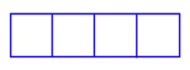

3. Suppose you decide to fence the rectangular garden in the corner of your yard. Then two sides of the garden are bounded by the yard fence which is already there, so you only need to use the 80 feet of fencing to enclose the other two sides. What are the dimensions of the new garden of largest area? What are the dimensions of the rectangular garden of largest area in the corner of the yard if you have F feet of new fencing available?

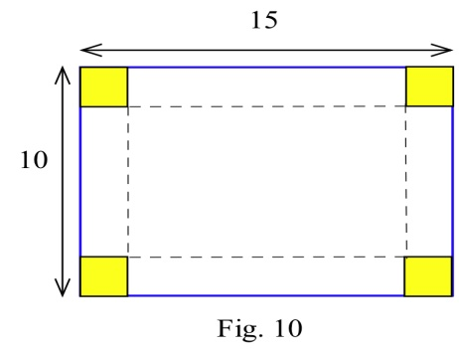

4. (a) You have a 10 inch by 15 inch piece of tin which you plan to form into a box (without a top) by cutting a square from each corner and folding up the sides. How much should you cut from each corner so the resulting box has the greatest volume?

(b) If the piece of tin is A inches by B inches, how much should you cut from each corner so the resulting box has the greatest volume?

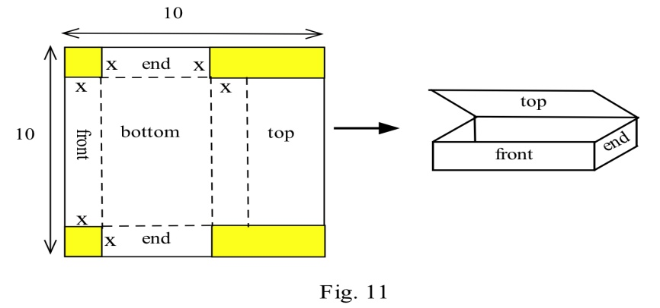

5. You have a 10 inch by 10 inch piece of cardboard which you plan to cut and fold as shown to form a box with a top. Find the dimensions of the box which has the largest volume.

6. (a) You have been asked to bid on the construction of a square-bottomed box with no top which will hold 100 cubic inches of water. If the bottom and sides are made from the same material, what are the dimensions of the box which uses the least material? (Assume that no material is wasted.)

(b) Suppose the box in part (a) uses different materials for the bottom and the sides. If the bottom material costs 5¢ per square inch and the side material costs 3¢ per square inch, what are the dimensions of the least expensive box which will hold 100 cubic inches of water?

7. (a) Determine the dimensions of the least expensive cylindrical can which will hold 100 cubic inches if the materials cost 2¢, 5¢ and 3¢ respectively for the top, bottom and sides.

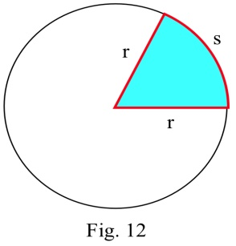 (b) How do the dimensions of the least expensive can change if the bottom material costs more than 5¢ per square inch?

8. You have 100 feet of fencing to build a pen in the shape of a circular sector, the "pie slice" shown. The area of such a sector is rs/2. What value of r maximizes the enclosed area?

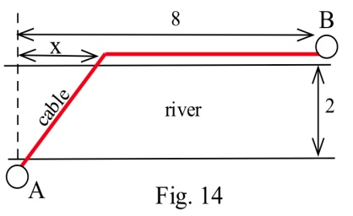9. (a) You have been asked to determine the least expensive route for a telephone cable which connects Andersonville with Beantown. If it costs $5000 per mile to lay the cable on land and $8000 per mile to lay the cable across the river and the cost of the cable is negligible, find the least expensive route.

(b) What is the least expensive route if the cable costs $7000 per mile plus the cost to lay it.

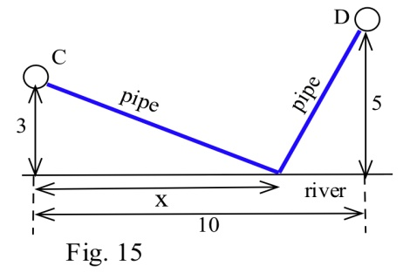10. You have been asked to determine where a water works should be built along a river between Chesterville and Denton to minimize the total cost of the pipe to the towns.

(a) Assume that the same size (and cost) pipe is used to each town. (This part can be done quickly without using calculus.)

(b) Assume that the pipe to Chesterville costs $3000 per mile and to Denton it costs $7000 per mile.

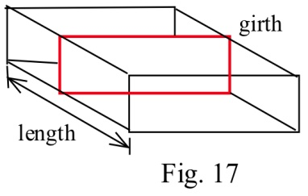13. U.S. postal regulations state that the sum of the length and girth (distance around) of a package must be no more than 108 inches.

(a) Find the dimensions of the acceptable box with a square end

which has the largest volume.

(b) Find the dimensions of the acceptable box which has the largest volume if its end is a rectangle twice as long as it is width.

(c) Find the dimensions of the acceptable box with a circular end which has the largest volume.

14. D. Simonton claims that the "productivity levels" of people in different fields can be described as a function of their "career age" t by p(t) = e–at – e –bt where a and b are constants which depend on the field of work, and career age is approximately 20 less than the actual age of the individual.

(a) Based on this model, at what ages do mathematicians (a=.03, b=.05), geologists (a=.02, b=.04), and historians (a=.02, b=.03) reach their maximum productivity?

(b) Simonton says "With a little calculus we can show that the curve ( p(t) ) maximizes at t =   ln( )." Use calculus to show that Simonton is correct.

Note: Models of this type have uses for describing the behavior of groups, but it is dangerous and usually invalid to apply group descriptions or comparisons to **individuals** in the group.

(Scientific Genius, by Dean Simonton, Cambridge University Press, 1988, pp. 69 – 73)

15. You own a small airplane which holds a maximum of 20 passengers. It costs you $100 per flight from St. Thomas to St. Croix for gas and wages plus an additional $6 per passenger for the extra gas required by the extra weight. The charge per passenger is $30 each if 10 people charter your plane (10 is the minimum number you will fly), and this charge is reduced by $1 per passenger for each passenger over 10 who goes (that is, if 11 go they each pay $29, if 12 go they each pay $28, etc.). What number of passengers on a flight will maximize your profits?

16. In the planning of a coffee shop, we estimate that if there is seating for between 40 and 80 people, the daily profit will be $50 per seat. However, if the seating capacity is more than 80 places, the daily profit per seat will be decreased by $1 for each additional seat over 80. What should the seating capacity be in order to maximize the coffee shop’s total profit?

17. In the planning of a taco restaurant, we estimate that if there is seating for between 10 and 40 people, the daily profit will be $10 per seat. However, if the seating capacity is more than 40 places, the daily profit per seat will be decreased by $0.20 per seat. What should the seating capacity be in order to maximize the taco restaurant’s total profit?

18. The total cost in dollars for Alicia to make *q* oven mitts is given by .

(a) What is the fixed cost?

(b) Find a function that gives the marginal cost.

(c) Find a function that gives the average cost.

(d) Find the quantity that minimizes the average cost.

(e) Confirm that the average cost and marginal cost are equal at your answer to part (d).

19. Shaki makes and sells backpack danglies. The total cost in dollars for Shaki to make *q* danglies is given by . Find the quantity that minimizes Shaki’s average cost for making danglies.

## Section 10: Other Applications

### Tangent Line Approximation

Back when we first thought about the derivative, we used the slope of secant lines over tiny intervals to approximate the derivative:



Now that we have other ways to find derivatives, we can exploit this approximation to go the other way. Solve the expression above for *f*(*x*), and you’ll get the tangent line approximation:

**The Tangent Line Approximation (TLA)**

To approximate the value of *f*(*x*) using TLA, find some *a* where

1. *a* and *x* are “close,” and

2. You know the exact values of both *f* (*a*) and *f* ‘(*a*).

Then 

Another way to look at the same formula:



How close is close? It depends on the shape of the graph of *f*. In general, the closer the better.

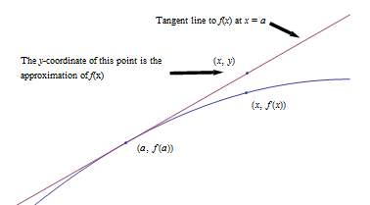

Example 1

Suppose we know that *g*(20) = 5 and *g*’(20) = 1.4. Use this information to approximate *g*(23) and *g*(18).

Using the tangent line approximation:

*g*(23) ≈ 5 + (1.4)(23 – 20) = 9.2

*g*(18) ≈ 5 + (1.4)(18 – 20) = 2.2

Note that we don’t know if these approximations are close – but they’re the best we can do with the limited information we have to start with. Note also that 18 and 23 are sort of close to 20, so we can hope these approximations are pretty good. We’d feel more confident using this information to approximate *g*(20.003). We’d feel very unsure using this information to approximate *g*(55).

### Elasticity

We know that demand functions are decreasing, so when the price increases, the quantity demanded goes down. But what about revenue = price × quantity? When the price increases will revenue go down because the demand dropped so much? Or will revenue increase because demand didn’t drop very much?

Elasticity of demand is a measure of how demand reacts to price changes. It’s normalized – that means the particular prices and quantities don’t matter, and everything is treated as a percent change. The formula for elasticity of demand involves a derivative, which is why we’re discussing it here.

**Elasticity of Demand**

Given a demand function that gives q in terms of p,

**The elasticity of demand is **

(Note that since demand is a decreasing function of p, the derivative is negative. That’s why we have the absolute values – so E will always be positive.)

If **E < 1,** we say demand is **inelastic.** In this case, raising prices increases revenue.

If **E > 1**, we say demand is **elastic.** In this case, raising prices decreases revenue.

If **E = 1**, we say demand is **unitary**. E = 1 at critical points of the revenue function.

**Interpretation of elasticity:**

If the price increases by 1%, the demand will decrease by **E**%.

Example 2

A company sells *q* ribbon winders per year at $*p* per ribbon winder. The demand function for ribbon winders is given by. Find the elasticity of demand when the price is $70 apiece. Will an increase in price lead to an increase in revenue?

First, we need to solve the demand equation so it gives *q* in terms of *p*, so that we can find :

. Then .

We need to find *q* when *p* = 70: *q* = 11500.

Now compute .

E < 1, so demand is inelastic. Increasing the price by 1% would only cause a 0.3% drop in demand. Increasing the price would lead to an increase in revenue, so it seems that the company should increase its price.

The demand for products that people have to buy, such as onions, tends to be inelastic. Even if the price goes up, people still have to buy about the same amount of onions, and revenue will not go down. The demand for products that people can do without, or put off buying, such as cars, tends to be elastic. If the price goes up, people will just not buy cars right now, and revenue will drop.

Example 3

A company finds the demand *q*, in thousands, for their kites to be  at a price of *p* dollars. Find the elasticity of demand when the price is $5 and when the price is $15. Then find the price that will maximize revenue.

Calculating the derivative, . The elasticity equation as a function of *p* will be:

****

Evaluating this to find the elasticity at $5 and at $15:

****. The demand is inelastic when the price is $5.

At a price of $5, a 1% increase in price would decrease demand by only 0.133%. Revenue could be raised by increasing prices.

****. The demand is elastic when the price is $15.

At a price of $15, a 1% increase in price would decrease demand by 2.571%. Revenue could be raised by decreasing prices.

To maximize the revenue, we could solve for when *E* = 1.

****

****

****

****.

A price of $11.55 will maximize the revenue.

### 2.10 Exercises

1. If and , estimate the value of .

2. If and , estimate the value of .

3. Use the Tangent Line Approximation to estimate the cube root of 9.

4. Use the Tangent Line Approximation to estimate the fifth root of 30.

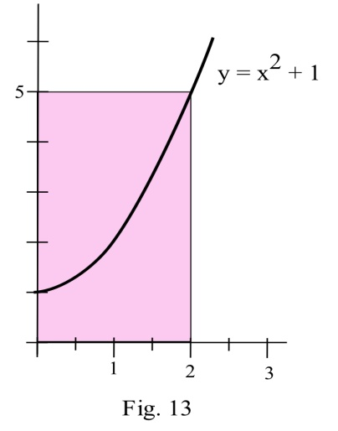5. A rectangle has one side on the x–axis, one side on the y–axis, and a corner on the graph of y = x2 + 1 .

(a) Use Linear Approximation of the area formula to estimate the increase in the area of the rectangle if the base grows from 2 to 2.3 inches.

(b) Calculate exactly the increase in the area of the rectangle as the base grows from 2 to 2.3 inches.

6. You can measure the diameter of a circle to within 0.3 cm.

(a) How large is the "error" in the calculated area of a circle with a measured diameter of 7.4 cm?

(b) How large is the "error" in the calculated area of a circle with a measured diameter of 13.6 cm?

(c) How large is the percentage error in the calculated area of a circle with a measured diameter of d?

7. The demand function for Alicia’s oven mitts is given by (*q* is the number of oven mitts, *p* is the price in dollars). Find the elasticity of demand when *p* = $7.50. Will revenue increase if Alicia raises her price from $7.50?

8. The demand function for Shaki’s danglies is given by (*q* is the number of danglies, *p* is the price in dollars per dangly). Find the elasticity of demand when *p* = $5. Should Shaki raise or lower his price to increase revenue?

## Section 11: Implicit Differentiation and Related Rates

In our work up until now, the functions we needed to differentiate were either given **explicitly,** such as ****, or it was possible to get an explicit formula for them, such as solving

**** to get ****. Sometimes, however, we will have an equation relating *x* and *y* which is either difficult or impossible to solve explicitly for *y* , such as ****. In any case, we can still find y ' = f '(x) by using implicit differentiation.

The key idea behind implicit differentiation is to **assume that *y* is a function of *x*** even if we cannot explicitly solve for *y*. This assumption does not require any work, but we need to be very careful to treat *y* as a function when we differentiate and to use the Chain Rule.

Example 1

Assume that *y* is a function of *x* . Calculate

(a) **** (b) ****  and (c) ****

(a) We need the chain rule since *y* is a function of *x*:

****

(b) We need to use the product rule and the Chain Rule:

****

(c) We know ****, so we use that and the Chain Rule:

****

**IMPLICIT DIFFERENTIATION:**

To determine **y '** , differentiate each side of the defining equation, **treating y**

**as a function of x** , and then algebraically solve for y '.

Example 2

Find the slope of the tangent line to the circle x2 + y2 = 25 at the point (3,4) using implicit differentiation.

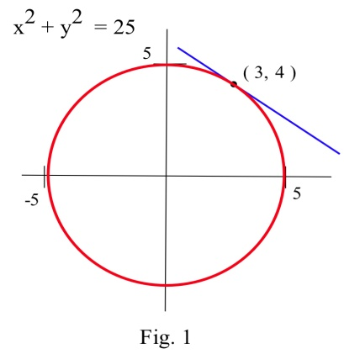We differentiate each side of the equation x2 + y2 = 25 and then solve for **y'**

****

****

Solving for **y'**, we have ****, and, at the point (3,4), **y'** = – 3/4.

In the previous example, it would have been easy to explicitly solve for y, and then we could differentiate y to get y '. Because we could explicitly solve for y , we had a choice of methods for calculating y '. Sometimes, however, we can not explicitly solve for y , and the only way of determining y ' is implicit differentiation.

### Related Rates

If several variables or quantities are related to each other and some of the variables are changing at a known rate, then we can use derivatives to determine how rapidly the other variables must be changing.

Example 3

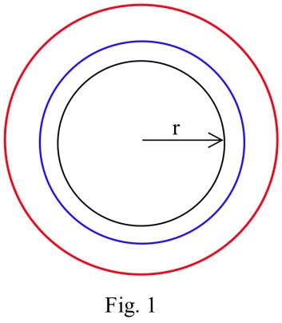Suppose the border of a town is roughly circular, and the radius of that circle has been increasing at a rate of 0.1 miles each year. Find how fast the area of the town has been increasing when the radius is 5 miles.

We could get an approximate answer by calculating the area of the circle when the radius is 5 miles ( A = πr2 = π(5 miles)2 ≈ 78.6 miles2 ) and 1 year later when the radius is 0.1 feet larger than before ( A = πr2 = π(5.1 miles)2 ≈ 81.7 miles2 ) and then finding ∆Area/∆time = (81.7 mi2 – 78.6 mi2)/(1 year) = 3.1 mi2/yr. This approximate answer represents the average change in area during the 1 year period when the radius increased from 5 miles to 5.1 miles, and would correspond to the secant slope on the area graph.

To find the exact answer, though, we need derivatives. In this case both radius and area are functions of time:

*r(t)* = radius at time *t* *A(t)* = area at time *t*

We know how fast the radius is changing, which is a statement about the derivative:

****. We also know that *r* = 5 at our moment of interest.

We are looking for how fast the area is increasing, which is ****.

Now we need an equation relating our variables, which is the area equation: ****.

Taking the derivative of both sides of that equation with respect to *t*, we can use implicit differentiation:

****

****

Plugging in the values we know for *r* and *dr/dt*,

****

The area of the town is increasing by 3.14 square miles per year when the radius is 5 miles.

**Related Rates**

When working with a related rates problem,

1. Identify the quantities that are changing, and assign them variables

2. Find an equation that relates those quantities

3. Differentiate both sides of that equation with respect to time

4. Plug in any known values for the variables or rates of change

5. Solve for the desired rate.

Example 4

A company has determined the demand curve for their product is ****, where *p* is the price in dollars, and *q* is the quantity in millions. If weather conditions are driving the price up $2 a week, find the rate at which demand is changing when the price is $40.

The quantities changing are *p* and *q*, and we assume they are both functions of time, *t*, in weeks. We already have an equation relating the quantities, so we can implicitly differentiate it.

****

****

****

****

Using the given information, we know the price is increasing by $2/week when the price is $40, giving **** when *p* = 40. Plugging in these values,

****

Demand is falling by 1.37 million items per week.

### 2.11 Exercises

In problems 1 – 10 find dy/dx by differentiating implicitly then find the value of dy/dx at the given point.

1. x2 + y2 = 100 , point (6, 8) 2. x2 + 5y2 = 45 , point (5, 2)

3. x2 – 3xy + 7y = 5 , point (2,1) 4. + = 5 , point (4,9)

5. + = 1 , point (0,4) 6. + = 1 , point (3,0)

7. ln(y) + 3x – 7 = 0 , point (2,e) 8. x2 – y2 = 16 , point (5,3)

9. x2 – y2 = 16 , point (5, –3) 10. y2 + 7x3 – 3x = 8 , point (1,2)

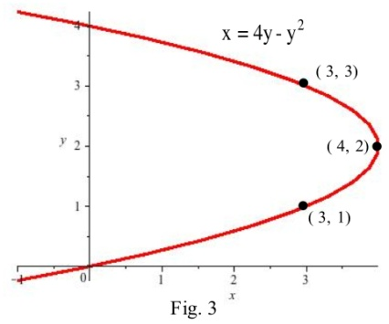

11. Find the slopes of the lines tangent to the graph in shown at the points (3,1), (3,3), and (4,2) .

12. Find the slopes of the lines tangent to the graph in shown where the graph crosses the y–axis.

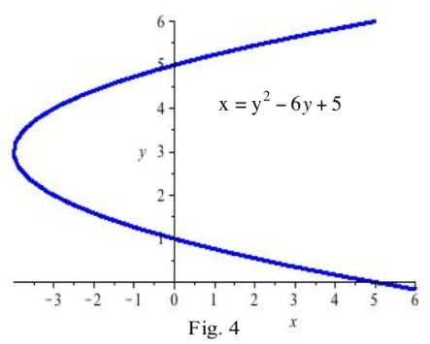13. Find the slopes of the lines tangent to the graph in graph shown at the points ((5,0), (5,6), and (–4,3).

14. Find the slopes of the lines tangent to the graph in the graph shown where the graph crosses the y–axis.

In problems 15 – 16 , find dy/dx using implicit differentiation and then find the slope of the line tangent to the graph of the equation at the given point.

15. y3 – 5y = 5x2 + 7 , point (1,3) 16. y2 – 5xy + x2 + 21 = 0 , point (2,5)

17. An expandable sphere is being filled with liquid at a constant rate from a tap (imagine a water balloon connected to a faucet). When the radius of the sphere is 3 inches, the radius is increasing at 2 inches per minute. How fast is the liquid coming out of the tap? ( V = π r3 )

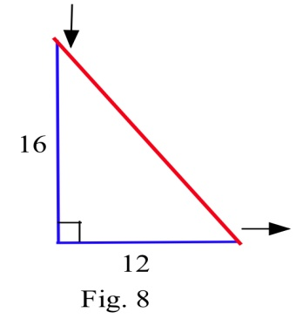

18. The 12 inch base of a right triangle is growing at 3 inches per hour, and the 16 inch height is shrinking at 3 inches per hour.

(a) Is the area increasing or decreasing?

(b) Is the perimeter increasing or decreasing?

(c) Is the hypotenuse increasing or decreasing?

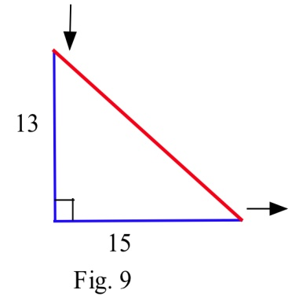19. One hour later the right triangle in Problem 2 is 15 inches long and 13 inches high, and the base and height are changing at the same rate as in Problem 18.

(a) Is the area increasing or decreasing now?

(b) Is the hypotenuse increasing or decreasing now?

(c) Is the perimeter increasing or decreasing now?

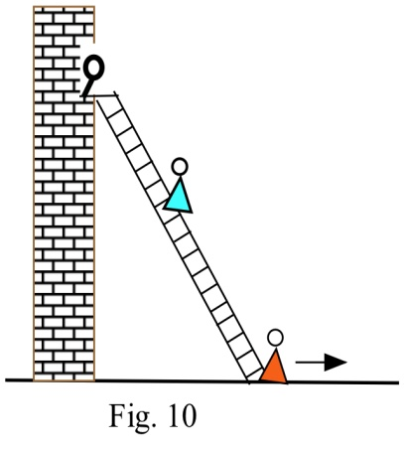20. A young woman and her boyfriend plan to elope, but she must rescue him from his mother who has locked him in his room. The young woman has placed a 20 foot long ladder against his house and is knocking on his window when his mother begins pulling the bottom of the ladder away from the house at a rate of 3 feet per second. How fast is the top of the ladder (and the young couple) falling when the bottom of the ladder is

(a) 12 feet from the bottom of the wall?

(b) 16 feet from the bottom of the wall?

(c) 19 feet from the bottom of the wall?

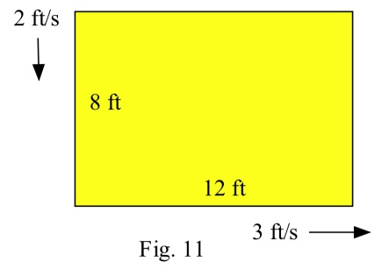21. The length of a 12 foot by 8 foot rectangle is increasing at a rate of 3 feet per second and the width is decreasing at 2 feet per second .

(a) How fast is the perimeter changing?

(b) How fast is the area changing?

22. An oil tanker in Puget Sound has sprung a leak, and a circular oil slick is forming. The oil slick is 4 inches thick everywhere, is 100 feet in diameter, and the diameter is increasing at 12 feet per hour. Your job, as the Coast Guard commander or the tanker's captain, is to determine how fast the oil is leaking from the tanker.