# Chapter 1: Review

## Section 1: Functions

**What is a Function?**

The natural world is full of relationships between quantities that change.  When we see these relationships, it is natural for us to ask “If I know one quantity, can I then determine the other?”  This establishes the idea of an input quantity, or independent variable, and a corresponding output quantity, or dependent variable.  From this we get the notion of a functional relationship in which the output can be determined from the input.

For some quantities, like height and age, there are certainly relationships between these quantities.  Given a specific person and any age, it is easy enough to determine their height, but if we tried to reverse that relationship and determine height from a given age, that would be problematic, since most people maintain the same height for many years.

Function

**Function:**  A rule for a relationship between an input, or independent, quantity and an output, or dependent, quantity in which each input value uniquely determines one output value.  We say “the output is a function of the input.”

Example 1

In the height and age example above, is height a function of age? Is age a function of height?

In the height and age example above, it would be correct to say that height is a function of age, since each age uniquely determines a height.  For example, on my 18th birthday, I had exactly one height of 69 inches.

However, age is not a function of height, since one height input might correspond with more than one output age. For example, for an input height of 70 inches, there is more than one output of age since I was 70 inches at the age of 20 and 21.

**Function Notation**

To simplify writing out expressions and equations involving functions, a simplified notation is often used.  We also use descriptive variables to help us remember the meaning of the quantities in the problem.

Rather than write “height is a function of age”, we could use the descriptive variable *h* to represent height and we could use the descriptive variable *a* to represent age.

“height is a function of age” if we name the function *f* we write

“*h* is *f* of *a*” or more simply

*h = f(a)* we could instead name the function *h* and write

*h(a)* which is read “*h* of *a*”

Remember we can use any variable to name the function; the notation *h(a)* shows us that *h* depends on *a*. The value “*a*” must be put into the function “*h*” to get a result. Be careful - the parentheses indicate that age is input into the function (Note: do not confuse these parentheses with multiplication!).

Function Notation

The notation output = *f*(input) defines a function named *f*.

This would be read “output is *f* of input”

Example 2

A function *N = f(y)* gives the number of police officers, *N*, in a town in year *y*.  What does *f*(2005) = 300 tell us?

When we read *f*(2005) = 300, we see the input quantity is 2005, which is a value for the input quantity of the function, the year (*y*). The output value is 300, the number of police officers (*N*), a value for the output quantity. Remember *N=f(y)*.  So this tells us that in the year 2005 there were 300 police officers in the town.

**Tables as Functions**

Functions can be represented in many ways:  Words (as we did in the last few examples), tables of values, graphs, or formulas.  Represented as a table, we are presented with a list of input and output values.

This table represents the age of children in years and their corresponding heights. While some tables show all the information we know about a function, this particular table represents just some of the data available for height and ages of children.

|  |  |  |  |  |  |  |  |
| --- | --- | --- | --- | --- | --- | --- | --- |
| (input) *a*, age in years | 5 | 5 | 6 | 7 | 8 | 9 | 10 |
| (output) *h*, height inches | 40 | 42 | 44 | 47 | 50 | 52 | 54 |

Example 3

Which of these tables define a function (if any)?

|  |  |
| --- | --- |
| Input | Output |
| 2 | 1 |
| 5 | 3 |
| 8 | 6 |

|  |  |
| --- | --- |
| Input | Output |
| -3 | 5 |
| 0 | 1 |
| 4 | 5 |

|  |  |
| --- | --- |
| Input | Output |
| 1 | 0 |
| 5 | 2 |
| 5 | 4 |

The first and second tables define functions.  In both, each input corresponds to exactly one output.  The third table does not define a function since the input value of 5 corresponds with two different output values.

**Solving and Evaluating Functions:**

When we work with functions, there are two typical things we do: evaluate and solve.  Evaluating a function is what we do when we know an input, and use the function to determine the corresponding output.  Evaluating will always produce one result, since each input of a function corresponds to exactly one output.

Solving equations involving a function is what we do when we know an output, and use the function to determine the inputs that would produce that output.  Solving a function could produce more than one solution, since different inputs can produce the same output.

Example 4

Using the table shown, where *Q=g(n)*

|  |  |  |  |  |  |
| --- | --- | --- | --- | --- | --- |
| *n* | 1 | 2 | 3 | 4 | 5 |
| *Q* | 8 | 6 | 7 | 6 | 8 |

a) Evaluate *g*(3)

Evaluating *g*(3) (read: “*g* of 3”) means that we need to determine the output value, *Q*, of the function *g* given the input value of *n*=3.  Looking at the table, we see the output corresponding to *n*=3 is *Q*=7, allowing us to conclude *g*(3) = 7.

b) Solve *g(n)* = 6

Solving *g(n)* = 6 means we need to determine what input values, *n*, produce an output value of 6.  Looking at the table we see there are two solutions: *n* = 2 and *n* = 4.

When we input 2 into the function *g*, our output is *Q* = 6

When we input 4 into the function *g*, our output is also *Q* = 6

**Graphs as Functions**

Oftentimes a graph of a relationship can be used to define a function.  By convention, graphs are typically created with the input quantity along the horizontal axis and the output quantity along the vertical.

Example 5

Which of these graphs defines a function *y=f(x)*?

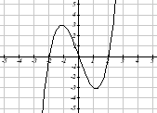 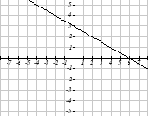 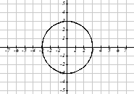

Looking at the three graphs above, the first two define a function *y=f(x)*, since for each input value along the horizontal axis there is exactly one output value corresponding, determined by the *y*-value of the graph.  The 3rd graph does not define a function *y=f(x)* since some input values, such as *x*=2, correspond with more than one output value.

Vertical Line Test

The **vertical line test** is a handy way to think about whether a graph defines the vertical output as a function of the horizontal input.  Imagine drawing vertical lines through the graph.  If any vertical line would cross the graph more than once, then the graph does not define only one vertical output for each horizontal input.

Evaluating a function using a graph requires taking the given input and using the graph to look up the corresponding output.  Solving a function equation using a graph requires taking the given output and looking on the graph to determine the corresponding input.

Example 6

Given the graph below,

a) Evaluate *f*(2)

b) Solve *f(x)* = 4

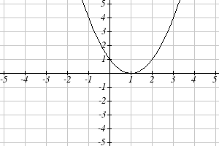

a) To evaluate *f*(2), we find the input of *x*=2 on the horizontal axis.  Moving up to the graph gives the point (2, 1), giving an output of *y*=1.  So *f*(2) = 1

b) To solve *f(x)* = 4, we find the value 4 on the vertical axis because if *f(x)* = 4 then 4 is the output.  Moving horizontally across the graph gives two points with the output of 4: (-1,4) and (3,4).  These give the two solutions to *f(x)* = 4:  *x* = -1 or *x* = 3

This means *f*(-1)=4 and *f*(3)=4, or when the input is -1 or 3, the output is 4.

Notice that while the graph in the previous example is a function, getting two input values for the output value of 4 shows us that this function is not one-to-one.

**Formulas as Functions**

When possible, it is very convenient to define relationships using formulas.  If it is possible to express the output as a formula involving the input quantity, then we can define a function.

Example 7

Express the relationship 2*n* + 6*p* = 12 as a function *p = f(n)* if possible.

To express the relationship in this form, we need to be able to write the relationship where *p* is a function of *n*, which means writing it as *p* = [something involving *n*].

2*n* + 6*p* = 12 subtract 2*n* from both sides

6*p* = 12 - 2*n* divide both sides by 6 and simplify



Having rewritten the formula as *p*=, we can now express *p* as a function:



Not every relationship can be expressed as a function with a formula.

As with tables and graphs, it is common to evaluate and solve functions involving formulas.  Evaluating will require replacing the input variable in the formula with the value provided and calculating.  Solving will require replacing the output variable in the formula with the value provided, and solving for the input(s) that would produce that output.

Example 8

Given the function 

a) Evaluate *k*(2)

b) Solve *k(t)* = 1

a) To evaluate *k*(2), we plug in the input value 2 into the formula wherever we see the input variable *t*, then simplify





So *k*(2) = 10

b) To solve *k(t)* = 1, we set the formula for *k(t)* equal to 1, and solve for the input value that will produce that output

*k(t)* = 1 substitute the original formula 

 subtract 2 from each side

 take the cube root of each side



When solving an equation using formulas, you can check your answer by using your solution in the original equation to see if your calculated answer is correct.

We want to know if  is true when .



= 

= 1 which was the desired result.

**Basic Toolkit Functions**

There are some basic functions that it is helpful to know the name and shape of. We call these the basic "toolkit of functions." For these definitions we will use *x* as the input variable and *f(x)* as the output variable.

Toolkit Functions

Linear

Constant: , where *c* is a constant (number)

Identity: 

Absolute Value: 

Power

Quadratic: 

Cubic: 

Reciprocal: 

Reciprocal squared: 

Square root: 

Cube root: 

**Graphs of the Toolkit Functions**

Constant Function:  Identity:  Absolute Value: 

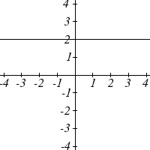 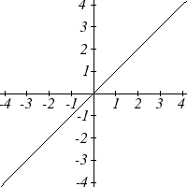 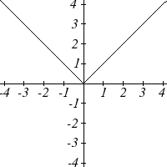

Quadratic:  Cubic:  Square root: 

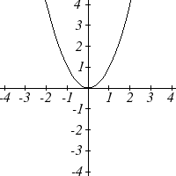 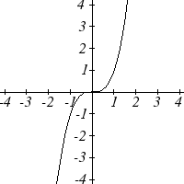 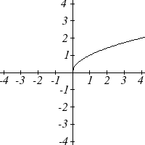

Cube root:  Reciprocal:  Reciprocal squared: 

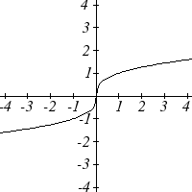 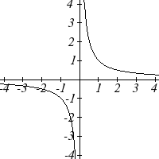 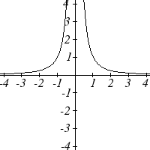

One of our main goals in mathematics is to model the real world with mathematical functions. In doing so, it is important to keep in mind the limitations of those models we create.

This table shows a relationship between circumference and height of a tree as it grows.

|  |  |  |  |  |  |
| --- | --- | --- | --- | --- | --- |
| Circumference, *c* | 1.7 | 2.5 | 5.5 | 8.2 | 13.7 |
| Height, *h* | 24.5 | 31 | 45.2 | 54.6 | 92.1 |

While there is a strong relationship between the two, it would certainly be ridiculous to talk about a tree with a circumference of -3 feet, or a height of 3000 feet. When we identify limitations on the inputs and outputs of a function, we are determining the domain and range of the function.

Domain and Range

**Domain:** The set of possible input values to a function

**Range:** The set of possible output values of a function

Example 9

Using the tree table above, determine a reasonable domain and range.

We could combine the data provided with our own experiences and reason to approximate the domain and range of the function *h = f(c)*. For the domain, possible values for the input circumference *c*, it doesn’t make sense to have negative values, so *c* > 0. We could make an educated guess at a maximum reasonable value, or look up that the maximum circumference measured is about 119 feet. With this information we would say a reasonable domain is feet.

Similarly for the range, it doesn’t make sense to have negative heights, and the maximum height of a tree could be looked up to be 379 feet, so a reasonable range is feet.

A more compact alternative to inequality notation is **interval notation**, in which intervals of values are referred to by the starting and ending values. Curved parentheses are used for “strictly less than,” and square brackets are used for “less than or equal to.” Since infinity is not a number, we can’t include it in the interval, so we always use curved parentheses with ∞ and -∞. The table below will help you see how inequalities correspond to interval notation:

|  |  |
| --- | --- |
| **Inequality** | **Interval notation** |
|  | (5, 10] |
|  | [5, 10) |
|  | (5, 10) |
|  |  |
|  |  |
| all real numbers |  |

Example 10

Describe the intervals of values shown on the line graph below using set builder and interval notations.



To describe the values, *x*, that lie in the intervals shown above we would say, “*x* is a real number greater than or equal to 1 and less than or equal to 3, or a real number greater than 5.”

As an inequality it is: 

In interval notation: 

Example 11

Find the domain of each function: a)  b) 

a) Since we cannot take the square root of a negative number, we need the inside of the square root to be non-negative.

 when .

The domain of *f(x)* is .

b) We cannot divide by zero, so we need the denominator to be non-zero.

 when *x* = 2, so we must exclude 2 from the domain.

The domain of *g(x)* is .

### 1.1 Exercises

1. The amount of garbage, *G*, produced by a city with population *p* is given by . *G* is measured in tons per week, and *p* is measured in thousands of people.
   1. The town of Tola has a population of 40,000 and produces 13 tons of garbage each week. Express this information in terms of the function *f*.
   2. Explain the meaning of the statement .
2. The number of cubic yards of dirt, *D*, needed to cover a garden with area *a* square feet is given by .
   1. A garden with area 5000 ft2 requires 50 cubic yards of dirt. Express this information in terms of the function *g*.
   2. Explain the meaning of the statement .
3. Select all of the following graphs which represent *y* as a function of *x*.

a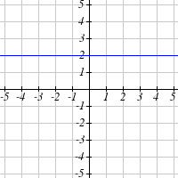 b 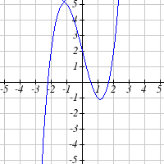 c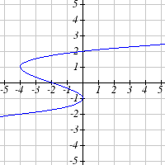

d 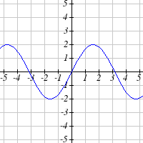 e 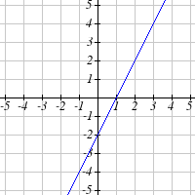 f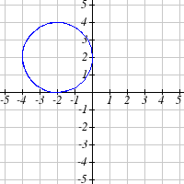

1. Select all of the following graphs which represent *y* as a function of *x*.

a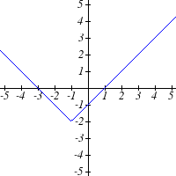 b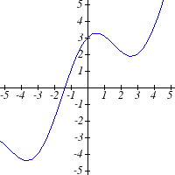 c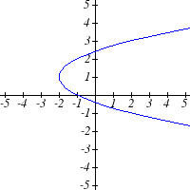

d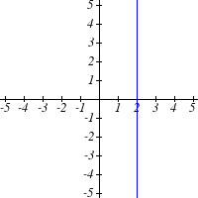 e 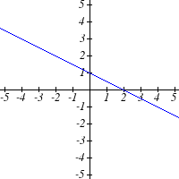 f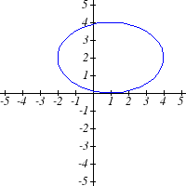

1. Select all of the following tables which represent *y* as a function of *x*.

|  |  |  |  |  |  |  |  |  |  |  |  |  |  |  |  |  |  |  |  |  |  |  |  |  |  |  |  |  |  |
| --- | --- | --- | --- | --- | --- | --- | --- | --- | --- | --- | --- | --- | --- | --- | --- | --- | --- | --- | --- | --- | --- | --- | --- | --- | --- | --- | --- | --- | --- |
| a. | |  |  |  |  | | --- | --- | --- | --- | | ***x*** | 5 | 10 | 15 | | ***y*** | 3 | 8 | 14 | | b. | |  |  |  |  | | --- | --- | --- | --- | | ***x*** | 5 | 10 | 15 | | ***y*** | 3 | 8 | 8 | | c. | |  |  |  |  | | --- | --- | --- | --- | | ***x*** | 5 | 10 | 10 | | ***y*** | 3 | 8 | 14 | |

1. Select all of the following tables which represent *y* as a function of *x*.

|  |  |  |  |  |  |  |  |  |  |  |  |  |  |  |  |  |  |  |  |  |  |  |  |  |  |  |  |  |  |
| --- | --- | --- | --- | --- | --- | --- | --- | --- | --- | --- | --- | --- | --- | --- | --- | --- | --- | --- | --- | --- | --- | --- | --- | --- | --- | --- | --- | --- | --- |
| a. | |  |  |  |  | | --- | --- | --- | --- | | ***x*** | 2 | 6 | 13 | | ***y*** | 3 | 10 | 10 | | b. | |  |  |  |  | | --- | --- | --- | --- | | ***x*** | 2 | 6 | 6 | | ***y*** | 3 | 10 | 14 | | c. | |  |  |  |  | | --- | --- | --- | --- | | ***x*** | 2 | 6 | 13 | | ***y*** | 3 | 10 | 14 | |

|  |  |
| --- | --- |
| 7. Given the function  graphed here,   * 1. Evaluate   2. Solve   Description: Description: Graphs | 8. Given the function  graphed here.   1. Evaluate 2. Solve   Description: Description: Graphs |

9. Based on the table below,

a. Evaluate  b. Solve 

|  |  |  |  |  |  |  |  |  |  |  |
| --- | --- | --- | --- | --- | --- | --- | --- | --- | --- | --- |
| ***x*** | 0 | 1 | 2 | 3 | 4 | 5 | 6 | 7 | 8 | 9 |
|  | 74 | 28 | 1 | 53 | 56 | 3 | 36 | 45 | 14 | 47 |

10. Based on the table below,

a. Evaluate  b. Solve 

|  |  |  |  |  |  |  |  |  |  |  |
| --- | --- | --- | --- | --- | --- | --- | --- | --- | --- | --- |
| ***x*** | 0 | 1 | 2 | 3 | 4 | 5 | 6 | 7 | 8 | 9 |
|  | 62 | 8 | 7 | 38 | 86 | 73 | 70 | 39 | 75 | 34 |

For each of the following functions, evaluate: , , , , and 

11.  12. 

13.  14. 

15.  16. 

17.  18. 

19. Let 

a. Evaluate  b. Solve 

20. Let 

*x*

*f(x)*

*a*

*b*

*c*

*p*

*r*

*t*

*K*

*L*

a. Evaluate  b. Solve 

21. Using the graph shown,

1. Evaluate 
2. Solve 
3. What are the coordinates of points *L* and *K*?

22. Match each graph with its equation.

a. 

|  |  |  |  |
| --- | --- | --- | --- |
| i. | ii. | iii. | iv. |
| Description: Description: Graphs | Description: Description: Graphs | Description: Description: Graphs | Description: Description: Graphs |
| v. | vi. | vii. | viii. |
| Description: Description: Graphs | Description: Description: Graphs | Description: Description: Graphs | Description: Description: Graphs |

b. 

c.

d. 

e. 

f. 

g. 

h. 

Write the domain and range of each graph as an inequality.  
23. 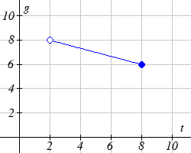 24. 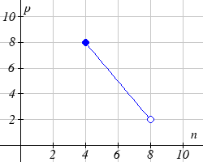

Find the domain of each function

25.  26. 

27.  28. 

29.  30. 

## Section 2: Operations on Functions

### Composition of Functions

Suppose we wanted to calculate how much it costs to heat a house on a particular day of the year. The cost to heat a house will depend on the average daily temperature, and the average daily temperature depends on the particular day of the year. Notice how we have just defined two relationships: The temperature depends on the day, and the cost depends on the temperature. Using descriptive variables, we can notate these two functions.

The first function, *C(T),* gives the cost *C* of heating a house when the average daily temperature is *T* degrees Celsius, and the second, *T(d)*, gives the average daily temperature of a particular city on day *d* of the year. If we wanted to determine the cost of heating the house on the 5th day of the year, we could do this by linking our two functions together, an idea called composition of functions. Using the function *T(d)*, we could evaluate *T*(5) to determine the average daily temperature on the 5th day of the year. We could then use that temperature as the input to the *C(T)* function to find the cost to heat the house on the 5th day of the year: *C(T(5)).*

Composition of Functions

When the output of one function is used as the input of another, we call the entire operation a **composition of functions**. We write *f(g(x))*, and read this as “*f* of *g* of *x*” or “*f* composed with *g* at *x*”.

An alternate notation for composition uses the composition operator: 

 is read “*f* of *g* of *x*” or “*f* composed with *g* at *x*”, just like *f(g(x)).*

Example 1

Suppose *c(s)* gives the number of calories burned doing *s* sit-ups, and *s(t)* gives the number of sit-ups a person can do in *t* minutes. Interpret *c*(*s*(3))*.*

When we are asked to interpret, we are being asked to explain the meaning of the expression in words. The inside expression in the composition is s(3). Since the input to the s function is time, the 3 is representing 3 minutes, and s(3) is the number of sit-ups that can be done in 3 minutes. Taking this output and using it as the input to the c(s) function will gives us the calories that can be burned by the number of sit-ups that can be done in 3 minutes.

**Composition of Functions using Tables and Graphs**

When working with functions given as tables and graphs, we can look up values for the functions using a provided table or graph. We start evaluation from the provided input, and first evaluate the inside function. We can then use the output of the inside function as the input to the outside function. To remember this, always work from the inside out.

Example 2

Using the graphs below, evaluate *.*

*g(x) f(x)*

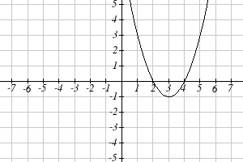 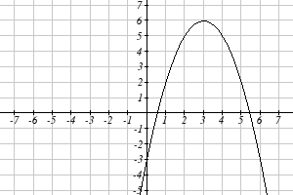

To evaluate **, we again start with the inside evaluation. We evaluate** using the graph of the *g(x)* function, finding the input of 1 on the horizontal axis and finding the output value of the graph at that input. Here, **. Using this value as the input to the *f* function, **. We can then evaluate this by looking to the graph of the *f(x)* function, finding the input of 3 on the horizontal axis, and reading the output value of the graph at this input. Here, **, so**.

**Composition using Formulas**

When evaluating a composition of functions where we have either created or been given formulas, the concept of working from the inside out remains the same. First we evaluate the inside function using the input value provided, then use the resulting output as the input to the outside function.

Example 3

Given  and , evaluate **.

Since the inside evaluation is**we start by evaluating the *h(x)* function at 1:



Then **, so we evaluate the *f(t)* function at an input of 5:



We are not limited, however, to using a numerical value as the input to the function. We can put anything into the function: a value, a different variable, or even an algebraic expression, provided we use the input expression everywhere we see the input variable.

Example 4

Let  and , find *f(g(x))* and *g(f(x)).*

To find *f(g(x))*, we start by evaluating the inside, writing out the formula for *g(x)*



We then use the expression  as input for the function *f*.



We then evaluate the function *f(x)* using the formula for *g(x)* as the input.

Since  then 

This gives us the formula for the composition: 

Likewise, to find *g(f(x))*, we evaluate the inside, writing out the formula for *f(x)*



Now we evaluate the function *g(x)* using *x*2 as the input.



Example 5

A city manager determines that the tax revenue, *R*, in millions of dollars collected on a population of *p* thousand people is given by the formula , and that the city’s population, in thousands, is predicted to follow the formula , where *t* is measured in years after 2010. Find a formula for the tax revenue as a function of the year.

Since we want tax revenue as a function of the year, we want year to be our initial input, and revenue to be our final output. To find revenue, we will first have to predict the city population, and then use that result as the input to the tax function. So we need to find *R(p(t))*. Evaluating this,



This composition gives us a single formula which can be used to predict the tax revenue during a given year, without needing to find the intermediary population value.

For example, to predict the tax revenue in 2017, when *t* = 7 (because *t* is measured in years after 2010):

million dollars

Later in this course, it will be desirable to decompose a function – to write it as a composition of two simpler functions.

Example 6

Write  as the composition of two functions.

We are looking for two functions, *g* and *h*, so . To do this, we look for a function inside a function in the formula for *f(x)*. As one possibility, we might notice that  is the inside of the square root. We could then decompose the function as:





We can check our answer by recomposing the functions:



Note that this is not the only solution to the problem. Another non-trivial decomposition would be  and 

### Transformations of Functions

Transformations allow us to construct new equations from our basic toolkit functions. The most basic transformations are shifting the graph vertically or horizontally.

Vertical Shift

Given a function *f(x)*, if we define a new function *g(x)* as

, where *k* is a constant

then *g(x)* is a **vertical shift** of the function *f(x)*, where all the output values have been increased by *k*.

If *k* is positive, then the graph will shift up

If *k* is negative, then the graph will shift down

Horizontal Shift

Given a function *f(x)*, if we define a new function *g(x)* as

, where *k* is a constant

then *g(x)* is a **horizontal shift** of the function *f(x)*

If *k* is positive, then the graph will shift left

If *k* is negative, then the graph will shift right

Example 7

Given , sketch a graph of .

The function *f* is our toolkit absolute value function. We know that this graph has a V shape, with the point at the origin. The graph of *h* has transformed *f* in two ways:  is a change on the inside of the function, giving a horizontal shift left by 1, then the subtraction by 3 in  is a change to the outside of the function, giving a vertical shift down by 3. Transforming the graph gives

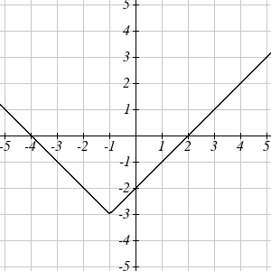

Example 8

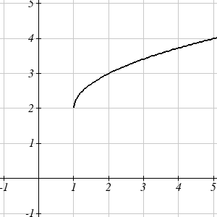Write a formula for the graph shown, a transformation of the toolkit square root function.

The graph of the toolkit function starts at the origin, so this graph has been shifted 1 to the right, and up 2. In function notation, we could write that as . Using the formula for the square root function we can write



Note that this transformation has changed the domain and range of the function. This new graph has domain  and range .

Another transformation that can be applied to a function is a reflection over the horizontal or vertical axis.

Reflections

Given a function *f(x)*, if we define a new function *g(x)* as ,

then *g(x)* is a **vertical reflection** of the function *f(x)*, sometimes called a reflection about the *x*-axis

If we define a new function *g(x)* as ,

then *g(x)* is a **horizontal reflection** of the function *f(x)*, sometimes called a reflection about the *y*-axis

Example 9

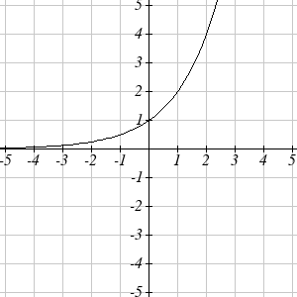A common model for learning has an equation similar to , where *k* is the percentage of mastery that can be achieved after *t* practice sessions. This is a transformation of the function  shown here. Sketch a graph of *k(t)*.

This equation combines three transformations into one equation.

A horizontal reflection:  combined with

A vertical reflection:  combined with

A vertical shift up 1: 

We can sketch a graph by applying these transformations one at a time to the original function:

The original graph Horizontally reflected Then vertically reflected

 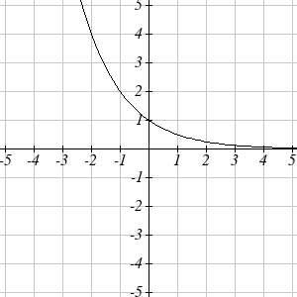 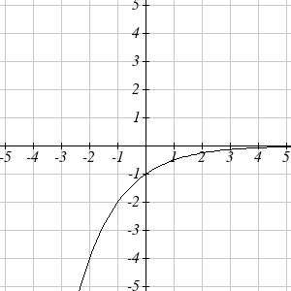

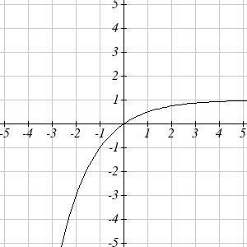

Then, after shifting up 1, we get the final graph:

.

Note: As a model for learning, this function would be limited to a domain of , with corresponding range .

With shifts, we saw the effect of adding or subtracting to the inputs or outputs of a function. We now explore the effects of multiplying the outputs.

Vertical Stretch/Compression

Given a function *f(x)*, if we define a new function *g(x)* as

, where *k* is a constant

then *g(x)* is a **vertical stretch or compression** of the function *f(x).*

If *k* > 1, then the graph will be stretched

If 0< *k* < 1, then the graph will be compressed

If *k* < 0, then there will be combination of a vertical stretch or compression with a vertical reflection

Example 10

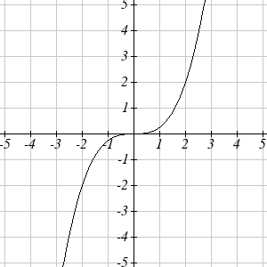The graph to the right is a transformation of the toolkit function . Relate this new function *g(x)* to *f(x)*, then find a formula for *g(x)*.

When trying to determine a vertical stretch or shift, it is helpful to look for a point on the graph that is relatively clear. In this graph, it appears that . With the basic cubic function at the same input, . Based on that, it appears that the outputs of *g* are ¼ the outputs of the function *f*, since . From this we can fairly safely conclude that:



We can write a formula for *g* by using the definition of the function *f*



**Combining Transformations**

When combining vertical transformations, it is very important to consider the order of the transformations. For example, vertically shifting by 3 and then vertically stretching by 2 does not create the same graph as vertically stretching by 2 and then vertically shifting by 3. The order follows nicely from order of operations.

Combining Vertical Transformations

When combining vertical transformations written in the form ,

first vertically stretch by *a*, then vertically shift by *k.*

Example 11

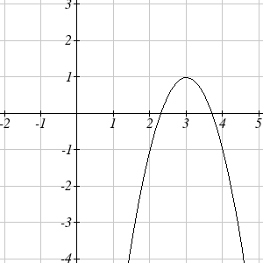Write an equation for the transformed graph of the quadratic function shown.

Since this is a quadratic function, first consider what the basic quadratic tool kit function looks like and how this has changed. Observing the graph, we notice several transformations:

The original tool kit function has been flipped over the *x* axis, some kind of stretch or compression has occurred, and we can see a shift to the right 3 units and a shift up 1 unit.

In total there are four operations:

Vertical reflection, requiring a negative sign outside the function

Vertical Stretch

Horizontal Shift Right 3 units, which tells us to put *x*-3 on the inside of the function

Vertical Shift up 1 unit, telling us to add 1 on the outside of the function

By observation, the basic tool kit function has a vertex at (0, 0) and symmetrical points at

(1, 1) and (-1, 1). These points are one unit up and one unit over from the vertex. The new points on the transformed graph are one unit away horizontally but 2 units away vertically. They have been stretched vertically by two.

Not everyone can see this by simply looking at the graph. If you can, great, but if not, we can solve for it. First, we will write the equation for this graph, with an unknown vertical stretch.

 The original function

 Vertically reflected

 Vertically stretched

 Shifted right 3

 Shifted up 1

We now know our graph is going to have an equation of the form . To find the vertical stretch, we can identify any point on the graph (other than the highest point), such as the point (2,-1), which tells us . Using our general formula, and substituting 2 for *x*, and -1 for *g(x)*



This tells us that to produce the graph we need a vertical stretch by two.

The function that produces this graph is therefore .

Example 12

On what interval(s) is the function  increasing and decreasing?

This is a transformation of the toolkit reciprocal squared function, :

 A vertical flip and vertical stretch by 2

 A shift right by 1

 A shift up by 3

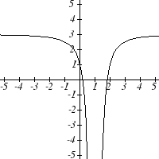

The basic reciprocal squared function is increasing on and decreasing on . Because of the vertical flip, the *g(x)* function will be decreasing on the left and increasing on the right. The horizontal shift right by 1 will also shift these intervals to the right one. From this, we can determine *g(x)* will be increasing on  and decreasing on . We also could graph the transformation to help us determine these intervals.

### 1.2 Exercises

Given each pair of functions, calculate  and .

1. ,  2. , 

3. ,  4. , 

Use the table of values to evaluate each expression

|  |  |  |
| --- | --- | --- |
| ***x*** |  |  |
| 0 | 7 | 9 |
| 1 | 6 | 5 |
| 2 | 5 | 6 |
| 3 | 8 | 2 |
| 4 | 4 | 1 |
| 5 | 0 | 8 |
| 6 | 2 | 7 |
| 7 | 1 | 3 |
| 8 | 9 | 4 |
| 9 | 3 | 0 |

1. 
2. 
3. 
4. 
5. 
6. 
7. 
8. 

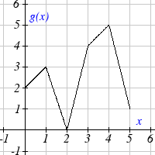Use the graphs to evaluate the expressions below.

1. 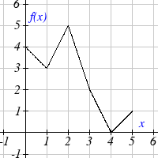
2. 
3. 
4. 
5. 
6. 
7. 
8. 

For each pair of functions, find  and . Simplify your answers.

21. ,  22. , 

23. ,  24. , 

25. ,  26.  , 

27. If ,and , find 

28. If ,  and  , find 

29. The function  gives the number of items that will be demanded when the price is *p*. The production cost,  is the cost of producing *x* items. To determine the cost of production when the price is $6, you would do which of the following:

a. Evaluate  b. Evaluate 

c. Solve  d. Solve 

30. The function  gives the pain level on a scale of 0-10 experienced by a patient with *d* milligrams of a pain reduction drug in their system. The milligrams of drug in the patient’s system after *t* minutes is modeled by . To determine when the patient will be at a pain level of 4, you would need to:

a. Evaluate  b. Evaluate 

c. Solve  d. Solve 

Find functions  and  so the given function can be expressed as .

31.  32. 

33.  34. 

35.  36. 

Sketch a graph of each function as a transformation of a toolkit function.

37. 38. 

39.  40. 

41.  42. 

43.  44. 

 Write an equation for each function graphed below.

45. 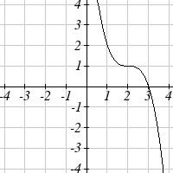 46.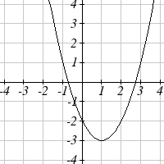

47.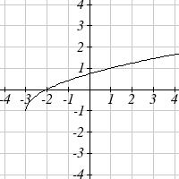 48. 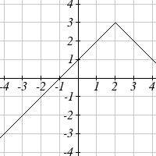  
49. 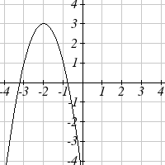 50. 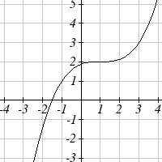

For each function graphed, estimate the intervals on which the function is increasing and decreasing.

51. 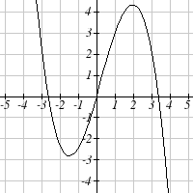 52. 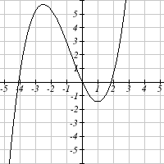

## Section 3: Linear Functions

As you hop into a taxicab in Allentown, the meter will immediately read $3.30; this is the “drop” charge made when the taximeter is activated. After that initial fee, the taximeter will add $2.40 for each mile the taxi drives. In this scenario, the total taxi fare depends upon the number of miles ridden in the taxi, and we can ask whether it is possible to model this type of scenario with a function. Using descriptive variables, we choose *m* for miles and *C* for Cost in dollars as a function of miles: *C(m)*.

We know for certain that , since the $3.30 drop charge is assessed regardless of how many miles are driven. Since $2.40 is added for each mile driven, we could write that if *m* miles are driven, because we start with a $3.30 drop fee and then for each mile increase we add $2.40.

It is good to verify that the units make sense in this equation. The $3.30 drop charge is measured in dollars; the $2.40 charge is measured in dollars per mile. So



When dollars per mile are multiplied by a number of miles, the result is a number of dollars, matching the units on the 3.30, and matching the desired units for the *C* function.

Notice this equation  consisted of two quantities. The first is the fixed $3.30 charge which does not change based on the value of the input. The second is the $2.40 dollars per mile value, which is a **rate of change**. In the equation this rate of change is multiplied by the input value.

Looking at this same problem in table format we can also see the cost changes by $2.40 for every 1 mile increase.

|  |  |  |  |  |
| --- | --- | --- | --- | --- |
| *m* | 0 | 1 | 2 | 3 |
| *C(m)* | 3.30 | 5.70 | 8.10 | 10.50 |

It is important here to note that in this equation, the **rate of change is constant**; over any interval, the rate of change is the same.

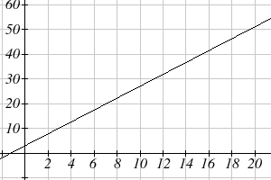

Graphing this equation,  we see the shape is a line, which is how these functions get their name: **linear functions**

When the number of miles is zero the cost is $3.30, giving the point (0, 3.30) on the graph. This is the vertical or *C(m)* intercept. The graph is increasing in a straight line from left to right because for each mile the cost goes up by $2.40; this rate remains consistent.

Linear Function

A **linear function** is a function whose graph produces a line. Linear functions can always be written in the form

 or ; they’re equivalent

where

*b* is the initial or starting value of the function (when input, *x* = 0), and

*m* is the constant rate of change of the function

This form of a line is called **slope-intercept form** of a line.

Many people like to write linear functions in the form  because it corresponds to the way we tend to speak:

“The output starts at *b* and increases at a rate of *m*.”

For this reason alone we will use the form for many of the examples, but remember they are equivalent and can be written correctly both ways.

Slope and Increasing/Decreasing

*m* is the constant rate of change of the function (also called **slope**). The slope determines if the function is an increasing function or a decreasing function.

 is an **increasing** function if 

 is a **decreasing** function if 

If , the rate of change zero, and the function  is just a horizontal line passing through the point (0, *b*), neither increasing nor decreasing.

Example 1

Marcus currently owns 200 songs in his iTunes collection. Every month, he adds 15 new songs. Write a formula for the number of songs, *N*, in his iTunes collection as a function of the number of months, *m*. How many songs will he own in a year?

The initial value for this function is 200, since he currently owns 200 songs, so . The number of songs increases by 15 songs per month, so the rate of change is 15 songs per month. With this information, we can write the formula:

.

*N(m)* is an increasing linear function.

With this formula we can predict how many songs he will have in 1 year (12 months):

. Marcus will have 380 songs in 12 months.

Calculating Rate of Change

Given two values for the input,, and two corresponding values for the output, , or a set of points,  and, if we wish to find a linear function that contains both points we can calculate the rate of change, *m*:



Rate of change of a linear function is also called the **slope** of the line.

Note in function notation, and , so we could equivalently write



Example 2

The population of a city increased from 23,400 to 27,800 between 2002 and 2006. Find the rate of change of the population during this time span.

The rate of change will relate the change in population to the change in time. The population increased by people over the 4 year time interval. To find the rate of change, the number of people per year the population changed by:

 = 1100 people per year

Notice that we knew the population was increasing, so we would expect our value for *m* to be positive. This is a quick way to check to see if your value is reasonable.

Example 3

The pressure, *P*, in pounds per square inch (PSI) on a diver depends upon their depth below the water surface, *d*, in feet, following the equation . Interpret the components of this function.

The rate of change, or slope, 0.434 would have units . This tells us the pressure on the diver increases by 0.434 PSI for each foot their depth increases.

The initial value, 14.696, will have the same units as the output, so this tells us that at a depth of 0 feet, the pressure on the diver will be 14.696 PSI.

We can now find the rate of change given two input-output pairs, and could write an equation for a linear function if we had the rate of change and initial value. If we have two input-output pairs and they do not include the initial value of the function, then we will have to solve for it.

Example 4

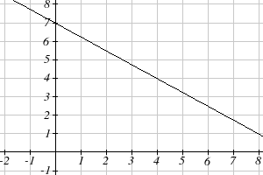Write an equation for the linear function graphed to the right.

Looking at the graph, we might notice that it passes through the points (0, 7) and (4, 4). From the first value, we know the initial value of the function is *b* = 7, so in this case we will only need to calculate the rate of change:



This allows us to write the equation:



Example 5

If is a linear function, , and , find an equation for the function.

In example 3, we computed the rate of change to be . In this case, we do not know the initial value, so we will have to solve for it. Using the rate of change, we know the equation will have the form. Since we know the value of the function when *x* = 3, we can evaluate the function at 3.

 Since we know that, we can substitute on the left side

 This leaves us with an equation we can solve for the initial value



Combining this with the value for the rate of change, we can now write a formula for this function:



As an alternative to the approach used above to find the initial value, *b*, we can use the **point-slope** form of a line instead.

Point-Slope Equation of a Line

An equation for the line passing through the point (*x*1, *y*1) with slope *m* can be written as



This is called the **point-slope form of a line**. It is a little easier to write if you know a point and the slope, but requires a bit of work to rewrite into slope-intercept form, and requires memorizing another formula.

Example 6

Working as an insurance salesperson, Ilya earns a base salary and a commission on each new policy, so Ilya’s weekly income, *I*, depends on the number of new policies, *n*, he sells during the week. Last week he sold 3 new policies, and earned $760 for the week. The week before, he sold 5 new policies, and earned $920. Find an equation for *I(n)*, and interpret the meaning of the components of the equation.

The given information gives us two input-output pairs: (3,760) and (5,920). We start by finding the rate of change.



Keeping track of units can help us interpret this quantity. Income increased by $160 when the number of policies increased by 2, so the rate of change is $80 per policy; Ilya earns a commission of $80 for each policy sold during the week.

We can now write the equation using the point-slope form of the line, using the slope we just found and the point (3,760):



If we wanted this in function form (slope intercept form), we could rewrite the equation into that form:







This form allows us to see the starting value for the function: 520. This is Ilya’s income when *n* = 0, which means no new policies are sold. We can interpret this as Ilya’s base salary for the week, which does not depend upon the number of policies sold.

Our final interpretation is: Ilya’s base salary is $520 per week and he earns an additional $80 commission for each policy sold each week.

### Graphs of Linear Functions

Graphical Interpretation of a Linear Equation

Graphically, in the equation

*b* is the **vertical intercept** of the graph and tells us we can start our graph at (0, *b*)

*m* is the **slope of the line** and tells us how far to rise & run to get to the next point

Once we have at least 2 points, we can extend the graph of the line to the left and right.

Example 7

Graph  using the vertical intercept and slope.

The vertical intercept of the function is (0, 5), giving us a point on the graph of the line.

The slope is . This tells us that for every 3 units the graph “runs” in the horizontal, the vertical “rise” decreases by 2 units. In graphing, we can use this by first plotting our vertical intercept on the graph, then using the slope to find a second point. From the initial value (0, 5) the slope tells us that if we move to the right 3, we will move down 2, moving us to the point (3, 3). We can continue this again to find a third point at (6, 1). Finally, extend the line to the left and right, containing these points.

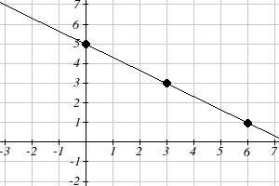

Another option for graphing is to use transformations of the identity function. In the equation, the *m* is acting as the vertical stretch of the identity function. When *m* is negative, there is also a vertical reflection of the graph. Looking at some examples will also help show the effect of slope on the shape of the graph.







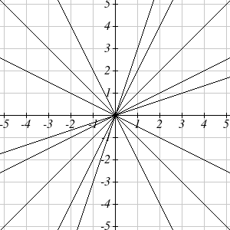











In, the *b* acts as the vertical shift, moving the graph up and down without affecting the slope of the line. Some examples:

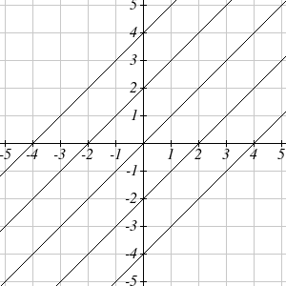











Example 8

Match each equation with one of the lines in the graph below



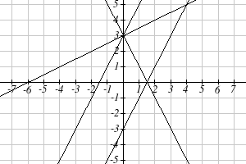

Only one graph has a vertical intercept of -3, so we can immediately match that graph with *g(x)*. For the three graphs with a vertical intercept at 3, only one has a negative slope, so we can match that line with *h(x)*. Of the other two, the steeper line would have a larger slope, so we can match that graph with equation *f(x)*, and the flatter line with the equation *j(x)*.











In addition to understanding the basic behavior of a linear function (increasing or decreasing, recognizing the slope and vertical intercept), it is often helpful to know the horizontal intercept of the function – where it crosses the horizontal axis.

Finding Horizontal Intercept

The **horizontal intercept** of the function is where the graph crosses the horizontal axis. If a function has a horizontal intercept, you can always find it by solving *f(x)* = 0.

Example 9

Find the horizontal intercept of 

Setting the function equal to zero to find what input will put us on the horizontal axis,



The graph crosses the horizontal axis at (6,0)

**Intersections of Lines**

The graphs of two lines will intersect if they are not parallel. They will intersect at the point that satisfies both equations. To find this point when the equations are given as functions, we can solve for an input value so that . In other words, we can set the formulas for the lines equal, and solve for the input that satisfies the equation.

Economics tells us that in a free market, the price for an item is related to the quantity that producers will supply and the quantity that consumers will demand. Increases in prices will decrease demand, while supply tends to increase with prices. Sometimes supply and demand are modeled with linear functions

Example 10

The supply, in thousands of items, for custom phone cases can be modeled by the equation , while the demand can be modeled by , where *p* is in dollars. Find the equilibrium price and quantity, the intersection of the supply and demand curves.

Setting ,

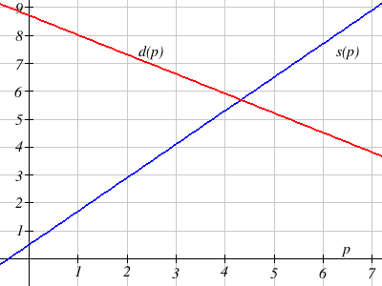





We can find the output value of the intersection point by evaluating either function at this input:



These lines intersect at the point (4.32, 5.68). Looking at the graph, this result seems reasonable.

**Business Applications**

In business, a very common application of functions is to model cost, revenue, and profit.

Cost, Revenue, Profit

When a company produces *q* items, the **total cost** is the cost of total cost of producing those items. The total cost includes both **fixed costs**, which are startup costs, like equipment and buildings, and **variable costs**, which are costs that depend on the number of items produced, like materials and labor.

In the most simple case, **Total Cost = (Fixed Costs) + (Variable Costs) ∙ *q***

**Revenue** is the amount of money a company brings in from sales.

In the most simple case, **Revenue = (Price per item) ∙ *q***

**Profit** is the amount of money brings in, after expenses.

**Profit = Revenue – Costs**

We often talk about the **break-even** point. This is the level of production where Revenue equals Cost, or equivalently where Profit is zero. This is typically the minimum level of sales necessary for the company to make a profit.

Example 11

A tech startup is looking at developing and launching a new mobile app. Initial development of the app will cost $300,000, and they estimate marketing and support for each user will cost $0.50. While the app will be free, they estimate they will be able to bring in $2 per user on average from in-app purchases. How many users will the company need to break even?

We start by modeling the cost, revenue, and profit. Let *q* = number of users.

The fixed (initial) costs are $300,000, and the variable (per-item) costs as $0.50 per user. We can write the total cost equation:



The revenue will be $2 per user, so the revenue equation will be:



We could find the break-even point by setting the total cost equal to the revenue, which is equivalent to finding the intersection of the lines.

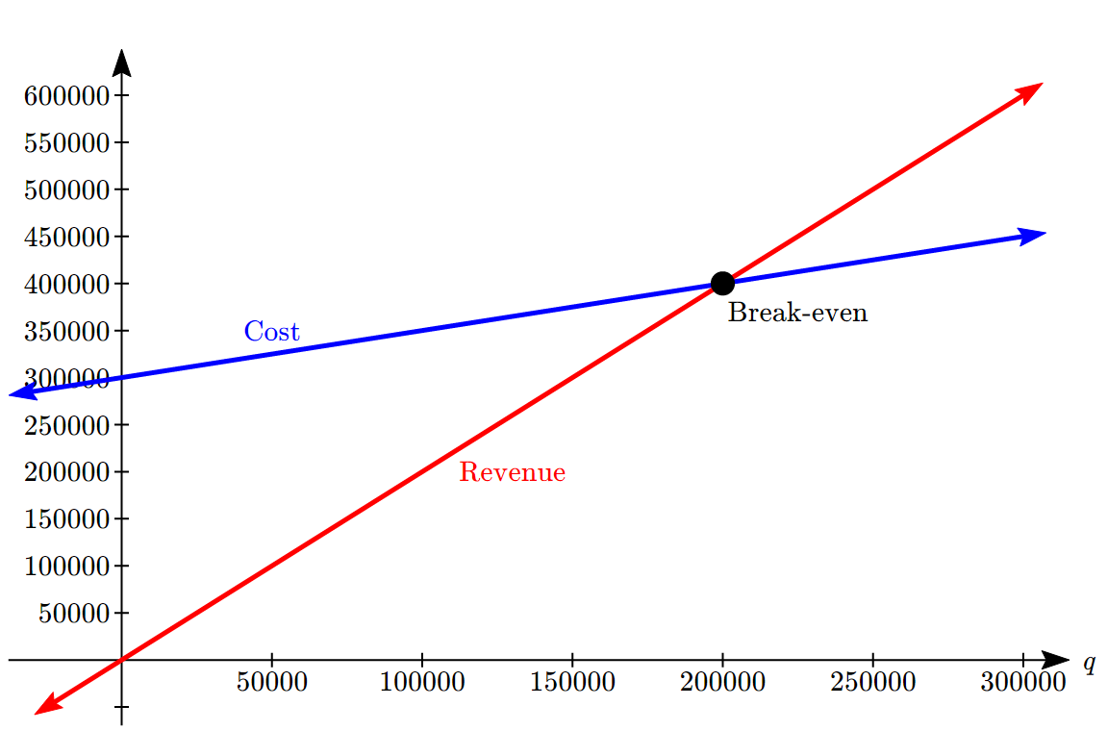

Alternatively, we could go ahead and find a profit equation first:



The break even point can be found by setting the profit equal to zero:



The company will have to acquire 200,000 users to break even.

In economics, there is a model for how prices are determined in a free market which states that **supply and demand** for a product is related to the price. The demand relationship shows the quantity of a certain product that consumers are willing to buy at a certain price. Typically the quantity demanded will decrease for an item if the price increases. The supply relationship shows the quantity of a product that suppliers are willing to produce at a certain sales price. Typically the supply demanded will increase if the price increases. Economic theory says that supply and demand will interact, and the intersection will be the equilibrium price, or market price, where the quantity supplied and demanded will be equal.

Supply and Demand

If *p* is the price of a product, then

*Qd* is the quantity demanded

*Qs* is the quantity supplied

The demand curve is a decreasing function, while the supply curve is an increasing function.

The intersection of the curves is the **equilibrium price and quantity**, also called the **market price and quantity**. This point is often notated as *p\**, *Q\**.

Later in the course you will explore supply and demand curves that are non-linear, but in this section we will focus on linear supply and demand functions.

In most economic books, you will see the supply and demand curve written with price as the input and quantity as the output, like . However, supply and demand graphs are drawn with price on the vertical axis and quantity on the horizontal. We can write the equation in whichever way is more convenient for us.

Example 12

At a price of $2.50 per gallon, there is a demand in a certain town for 42.5 thousand gallons of gas and a supply of 20 thousand gallons. At a price of $3.50, there is demand for 25.5 thousand gallons and a supply of 28 thousand gallons. Assuming supply and demand are linear, find the equilibrium price and quantity.

We start by finding a linear equation for both supply and demand. We will use price, *p* in dollars, as the output and quantity, *q* in thousands of gallons, as the input.

For supply, we have the points (20, 2.50) and (28, 3.50).

Finding the slope: 

We know the equation will look like , so substituting in (20, 2.50),



The supply equation is: 

For demand, we have the points (42.5, 2.50) and (25.5, 3.50). Using a similar approach, we can find the demand equation is: 

To find the equilibrium, we set the supply equal to the demand:

 Multiplying through by 8(17) = 136 to clear the fractions



 Now we solve for *q*



To find the equilibrium price, we can substitute that value back into either equation:



The equilibrium quantity will be 27.2 thousand gallons of gas at a price of $3.40.

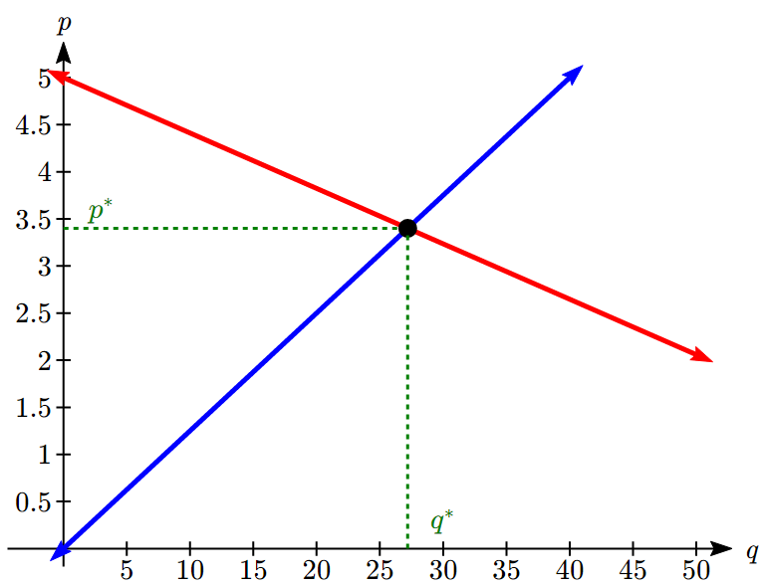

### 1.3 Exercises

1. A town's population has been growing linearly. In 2003, the population was 45,000, and the population has been growing by 1700 people each year. Write an equation,for the population *t* years after 2003.
2. A town's population has been growing linearly. In 2005, the population was 69,000, and the population has been growing by 2500 people each year. Write an equation,for the population *t* years after 2005.
3. Timmy goes to the fair with $40. Each ride costs $2. How much money will he have left after riding *n* rides?
4. At noon, a barista notices she has $20 in her tip jar. If she makes an average of $0.50 from each customer, how much will she have in her tip jar if she serves *n* more customers during her shift?
5. A phone company charges for service according to the formula: , where *n* is the number of minutes talked, and  is the monthly charge, in dollars.  
   Find and interpret the rate of change and initial value.
6. A phone company charges for service according to the formula: , where *n* is the number of minutes talked, and  is the monthly charge, in dollars.  
   Find and interpret the rate of change and initial value.

Given each set of information, find a linear equation satisfying the conditions, if possible

7. , and  8. , and 

9. Passes through (2, 4) and (4, 10) 10. Passes through (1, 5) and (4, 11)

11. Passes through (-1,4) and (5, 2) 12. Passes through (-2, 8) and (4, 6)

13. *x* intercept at (-2, 0) and *y* intercept at (0, -3)

14. *x* intercept at (-5, 0) and *y* intercept at (0, 4)

Find an equation for the function graphed

15. 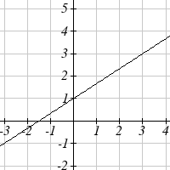 16. 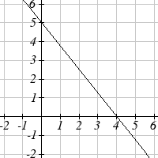

17. A clothing business finds there is a linear relationship between the number of shirts, *n*, it can sell and the price, *p*, it can charge per shirt. In particular, historical data shows that  shirts can be sold at a price of , while  shirts can be sold at a price of . Find a linear equation in the form  that gives the price *p* they can charge for *n* shirts.

18. A farmer finds there is a linear relationship between the number of bean stalks, *n*, she plants and the yield, *y*, each plant produces. When she plants 30 stalks, each plant yields 30 oz of beans. When she plants 34 stalks, each plant produces 28 oz of beans. Find a linear relationships in the form  that gives the yield when *n* stalks are planted.

Match each linear equation with its graph

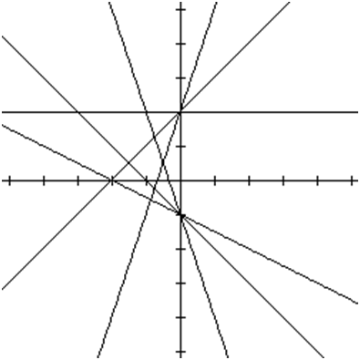

*A*

*B*

*C*

*D*

*E*

*F*

19. 

20. 

21. 

22. 

23. 

24. 

Sketch the graph of each equation

25.  26. 

27.  28. 

29. Find the point at which the line  intersects the line 

30. Find the point at which the line  intersects the line 

31. A car rental company offers two plans for renting a car.   
Plan A: 30 dollars per day and 18 cents per mile   
Plan B: 50 dollars per day with free unlimited mileage   
How many miles would you need to drive for plan B to save you money?

32. A cell phone company offers two data options for its prepaid phones

Pay per use: $0.002 per Kilobyte (KB) used

Data Package: $5 for 5 Megabytes (5120 Kilobytes) + $0.002 per addition KB

Assuming you will use less than 5 Megabytes, under what circumstances will the data package save you money?

33. The Federal Helium Reserve held about 16 billion cubic feet of helium in 2010, and is being depleted by about 2.1 billion cubic feet each year.

* 1. Give a linear equation for the remaining federal helium reserves, *R*, in terms of *t*, the number of years since 2010.
  2. In 2015, what will the helium reserves be?
  3. If the rate of depletion doesn’t change, when will the Federal Helium Reserve be depleted?

34. Suppose the world's current oil reserves are 1820 billion barrels. If, on average, the total reserves is decreasing by 25 billion barrels of oil each year:

* 1. Give a linear equation for the remaining oil reserves, *R*, in terms of *t*, the number of years since now.
  2. Seven years from now, what will the oil reserves be?
  3. If the rate of depletion isn’t change, when will the world’s oil reserves be depleted?

## Section 4: Exponents

The Laws of Exponents let you rewrite algebraic expressions that involve exponents. The last three listed here are really definitions rather than rules.

**Laws of Exponents:**

All variables here represent real numbers and all variables in denominators are nonzero.

1)  2)  3) 

4)  5)  6) , provided 

7) , provided  8)  provided 

Example 1

Simplify .

We'll begin by simplifying the  portion. Using property #4, we can write

 Evaluate 23, and use property #3

 Multiply the constants, and use property #1, recalling *x* = *x*1



Being able to work with negative and fractional exponents will be very important later in this course.

Example 2

Rewrite  using negative exponents.

Since , then .



Example 3

Simplify as much as possible and write your answer using only positive exponents: 



Example 4

Rewrite  using exponents.

A square root is a radical with index of two. In other words, . Using the exponent rule give above, . Rewriting the square roots using the fractional exponent,



Now we can use the negative exponent rule to rewrite the second term in the expression.



Example 5

Rewrite using only positive exponents: 



Example 6

Rewrite  as a radical.

First, we can use the negative exponent rule to rewrite this as .

Since , we can use laws of exponents to rewrite this as.

Now using the radical equivalence, we can rewrite this as .

### 1.4 Exercises

Simplify each expression

1.  2. 

3.  4. 

5.  6. 

7.  8. 

Simplify, and rewrite without negative exponents

9.  10. 

11.  12. 

13.  14. 

Rewrite using negative or fractional exponents

15.  16. 

17.  18. 

19.  20. 

Rewrite as a radical

21.  22. 

23.  24. 

## Section 5: Quadratics

### Quadratics

Quadratics are transformations of the  function. Quadratics commonly arise from problems involving areas, as well as revenue and profit, providing some interesting applications.

Example 1

A backyard farmer wants to enclose a rectangular space for a new garden. She has purchased 80 feet of wire fencing to enclose 3 sides, and will put the 4th side against the backyard fence. Find a formula for the area enclosed by the fence if the sides of fencing perpendicular to the existing fence have length *L*.

Backyard

Garden

*W*

*L*

In a scenario like this involving geometry, it is often helpful to draw a picture. It might also be helpful to introduce a temporary variable, *W*, to represent the side of fencing parallel to the 4th side or backyard fence.

Since we know we only have 80 feet of fence available, we know that , or more simply, . This allows us to represent the width, *W*, in terms of *L*: 

Now we are ready to write an equation for the area the fence encloses. We know the area of a rectangle is length multiplied by width, so





This formula represents the area of the fence in terms of the variable length *L*.

Example 2

A local newspaper currently has 84,000 subscribers, at a quarterly charge of $30. Market research has suggested that if they raised the price to $32, they would lose 5,000 subscribers. Assuming that subscriptions are linearly related to the price, create an equation to model their revenue as a function of the quarterly charge.

Revenue is the amount of money a company brings in. In this case, the revenue can be found by multiplying the charge per subscription times the number of subscribers. We can introduce variables, *C* for charge per subscription and *S* for the number subscribers, giving us the equation:

Revenue = *CS*

Since the number of subscribers changes with the price, we need to find a relationship between the variables.

We know that currently *S* = 84,000 and *C* = 30, and that if they raise the price to $32 they would lose 5,000 subscribers, giving a second pair of values, *C* = 32 and *S* = 79,000. From this we can find a linear equation relating the two quantities. Treating *C* as the input and *S* as the output, the equation will have form . The slope will be



This tells us the paper will lose 2,500 subscribers for each dollar they raise the price. We can then solve for the vertical intercept

 Plug in the point *S* = 84,000 and *C* = 30

 Solve for *b*



This gives us the linear equation  relating cost and subscribers. Note this is a demand equation where *C* is the price and *S* is the quantity demanded. We now return to our revenue equation.

 Substituting the equation for *S* from above

 Expanding



We now have a quadratic equation for revenue as a function of the subscription charge. Later in the course we will use equations like this to determine the price to charge to maximize revenue.

Forms of Quadratic Functions

The **standard form** of a quadratic function is 

The **transformation form** of a quadratic function is 

The **vertex** of the quadratic function is located at (*h*, *k*), where *h* and *k* are the numbers in the transformation form of the function. Because the vertex appears in the transformation form, it is often called the **vertex form**.

Example 2

Write an equation for the quadratic graphed below as a transformation of .

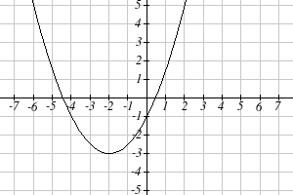

We can see the graph is the basic quadratic shifted to the left 2 and down 3, putting the vertex at (-2, 3), giving a formula in the form . By plugging in a point that falls on the grid, such as (0,-1), we can solve for the stretch factor:



The equation for this formula is .

**Short run Behavior: Intercepts**

As with any function, we can find the vertical intercepts of a quadratic by evaluating the function at an input of zero, and we can find the horizontal intercepts by solving for when the output will be zero. Notice that depending upon the location of the graph, we might have zero, one, or two horizontal intercepts.

|  |  |  |
| --- | --- | --- |
|  |  |  |
| zero horizontal intercepts | one horizontal intercept | two horizontal intercepts |

Notice that in the standard form of a quadratic, the constant term *c* reveals the vertical intercept of the graph, since .

Example 3

Find the vertical and horizontal intercepts of the quadratic 

We can find the vertical intercept by evaluating the function at an input of zero:

 Vertical intercept at (0,-2)

For the horizontal intercepts, we solve for when the output will be zero



In this case, the quadratic can be factored easily, providing the simplest method for solution



 or  Horizontal intercepts at  and (-2,0)

When a quadratic is not factorable or is hard to factor, we can turn to the quadratic formula.

Quadratic Formula

For a quadratic function given in standard form , the **quadratic formula** gives the horizontal intercepts of the graph of this function.



Example 4

A ball is thrown upwards from the top of a 40 foot high building at a speed of 80 feet per second. The ball’s height above ground can be modeled by the equation . When does the ball hit the ground?

To find when the ball hits the ground, we need to determine when the height is zero – when *H(t)* = 0. While we could do this using the transformation form of the quadratic, we can also use the quadratic formula:



Since the square root does not simplify nicely, we can use a calculator to approximate the values of the solutions:

 or 

The second answer is outside the reasonable domain of our model, so we conclude the ball will hit the ground after about 5.458 seconds.

Example 5

The supply for a certain product can be modeled by  and the demand can be modeled by , where *p* is the price in dollars, and *q* is the quantity in thousands of items. Find the equilibrium price and quantity.

Recall that the equilibrium price and quantity is found by finding where the supply and demand curve intersect. We can find that by setting the equations equal:

 Add  to both sides

 Divide by 5 on both sides

 Take the square root of both sides



Since it doesn’t make sense to talk about negative quantities, the equilibrium quantity is *q* = 18. To find the equilibrium price, we evaluate either function at the equilibrium quantity.



The equilibrium is 18 thousand items, at a price of $972.

### 1.5 Exercises

Write an equation for the quadratic function graphed.

1. 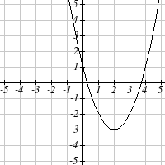 2. 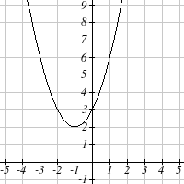

3. 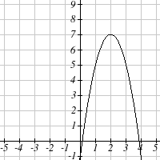 4. 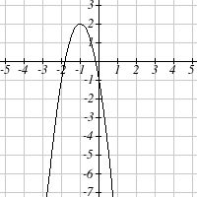

5. 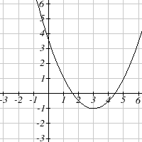 6. 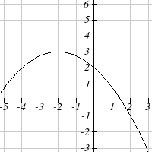

For each of the follow quadratic functions, find the vertical and horizontal intercepts.

7.  8. 

9.  10. 

11.  12. 

13. The height of a ball thrown in the air is given by , where *x* is the horizontal distance in feet from the point at which the ball is thrown.

1. How high is the ball when it was thrown?
2. What is the maximum height of the ball?
3. How far from the thrower does the ball strike the ground?

14. A javelin is thrown in the air. Its height is given by , where *x* is the horizontal distance in feet from the point at which the javelin is thrown.

1. How high is the javelin when it was thrown?
2. What is the maximum height of the javelin?
3. How far from the thrower does the javelin strike the ground?

## Section 6: Polynomials and Rational Functions

### Polynomial Functions

Terminology of Polynomial Functions

A **polynomial** is function that can be written as 

Each of the *ai* constants are called **coefficients** and can be positive, negative, or zero, and be whole numbers, decimals, or fractions.

A **term** of the polynomial is any one piece of the sum, that is any . Each individual term is a transformed power function.

The **degree** of the polynomial is the highest power of the variable that occurs in the polynomial.

The **leading term** is the term containing the highest power of the variable: the term with the highest degree.

The **leading coefficient** is the coefficient of the leading term.

Because of the definition of the “leading” term we often rearrange polynomials so that the powers are descending.



Example 1

Identify the degree, leading term, and leading coefficient of the polynomial

For the function *f(x)*, the degree is 3, the highest power on *x*. The leading term is the term containing that power, . The leading coefficient is the coefficient of that term, -4.

**Short run Behavior: Intercepts**

As with any function, the vertical intercept can be found by evaluating the function at an input of zero. Since this is evaluation, it is relatively easy to do it for a polynomial of any degree. To find horizontal intercepts, we need to solve for when the output will be zero. For general polynomials, this can be a challenging prospect. Consequently, we will limit ourselves to three cases:

1. The polynomial can be factored using known methods: greatest common factor and trinomial factoring.
2. The polynomial is given in factored form.
3. Technology is used to determine the intercepts.

Example 2

Find the horizontal intercepts of .

We can attempt to factor this polynomial to find solutions for *f(x)* = 0.

 Factoring out the greatest common factor

 Factoring the inside as a quadratic in *x*2

 Then break apart to find solutions

 or  or 

This gives us 5 horizontal intercepts.

Example 3

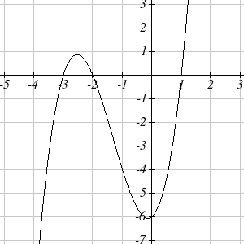Find the horizontal intercepts of 

Since this polynomial is not in factored form, has no common factors, and does not appear to be factorable using techniques we know, we can turn to technology to find the intercepts.

Graphing this function, it appears there are horizontal intercepts at *t* = -3, -2, and 1.

We could check these are correct by plugging in these values for *t* and verifying that .

**Solving Polynomial Inequalities**

One application of our ability to find intercepts and sketch a graph of polynomials is the ability to solve polynomial inequalities. It is a very common question to ask when a function will be positive and negative, and one we will use later in this course.

Example 4

Solve 

As with all inequalities, we start by solving the equality , which has solutions at *x* = -3, -1, and 4. We know the function can only change from positive to negative at these values, so these divide the inputs into 4 intervals.

We could choose a test value in each interval and evaluate the function  at each test value to determine if the function is positive or negative in that interval

|  |  |  |  |
| --- | --- | --- | --- |
| Interval | Test *x* in interval | *f(* test value*)* | >0 or <0? |
| *x* < -3 | -4 | 72 | > 0 |
| -3 < *x* < -1 | -2 | -6 | < 0 |
| -1 < *x* < 4 | 0 | -12 | < 0 |
| *x* > 4 | 5 | 288 | > 0 |

On a number line this would look like:

0

0

0

positive

negative

negative

positive

Description: Description: Graphs

From our test values, we can determine this function is positive when *x* < -3 or *x* > 4, or in interval notation, 

### Rational Functions

Rational functions are the ratios, or fractions, of polynomials. They can arise from both simple and complex situations.

Example 5

You plan to drive 100 miles. Find a formula for the time the trip will take as a function of the speed you drive.

You may recall that multiplying speed by time will give you distance. If we let *t* represent the drive time in hours, and *v* represent the velocity (speed or rate) at which we drive, then . Since our distance is fixed at 100 miles, . Solving this relationship for the time gives us the function we desired:



Notice that this is a transformation of the reciprocal toolkit function, . Several natural phenomena, such as gravitational force and volume of sound, behave in a manner **inversely proportional to the square** of another quantity. For example, the volume, *V*, of a sound heard at a distance *d* from the source would be related by  for some constant value *k*. These functions are transformations of the reciprocal squared toolkit function .

We have seen the graphs of the basic reciprocal function and the squared reciprocal function from our review of toolkit functions. These graphs have several important features.

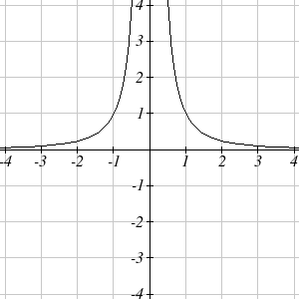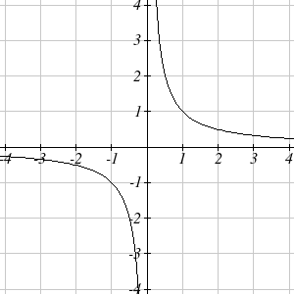

 

Let’s begin by looking at the reciprocal function, . As you well know, dividing by zero is not allowed and therefore zero is not in the domain, and so the function is undefined at an input of zero.

**Short run behavior:**

As the input values approach zero from the left side (taking on very small, negative values), the function values become very large in the negative direction (in other words, they approach negative infinity).

We write: as, .

As we approach zero from the right side (small, positive input values), the function values become very large in the positive direction (approaching infinity).

We write: as,.

This behavior creates a **vertical asymptote**. An asymptote is a line that the graph approaches. In this case the graph is approaching the vertical line *x* = 0 as the input becomes close to zero.

**Long run behavior:**

As the values of *x* approach infinity, the function values approach 0.

As the values of *x* approach negative infinity, the function values approach 0.

Symbolically: as,

Based on this long run behavior and the graph we can see that the function approaches 0 but never actually reaches 0, it just “levels off” as the inputs become large. This behavior creates a **horizontal asymptote**. In this case the graph is approaching the horizontal line as the input becomes very large in the negative and positive directions.

Vertical and Horizontal Asymptotes

A **vertical asymptote** of a graph is a vertical line *x* = *a* where the graph tends towards positive or negative infinity as the inputs approach *a*. As,.

A **horizontal asymptote** of a graph is a horizontal line where the graph approaches the line as the inputs get large. As,.

Example 6

Sketch a graph of the reciprocal function shifted two units to the left and up three units. Identify the horizontal and vertical asymptotes of the graph, if any.

Transforming the graph left 2 and up 3 would result in the function

, or equivalently, by giving the terms a common denominator, 

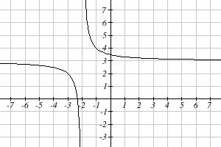

Shifting the toolkit function would give us this graph. Notice that this equation is undefined at *x* = -2, and the graph also is showing a vertical asymptote at *x* = -2.

As,, and as ,

As the inputs grow large, the graph appears to be leveling off at output values of 3, indicating a horizontal asymptote at .

As , .

Notice that horizontal and vertical asymptotes get shifted left 2 and up 3 along with the function.

A general rational function is the ratio of any two polynomials.

Rational Function

A **rational function** is a function that can be written as the ratio of two polynomials, *P(x)* and *Q(x)*.



Rational functions can arise from real situations.

Example 7

A large mixing tank currently contains 100 gallons of water, into which 5 pounds of sugar have been mixed. A tap will open pouring 10 gallons per minute of water into the tank at the same time sugar is poured into the tank at a rate of 1 pound per minute. Find the concentration (pounds per gallon) of sugar in the tank after *t* minutes.

Notice that the amount of water in the tank is changing linearly, as is the amount of sugar in the tank. We can write an equation independently for each:

 

The concentration, *C*, will be the ratio of pounds of sugar to gallons of water



Vertical Asymptotes of Rational Functions

The **vertical asymptotes** of a rational function will occur where the denominator of the function is equal to zero and the numerator is not zero.

Horizontal Asymptote of Rational Functions

The **horizontal asymptote** of a rational function can be determined by looking at the degrees of the numerator and denominator.

Degree of denominator > degree of numerator: Horizontal asymptote at 

Degree of denominator < degree of numerator: No horizontal asymptote

Degree of denominator = degree of numerator: Horizontal asymptote at ratio of leading coefficients.

Example 8

In the sugar concentration problem from earlier, we created the equation .

Find the horizontal asymptote and interpret it in context of the scenario.

Both the numerator and denominator are linear (degree 1), so since the degrees are equal, there will be a horizontal asymptote at the ratio of the leading coefficients. In the numerator, the leading term is *t*, with coefficient 1. In the denominator, the leading term is 10*t*, with coefficient 10. The horizontal asymptote will be at the ratio of these values: As , . This function will have a horizontal asymptote at .

This tells us that as the input gets large, the output values will approach 1/10. In context, this means that as more time goes by, the concentration of sugar in the tank will approach one tenth of a pound of sugar per gallon of water or 1/10 pounds per gallon.

Example 9

Find the horizontal and vertical asymptotes of the function



First, note this function has no inputs that make both the numerator and denominator zero, so there are no potential holes. The function will have vertical asymptotes when the denominator is zero, causing the function to be undefined. The denominator will be zero at *x* = 1, -2, and 5, indicating vertical asymptotes at these values.

The numerator has degree 2, while the denominator has degree 3. Since the degree of the denominator is greater than the degree of the numerator, the denominator will grow faster than the numerator, causing the outputs to tend towards zero as the inputs get large, and so as , . This function will have a horizontal asymptote at .

As with all functions, a rational function will have a vertical intercept when the input is zero, if the function is defined at zero. It is possible for a rational function to not have a vertical intercept if the function is undefined at zero.

Likewise, a rational function will have horizontal intercepts at the inputs that cause the output to be zero (unless that input corresponds to a hole). It is possible there are no horizontal intercepts. Since a fraction is only equal to zero when the numerator is zero, horizontal intercepts will occur when the numerator of the rational function is equal to zero.

Example 10

Find the intercepts of 

We can find the vertical intercept by evaluating the function at zero



The horizontal intercepts will occur when the function is equal to zero:

 This is zero when the numerator is zero



### 1.6 Exercises

Find the degree and leading coefficient of each polynomial

1.  2. 

3.  4. 

5.  6. 

Find the vertical and horizontal intercepts of each function.

7.  9. 

9.  10. 

11.  12. 

Use your calculator or other graphing technology to solve graphically for the zeros of the function.

13.  14. 

Solve each inequality.

15.  16. 

17.  18. 

For each function, find the horizontal intercepts, the vertical intercept, the vertical asymptotes, and the horizontal asymptote.

19. 20. 

21.  22. 

23.  24. 

25.  26. 

27. A scientist has a beaker containing 20 mL of a solution containing 20% acid. To dilute this, she adds pure water.

* 1. Write an equation for the concentration in the beaker after adding *n* mL of water.
  2. Find the concentration if 10 mL of water has been added.
  3. How many mL of water must be added to obtain a 4% solution?
  4. What is the behavior as , and what is the physical significance of this?

28. A scientist has a beaker containing 30 mL of a solution containing 3 grams of potassium hydroxide. To this, she mixes a solution containing 8 milligrams per mL of potassium hydroxide.

* 1. Write an equation for the concentration in the tank after adding *n* mL of the second solution.
  2. Find the concentration if 10 mL of the second solution has been added.
  3. How many mL of water must be added to obtain a 50 mg/mL solution?
  4. What is the behavior as , and what is the physical significance of this?

## Section 7: Exponential Functions

Consider these two companies:

Company *A* has 100 stores, and expands by opening 50 new stores a year

Company *B* has 100 stores, and expands by increasing the number of stores by 50% of their total each year.

Company *A* is exhibiting linear growth. In linear growth, we have a constant rate of change – a constant *number* that the output increased for each increase in input. For company A, the number of new stores per year is the same each year.

Company *B* is different – we have a *percent* rate of change rather than a constant number of stores/year as our rate of change. To see the significance of this difference compare a 50% increase when there are 100 stores to a 50% increase when there are 1000 stores:

100 stores, a 50% increase is 50 stores in that year.

1000 stores, a 50% increase is 500 stores in that year.

Calculating the number of stores after several years, we can clearly see the difference in results.

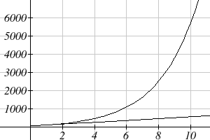 *B*

|  |  |  |
| --- | --- | --- |
| years | Company *A* | Company *B* |
| 2 | 200 | 225 |
| 4 | 300 | 506 |
| 6 | 400 | 1139 |
| 8 | 500 | 2563 |
| 10 | 600 | 5767 |

*A*

This percent growth can be modeled with an exponential function.

Exponential Function

An **exponential growth or decay function** is a function that grows or shrinks at a constant percent growth rate. The equation can be written in the form

 or  where *b* = 1+*r*

Where

*a* is the initial or starting value of the function

*r* is the percent growth or decay rate, written as a decimal

*b* is the growth factor or growth multiplier. Since powers of negative numbers behave strangely, we limit *b* to positive values.

Example 1

India’s population was 1.14 billion in the year 2008 and is growing by about 1.34% each year. Write an exponential function for India’s population, and use it to predict the population in 2020.

Using 2008 as our starting time (*t* = 0), our initial population will be 1.14 billion. Since the percent growth rate was 1.34%, our value for *r* is 0.0134.

Using the basic formula for exponential growth we can write the formula, 

To estimate the population in 2020, we evaluate the function at *t* = 12, since 2020 is 12 years after 2008.

billion people in 2020

Example 2

A certificate of deposit (CD) is a type of savings account offered by banks, typically offering a higher interest rate in return for a fixed length of time you will leave your money invested. If a bank offers a 24 month CD with an annual interest rate of 1.2% compounded monthly, how much will a $1000 investment grow to over those 24 months?

First, we must notice that the interest rate is an annual rate, but is compounded monthly, meaning interest is calculated and added to the account monthly. To find the monthly interest rate, we divide the annual rate of 1.2% by 12 since there are 12 months in a year: 1.2%/12 = 0.1%. Each month we will earn 0.1% interest. From this, we can set up an exponential function, with our initial amount of $1000 and a growth rate of *r* = 0.001, and our input *m* measured in months.





After 24 months, the account will have grown to 

Example 3

Bismuth-210 is an isotope that radioactively decays by about 13% each day, meaning 13% of the remaining Bismuth-210 transforms into another atom (polonium-210 in this case) each day. If you begin with 100 mg of Bismuth-210, how much remains after one week?

With radioactive decay, instead of the quantity increasing at a percent rate, the quantity is decreasing at a percent rate. Our initial quantity is *a* = 100 mg, and our growth rate will be negative 13%, since we are decreasing: *r* = -0.13. This gives the equation:



This can also be explained by recognizing that if 13% decays, then 87 % remains.

After one week, 7 days, the quantity remaining would be

mg of Bismuth-210 remains.

Example 4

*T(q)* represents the total number of Android smart phone contracts, in thousands, held by a certain Verizon store region measured quarterly since January 1, 2010,

Interpret all of the parts of the equation .

Interpreting this from the basic exponential form, we know that 86 is our initial value. This means that on Jan. 1, 2010 this region had 86,000 Android smart phone contracts. Since *b* = 1 + *r* = 1.64, we know that every quarter the number of smart phone contracts grows by 64%. *T*(2) = 231.3056 means that in the 2nd quarter (or at the end of the second quarter) there were approximately 231,305 Android smart phone contracts.

When working with exponentials, there is a special constant we must talk about. It arises when we talk about things growing continuously, such as continuous compounding, or natural phenomena like radioactive decay that happen continuously.

Euler’s Number: *e*



Because *e* is often used as the base of an exponential, most scientific and graphing calculators have a button that can calculate powers of *e*, usually labeled *ex*. Some computer software instead defines a function *exp(x)*, where *exp(x)* = *ex*. Since calculus studies continuous change, we will almost always use the *e*-based form of exponential equations in this course.

Continuous Growth Formula

**Continuous Growth** can be calculated using the formula



where

*a* is the starting amount

*r* is the continuous growth rate

Example 5

Radon-222 decays at a continuous rate of 17.3% per day. How much will 100mg of Radon-222 decay to in 3 days?

Since we are given a continuous decay rate, we use the continuous growth formula. Since the substance is decaying, we know the growth rate will be negative: *r* = -0.173

mg of Radon-222 will remain.

### Graphs of Exponential Functions

Graphical Features of Exponential Functions

Graphically, in the function 

*a* is the vertical intercept of the graph

*b* determines the rate at which the graph grows

the function will increase if *b >* 1

the function will decrease if 0 < *b* < 1

The graph will have a horizontal asymptote at *y* = 0

The graph will be concave up if *a* > 0; concave down if *a* < 0.

The domain of the function is all real numbers

The range of the function is 

When sketching the graph of an exponential function, it can be helpful to remember that the graph will pass through the points (0, *a*) and (1, *ab*).

The value *b* will determine the function’s long run behavior:

If *b >* 1, as  ,  and as , .

If 0 < *b* < 1, as , and as , .

Example 6

Sketch a graph of 

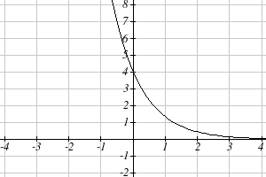

This graph will have a vertical intercept at (0,4), and pass through the point . Since *b* < 1, the graph will be decreasing towards zero. Since *a* > 0, the graph will be concave up.

We can also see from the graph the long run behavior: as ,  and as , .

To get a better feeling for the effect of *a* and *b* on the graph, examine the sets of graphs below.

The first set shows various graphs, where *a* remains the same and we only change the value for *b*. Notice that the closer the value of *b* is to 1, the less steep the graph will be.













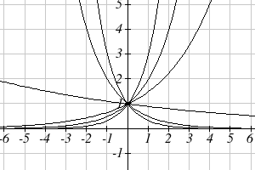

In the next set of graphs, *a* is altered and our value for *b* remains the same.

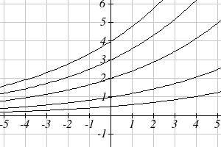











Notice that changing the value for *a* changes the vertical intercept. Since *a* is multiplying the *bx* term, *a* acts as a vertical stretch factor, not as a shift. Notice also that the long run behavior for all of these functions is the same because the growth factor did not change and none of these *a* values introduced a vertical flip.

Example 7

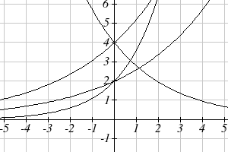Match each equation with its graph.



The graph of *k(x)* is the easiest to identify, since it is the only equation with a growth factor less than one, which will produce a decreasing graph. The graph of *h(x)* can be identified as the only growing exponential function with a vertical intercept at (0,4). The graphs of *f(x)* and *g(x)* both have a vertical intercept at (0,2), but since *g(x)* has a larger growth factor, we can identify it as the graph increasing faster.

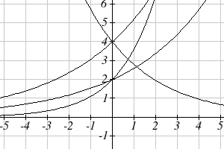

*f(x)*

*g(x)*

*k(x)*

*h(x)*

### 1.7 Exercises

1. A population numbers 11,000 organisms initially and grows by 8.5% each year. Write an exponential model for the population.

2. A population is currently 6,000 and has been increasing by 1.2% each day. Write an exponential model for the population.

3. A vehicle purchased for $32,500 depreciates at a constant rate of 5% each year. Determine the approximate value of the vehicle 12 years after purchase.

4. A business purchases $125,000 of office furniture which depreciates at a constant rate of 12% each year. Find the residual value of the furniture 6 years after purchase.

5. If $4,000 is invested in a bank account at an interest rate of 7 per cent per year, find the amount in the bank after 9 years if interest is compounded annually, quarterly, monthly, and continuously.

6. If $6,000 is invested in a bank account at an interest rate of 9 per cent per year, find the amount in the bank after 5 years if interest is compounded annually, quarterly, monthly, and continuously.

Match each function with one of the graphs below.

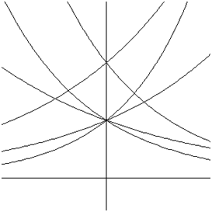

*A*

*B*

*C*

*D*

*E*

*F*

7. 

8. 

9. 

10. 

11. 

12. 

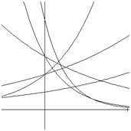

*A*

*B*

*C*

*D*

*E*

*F*

If all the graphs to the right have equations with form ,

13. Which graph has the largest value for *k*?

14. Which graph has the smallest value for *k*?

15. Which graph has the largest value for *a*?

16. Which graph has the smallest value for *a*?

## Section 8: Logarithmic Functions

Logarithms are the inverse of exponential functions -- they allow us to undo exponential functions and solve for the exponent. They are also commonly used to express quantities that vary widely in size.

Logarithm Equivalent to an Exponential

**The logarithm** (base *b*) function, written , is the inverse of the exponential function (base *b*), .

This means the statement  is equivalent to the statement .

Properties of Logs: Inverse Properties





Example 1

Write these exponential equations as logarithmic equations:

a)  b)  c) 

a)  is equivalent to 

b)  is equivalent to 

c)  is equivalent to 

Example 2

Solve  for *x*.

By rewriting this expression as a logarithm, we get 

While this does define a solution, and an exact solution at that, you may find it somewhat unsatisfying since it is difficult to compare this expression to the decimal estimate we made earlier. Also, giving an exact expression for a solution is not always useful – often we really need a decimal approximation to the solution. Luckily, this is a task calculators and computers are quite adept at. Unluckily for us, most calculators and computers will only evaluate logarithms of two bases. Happily, this ends up not being a problem, as we’ll see briefly.

Common and Natural Logarithms

The **common log** is the logarithm with base 10, and is typically written .

The **natural log** is the logarithm with base *e*, and is typically written .

Example 3

Evaluate  using the definition of the common log.

**Values of the common log**

|  |  |  |
| --- | --- | --- |
| number | number as  exponential | log(number) |
| 1000 | 103 | 3 |
| 100 | 102 | 2 |
| 10 | 101 | 1 |
| 1 | 100 | 0 |
| 0.1 | 10-1 | -1 |
| 0.01 | 10-2 | -2 |
| 0.001 | 10-3 | -3 |

To evaluate , we can say , then rewrite into exponential form using the common log base of 10.



From this, we might recognize that 1000 is the cube of 10, so *x* = 3.

We also can use the inverse property of logs to write 

Example 4

Evaluate log(500) using your calculator or computer.

Using a computer or calculator, we can evaluate 

Another property provides the basis for solving exponential equations.

Properties of Logs: Exponent Property



Solving exponential equations:

Isolate the exponential expressions when possible

Take the logarithm of both sides

Utilize the exponent property for logarithms to pull the variable out of the exponent

Use algebra to solve for the variable.

Example 5

In the last section, we predicted the population (in billions) of India *t* years after 2008 by using the function . If the population continues following this trend, when will the population reach 2 billion?

We need to solve for the *t* so that *f(t)* = 2

 Divide by 1.14 to isolate the exponential expression

 Take the logarithm of both sides of the equation

 Apply the exponent property on the right side

 Divide both sides by ln(1.0134)

 years

If this growth rate continues, the model predicts the population of India will reach 2 billion about 42 years after 2008, or approximately in the year 2050.

Example 6

Solve  for *t*.

First we divide by 5 to isolate the logarithm



Since this equation involves *e*, it makes sense to use the natural log:

 Utilizing the inverse property for logs,

 Now dividing by -0.3,



In addition to solving exponential equations, logarithmic expressions are common in many physical situations.

Example 7

In chemistry, pH is a measure of the acidity or basicity of a liquid. The pH is related to the concentration of hydrogen ions, [*H*+], measured in moles per liter, by the equation .

If a liquid has concentration of 0.0001 moles per liber, determine the pH.

Determine the hydrogen ion concentration of a liquid with pH of 7.

To answer the first question, we evaluate the expression . While we could use our calculators for this, we do not really need them here, since we can use the inverse property of logs:



To answer the second question, we need to solve the equation . Begin by isolating the logarithm on one side of the equation by multiplying both sides by -1:



Rewriting into exponential form yields the answer

 moles per liter.

While we don't often need to sketch the graph of a logarithm, it is helpful to understand the basic shape.

Graphical Features of the Logarithm

Graphically, in the function 

The graph has a horizontal intercept at (1, 0)

The graph has a vertical asymptote at *x* = 0

The graph is increasing and concave down

The domain of the function is *x* > 0, or 

The range of the function is all real numbers, or 

When sketching a general logarithm with base *b*, it can be helpful to remember that the graph will pass through the points (1, 0) and (*b*, 1).

To get a feeling for how the base affects the shape of the graph, examine the graphs below.



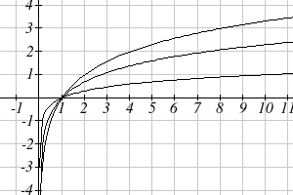





Another important observation made was the domain of the logarithm: *x* > 0. Like the reciprocal and square root functions, the logarithm has a restricted domain which must be considered when finding the domain of a composition involving a log.

Example 8

Find the domain of the function 

The logarithm is only defined with the input is positive, so this function will only be defined when . Solving this inequality,



The domain of this function is , or in interval notation, 

### 1.8 Exercises

Rewrite each equation in exponential form

1.  2.  3.  4. 

Rewrite each equation in logarithmic form.

5.  6.  7.  8. 

Solve each equation for the variable.

9.  10.  11.  12. 

13.  14.  15.  16. 

17.  18. 

19.  20. 

21.  22. 

23.  24. 

25. The population of Kenya was 39.8 million in 2009 and has been growing by about 2.6% each year. If this trend continues, when will the population exceed 45 million?

26. The population of Algeria was 34.9 million in 2009 and has been growing by about 1.5% each year. If this trend continues, when will the population exceed 45 million?

27. If $1000 is invested in an account earning 3% compounded monthly, how long will it take the account to grow in value to $1500?

28. If $1000 is invested in an account earning 2% compounded quarterly, how long will it take the account to grow in value to $1300?

29. Sketch a graph of: 

Find the domain of each function.

30.  31. 

32.  33. 